Poster worksheet and troubleshooting guide

What you should and should not change
- Do change the poster title, your name, your email, the main finding sentence, the written sections, and the commented code inside the existing chunks.
- Do not change the YAML header at the very top of the template.
- Do not change the HTML structure. Leave all <div>, </div>, <h2>, <h3> and other angle-bracket tags exactly as they are. These just making the column breaks.
- Do not change the code chunk headers or chunk options. This includes the lines that start with ```{r ...}. These control figure size and formatting so the poster fits the page.
- Use <br> if you need to create extra spacing between sections. This is the safe way to adjust spacing in this format.
- Keep knitting regularly so you can spot problems as soon as they appear.

Packages and setup
you need the packages knitr and tidyverse installed on their computer, and the template will then load them in the setup chunk. If they are not installed already, they should run the following once in the Console:
install.packages("tidyverse")
install.packages("knitr")
The setup chunk in the template already contains:
library(tidyverse)
library(knitr)
You should save your personal CSV data file in the data folder and update the file name in the read.csv() line as required.
You should save the poster_columns.css file into that same folder as the Rmd template. You do not need to open or edit the CSS file. The template accesses it automatically through the line in the YAML header.
To create the PDF version, you need the saveaspdf.R script saved in the same folder. After the poster has knitted successfully to HTML, they should open saveaspdf.R, select the whole script, and run it once. This converts the knitted HTML poster into a PDF. This pdf is automatically saved in the same folder (nothing pops up in R).

Poster structure
The layout is fixed into three columns. You can’t add extra panels or move sections around. They should edit the text so that it fits the existing spaces.
Column 1 | Introduction and Methods
Column 2 | Descriptive Results
Column 3 | Regression Results and Conclusion
General rule | Everything must fit inside these existing sections. You should shorten your wording or alter spacing using <br> (same as adding a space in a word document) rather than changing the layout.

As an FYI – you will not be marked down if your columns are not identical lengths. Do not worry if they are not aligned. Please see the example poster as an example below where the three columns aren’t perfectly ending at the same point.

To maintain this structure you should not edit any of the div>, </div>, <h2>, <h3> and other angle-bracket tags. These set the headers and columns. E.g.

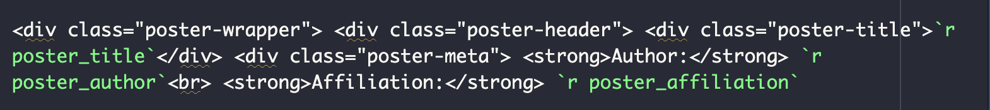

You should however edit the sections in purple caps (might be a different colour in your R). This is where you write your one sentence finding, or your introduction etc. Once you have finished editing these sentence remove the * * at either end, because if not your text will be in italics.

E.g. *WRITE YOUR MAIN FINDING* should become “Older children have been emotional regulation” without ** at either side.

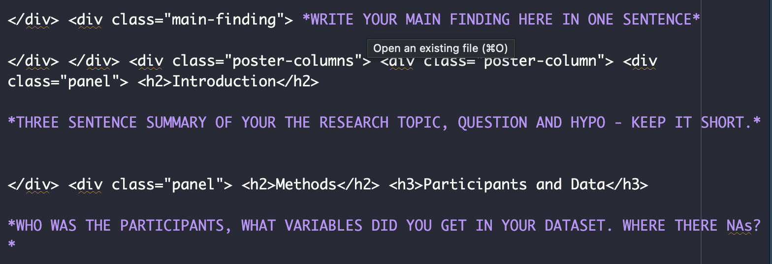

Section-by-section guidance

1. YAML and poster header
You should fill in the poster title, author details and affiliation where shown in the template where commented “EDIT THIS”. Do not touch anything which says “DON’T EDIT THIS”. Eg -
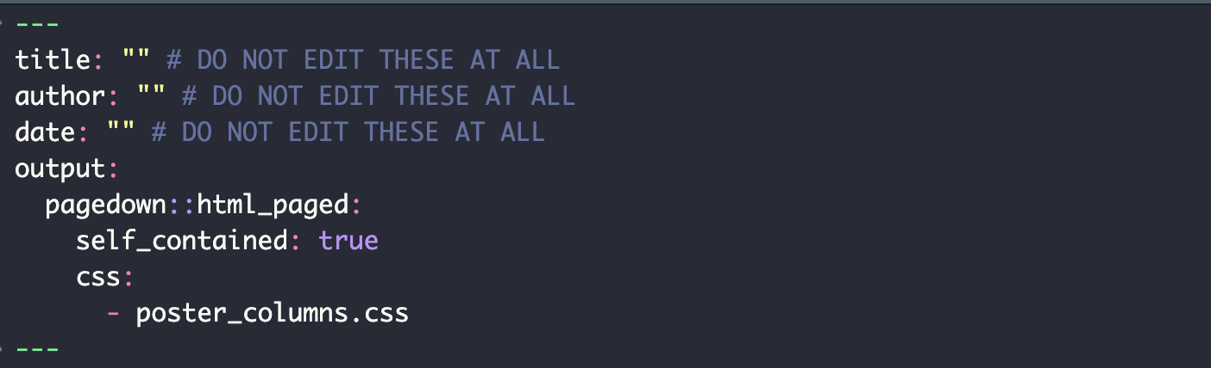

Do no alter the output format, CSS line, or any of the surrounding structure.
You should change the title, name and email etc where shown. You should also replace the main finding sentence with one clear sentence summarising the overall result of their own analysis. This is highlighted in the text.
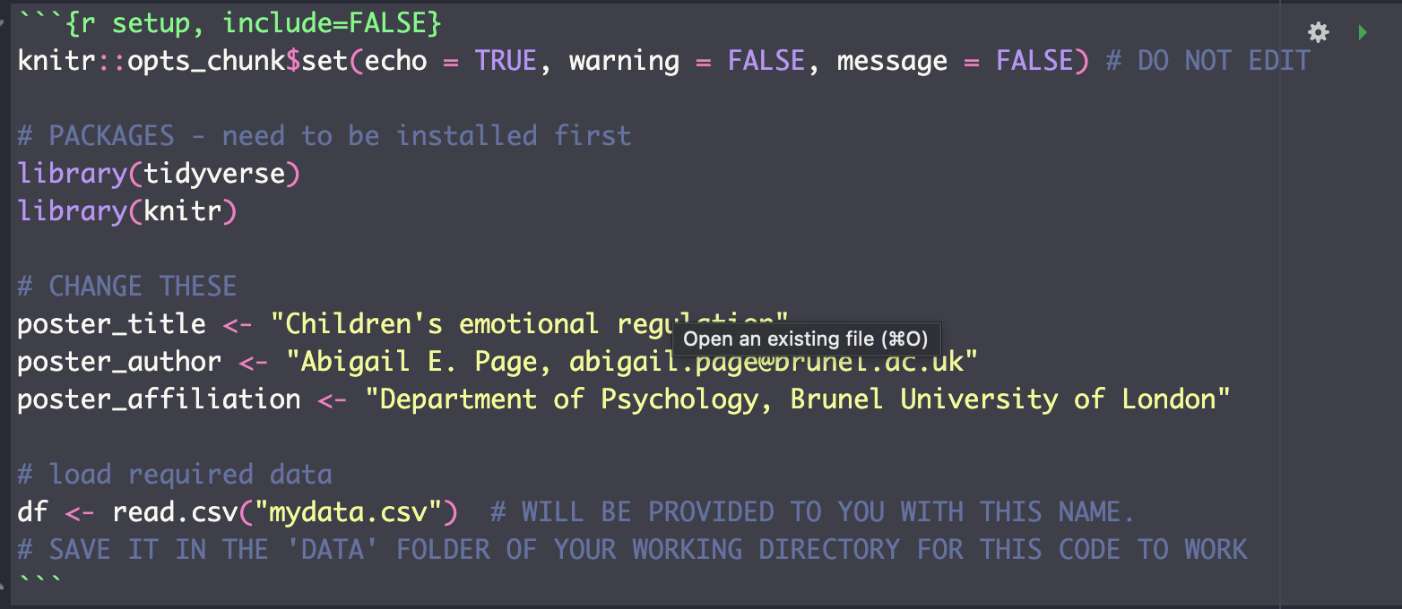

2. Introduction and Methods column
The left column contains the Introduction and Methods panels. You should keep these sections short. The Introduction should be around three sentences. The Methods subsections should be concise and written into the existing headings: Participants and Data, Data Preparation, and Descriptive and Inferential Statistics.
In the Data Preparation code chunk, you should show and comment their own use of rename(), mutate() and drop_na().
Once you finished writing your code chunk please delete the guidance comments. If not they will show up in your poster!

3. Descriptive Results column
The middle column contains the descriptive summary table and two distribution plots. You should report the mean and SD of the independent and dependent variables, then briefly describe what the distributions look like.
The template example now uses density plots, but if students are asked to use a histogram, they must keep the chunk header exactly as provided so the figure fits the poster.
Example histogram code that matches the poster format:
```{r, echo=FALSE, fig.width=13, fig.height=13}
ggplot(df_clean, aes(x = age)) +
geom_histogram() +
labs(x = "Age (years)", y = "Count", title = "") +
theme_minimal(base_size = 26)
```
The same figure size (base_size = 26) can be used for the dependent variable histogram, just replacing age with the relevant variable name and updating the axis label.

4. Regression Results and Conclusion column
The right column contains the regression write-up, regression coefficients table, scatterplot, residual normality sentence and conclusion. You should keep the write-up concise and in APA style, reporting model fit, R-squared, the regression coefficient, standard error and p-value. You only need to present a Q-Q if there is space.
The conclusion should be around three sentences and should interpret the result in relation to the study question.

Checklist before knitting
- I only changed the commented text/code and the specific placeholder content.
- I did not edit the <div> structure or the code chunk headers.
- I kept my wording short enough to fit the fixed poster panels.
- I used <br> only where needed for spacing.
- The poster knits successfully to HTML before I run saveaspdf.R to create the PDF.
- poster_columns.css is saved in the same folder as my Rmd file.
- The saveaspdf.R is saved in the same folder and I know I only need to run the whole script after knitting the HTML.
- knitr and tidyverse are installed and loaded.

FAQ
Error | What to do
File not found | Check that the CSV is in the correct data folder and that the file name in read.csv() exactly matches the saved file name.
Object not found | Check spelling and make sure the object or variable was created earlier in the script.
Unexpected symbol | Check missing commas, brackets, quotation marks or a missing %>% pipe.
Plots too big or poster layout breaks | Do not edit the chunk headers or figure size options.
Spacing looks wrong | Use the existing <br> lines rather than changing the HTML structure.
Poster will not knit | Restart R, run the script again and then knit. Knit regularly so it is obvious where a problem begins.

The poster always knits to HTML first. You should keep the saveaspdf.R script in the same folder as the template, the HTML output, and the poster_columns.css file. Once the HTML poster has knitted successfully, they should open saveaspdf.R, select all of the code, and run the entire script once so the HTML poster is saved as a PDF. If the script refers to an HTML file name, that file name must match the knitted HTML file exactly.

Final advice: only edit the sections highlighted, keep the structure fixed, keep the writing brief and knit often.

