**HOTEL MANAGEMENT SOFTWARE**

**1.0 INTRODUCTION**

While the practice of renting space to travelers stretches back to antiquity, what could be considered the modern concept of a hotel derives from the 18th century. The hotel industry is a mature industry marked by intense competition. Market share increases typically comes at a competitor’s expense. Industry-wide, most growth occurs in the international, rather than the domestic, arena.

Hotels are the planned destination of guests, usually vacationers or businessmen. For vacationers some of the Hotels are located at sea side or in the mountains away from inner cities. These may offer any form of entertainment to keep their guests happy and busy.

There are various types of hotels as depicted in the diagram below:

This project has been developed for Hotel Management as per the requirements of the CBSE Class XII Board for Computer Science. We have tried our best to make the process of Hotel Management as simple as possible using a structured menu approach. The design of software is in such a way that user may not have any difficulty in using this package. The main purpose of this software is to handle all the front desk activities in a Hotel to reduce the manual effort which is time consuming.

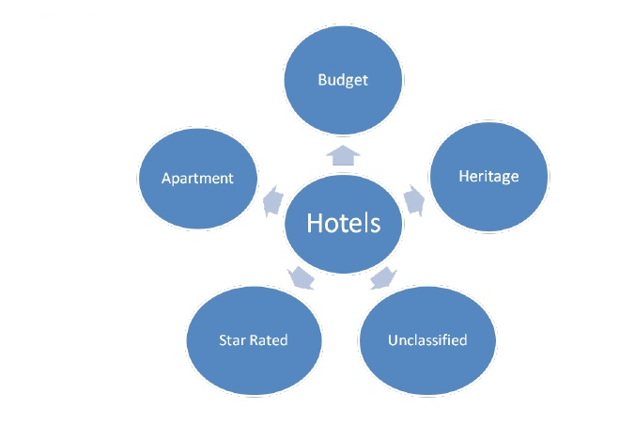

**2.0 OBJECTIVE**

The primary objective of the software is to improve the quality of service to its customers in a hotel. The objective of this software is to provide facilities for booking hotel rooms and related maintenance. In a manual system, all the activities in the front desk are handled physically and hence are extremely time consuming and inefficient. The automated system helps in handling the entire front desk activities like booking, check-in, check-out, restaurant service and taxi service of customers. The software generates necessary bills and reports. We are confident that this software package can be readily used by non-programming personal. The searching of data has been made quite simple by providing several enquiry options for each of the activities. The system has automatic data validation, user friendly environment, security and reliability.­

**­**

**3.0 ADVANTAGES**

The software has been designed to automate the front desk activities in a hotel. The following are the main advantages of the system:

**User Friendliness:** The application is menu driven and user friendly with validations provided at various levels of the software. Appropriate messages are provided in the application.

**Performance:** Earlier, the records at hotels were handled manually for all activities. The manual handling of records are time consuming and hence are highly prone to errors. This software provides improvement in the performance of all the activities at the front desk in a hotel.

**Control:** The complete control of the project is under the hands of an authorized person who has the password to access this project. Here, access is provided through user-id and password.

**Enquiry/ Reporting:** The software provides an option to enquiry for all activities like booking, check-in, check-out, cancellation. It also provides a summarized status of the availability of rooms for booking.

**SOFTWARE DEVELOPMENT PROCESS**

The software development process involves the following stages:

* System Analysis and Requirement phase
* Design phase
* Testing phase
* Implementation phase

1. **System Analysis**

System analysis is the process of gathering and interpreting facts, diagnosing problems and using the facts to improve the system. This process specifies what the system should do. A system is a set of components that interact to accomplish a particular­­ purpose.

**1.1 Requirement specification**

Requirement specification means of translating the business idea into a formal document for development of software. The main features of this include:

* Understanding all user requirements and establishing basis for an agreement between the user and developer.
* Producing a reference for validation of the final product.

The software requirement specification assists users in determining if the software meets their requirements.

**1.2 Feasibility Study**

The feasibility analysis covers the need for the project and explores if there are any alternate means to achieve the task. The feasibility study should include the overall outcome of the project analysis. This may indicate an endorsement or disapproval of the project. Recommendations on what should be done should be included in the feasibility report.

1. **Design Phase**

System design provides the understanding and procedural details necessary for implementing the system recommended in the system study .Emphasis is on translating the user requirements into technical design specifications.

**3.0 Testing phase**

Testing will be carried out for all the activities covered in the project. All test results should be documented which demonstrates that the testing objectives and software requirements have been met. The final product shall be verified with the functionality of the software as specified in the Software Requirements Specification document.

1. **Implementation phase**

Subsequent to testing of the product the software shall be implemented in a live environment.

**SYSTEM ENVIRONMENT**

The following are hardware and software requirements for the software:

**Hardware Configuration (Minimum)**

* Processor : Pentium III or higher
* RAM : 128 MB or More
* Hard Disk : 20 GB or More
* Modem : 56KBPS / LAN Card

**Software Configuration**

* Operating System: Windows XP, VISTA, 7.
* Compiler : Turbo C++
* Language : C++
* Shareware : DosBox for 64 bit systems

**HIGH LEVEL SOFTWARE FLOW DIAGRAM**

**(MAIN MENU)**

**CHECK-IN**

**BOOKING**

**CREATE BILL**

**ENQUIRY SUBMENU**

**CHECK-OUT**

**HOTEL MANAGEMENT SOFTWARE**

**TAXI SERVICE**

**CANCELLATION**

**RESTAURANT**

**HIGH LEVEL SOFTWARE FLOW DIAGRAM**

**(ENQUIRY SUB-MENU)**

**ROOMS AVAILABILITY**

**CHECK-IN**

**BOOKING**

**ENQUIRY SUBMENU**

**CANCELLATION**

**CHECK OUT**

**BIBLIOGRAPHY**

The following books were referred to for the development of the Hotel Management Software Project:

1. Computer Science C++ by Sumita Arora
2. Reeta Sahoo – C++ Textbook
3. Programming with C++ by Ravichandran
4. Let us C++ by Kanetkar

***Thank You***