Product Requirement Document (PRD)

# 1. Overview

Objective

To design and implement an AI-powered product recommendation engine that improves product discovery and boosts conversion rates by suggesting relevant items to users based on their behavior, preferences, and shopping history.

# 2. Problem Statement

Customers often find it difficult to discover new or relevant products, especially when they don’t know what exactly they’re looking for. This leads to:

- Longer decision-making time

- Higher bounce rates

- Lower conversion rates

# 3. Goals and Success Metrics

Goals

- Improve user experience through relevant suggestions

- Increase average order value (AOV)

- Increase time spent on site

- Reduce bounce rate on product and homepage

Success Metrics

# 4. Scope

In-Scope

- Personalized product recommendations on the homepage, product pages, and cart/checkout page

- Backend recommendation algorithm

- Admin dashboard for the marketing team

Out-of-Scope

- Email or SMS recommendations

- On-app notifications

- Integration with third-party platforms

# 5. User Stories

As a logged-in user, I want to see products I’m likely to be interested in, so I can discover new items quickly without endlessly searching.

As a guest user, I want product suggestions based on browsing history, so I can still get relevant options without signing in.

As a product manager, I want to track the performance of recommendation modules so that I can evaluate and iterate on the feature.

# 6. Functional Requirements

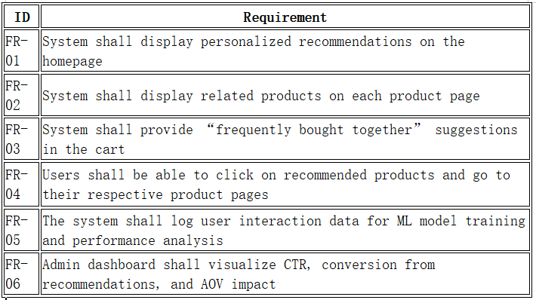

# 7. Non-Functional Requirements

- Performance: Recommendations must load within 1.5 seconds

- Scalability: Handle at least 500,000 users concurrently

- Privacy: Comply with NDPR

- Availability: 99.9% uptime required

# 8. Technical Requirements

- Frontend: React components

- Backend: Python (FastAPI), ML (sci-kit-learn/TensorFlow)

- Data Pipeline: Clickstream data, Airflow jobs

- Storage: PostgreSQL, Redis

- APIs: /recommendations/user/{user_id}, /recommendations/product/{product_id}, /admin/metrics

# 9. UX/UI Requirements

- Display 4-6 recommended products per section

- Include image, name, price, and rating

- AJAX load for updates

- CTA buttons (Add to cart, View more)

# 10. Dependencies

- Data Engineering

- Machine Learning

- DevOps

- Design

- Legal

# 11. Risks and Mitigations

# 12. Milestones

# 13. Appendix

- Figma design link

- Recommendation algorithm pseudocode

- User personas

- API documentation

## Success Metrics

| Metric | Baseline | Target (Post-Launch) |
| --- | --- | --- |
| Conversion rate | 3.2% | 4.5% |
| Average Order Value (AOV) | ₦10,000 | ₦12,000 |
| Session Duration | 4 mins | 6 mins |
| CTR on recommendations | 2.5% | 6% |

## Functional Requirements

| ID | Requirement |
| --- | --- |
| FR-01 | Display personalized recommendations on the homepage |
| FR-02 | Display related products on each product page |
| FR-03 | Show “frequently bought together” in the cart |
| FR-04 | Clickable recommended products to respective pages |
| FR-05 | Log user data for ML training and analysis |
| FR-06 | Admin dashboard to visualize performance metrics |

## Risks and Mitigations

| Risk | Mitigation |
| --- | --- |
| Low-quality recommendations | Use A/B testing to validate model versions |
| Cold start for new users | Use a hybrid system with a fallback to popular products |
| Performance bottlenecks | Use caching and async API calls |
| User privacy concerns | Anonymize data and comply with NDPR |

## Milestones

| Milestone | Target Date |
| --- | --- |
| PRD Finalization | June 10, 2025 |
| Design and UI Mockups Ready | June 14, 2025 |
| Backend Algorithm MVP | June 24, 2025 |
| Frontend Integration | July 2, 2025 |
| Internal QA | July 8, 2025 |
| Beta Launch (10% users) | July 15, 2025 |
| Full Launch | July 22, 2025 |