In the matlab command line type “eeglab” and press enter

To extract eeglab data from the Brain Products recording files:

Select File > Import Data > Using EEGLAB functions and plugins > From Brain Vis. Rec. .vhdr file

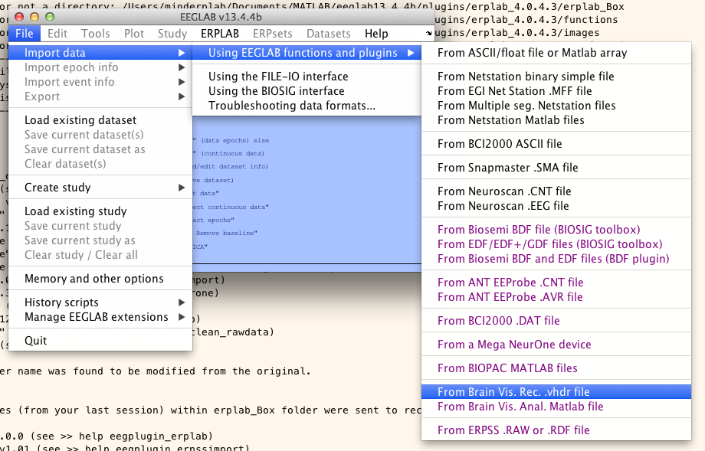

Navigate to the appropriate folder:

* For DT: REDWOOD/Blackbird/Intern Folder/ERP/160907-/DT/[participant id number, i.e., 173]
* For eDT_angry: REDWOOD/Blackbird/Intern Folder/ERP/160907-/eDT_angry/[participant id number, i.e., 173]
* For eDT_happy: REDWOOD/Blackbird/Intern Folder/ERP/160907-/eDT_happy/[participant id number, i.e., 173]
* For eDT_calm: REDWOOD/Blackbird/Intern Folder/ERP/160907-/eDT_calm/[participant id number, i.e., 173]
* For eGNG_faces_angry: REDWOOD/Blackbird/Intern Folder/ERP/160907-/eGNG_faces_angry/[participant id number, i.e., 173]
* For eGNG_faces_happy: REDWOOD/Blackbird/Intern Folder/ERP/160907-/eGNG_faces_happy/[participant id number, i.e., 173]
* For eGNG_IAPS_negative: REDWOOD/Blackbird/Intern Folder/ERP/160907-/eGNG_IAPS_negative/[participant id number, i.e., 173]
* For eGNG_IAPS_positive: REDWOOD/Blackbird/Intern Folder/ERP/160907-/eGNG_IAPS_positive/[participant id number, i.e., 173]
* For GNG: REDWOOD/Blackbird/Intern Folder/ERP/160907-/GNG/[participant id number, i.e., 173]

Select the file:

* For DT start with: DT_blue_session1_[participant id number, i.e., 173]
* For eDT_angry start with: eDT_Angry_Session1_[participant id number, i.e., 173]
* For eDT_calm start with: eDT_Calm_Session1_[participant id number, i.e., 173]
* For eDT_happy start with: eDT_Happy_Session1_[participant id number, i.e., 173]
* For eGNG_faces_angry start with: eGNG_Angry_Session1_[participant id number, i.e., 173]
* For eGNG_faces_happy start with: eGNG_Happy_Session1_[participant id number, i.e., 173]
* For eGNG_IAPS_negative start with: eGNG_IAPS_negative_Session1_[participant id number, i.e., 173]
* For eGNG_IAPS_positive start with: eGNG_IAPS_positive_Session1_[participant id number, i.e., 173]
* For GNG start with: GNG_Session1_[participant id number, i.e., 173]

The “Load a Brain Vision Data Exchange format dataset” window appears. Enter nothing beside Interval, and 35 beside Channels.

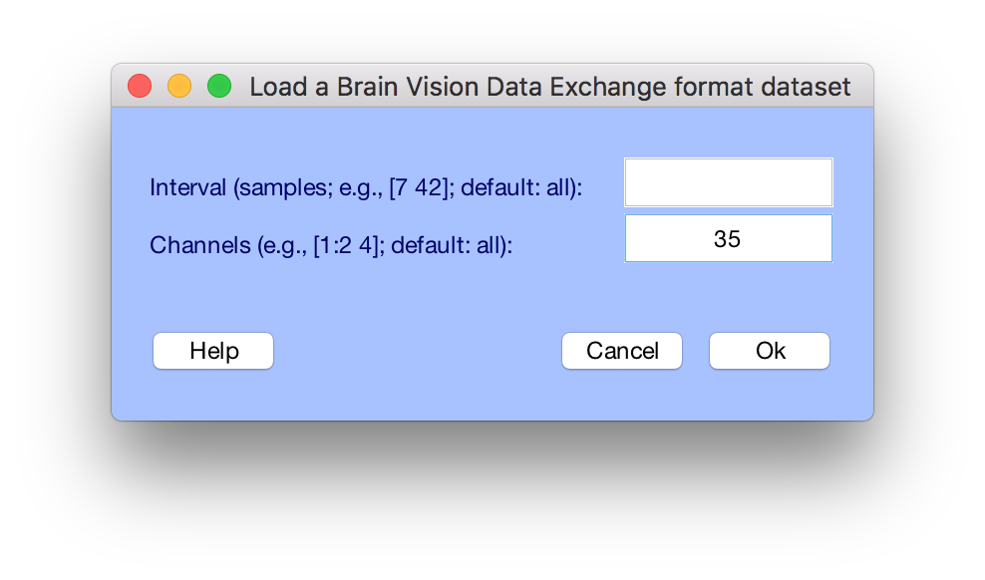

You will be asked to name the dataset, give it the same name it previously had (i.e., “eDT_Happy_Session1_[participant id number, i.e., 173]”)

Repeat for all sessions in folder.

* For DT there are 6 sessions
* For eDT_angry there are 2 sessions
* For eDT_calm there are 2 sessions
* For eDT_happy there are 2 sessions
* For eGNG_faces_angry there are 5 sessions for CARPP participants, 2 sessions for BETTA participants
* For eGNG_faces_happy there are 5 sessions for CARPP participants, 2 sessions for BETTA participants
* For eGNG_IAPS_negative there are 2 sessions
* For eGNG_IAPS_positive there are 2 sessions
* For GNG there are 5 sessions for CARPP participants, 2 sessions for BETTA participants

Note, after the first file the name dataset dialogue box will look like this. You only need to fill out the first field.

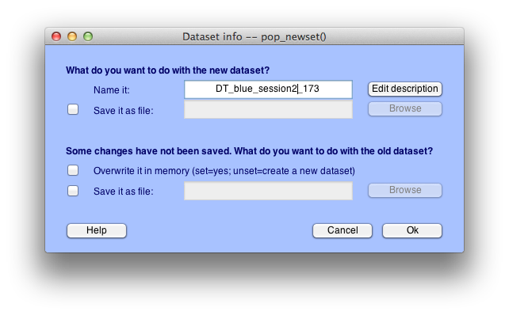

Go to edit > append datasets

* For DT enter 1:6 in the dialogue box and press “okay”
* For eDT_angry enter 1:2 in the dialogue box and press “okay”
* For eDT_calm enter 1:2 in the dialogue box and press “okay”
* For eDT_happy enter 1:2 in the dialogue box and press “okay”
* For eGNG_faces_angry enter 1:5 or 1:2 (depending on number of sessions) in the dialogue box and “okay”
* For eGNG_faces_happy enter 1:5 or 1:2 (depending on number of sessions)in the dialogue box and “okay”
* For eGNG_IAPS_negative enter 1:2 in the dialogue box and press “okay”
* For eGNG_IAPS_positive enter 1:2 in the dialogue box and press “okay”
* For GNG enter 1:5, or 1:2 (depending on number of sessions)in the dialogue box and press “okay”

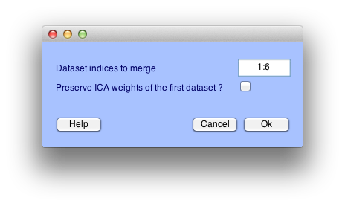

Name it with the [task]_[participant id]_HR, e.g., DT_173_HR

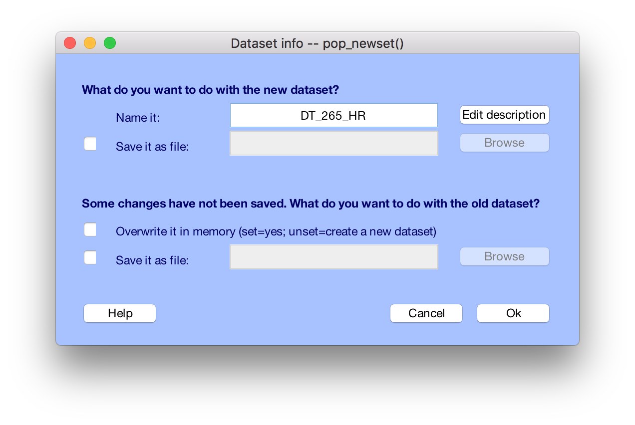

IMPORTANT!!! File > Save Current Dataset As

Name after [task]_[participant id]_HR i.e., DT_173_HR

click okay

Tools > Remove Baseline

IMPORTANT!!! File > Save Current Dataset As

Name after [task]_[participant id]_HR_rmbl i.e., DT_173_HR_rmbl

click okay

ERPLAB > Utilities > Insert event codes > Insert event codes at TTL onsets (continuous EEG)

Threshold you will be playing around with to find the right value, you can start at 300 if you like

For TTL channel select 1 = BloodPulse

For Event code to insert enter 88

Click Run

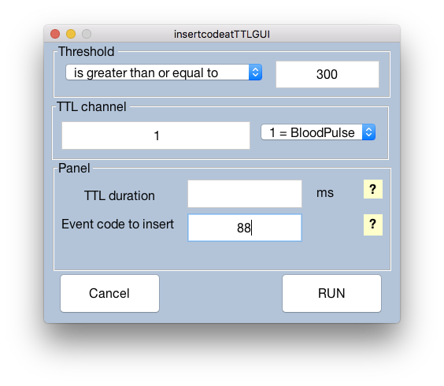

Name it [task]_[participant id]_HR_inscottl, don’t save it yet, click ok

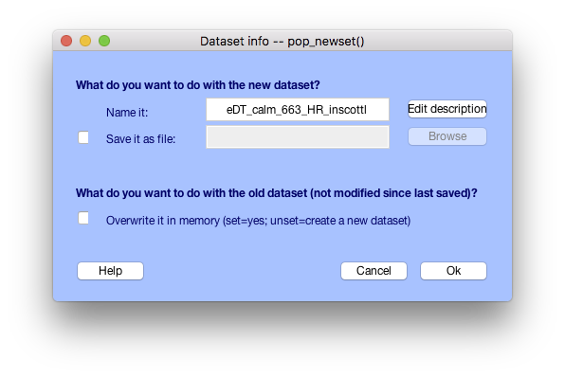

Plot > Channel data (scroll)

It should look about like this:

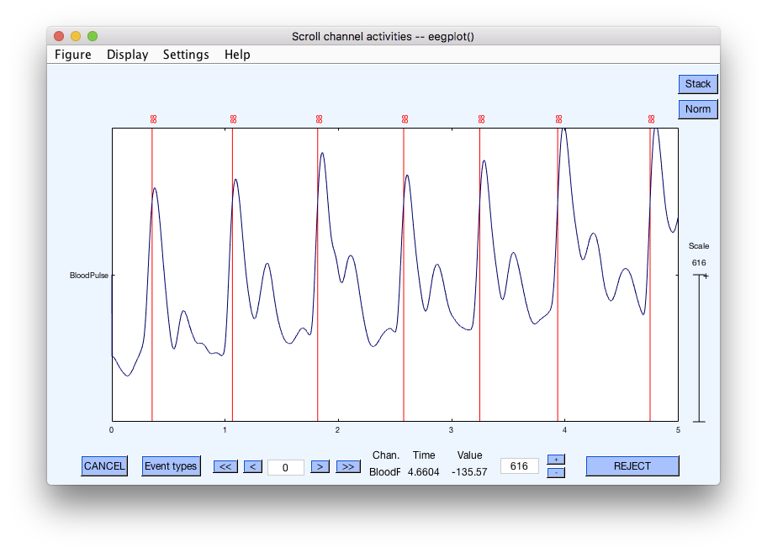

Scroll through the entire dataset, check that the lines tend to intersect with the large R waves, not he smaller waves. If there are many false positives (intersections with smaller waves) make you threshold larger. If there are many misses (R waves without lines through them) make you threshold smaller. Once you have settled on a threshold ask Abbie for approval.

ERPLAB > Eventlist > Create EEG Eventlist

Leave the defaults, click “create”

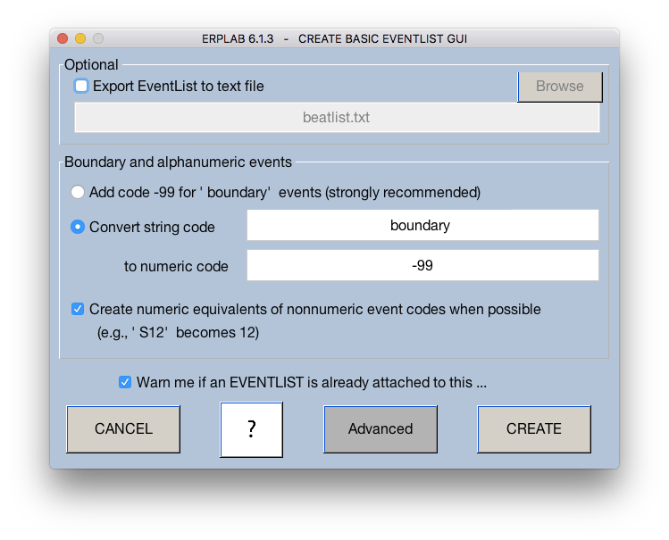

When prompted select “overwrite”

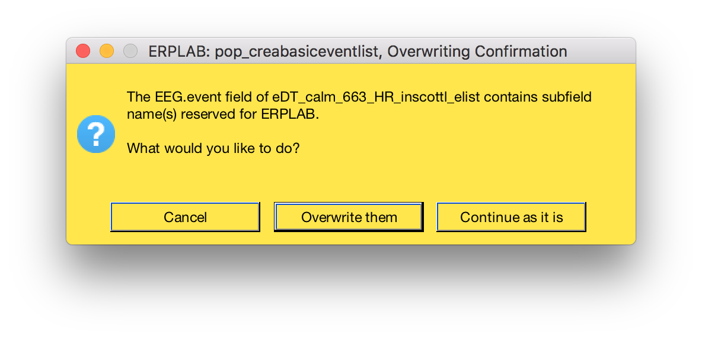

Then name it [task]_[participant id]_HR_inscottle_elist

IMPORTANT!!! File > Save Current Dataset As

Name after [task]_[participant id]_HR_rmbl i.e., DT_173_HR_inscottle_elist

click okay

ERPLAB > EventList > Export EEG EVENTLIST to text file

Name after [task]_[participant id]_beatlist.txt

In finder, navigate to your beatlist, right click > open with > Microsoft excel

First it will look like this:

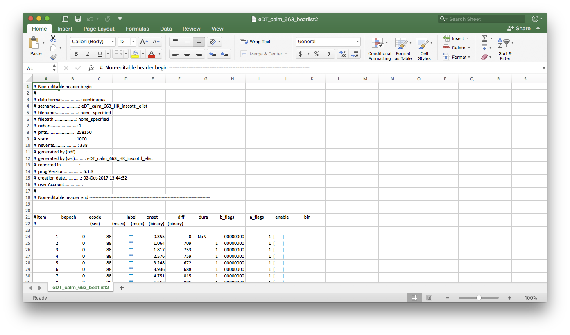

delete columns a – d, and f – k (so only the comment where row 21 is “onset” is left)

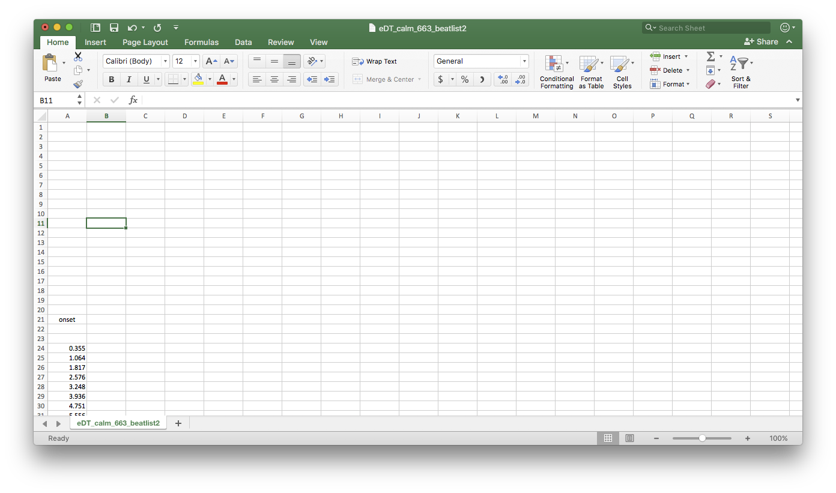

delete rows 1 – 23 (so it starts with the first numeric row)

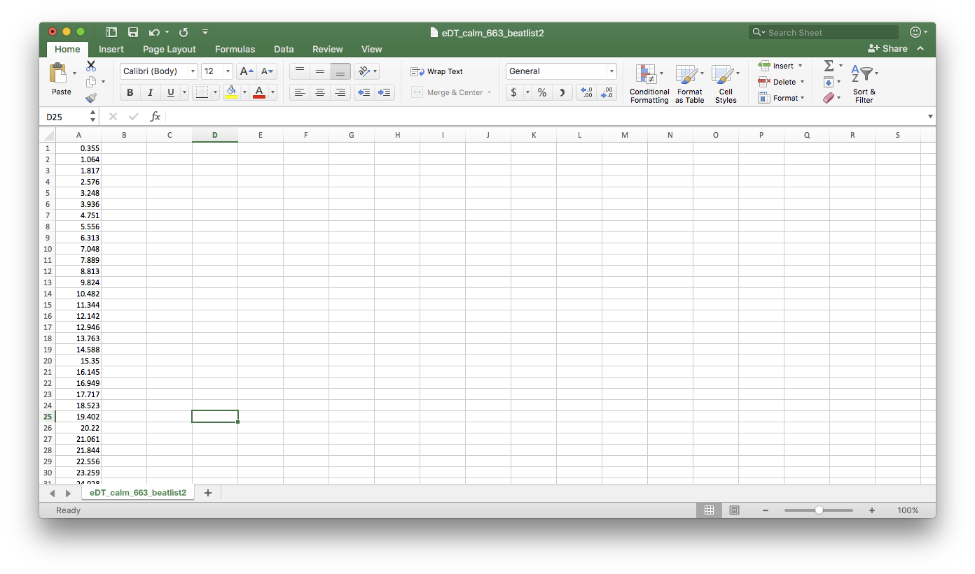

File > Save As…

Save as [task]_[participant id]_simple_beatlist

File Format should be tab delimited text (.txt)

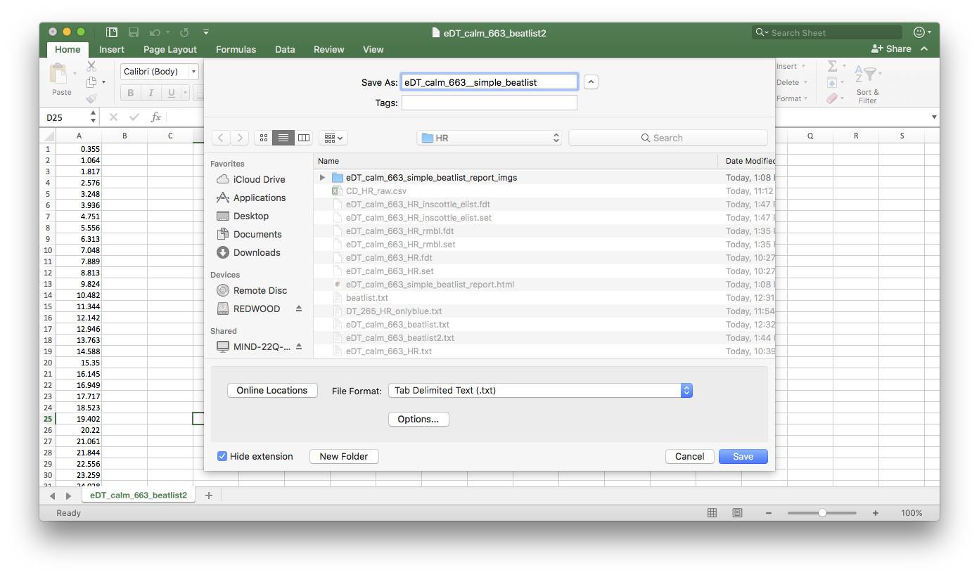

in gHRV under Heart rate data click “Load…”

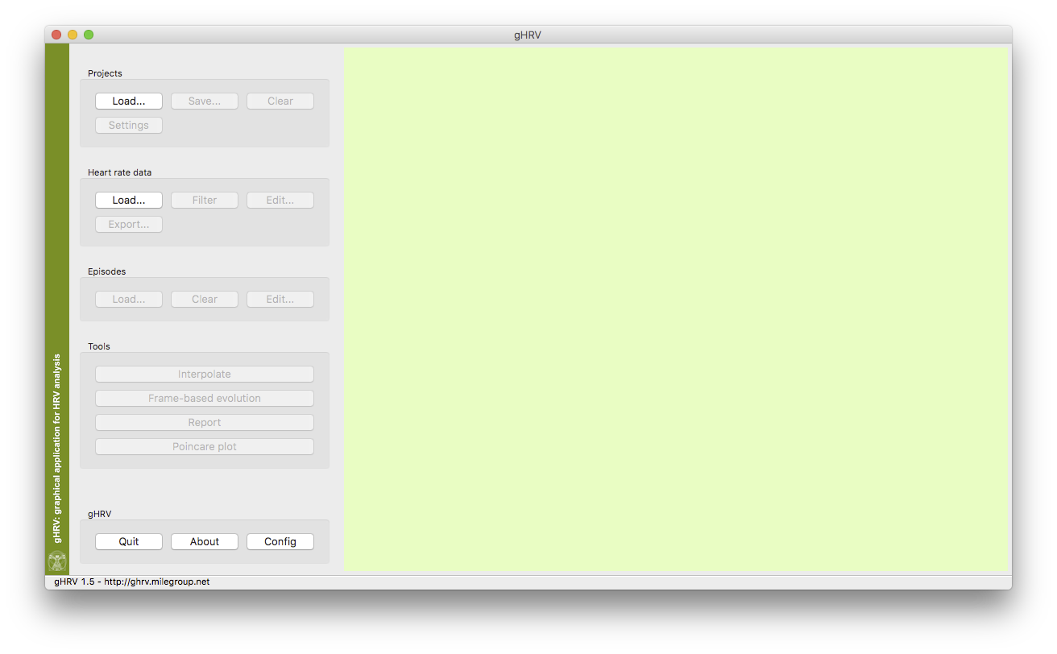

select your simple_beatlist file and click “open”

click “Interpolate”

click “Report”

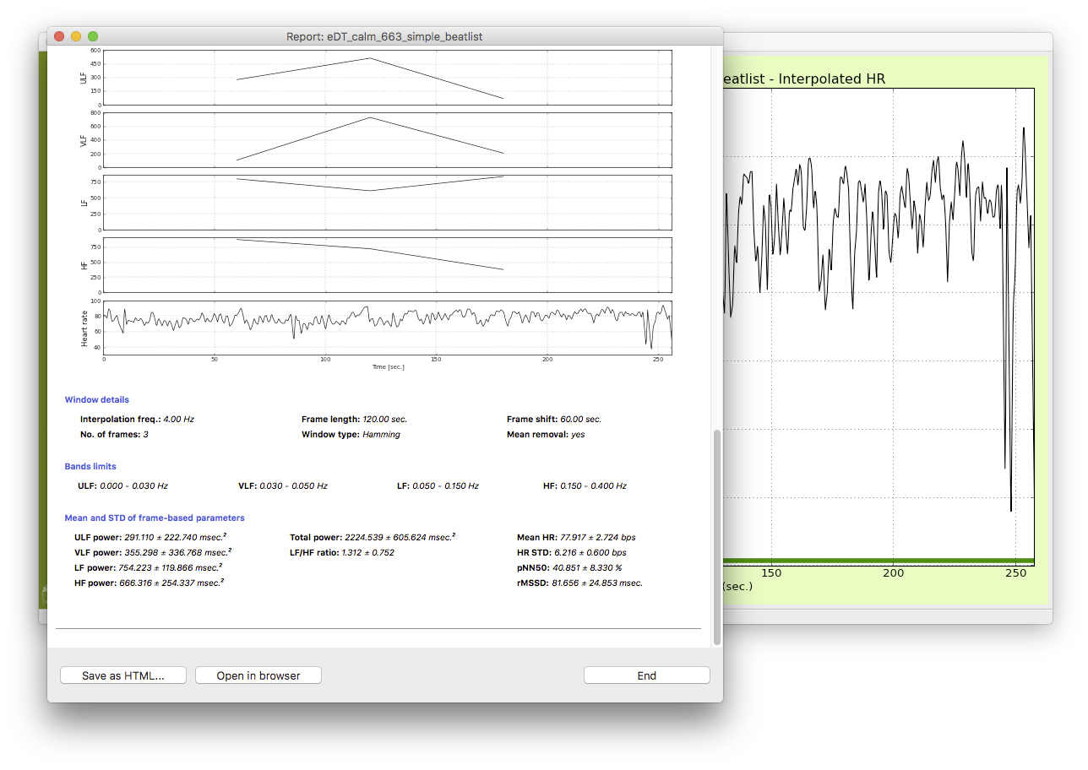

Click “Save as HTML”

Name [task]_[participant id]_simple_beatlist_report

close eeglab and repeat for next participant