Program 480a
(really cheap beach ball company)

Program Description: The Really Cheap Beach Ball Company produces inflatable beach balls. It produces between 10,000 and 20,000 balls per day. Of these, 2.75% are defective and unsaleable. The average cost of producing a saleable ball is given by the formula

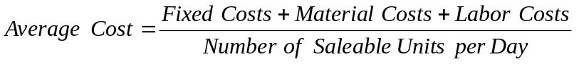

The fixed costs are $5500 for insurance, taxes, etc.; the material costs are 85 cents per ball (saleable only, since bad materials can be reused); and labor costs are $1.03 per ball (saleable and unsaleable). The balls sell for $3.99 per ball. Use the random number generator to simulate the daily production and compute the average cost per day and per week for the company. The output should be in the form of the sample, although the numbers of course will vary because of the random numbers. Round all monies to dollars and cents.

The average cost for the week must use the same formula, but the totals for each column will go into the formulas. Do not average the daily averages.

Statements Required: input, output, decision making, loop control, arrays

Sample Output:

___________________________________________________________________________

Day Units Saleable Fixed Material Labor Average
Produced Units Costs Costs Costs Costs
Produced
___________________________________________________________________________

Monday 12895 12541 5500 10659.85 13281.85 2.35
Tuesday 17028 16560 5500 14076.00 17539.84 2.24
Wednesday 14328 13934 5500 11843.90 14757.84 2.30
Thursday 16716 16257 5500 13918.45 17217.48 2.25
Friday 13027 12669 5500 10768.65 13417.81 2.34
Saturday 12401 12060 5500 10251.00 12773.03 2.37
___________________________________________________________________________

Totals 86395 84021 33000 71417.05 88986.85 2.30

