**Project 1: DJs on Demand**

**Step 1 – Recognizing attributes for an entity**

|  |  |  |  |
| --- | --- | --- | --- |
| **SONG** | **EVENT** | **CUSTOMER** | **Attributes** |
| Yes | Yes |  | Title |
| Yes | Yes |  | Description |
|  | Yes |  | Venue |
|  |  | Yes | First Name |
|  |  | Yes | Phone Number |
| Yes |  |  | Release date |
|  |  | Yes | Last Name |
| Yes | Yes |  | Type |
|  |  | Yes | Email address |

**Step 2 – Understanding relationship between SONG and TYPE**

You have learned about the relationship between SONG and TYPE. Answer the following questions:

* + - Must every SONG have a TYPE? Yes
    - Can you have a SONG that doesn’t fall under any one TYPE? What would you do in this case? Yes, we can select for the main classification for the selected song
    - Must every TYPE describe or classify a SONG? Yes

Why would we want to have a TYPE with no songs under it? we can add new types for the upcoming songs that may not be under the current song types

* + - How many songs can fall under one type? Many as possible
    - Think about attributes for both of these entities.

Can you categorize the following music into playlists the same way SONGS are categorized into TYPES? Yes

**Step 3 – Understanding relationship between clients, events, and types**

You learned about entities and saw how the CLIENT, EVENT and THEME entities relate. Can you think of other entities for the DJs on Demand project? We can include the year the song is released

You can go back to the structural business rules described in the Case Study section of this project.

### Step 4 – Procedural business rules

You are already familiar with the structural business rules presented in the Case Study section. Another important piece of information, important when effectively modeling a database, is represented by the procedural business rules.

An example of a procedural business rule is described in lesson 2 of section 4: Initial contact with the client must be made by the project manager. How could you incorporate this constraint in your ERD?

Client

Project Manager

Can you think of other examples of procedural business rules?

**Each floor in all buildings has a VIP room which should be allocated to normal patient only when all other normal rooms are full.**

### Step 6 – Understanding CRUD requirements

Performing a CRUD analysis on the model you created so far for the DJs on Demand project is important. A CRUD analysis helps you to check the completeness and accuracy of the data model. Use the business rules presented in the Case Study section and create a table following the example below.

Look for words and phrases that impact CRUD (we want to track data, we need to enter data). Is there an entity or attribute or relationship that allows a user of the DJs on Demand to create, retrieve, update, or delete?

***Hint:*** All entities need to have one create and retrieve function. This means you need to have the business rules that points to entering data in the entity and viewing the data once it is in the database.

#### Table 3 CRUD requirements example worksheet

|  |  |  |
| --- | --- | --- |
| Entity | Business Rules | CRUD Function? |
| EVENT | Since several partners can work on an event, and an event can be assigned to several partners,  We like to keep track of who is working on which event. | CREATE  RETRIEVE |
| ENTITY NAME | Specific business rule relating to the entity |  |

**Table 4 CRUD examples**

|  |  |
| --- | --- |
| "Whenever we get a new customer, we take down basic information (name, address, email) and assign an ID." | Create |
| "We'd like to print out a list of songs to be played at each event." | Retrieve |
| "The event manager reserves the location and may do a site visit. Then she notes down the status and date of each job." | Update |
| "A number of our customers were small companies that were hit hard by the recession. They went out of business. We removed them from our current records." | Delete |

**Step 7 – Mutually exclusive relationships**

You have learned that you can represent mutually exclusive relationships through arcs. Incorporate the exclusive OR relationship between EVENT and PRIVATE HOME and PUBLIC SPACE in your ERD.

Events

held

held

Private home

Public space  
renter

Can you think of another example using the same method of mutually exclusive relationship?

### Step 8 – Supertypes and subtypes

In lessons 1 and 2 of section 7, you learned about the two ways to represent supertypes and subtypes: as arcs or through recursive relationships. Think about the advantages and drawbacks of each model. Which way would you choose to incorporate the supertype PARTNER, followed by the subtypes EVENT PLANNER, DJ, MANAGER, and OTHER in your ERD?

***Hint:*** Take into account the procedural business rule about the manager described above.

### Step 9 – Presenting the design to the instructor

Create a presentation for the DJs on Demand Director, whose role will be played by your instructor. Organize your presentation, by including:

* + - Statement of the problem
    - Information requirements of the business clearly stated
    - Assumptions and constraints you took into account
    - The ERD

You will present this to your instructor, and you will be given the opportunity to present the ERD as a communication tool, along with the business rules, to show the client that you understand their needs and that these needs are being met by your design.

A suggested order for the presentation is a follows:

1. Introduce the group members
2. State the business issue that you addressed
3. Present and explain the ERD (large enough for all to see)
4. Summarize how your solution will meet the client’s needs
5. Present written documentation
6. State assumptions that you made in creating your solution
7. Thank the clients for their time
8. Exit gracefully

***Remember:*** When you have a very large diagram, it may also help to break it up into smaller diagrams of functionally related entities. You could use the smaller sub-diagrams when presenting to different groups within the customer’s company.

***Hint:*** Review Section 11 Lesson 1 for drawing conventions for readability.

### Step 10 – Making modifications and new requirements

Modify your ERD based on the feedback received from the presentation to the DJs on Demand Director. Produce a Design Revision Document outlining the changes made since the presentation was given. Include the modified ERD with the Design Revision Document and submit the package to your instructor for review.

Think of reports that can be generated from the future system, which includes the modifications you just made. Document how you imagine these reports could be used in the business.

For example, the staffing manager could run an “Events Report” that lists the names of the partners who worked on different projects. If it looks like some of the partners are busier and perform better, then, the manager can promote them.

### Step 11 – Checking data integrity in the DJ database

Examine the sample data for these tables in the DJs on Demand database.

Check for entity, referential, and column integrity. Identify any data integrity violations. Assume that all date columns should have a date format and all cost columns should have a number format.

#### Figure 1 Sample data for DJs on Demand database

**Primary Key**

**refers to**

**CLIENTS**



|  |  |  |  |  |
| --- | --- | --- | --- | --- |
| **id** | **first_name** | **last_name** | **phone_num** | **Email** |
| 100 | Antonio | Peters | 555-1891 | [apeters@yahoo.com](mailto:apeters@yahoo.com) |
| 45 | Mary | Collins | 662-2275 |  |
|  | Sarika | Patel | 383-4572 | [sari@patel.com](mailto:sari@patel.com) |
| 19 | Ivan | Balazs | 777-5511 | [ibalazs@aol.com](mailto:ibalazs@aol.com) |

**Primary Key Foreign Key**

**Foreign Key**

 **EVENTS**

|  |  |  |  |  |  |  |
| --- | --- | --- | --- | --- | --- | --- |
| **id** | **name** | **date** | **description** | **cost** | **client**  **_id** | **theme_ code** |
| 15 | Peter’s  graduation | 22-Apr |  | 800.00 | 100 | BB |
| 17 | Collins wedding | 12-Mar | Cocktail hour followed by dinner | 2gs | 45 | TROP |
| 25 | Collins rehearsal dinner | Day before wedding | Garden party | 400.00 | 45 | TROP |
| 50 | Eiks Club annual fundraiser | 01-May | Black-tie affair | 1200.0  0 | 77 | SIXT |



refers to

#### Primary Key THEMES

|  |  |
| --- | --- |
| **code** | **description** |
| CARN | Carnival |
| SIXT | Sixties |
| TROP | Tropical |

### Step 12 – The PARTNER supertype

Transform the PARTNER supertype in the DJ model, using the supertype or single-table implementation.

**Project 2: Global Fast Foods**

### Step 1 – Speaking ERDish and drawing relationships

Read the following business rules for the Global Fast Foods project and think about entities and relationships:

### Step 2 – Supertypes and subtypes //Done

Read the additional interview notes for Global Fast Foods listed below. Revise the ERD to reflect this information.

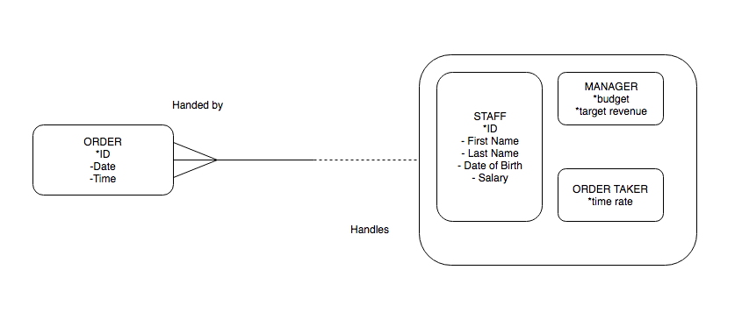

"I mentioned that we have different kinds of employees and how for all of them I need to know first name, last name, age, and phone number. Oh yes, every employee gets a salary. In addition to that, I need to know other things depending on what the employee responsibility is:

* + - A cook normally has some kind of training - vocational school, self- taught, apprentice work, etc. I like to record that.
    - The order taker is paid overtime on top of the standard salary. So I record how much we pay by the hour for every extra hour worked.
    - The manager is responsible for supervising all employees and has a budget for expenses and a target revenue for the restaurant that he/she is in charge of.

“That's it for now. As we expand, I may hire other types of employees, but I'm not sure what they would be at this time."

### Step 3 – Relationship transferability

Read the interview with the owner of Global Fast Foods and revise the ERD as necessary.

"When a CUSTOMER places an order with one of our STAFF, that ORDER TAKER is responsible for seeing that ORDER through - for making sure the chef gets it, for assembling it, and for collecting payment. If the CUSTOMER has changes or questions about that ORDER, he/she must go through the person the ORDER was placed with. The ORDER TAKER cannot ask another STAFF member to take care of it."

> An ORDER may only be taken by an ORDER TAKER. Therefore, it goes that on ORDER side of the relationship with the ORDER TAKER.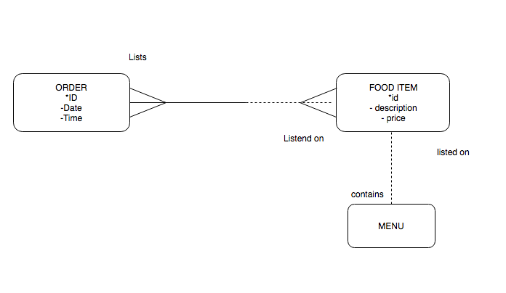

### Step 4 – Relationship types

Read the following additional notes from a conversation with the Global Fast Foods owner and modify the ERD as needed:

"You were asking about the items that can appear on an order? Well, mostly it's food items, but sometimes a customer can also purchase a frequent-diner card. This card entitles a customer to discounts at our restaurant. Also, if a customer buys this card, we can get information such as name and address. This way we can send the customer coupons and other promotional materials. The other benefit to us is that we can now track which items the customer likes to order regularly. When a customer comes in and uses the card, we now have a record of the orders placed with that particular card.

“Each customer may have one frequent-diner card, and each card is for only one customer. Only one frequent-diner card can be used to place an order.

“We have a variety of food items on our menu. Each order can be for multiple food items. And, of course, a food item (a hamburger, for example) can appear on many orders."

> Point out how the scenario clarifies the M:M relationship between FOOD ITEM and ORDER.

### Step 5 – Resolving many-to-many relationships

Resolve the many-to-many relationship between ORDER and FOOD ITEM. How do you track the quantity of each food item ordered?

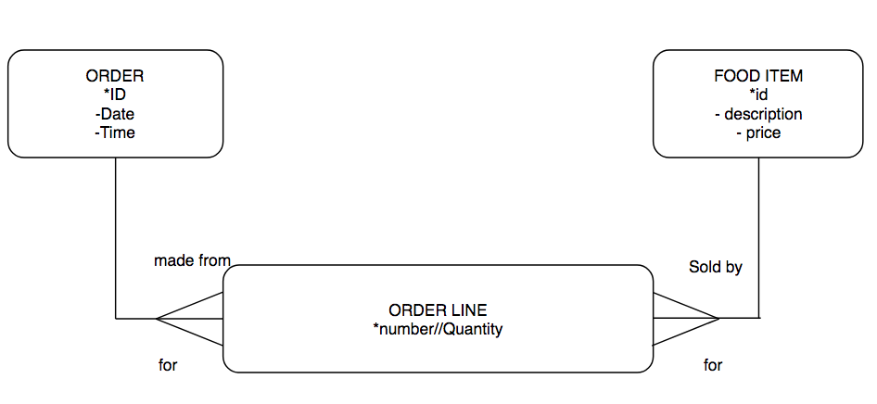

### Step 6 – Normalization and first normal form

Read the following notes from a subsequent interview with the owner of Global Fast Foods:

"All employees on our staff are assigned to shifts. We currently maintain a morning and an afternoon shift, but we are considering adding an early evening shift. Currently we just have a sign-in sheet for each shift. It keeps getting lost, and then it's hard for me to allocate the workload properly.

Several employees work on a single shift, and we do have employees who work consecutive shifts. It helps me to know which of my staff are overworked and which are underutilized, so I'd like to keep track of who is working double shifts, who is not working enough shifts, etc. Also, if there's a problem on a shift, I like to know immediately which employees were working during that time."

Modify the ERD to include these new requirements.

Go through each entity in your revised ERD and check that it is in first normal form. If not, modify the ERD so that it conforms to 1NF.

### Step 7 – Arcs

Read the following interview notes with the Global Fast Foods owner. Refine the ERD accordingly.

"We just started introducing a promotional menu. This menu features food items that are not available on the regular menu. It's a way for us to test new items and to take advantage of seasonal events (holidays, etc.) and commercial offerings (for example, when the movie "King Kong" was out, we offered oversized Kong burgers). Sometimes we have a little gift associated with a promotional item. For the Chinese New Year, we featured a mooncake on the promotional menu, and everyone who ordered it got a free toy dragon, because it was the year of the dragon. Each promotional menu has a name, such as Back to School or Summer Barbecue, and it has a start and end date. There is only one promotion in effect at any given time.

#### Figure 2 Menu arcs

|  |  |
| --- | --- |
| **code** | **description** |
| CARN | Carnival |
| SIXT | Sixties |
| TROP | Tropical |

“Our regular menus contain those items that customers expect when they come to Global Fast Foods. Right now we have two types: a breakfast menu, available from 6 a.m. to 11 a.m., and a lunch menu, available from 11:01 a.m. until closing time. We're still considering a separate dinner menu, but we'll have to test that first."

Redraw the REGULAR and PROMOTIONAL MENU entities as a supertype, and include the relationship to FOOD ITEM, based on the previously given scenario.

### Step 8 – Hierarchies and recursive relationships

The following was noted in an earlier interview with the owner of Global Fast Foods:

"The manager is responsible for supervising all employees and has a budget for expenses and a target revenue for the restaurant that he/she is in charge of."

Modify the ERD to include a recursive relationship on STAFF showing the manager's supervisory role.

### Step 9 – Modeling historical data

Revisit the SHIFT ASSIGNMENT entity in the Global Fast Foods ERD, and recall an earlier interview from Step 6:

"All employees on our staff are assigned to shifts. We currently maintain a morning and an afternoon shift, but we are considering adding an early

evening shift. Currently we just have a sign- in sheet for each shift. It keeps getting lost, and then it's hard for me to allocate the workload properly.

Several employees work on a single shift, and we do have employees who work consecutive shifts. It helps me to know which of my staff are overworked and which are underutilized, so I'd like to keep track of who is working double shifts, who is not working enough shifts, etc. Also, if there's a problem on a shift, I like to know immediately which employees were working during that time."

Notice that "consecutive shifts" means that an employee can work two shifts on the same date.

Answer the following questions:

1. What is the UID of this entity? How is it represented on the diagram?
2. Explain what would happen if the UID of SHIFT ASSIGNMENT included only the barred relationships to STAFF and SHIFT, and not the date.
3. Explain what would happen if the UID of SHIFT ASSIGNMENT included a barred relationship to STAFF, and the date?
4. Explain what would happen if the UID of SHIFT ASSIGNMENT included a barred relationship to SHIFT, and the date.

### Step 10 – Drawing conventions for readability

Review your Global Fast Foods data model so far.

1. Identify the high-volume entities and redraw your ERD to use the "crows fly south and east" convention as far as possible. Try to avoid criss-crossing lines, and make good use of white space.
2. Create a smaller diagram that contains all the entities that would be of interest to the order taker.

### Step 11 – Basic mapping: the transformation process

Transform the following entities in Global Fast Foods into table diagrams. Use suitable naming conventions.

#### Figure 3 Entities to table diagrams

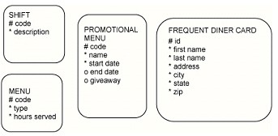

Refer to the completed Global Fast Foods model and map the following: entities:

* + FOOD ITEM
  + ORDER
  + ORDER LINE

Transform relationships into foreign-key columns. Use as many rows as necessary in the following table diagram.

#### Table 5 Primary, foreign, and unique key mapping

|  |  |  |
| --- | --- | --- |
| Key Type (pk,fk,uk) | Optionality (“*” or “o”) | Column Name |
|  |  |  |
|  |  |  |

Transform the STAFF supertype in the Global Fast Foods model, using the subtype or two-table implementation.

### Step 12 – Presenting the design to the instructor

Create a presentation for the Global Fast Foods client, whose role will be played by your instructor. Organize your presentation, by including:

* + Statement of the problem
  + Information requirements of the business clearly stated
  + Assumptions and constraints you took into account
  + ERD

One example of an assumption is that there is only one Global Fast Foods restaurant. The current model does not consider a chain of restaurants.

You will present this to your instructor, and you will be given the opportunity to present the ERD as a communication tool, along with the business rules, to show the client that you understand their needs and that these needs are being met by your design.

A suggested order for the presentation is a follows:

1. Introduce the group members
2. State the business issue that you addressed
3. Present and explain the ERD (large enough for all to see)
4. Summarize how your solution will meet the client’s needs
5. Present written documentation
6. State assumptions that you made in creating your solution
7. Thank the clients for their time
8. Exit gracefully

### Step 13 – Modifications and new requirements

Modify your ERD based on the feedback received from the presentation to the Global Fast Foods client. Produce a Design Revision Document outlining the changes made since the presentation was given. Include the modified ERD with the Design Revision Document and submit the package to your instructor for review.

Think of reports that can be generated from the future system, which includes the modifications you just made. Document how you imagine these reports could be used in the business.

**Project 3: Animal Shelter**

An animal shelter is a place where the main business is housing and finding permanent homes for animals, mainly dogs and cats, that are brought to the facility. Many activities occur, including recordkeeping, adoption, and financial transactions. Your consulting company, through research of other shelters and interviews, will create the database design for this animal shelter.

Examples of questions to ask the interviewee:

* + - What’s the business goal?
      * The animal shelter would like to track animals in their shelters.
    - What do you generally want to keep track of?
      * Keep track of who has adopted their animals.
    - What do you want to record for each animal in the record?
      * For all animals, track name, approximate age, health, whether they're vaccinated, spayed or neutered.
    - Any special information if it’s a dog/cat/other animal?
      * For cats, identify long-haired or short-haired.
    - What do you want to keep track of for the animal adopter?
      * For animal adopters, track name, address, phone number, email, dog/cat preference, animal adopted, and number of children in their house.
    - What about the non-adopters?
      * For non-adopters who would like to receive the newsletter, track name, address, email, and phone number.
    - What sort of information would you record for the cages?
      * Track in which cage an animal is.
    - What type of lists/reports are you interested in compiling from the database?
      * Obtain a list of all unadopted cats and dogs.
    - What other special requests/suggestions do you have?
      * Send only dog information to people who like dogs and cat information to people who like cats.

## Steps, Exercises and Examples

### Step 1 – Determining business needs

Your group will play the role of the consulting company. Your teacher will act as the director of a city animal shelter who needs a database.

Choose a meaningful name for your consulting company.

Spend about 15 minutes getting ready for the interview. The process can be broken down into the following steps:

1. Prepare for the interview
   1. Prepare a question list
   2. Set goals
   3. Determine and gather materials needed
2. Conduct the interview
   1. Take notes
   2. Ask for clarification
3. End the interview
   1. Summarize key points
   2. Thank the interviewee
4. Follow up.
   1. Review notes
   2. Look for missing information

Check out the following links for examples of real animal shelter websites.

* + - PetsLifeLine in Sonoma Valley, California at [http://www.petslifeline.org](http://www.petslifeline.org/)
    - Animal Care and Control of New York City at [http://www.nycacc.org](http://www.nycacc.org/)
    - Wood Green Animal Shelters’ Godmanchester Shelter in the UK at [http://www.woodgreen.org.uk](http://www.woodgreen.org.uk/)

Conduct an interview between the director and the consulting company to determine the business needs of the organization. At the end of the interview, you should be able to list the data and information requirements of the business.

### Step 2 – Documenting business requirements

Using notes taken from the interview with the director of the animal shelter (Step 1), construct the business rules for this project. Document at least two structural rules and two procedural rules.

Structural business rules indicate the types of information to be stored and how the information elements are interrelated. Example: Each animal must have a unique identification number.

Process rules are related to workflow or business process. Example: Each animal must undergo a medical examination when it arrives at the shelter.

If you make assumptions, document them as well. You can confirm or clarify them with the director in a follow-up interview. If there is time, begin to identify entities, attributes, and relationships.

• Each shelter contains dogs, cats, and the occasional other type of animal (bird, snake).

• Basic information taken for all animals: name, age, vaccinations, neuter status, health, reason being given up, and person giving up. If it is a dog, breed and size are noted. If it is a cat, it is classified as long or short-haired.

• Persons who come into the shelter are classified as adopters or non-adopters (volunteers or newsletter only). Adopters must provide name, address, phone number, email, animal preference, and number of children in the house.

• Dog-related mailings must be sent only to dog lovers; and cat-related mailings must be sent only to cat lovers.

#### Step 3 – Understanding CRUD requirements

Create your Animal Shelter ERD models. Do a CRUD analysis on the model. Capture the information from your CRUD analysis in a worksheet similar to the one below. Use your interview notes and business rules during your CRUD analysis. Look for words and phrases that impact CRUD (we want to track data, we need to enter data, etc.). Is there an entity or attribute or relationship that allows a user of the animal shelter to create, retrieve, update, or delete?

***Hint:*** All entities need to have one create and retrieve function. This means that you need to have interview notes or a business rule that points to entering data in the entity and viewing the data once it's in the database.

Use the worksheet below. One example has been created for you.

• "Whenever we get a new adopter, we take down basic information (name, address, email) and assign an ID." (CREATE)

• “Each week, a list of all cats and dogs that are not adopted are posted online in the respective “Cat Lovers” and “Dog Lovers” pages of the website.” (RETRIEVE)

• "Once an animal is adopted, we update its status and the associated information for the adopter." (UPDATE)

• "We remove records of un-adopters for whom newsletters were returned." (DELETE)

#### Table 6 CRUD requirements example worksheet

|  |  |  |
| --- | --- | --- |
| Entity | Interview Notes or Business Rules | CRUD Function |
| ANIMAL | When an animal comes  into the shelter, we assign an id and collect information | CREATE |
|  | We need to track animals in our shelters | RETRIEVE |

**Step 4 – Presenting requirements**

Create a presentation for the animal shelter director. Organize your presentation. Each presentation must contain the following:

* + - Statement of the problem
    - Statement of the proposed solution
    - The information requirements of the business/organization clearly stated (you should have this from your interview notes)
    - The business rules as they apply to the information requirements of the company/organization stated as single sentences (you should have this from the previous step)
    - The assumptions and constraints that are to be considered clearly stated. Assumptions can be relationships or rules for the data model that you do not have time to verify. They can also be conditions that need to be true in order for the proposed solution to be successful. These may not be directly reflected in the ERD.
    - Entity relationship model

* Remind the class that each group will be presenting to the "client" during the next meeting. They should start assigning roles and responsibilities for their presentation. If they took good notes during the interview and documented business rules and assumptions, they should have most of the written materials. Check with each team to see what they're missing. Each presentation must contain the following:

Your teacher will decide how much time you have to present to the "client." Remember: This is a "meeting" between the client and your consulting company. You will present your ERD to the "director." The ERD should serve as a communication tool, along with the business rules, to show the client that you understand their needs and that these needs are being met by the design. If a time limit is set for the meetings, be careful not to allow additional questioning after it is over.

A suggested order for the presentation is a follows:

1. Introduce the group members
2. State the business issue that you addressed
3. Present and explain the ERD (large enough for all to see)
4. Summarize how your solution will meet the client’s needs
5. Present written documentation
6. State assumptions that you made in creating your solution
7. Thank the clients for their time
8. Exit gracefully

#### Step 5 – Modifications

Modify the Animal Shelter ERD based on the input received from the presentation to the director of the animal shelter. Produce a Design Revision Document outlining the changes made since the presentation was given. Include the modified ERD with the Design Revision Document and submit the package to your teacher for review.

The Design Revision Document may have the following contents:

* + Project Name
  + Presentation Date
  + Consultant Name
  + Presentation Attendees
  + Business Requirements Identified
  + New Business Requirements Impact Statement
  + Request for Approval – Signature line

#### Step 6 – New requirements

Make modifications to your Animal Shelter ERD based on these additional requirements:

* + - "Even though we did not require employees of the shelter to be part of the design, we do need to know which employee received the animal at the shelter. No need to tie it to our employee system - we just want to capture the name."
    - “We also need to know the date and time the animal was taken in at the shelter.”
    - “We also need to know special information about the date the animal is adopted (was the date a holiday?) and special notes about the date. For special notes, we'd like to know things such as, "general weather conditions" or "schools finish this week for summer."
    - “We're trying to find trends that affect animal adoption. We need this information so that we can give good reports to our staffing manager about the number of employees needed for each shift and on special days of the year. You don't need to design information about "shifts" (we already have that in the other system)."

Think of at least one report or statistic that can be generated from the future system that includes the modifications you just made. Document how you imagine these reports could be used in the business.

For example, the staffing manager could run a "Receiving Report" that lists names of employees who received the animals and the dates received. If it looks as though some days of the week are a lot busier, and there are less employees working on those days, then more employees could be scheduled to work.

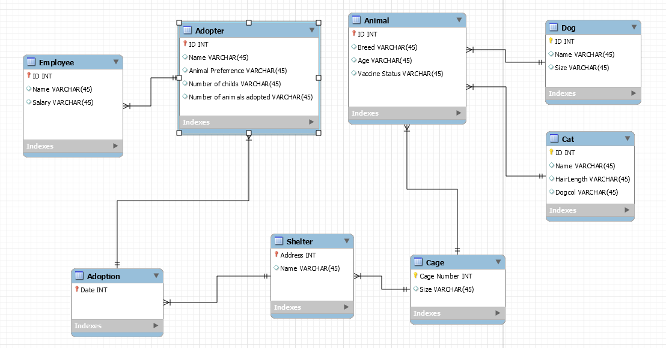

**Step 7 – Adding the time** **element to the** **Animal Shelter** **ERD**

Read the following extra requirement and modify the ERD.

"We'd also like to capture data on the days that animals are brought to the shelter. Does it happen more after holidays? On rainy days? This will help us staff the shelter more appropriately if we anticipate a large number of animals being dropped off."

“Each ANIMAL that will be delivered to the shelter can only be received on one and only ONE DAY.” For this will be more convenient for the staff shelter.

“Each ANIMAL can be delivered after the first attempt of first drop-off is not successful” . On the other hand, for the staff shelter to lessen their workload and fixing their ANIMAL receiving history.