Orsolino, Abigail A.

CITCS2H-Psych100

1. **RITUALS FROM YOUR Province/CULTURE**

**PROVINCE:** LEYTE AND SAMAR

**Kuratsa dance**- is a very popular traditional dance of the Waray-Waray at many social gatherings, especially weddings. It is very common throughout Samar. The couple who dances the Kuratsa are showered with money by the people around them. The belief is that the more money showered upon them, the more blessings will come their way.

The Waray-Waray are often stereotyped as **brave warrior**s, as popularized in the tag-line, “basta ang Waray, hindi uurong sa away” (Waray never back down from a fight.)

**Tinnikling** is considered the national folkdance with a pair of dancers hopping between two bamboo poles held just above the ground and stuck together in time to music . Originated from leyte province, this dance is in fact a mimic movement of “tickling birds” hopping tress, grass stems or over bamboo traps set by farmers.

**Superstitious beliefs during the wake:**

When your relatives or love one dies you are not supposed to take shower, bathe, or mind too much about cleaning up yourself because it is an insult to the death, and you are suppose to be grieving by showing that you don’t care about your self. Also you are not even allowed to comb or brush your hair but just arrange them with your hand so as not to look too messy. Since the dead should not be left alone, family members or anyone should stay awake the whole night and may go to sleep during the day time. Also, during night time various forms of activities are done to keep people awake, including:

-Playing board games, cards, and some are even doing gambling to pass the time and to keep them excited, thus, keeping them awake;

-Drinking coffee or some a bit of alcohol

-or simply talking about the dead persons good life and other family related topics.

1. **INFLUENCE AND TEACHING**

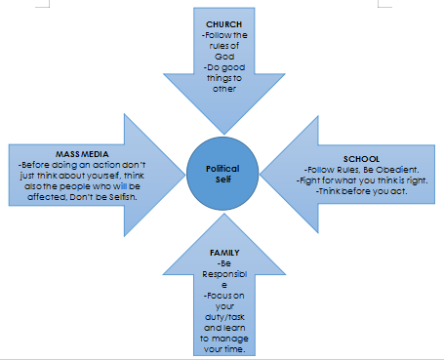

1. **Make an outline of chapter III.**

**III. MANAGING AND CARING FOR ONESELF**

A. Michael, 2018.

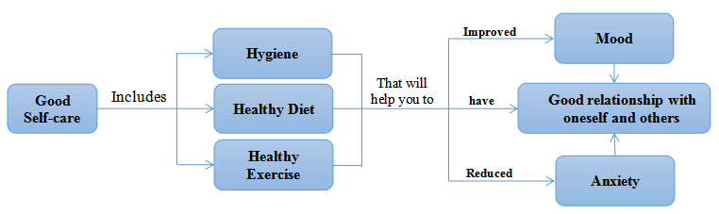

1. Barrata (2018)

|  |
| --- |
| **SELF-CARE means:** |
| 1. Knowing who you are and your limits. |
| 1. Getting the sleep you need and knowing how to rest. |
| 1. Making sure that you’re well fed. |
| 1. Finding a way to decompress throughout your day |
| 1. Giving some thought to changing a difficult work situation. |
| 1. Taking time to get to know you better |
| 1. Identifying what you enjoy doing and make a serious effort to integrate it into your day |
| 1. Knowing how to debrief from a day’s work |
| 1. Feeding your spiritual self. |
| 1. Taking time to love yourself |

1. **HOW TO BECOME A BETTER STUDENT**

|  |  |  |
| --- | --- | --- |
| **Retuya, Ceniza, Lara, a& Quinan (2017)** | They explained that Filipinos value their families, which is why they might view their performance in school as a way of fulfilling their responsibilities to their parents and family. | |
| **Yazon (2016)** | Explained that someone with high self-esteem is expected to perform well academically. | |
| **Geller, et al., (2017)** | States that individual differences in achievement goals may account for differences in students’ approaches to studying. | |
| **Dunlosky, Rawson, Marsh, Nathan, & Willingham (2013)** identified *10 effective learning techniques and these are:* | | |
| 1. Elaborate Interrogation | | 6. Imagery for text |
| 2. Self-Explanation | | 7. Rereading |
| 3. Summarization | | 8. Practice Testing |
| 4. Highlightning/ underlining | | 9. Distributed Practice |
| 5. Keyword mnemonic | | 10. Interleaved Practice |

1. **SETTING GOALS FOR SUCCESS**
2. **foundation for goal-setting Behavior**
3. **Albert bandura’s, Self-Efficacy** - He emphasized that self-efficacy has four processes, namely: cognitive, motivational, affective, and selection processes.
4. **Dweck’s Mindset** - There are 2 types of mindset, a fixed mindset and a growth mindset which was identified by Dweck as the entity theory and the incremental theory.
5. **Locke’s Goal Setting Theory** - His theory is based on the simplest of introspective observations, namely, that conscious human behavior is purposeful, and is regulated by the individual’s goals.

|  |  |
| --- | --- |
| **Locke and Latham’s 5 Principles of Goal Setting** | |
| 1. Clarity | 3. Commitment |
| 2. Challenge | 4. Feedback |
| 5. Task Complexity | |

1. **TAKING CHARGE OF ONE’S HEALTH**

STRESS is a responsive to events that are threatening to one’s well being.

* Nordqvist (2018) - Stress, is a feeling that people have when they are overloaded and struggling to cope with demands.
* McEwen & Sapolsky (2006) - Stress in people can be physical, Emotional, or Psychological. They also explained that allostasis is the process of how the body responds to stress, whether it is acute (short-term) or chronic (long-term).
* Matlin (1992) - Stress is the result of an interaction between a person and the environment, in which the person believes the situation to be overwhelming and dangerous to his or her well-being.
* Hans Selye (1956) - One of the first people to study and popularize the concept of stress. He called his stress model the General Adaptation Syndrome (GAS). and it includes three phases:

1. Alarm Phase
2. Resistance Phases
3. Exhaustion Phase
4. According to Weiten (1992) the **Sources of Stress** are:

**A. Frustration** - a negative emotion that stems from the blocking of a goal-directed behavior. And the three main factors that leads to frustration are:

1. **Personal Factors.** - factor that include personal limitations and weaknesses that may deter the individual to achieve his or her goal.
2. **Environmental Factors** - Refers to physical conditions of the environment that may keep the person from satisfying his need or achieving his goals.
3. **Sociocultural Factors** - Refers to social and cultural factors that hinder goal attainment.

**B. Conflict** - derived from the Latin word ‘conflictus’ which means ‘to strike together’.

Types of conflict:

1. **Approach-approach Conflict**
2. **Approach-avoidance Conflict**
3. **Avoidance-avoidance Conflict**
4. **Double-approach avoidance Conflict**

**C. Change** - Life changes are any noticeable alterations in one’s living circumstances that require readjustment.

**D. Pressure** - It involves expectations or demands that one behaves in a certain way

|  |  |
| --- | --- |
| **II. RESPONSES TO STRESS** | **III. Effects of Stress** |
| 1. Anxiety | 1. Disrupt Bahaviors |
| 2. Aggression | 2. Impair Cognitive Processes |
| 3. | 3. Disrupts Emotions |
| 4. Dejection and Grief | 4. Psychological Responses |

**IV. POST-TRAUMATIC STRESS DISORDER (PTSD)**

This is a disorder characterized by a delayed reaction to stressful situations or experiences.

* Holmes (1991) - This is apparent in diminished interest in usual activities, feelings of detachment from others and blunted emotional responses when the individual is not re-experiencing the traumatic event.

**V. FACTORS MODERATING THE IMPACT OF STREE (Weiten, 1992)**

|  |  |
| --- | --- |
| **1. Social Support** | a. Emotional Support |
| b. Appraisal Support |
| c. Informational Support |
| d. Instrumental Support |
| **2. Personality** | a. Behavioral Pattern |
| b. Hardiness |
| c. Optimism |
| **3. Psychological Control** | People who have more control of their lives are less prone to illness and stress. |

|  |
| --- |
| **VI. COPING STRATEGIES** |
| 1. Active-Cognitive Strategies (Active Thinking) |
| 2. Active-Behavioral Strategies (Action) |
| 3. Avoidance Strategies (Awareness) |

|  |  |  |
| --- | --- | --- |
| **VII. DEFENSE MECHANISM** | | |
| A. Displacement | G. Reaction Formation | |
| B. Rationalization | H. Repression | |
| C. Intellectualization | I. Regression | |
| D. Compensation | J. Nomadism | |
| E. Sublimation | K. Denial | |
| F. Projection | L. Identification | |
| M. Fantasy | | |
| **VIII. CAUSES OF STRESS (Nordqvist, 2018)** | | |
| 1. Job issues or retirement | 8. Abortion and miscarriage | |
| 2. Lack of time and money | 9. Driving in heavy traffic | |
| 3. Bereavement | 10. Fear of an accident | |
| 4. Family Problems | 11. Fear of crime | |
| 5. Illness | 12. Problems with neighbors | |
| 6. Moving Home | 13. Pregnancy & becoming a parent | |
| 7. Relationship, marriage and divorce | 14. Excessive noise, overcrowding | |
| 15. Uncertainty or waiting for an important outcome | | |
| **Top 5 overall stressors of the Filipino college students** (DY, Espiritu-Santo, Ferido, and Sanchez (2017)) | | |
| 1. Academics Difficulty of Subject Matter | | |
| 2. Workload due to subjects | | |
| 3. Time management because of subjects | | |
| 4. Responsibilities due to being on one’s own | | |
| 5. Time Management because of both subjects and organizations. | | |
| **Health Problems (McEwen & Sapolsky, 2006)** | | | |
| 1. Stomach ache | | 6. Depression | |
| 2. Diarrhea | | 7. Loss of Sleep | |
| 3. Obesity | | 8. Lack of interest in Physical Activity | |
| 4. Weakening of Immune System | | 9. Increase in Blood Pressure | |
| 5. Anxiety | | 10. Increase in blood sugar level | |
| **Effects of Stress on Body Functions** | | |
| 1. Declarative memory disorders | 3. Weakening in verbal Memory | |
| 2. Reduction in Spatial Memory | 4. Decrease in Reaction time | |
| 5. Behavioral, Cognitive and Mood Disorders | | |
| **Social and Cultural Dimensions of Stress among Filipino** | | |
| *Utilize Community Health Workers for mental | | |
| *Cognitive Restructuring | | |
| *Taking control of one’s own body, and the failing spirit | | |
| *Aromatherapy | | |
| *Hilot (traditional/village masseur-healer | | |
| *Community Action | | |

**IX. WHAT IS ANXIETY?**

Anxiety is an emotion characterized by feelings of tension, worried thoughts and physical changes.

**X. WHAT IS DEPRESSION?**

“Depression is being color blind, and constantly told how colorful the world is.”-Atticus

**XI. WHAT IS SELF-COMPASSION?**

“Having compassion starts and ends with having compassion for all those unwanted parts of ourselves.” - Pema Chodron

Dr. Kristin Neff, Defines Self-compassion as acting the same way towards yourself when you are having a difficult time, fail, or notice something you don’t like about yourself.