1. **PHOTOGRAPHY**

**“DELIGHT”**

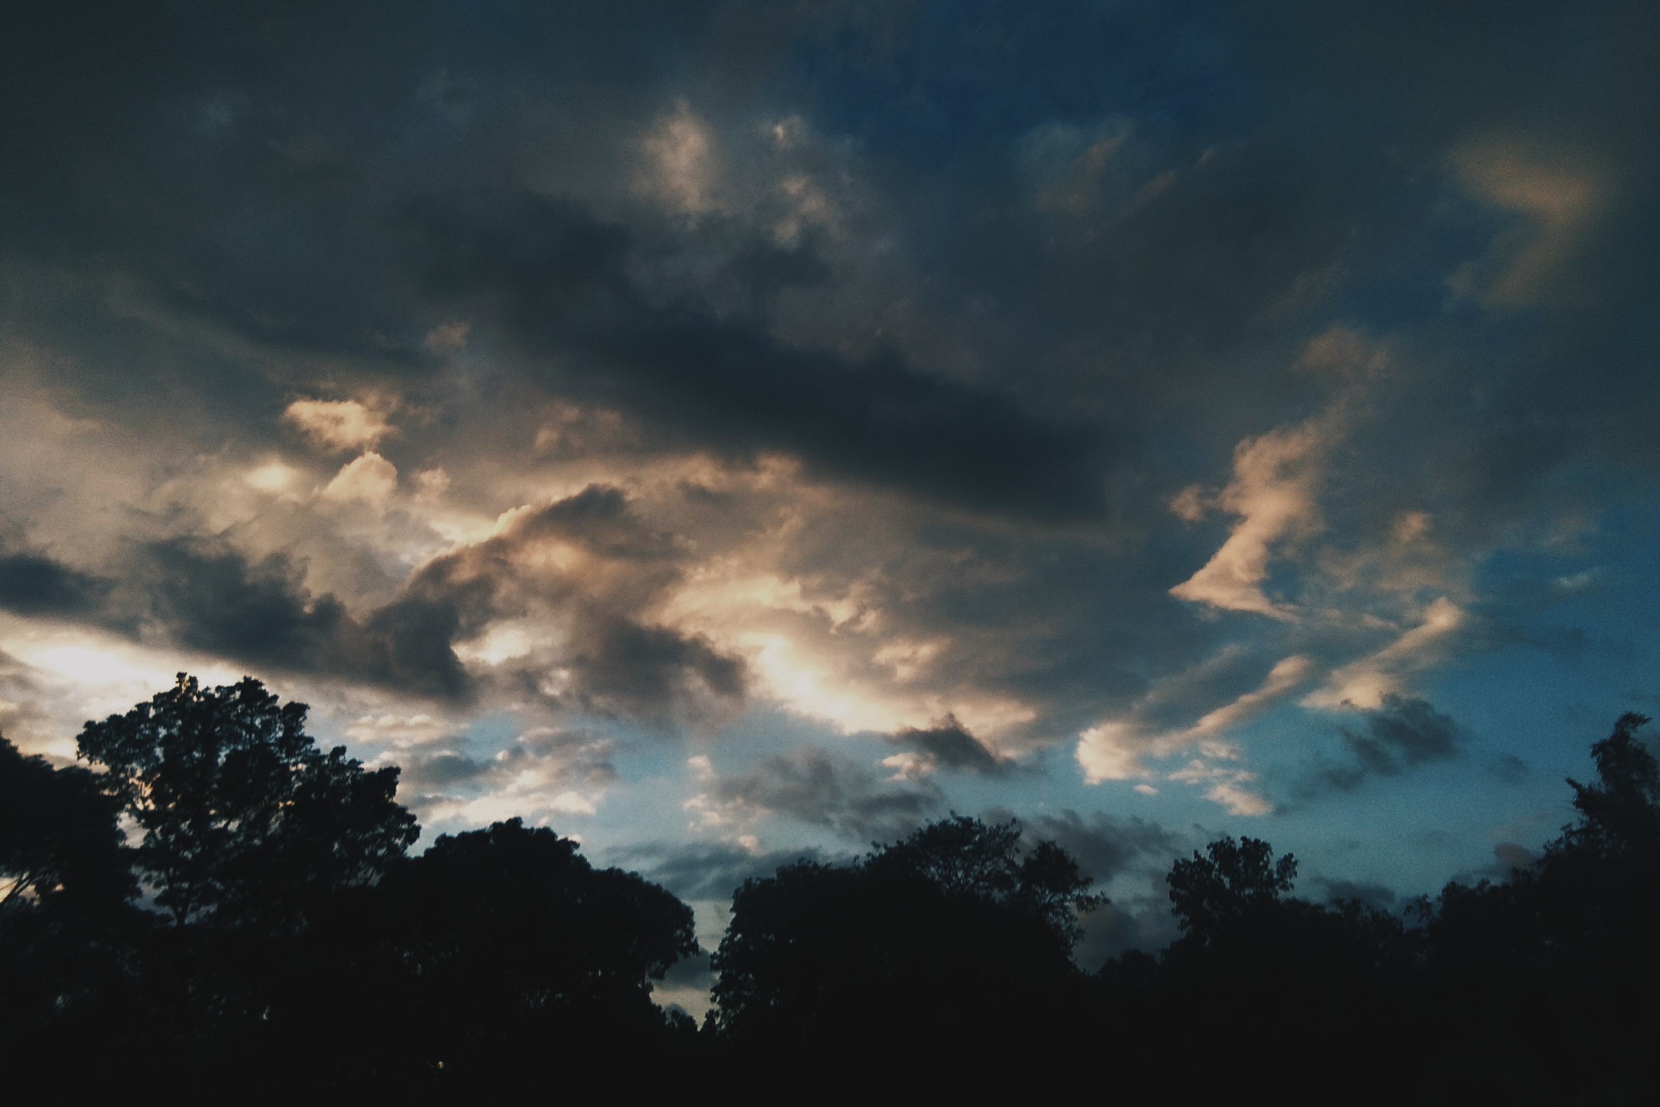

This photo was taken in La Union, It is the time when me

and my friends go their for a vacation time it was taken in the afternoon at the backyard of my friend house, as you can see on the picture the clouds are a little bit dull because it was taken after the rain. I love looking at the sky and taking picture of it that’s why I chose this picture and for me this is the best picture I’ve taken so far.

I chose delight as the title of the picture because for me looking at the sky gives me joy, and because sky is one of my source of delight.

1. **PAINTING**

So this is my painting as I’ve said awhile ago I love a sky scenery that’s why I painted a starry night with a silhouette of a tree and flying birds. There combination are beautiful that’s why I chose to painted it.

1. **SCULPTURE**

This sculpture is in the (PMA) Philippine Military Academy, here in Baguio. I chose these sculpture because It symbolized Courage, Integrity and Loyalty, and also because for me it symbolized the strengths of the Filipino Soldiers who sacrifice their lives for our country.

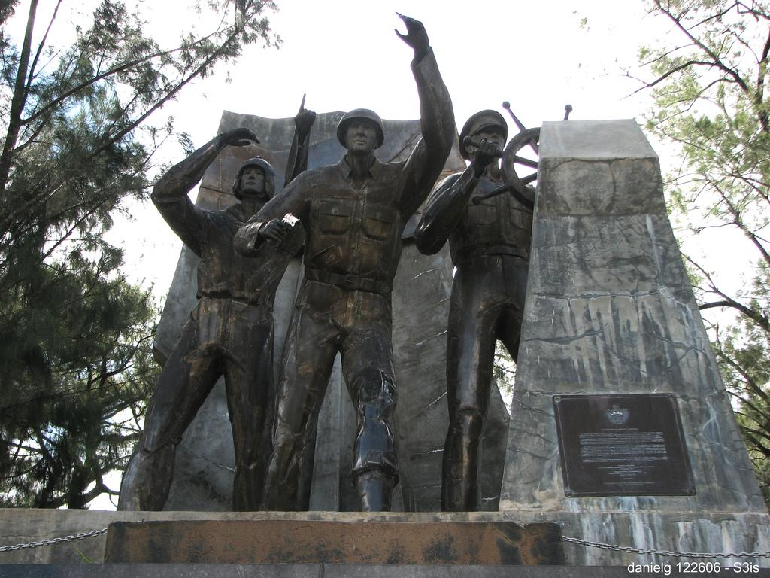

1. **SONG**

This is one of my favorite song by Christina Perri entitled;

**“HUMAN”**

I can hold my breath

I can bite my tongue

I can stay awake for days if that's what you want

Be your number one

I can fake a smile

I can force a laugh

I can dance and play the part if that's what you ask

Give you all I am

[Pre-Chorus]

I can do it

I can do it

I can do it

[Chorus]

But I'm only human

And I bleed when I fall down

I'm only human

And I crash and I break down

Your words in my head, knives in my heart

You build me up and then I fall apart

I'm only human

I can turn it on

Be a good machine

I can hold the weight of worlds if that's what you need

Be your every-thing

[Pre-Chorus]

I can do it

I can do it

I can do it

[Chorus]

But I'm only human

And I bleed when I fall down

I'm only human

And I crash and I break down

Your words in my head, knives in my heart

You build me up and then I fall apart

I'm only human

[Pre-Chorus]

I can do it

I can do it

I can do it

[Bridge]

I can take so much

'Til I've had enough

[Chorus]

But I'm only human

And I bleed when I fall down

I'm only human

And I crash and I break down

Your words in my head, knives in my heart

You build me up and then I fall apart

I'm only human

1. **Effect of its music/Lyrics to you as a young person**

The lyrics of these song is so meaningful, it has a big effect for me as a young person, well because if you look the meaning of these song, its about a person who’s loving so much that he/she will do everything to make the person they love to be satisfied. But if you look the deeper meaning of these song we can actually relate it to anything, like; about family, Me, doing anything to make my parents proud, that even if I’m tired I still do everything to reach their expectations, also About friendship, helping my friends on their problem even though I also have a problem, I still make them as my priority because I love them and I treasure them. And also about Education, Having a lot of requirements in school, with the same date of passing, it makes me frustrated, and stressed out, lack of sleep and no time for eating, its like my body wants to break down already but because I have a goal and I want to pass, I still do everything to accomplish it, and to gain high grades. These song is like an inner voice of a person who wants to give up already but he/she choose not to, just like me I want to give up but I chose not to, because I know that God has still a better plan for me, and also these song is trying to say that even if I’m fine, even if I’m smiling in front of a lot of people, I hope you still consider my feelings as a person, that I’m still a human, I still feel hurt and I break down. These song is really beautiful the lyrics and its tone, its like a lullaby, and and if you listen to Christina Perri while singing these song its like shes telling a sad story that will really touch your hart.

1. **Connection of the lyrics of the song to its music**

If you read the lyrics, its a sad story. The music used are soft and slow, its like a lullaby, a lullaby that has a hurt feeling, the combination of the lyrics and its music, makes the song dramatic, and hearing the song makes your heart flatter. The way that Christina Perri sang it makes it more beautiful and hurtful at the same time. But overall, its a beautiful song and the connection of the lyrics and its music is a perfect combination.

1. **LITERARY WORK: FOLKTALE**

**“Moments in the dark”**

It was dark, it was silent and all I can hear, is our heart beating for each other, it was cold but your hand holding mine keeps me warm, I was scared but seeing you smiling at me makes me feel safe and secure. I was scared in the dark but you gave me the reason to love it, you always walked me home, and we always walked on the dark path, and I was really scared, but you’re here beside me saying that it will be fine, you show me the beauty of the night, and that’s the time I felt like, every night is the start of our adventure, you beside me on the dark night that embracing the moon, makes me feel like it was the happiest moment of my life.

It was evening, we’re walking on the same dark path, it was silence, but we break that silence, laughing at each others silliness, telling stories about something, enjoying ourselves with each other, it was again another happiest moment of my life, I was laughing so hard that tears were already forming in my eyes and just come down to my cheek and you were watching me, smiling.

I was wiping the tears in my eyes when suddenly I feel something touched my skin, and I saw a butterfly, its like it’s looking at me, it was so beautiful, but looking at it only makes me sad, and suddenly a tear fell from my eyes, I looked back to were you were standing and you were still their smiling at me, but your eyes were sad, I was about to ask you why you were sad but the butterfly flew, and it was going to your direction, but suddenly it disappear, and so do you. I looked around, and I couldn’t see you anywhere, and I know I couldn’t see you anymore…

The wind blows and suddenly I feel the cold, I look at the moon and it was fading in the dark, it was silent, and all I can hear is my heart beating, it was cold and only the jacket that I’m wearing and the candle beside me keeps me warm, the time that I break the silence wasn’t the time that I was laughing, it was the time that I was crying, and now seating beside you wasn’t make me happy anymore, but it makes me sad and lonely, looking at your grave is the saddest moment in my life.