**CHAPTER 1**

**PROJECT OVERVIEW**

The Retail Industry is the Inventory System (IS) of the company that we’ve chosen, The role of this type of IS is that it helps the company To increase the company’s ability to respond to the evolving marketplace through enhanced speed and flexibility. It also helps the company To collect and analyze customer data while enhancing differentiation and to improve their business processes.

Retailing Industry involves the selling of goods to customers. While meeting the needs of customers. Retailing is a distribution channel function where one organization buys products from supplying firms or manufactures the product themselves, and then sells these directly to consumers. A retailer is a reseller (i.e., obtains product from one party in order to sell to another) from which a consumer purchases products.

The Benefits of Retailers are; It has*Access to Customers* - For suppliers, the most valuable benefits provided by retailers are the opportunities they offer for reaching the supplier’s target market, building product demand through retail promotions, and providing consumer feedback ﻿and *Access to Products* - For consumers, the most significant benefits offered by retailers relate to the ability to purchase products that may not otherwise be easily available if the consumers had to deal directly with product suppliers. In particular, retailers provide consumers with the ability to purchase small quantities of a wide assortment of products at prices that are considered reasonably affordable.

**1.1 Background of the Study**

The company Salon De Feliz is a small skin care establishment in Baguio City. The business offers a variety of services which includes basic facial, acne treatment, massage, etc. It also includes selling skin care products which includes Hydrating Cream, Day Cream, Sunblock and many more. In this study we will focus more on the inventory system of the products sold rather than the system of the services that they give. Salon De Feliz is only using a manual system for their inventory system and it may lead to duplication of documents and work redundancy. Just like other small businesses here in the Philippines, the company only relies on log books which can be hard to analyze and organize. After filling out the log book, they computerize everything again and this leads to work redundancy. This type of process also has a risk of committing error.

**Related Literature**

Management system is the framework of processes and procedures used to ensure that an organization can fulfil all tasks required to achieve its objectives. In recent times, most organizations will opt to use management system in their daily business task.

There are those who still use the non-computerized system as opposed to the computerized management system. The non-computerized system may be effective but it also causes greater task load when implemented. Computerized system makes it easier for users with functions such as searching, automatic calculation, and display of related information with minimal queries.

Manufacturers and trade re-sellers can both benefit from a thorough solution, where single transaction entry records necessary details on the customer, products purchased, price and date while also updating inventory levels.

Using computerized sales and inventory systems allows for much greater accuracy in stocking and product management. They encourage ease of interaction between employees and shoppers as transactions are processed and items move from the business to the consumer. Computerized sales help provide better insight into which products are most popular. It also allows for enhanced marketing, stocking and oversight of critical sales objectives.

Computerized sales and inventory systems save time for businesses by speeding up transactions while raising accuracy. This allows for confidence in accounting and accountability among employees as it is easy to verify how much money and what time transactions took place.

They also allow for consistent experiences in terms of customer service. People know there is always a uniform interaction at the register that requires tendering payment, taking a receipt and transition of ownership of products and services. This generates confidence in a business and ensures ongoing consumer relationships. Computerized systems are the most common method of inventory control and sales processing in retail markets.

In using this computerized sales and inventory system you can establish the benefits you and your business handling may have. First is time savings. The amount of time that can be saved by a business is perhaps the biggest benefit of using a computerized inventory system. In cases where a shop maintains all data manually, its manager must reconcile each sales receipt with every piece of physical inventory. Depending on the size of the establishment and how many different products are sold, this can be a daunting and time consuming task. If that same store, however, used a computerized point of sale or POS System, the master inventory list would be updated electronically each time a sale is made. The only thing a manager would have to do each day is print out the report highlighting the inventory to be restocked. Second is accuracy. An additional benefit of using a computerized inventory system is the accuracy it ensures. When an inventory list is maintained by hand, the margin of error widens with each update. If one mathematical calculation is wrong or one typo is made, disaster may occur. And lastly is the consistency. A small business operates most efficiently when its processes are executed in a consistent manner. By using a computerized inventory system, a business owner can ensures that all orders, reports and other documents relating to inventory are uniform in their presentation, regardless of who has created them. This will allow ease of reading. In addition, uniformity creates a professional appearance, which can go a long way to impress associates, such as potential investors.

**7-Eleven Inventory Management System**

In a post of 7-Eleven about their Inventory Management System in 2016, they showed the benefits of these to their franchisees and why the system matter. The company uses a real-time inventory management software which shows the 7-Eleven Franchisees which products are selling and which aren’t, enabling them to optimize their product selection and automate the restocking process. The system also automatically records replenishment rates and creates statistical recommendations relevant to a specific store and neighborhood and this results to huge profits since they know what the current trend is and what products the customers like.

**1.2 Company Profile**

**Company History**

Salon De Feliz started 20 years ago when Merlinda Bermuder starts her business. At first she was only an assistant with her aunt, her aunt named Dra. Jane Enriquez a dermatologist by profession and the president of fellow Dermatologist of the Philippines. Merlinda Bermuder starts the business with only 2 bed and 1 assistant to perform the basic facial and warts removal, then they did only the basic steps and procedures for facial. The basic steps and procedures in doing facial has been the trademark for the company and the reason for the customer to come back now and then. As the years go by, Merlina Bermuda hired additional staff to train them the traditional procedure of facial and the other services, they added some products on skin regimen like moisturizer, sunblock ,toner and soap. The salon has an exclusive chemist who are making the products that only be used and sold by the company. Salon de Feliz now has _____ branches as legacy of Merlinda Bermuda to her family and staff.

**Company Industry**

Retail Industry

**Company Operation**

The day to day operation of Salon De Feliz Salon is dedicated in promoting affordable yet best quality safe skin products and services that the customers will have a reason to come back again. The purpose of this salon is to provide an environment conducive to giving relaxing and professional services, also offering the clients a wide range of services in one setting.

The traditional facial procedure is the company's valuable asset to sustain the future growth to stay ahead of future requirements.

**1.3 Objectives**

The business process that we want to analyze are [Administration](https://simplicable.com/new/administration), Sales and Operation Planning, Information Security, Marketing, Sales and Customer Service. Administration is where the on-boarding new employees and providing them an id to access the system and with that id they will do different roles. Sales & Operations Planning, a plan-to-inventory process includes all the steps required to [plan inventory levels](https://simplicable.com/new/sales-and-operations-planning) based on factors such as customer demand and production capacity. [Information Security](https://simplicable.com/new/information-security), An information security audit method checks for vulnerabilities in systems like access management lists that embody unused or inessential permissions. [Marketing](https://simplicable.com/new/marketing), An idea-to-offering process includes everything required to [develop](https://simplicable.com/new/product-development) and launch a new product to market. [Customer Service](https://simplicable.com/new/customer-service), A [customer service](https://simplicable.com/new/customer-service) process investigates customer complaints and determines if customers are owed compensation. The process also drives improvement to the organization as failures may be logged as problems and fixed.

The objective of this research is to help the company to be more organized and to improve their business processes. This research will help them to increase the company’s ability to respond to the evolving marketplace through enhance speed and flexibility. Also, this will help the company to be more productive.

**1.4 Data Gathering Techniques** Interviews are used to collect data from a small group of subjects on a broad range of topics. We will use structured interviews. Structured interviews are comparable to a questionnaire, with the same questions in the same order for each subject and with multiple choice answers.  
 Observation a data collection method, by which we gather knowledge of the activity through making observations of the activity, as and when it occurs, we will also aim to focus our observations on the processes on how they check their inventory.  
 With that said this are the two Data Gathering Techniques we will use, for it will give us a more compact and detailed information when we will be gathering the data.

**1.5 Sources of Data** We will gather data within the said company Feliz FACIAL SALON(s) management.

**CHAPTER 2**

**Methodology**

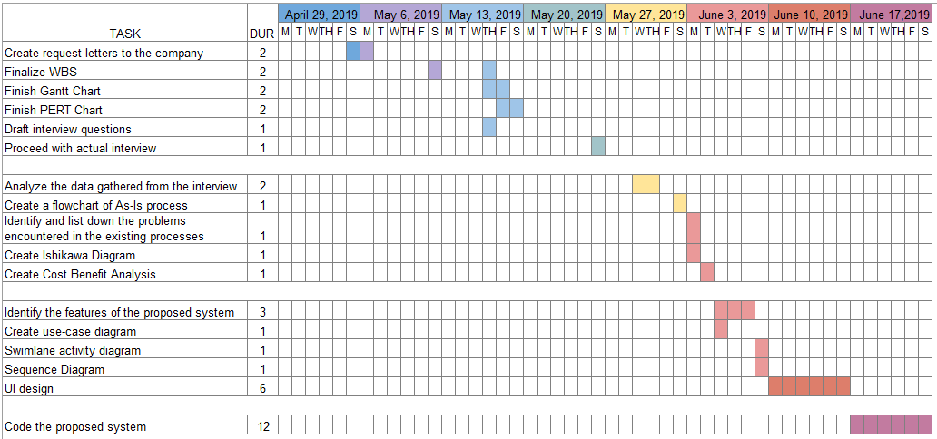Work Breakdown Structure (WBS)

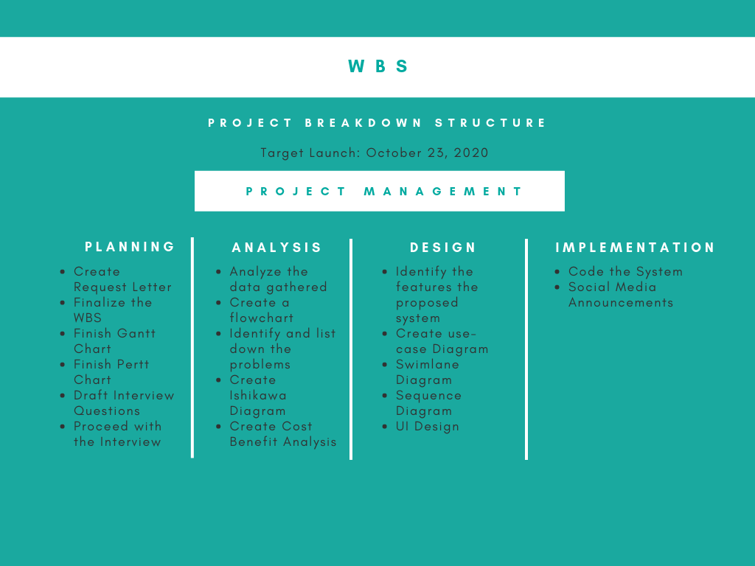

Gantt Chart

PERTT CHART

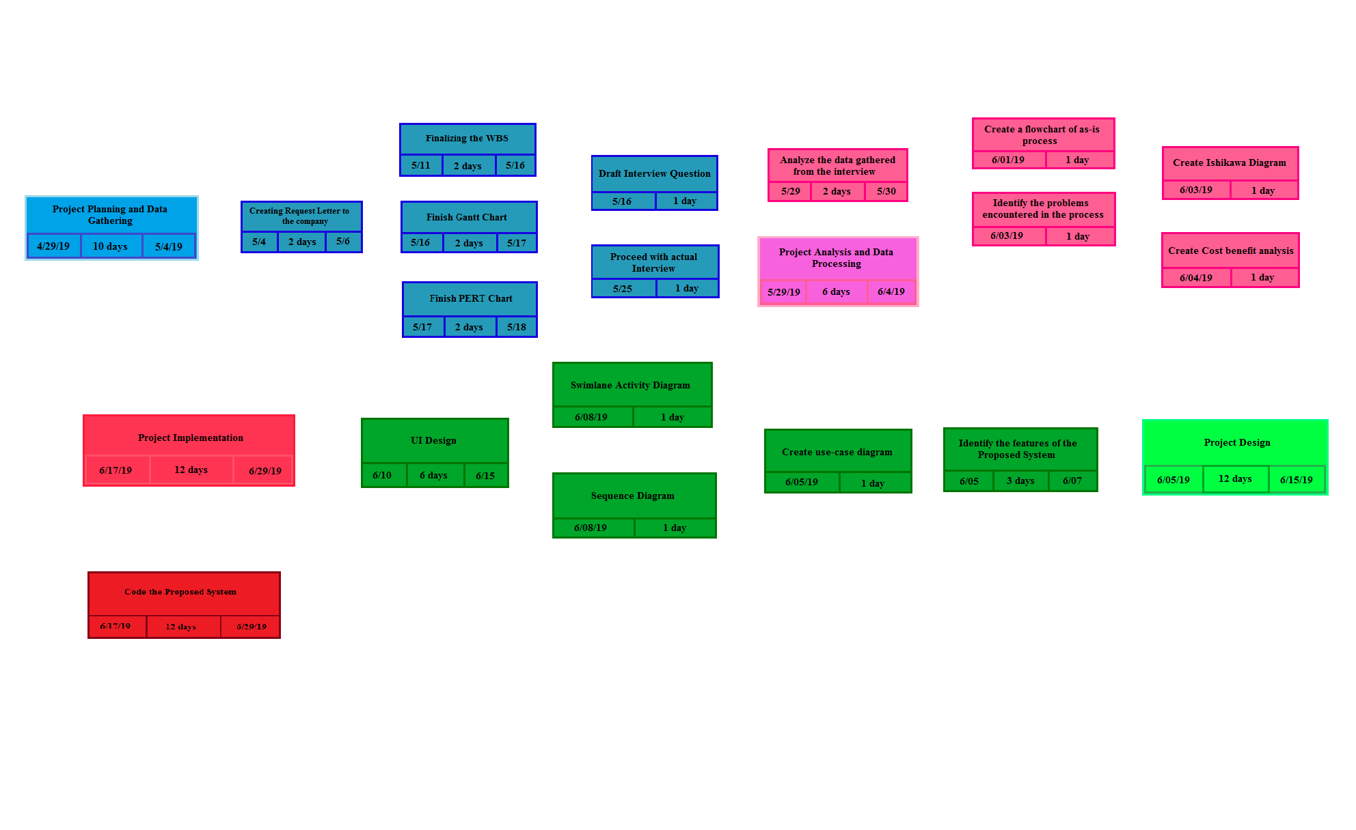

**2.4 Scope and Delimitation**

The study will focus only on the inventory system of the products they sell in Salon De Feliz and does not generate the reports of services of the salon. The proposed system can store, update, view the current stocks of the company and can also generate a list of reports.

The study consists of the statistical reports such as records of stocks and the summary of sales which (daily and monthly).

In addition, only authorized personnel are allowed to access the system. The manager and other employees are given individual usernames and access codes for accessing the system. Unauthorized personnel cannot access the system.

Moreover, the inventory system is focused only on La Trinidad Branch of the whole company.

**2.5 System Analysis and Design Tools**

The tools we are planning to use are

• **Tools**

MICROSOFT OFFICE - all the documentation and graphs

DRAW.IO - for the models and diagrams

NETBEANS - creating the prototype of the system

•  **Technique**

The technique that was used was interview, interviewing the employees in the company ensures the understanding the situation before making any proposals or improvements. With the interview results the team would know exactly what requirements are needed to be included in the system. By performing this in-depth requirements gathering, it will save time and increase the quality of the analysis. This will in turn save time for the design and implementation phases of the Systems Development Life Cycle (SDLC).

• **Models**

- Use Case

A use case diagram is essentially a picture showing system behavior along with the key actors that interact with the system. .With the help of use case containing the system activities it is also a powerful tool in planning and tracking of the system development. Furthermore, use case for a system served as the entire development process, it continues beyond its authoring to cover activities such as analysis, design, implementation, and testing.

-Swimlane Flow Diagram

By providing a graphical presentation or the swimlane flow diagram of the whole processes it helps to identify the different elements of a process and understand the interrelationships among the various steps. It also very important to see the configuration of the system to ease the process of building a system and helps reduce failures or overlooked steps.

-Data Flow Diagram

In order to show the system's scope and boundaries and illustrates the flow of data through an information system, Data Flow Diagram is a must. By creating a data flow diagram it allows in creating program with minimal discomfort in programming the actual code. Data flow diagrams can be used in both Analysis and Design phase wherein it is an initial stage of design phase that functionally divides the requirement specifications down to the lowest level of detail

-Wireframing

Wireframing is a quick and effective way to identify usability issues early on the design process. It allows mapping out the functionality of the system, catch problems early, and save time on revisions later. In other words, mapping out the functionality early will reduce the amount of back and forth that often comes with the development phase.

**Chapter 3**

**Findings of the Study**

**3.1 Existing Processes of the <Business Process>**

**Narrative description of As-Is process**

Feliz Facial Salon  
**Mission**

We are purpose-driven company dedicated in promoting affordable yet best quality and safe skin care products and services through teamwork, faith, hard work and professionalism.

**Vision**

Be recognized as a skin care establishment that promotes timeless skin care regimen and surpass traditional customer service.

For this narrative report we are given the chance to know what and what's not happening inside the said company, this also includes the following:

* Were there any internal risks or additional costs within your company?
* ﻿How do you keep track with your products?
* ﻿What are the problems that you usually encounter within your products?
* ﻿How long does it take for the products to arrive in your company? ﻿
* Which season of the year are toughest in your job? Toughest season of our job is what we call the "peak" and "lean/rainy" season.
* Could you please discuss in detail the process of your current inventory system?
* Could you describe one of your typical work days?
* Are there any negatives to your job?
* How many hours do you work in a typical week?

Not totally risks but when there will be new staff or trainee we need to add them to the monthly salary. Another thing is that when we purchase new machine or equipment which costs thousands.

We have our own chemist who makes the products we sell and used it in our clinic's operation. So before our products go out of stock we will immediately call to our manufacturer for another set of products.

Some of the ingredients of our products are coming abroad and costs expensively. there are times when the manufacturer wants to increase the price of the products due to the expensive costs of the raw materials but the supplier will refuse, that's when the manufacturer doesn't want to supply products anymore.

It depends on the availability of stocks. sometimes it is on the date of delivery agreed on but sometimes it takes a longer time because of the shipping

For the peak season especially in october to march, we as a therapist are also tired at work there are clients that sometimes we cannot accommodate.

For the lean season there are not many customers coming so our company has lower sales than the peak season

Our inventory system is the traditional way, when a customer buys a product/s we will just write it in our logbook and we call it “variance”. At the end of the month we are required to encode the service/s done to the customer and products going out in our company that will be sent to the main branch of the company for compilation  
 When there are a lot of customers with different kinds of personalities and demands, at the end of the day we just wanna finish our work and go home at the same time provide their good service to our customers

There will always be, just like for example there are some clients that are demanding that when they enter the salon they are the first to be taken care of without considering the first clients ahead in line. Another thing, is when there are no products delivered, we don't have the exact date to promise to the clients when the products will be coming.   
 Lastly the work hours stays around 8 hours or extended.

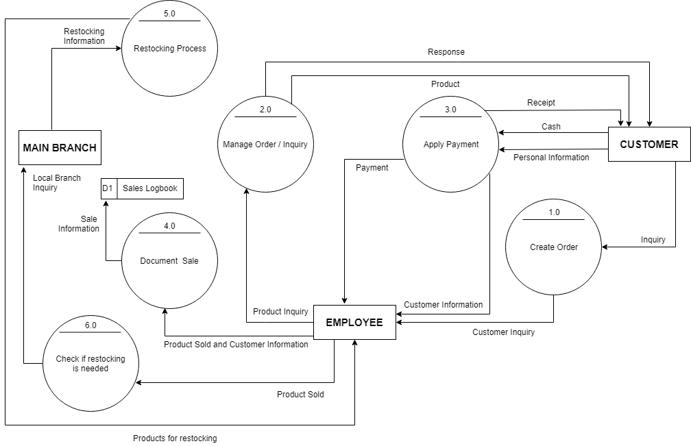

**DFD of As-Is process**

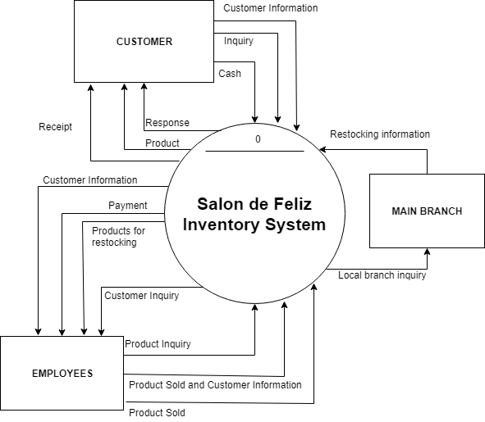

**Narrative Flowchart of As-Is process**

In Swim lane flowchart we can see the manual process on how does their inventory system works, and to start with, the customer should inquire first, after that the employee would go and check if there are any available product or stocks,if no the employee would go and tell

the customer that the products are out of stock, after that the employee or the manager will call the main branch for restocking, then the main branch will do the process to make a new product and once its done they will deliver it to the company (Salon De Feliz). But If it is yes the employee will collect the information of the customer and the product including the name of the customer, the receipt number, name of the product, the date, the price of the product, and the quantity or the number of the product that client bought, and once its

done the employee will give the ordered product and will proceed to the billing process. And if it's all done, the employee will now write the information on their sales logbook, and will check if the quantity of the remaining products are already on the minimum number of stocks, if yes the manager will call the main branch and ask for a new stocks or product then the main branch will do the process and will deliver the product to the company, and will repeat the process.

**3.2 Problems Encountered in the Existing Process**

**(Inefficient Inventory Process System)**

**Manpower**

With the exception of some very small businesses, such as sole proprietorships, company manpower is a critical issue. Manpower impacts everything from production to client relationships so managers pay careful attention to the number of workers a business engages at any given time. The importance of company manpower is best understood by looking at its benefits in depth.

The link between manpower and company projects is fairly simple: Manpower is proportional to productivity. The more people are available to work, the faster workload can be completed or the more workload a company can take on. Conversely, a lack of adequate manpower prevents businesses from completing tasks. The lack of productivity translates into a reduction in revenue and profit, which in some cases means the business can’t stay operational. When a company doesn’t have enough workers, workers generally do not need to work a high number of overtime hours. The assigned workload is more appropriate because there are more people to handle tasks. As a result, workers usually are less stressed and more rested and alert. Similarly, when enough workers are on the clock, there are more people to check adherence to safety regulations and policies, and workers can seek assistance for physically challenging work. A good level of manpower thus helps prevent problems such as burnout and injury.

When the level of manpower in a company is adequate, the business has more options in how it operates. It has some flexibility in terms of which employees cover shifts; it is easier to get people to fill in. The company also has a greater pool of workers with which to construct strong teams and is more likely to have employees with the skills, knowledge and abilities to tackle current company problems. Additionally, the company has more employees who can give their own ideas and perspectives. It therefore may have an easier time remaining innovative and competitive.

Good manpower allows companies to keep the production and delivery promises they make. If companies do this, they can establish and maintain good client relationships. This can lead to additional sales. At the same time, keeping promises can prevent companies from having to pay fines and penalties, which keeps the amount of profit higher.

**Methods**

With their current methods regarding the stocks and sales that they’re using, first is time consuming and manual operations, which gives up a lot of time where they write everything down on a logbook which is not advisable when they’re dealing with a lot of stocks, simply writing it down within a logbook will cause them to lose track with the stocks and quantity of their products being stored when there’s an unexpected incident happen.

**Materials**

As said within the method, they use a logbook which is not advisable to store all the products that are being stored inside their company, also there’ll be no back-up ones it is lost.

**Machine**

As for the machine, they’re not currently using machine which is not a good thing since there are products that is constantly being changed also with the prices fluctuating they need to have a system or a machine where they can store and edit the products ones it is changed.

Ishikawa Diagram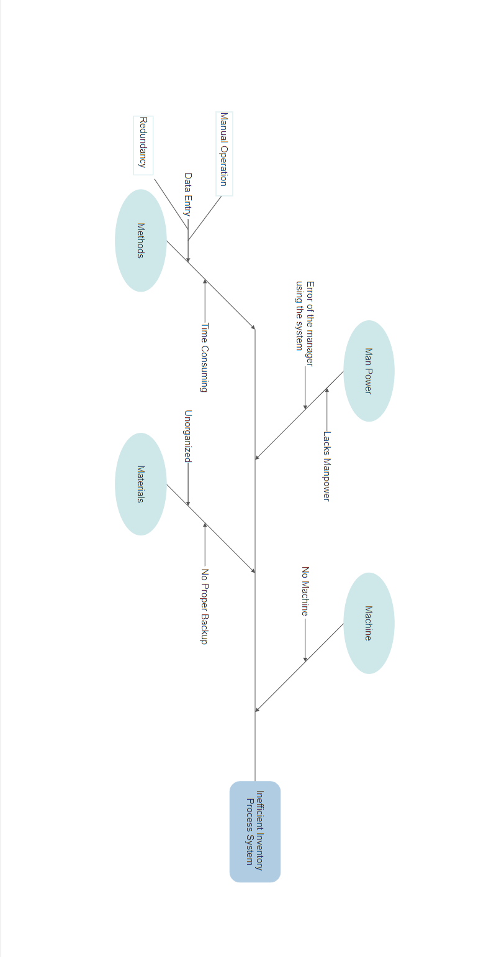

**3.3 Features of the Proposed System**

**Narrative description for each feature of the proposed system**

The Features of our proposed system is that they can sign-up, login, system verification of accounts, view stocks, view reports, and Add Sales. The actor will be the employee because they will be the user of the system. Each employee must use first the sign up feature to make a new account and will be used in the login feature to access other features. Login feature is where the employees enter their username and password for them to be able to access the other features. Login feature is included in verify user feature because every input of the employee it verifies the user if the employee has already signed up and their username and password are in the database, otherwise they cannot be able to access the other features that are included in Login feature. The features that are included in login feature are view stock, view reports, and add sales, this features are included to login feature because for the security of the data. In view stock the employee would be able to see the name, price, quantity and the status of products, also in status it indicates if the quantity of the product is enough and if not they need to restock. For the view reports it shows the sales of product where they can be able to see the date when the product was bought, the customer's name, the receipt no., the name of the product, the quantity and total price. It will also show the most bought product and they can also see the details of restock like date of when did they restock and the quantity of product. And for add sales feature, the employee will input the name of the customer, receipt number, the product name, the quantity, the price, and the date when it was bought.

**Use Case Diagram**

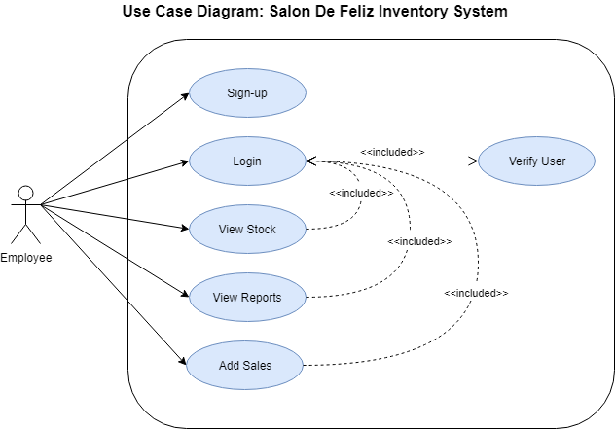

Swimlane Activity Diagram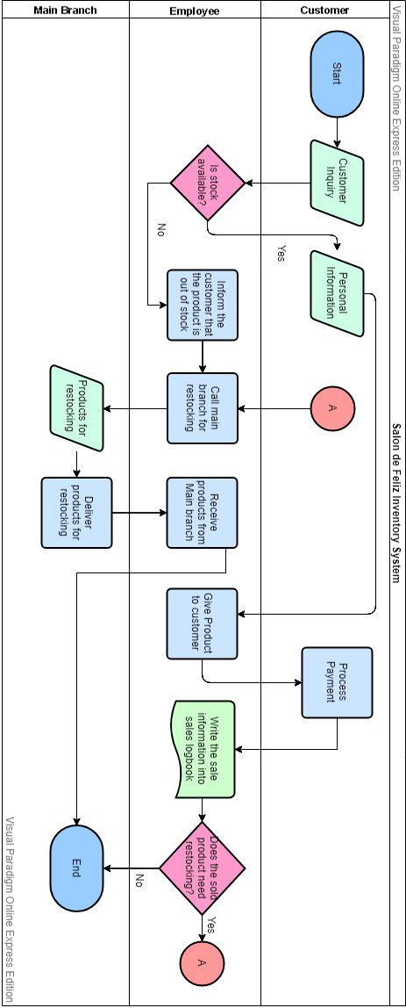

**Sequence diagram**

**UI design**

**Chapter IV: Conclusions and Recommendations**

**Conclusion**

As the paper have indicated within the project overview, the Retail Industry is the Inventory System of the company, and the role of this type of Inventory System will help the company Increase the ability to respond to the evolving marketplace through enhanced speed and flexibility. So, the objective of this project is to build a program for maintaining the details of all the Stocks and Products within the company. The system developed is able to meet all the basic requirements. It will provide the facility to the employee so that they can keep track of all the stocks and products being supplied. Inventory management is one of the important aspects in production system as well as business affairs. At present, the management of the Inventory will also be benefited by the proposed system, as it will automate the whole process of their Inventory, which will reduce the workload. The security of the system is also one of the prime concerns.

There is always a room for improvement in any software, however as efficient the system may be. The important thing is that the system should be flexible enough for future modifications. The system has been factored into different modules to make system adapt to further changes. Every effort has been made to cover all user requirements and make it user friendly.

**Limitations and Recommendations**

Any research work has got its own limitations due to the time and resource constraints. Quality of response data and analytical tool used. These limitations give new dimensions to future research works. Some limitations of this study which have been come across during this research work and must be addressed in future research are as follows:

· The study is about the relationship between the employee and stocks. Future research may include customers also to extend the study to collaborate the findings of this study.

· The hypermarkets and departments store formats of Organized Retail Industry were considered for the research. Future research may focus on bringing in analysis and result in retail format wise.

· Future research may incorporate to establish path analysis with supplier selection and purchasing strategy design dimensions to its linkage to retailer’s overall business performance (R.H. Hoyle, 1995).

· Also for future research it will also be versatile and flexible enough for further modifications (e.g. adding an automated ID number scanner for the system for easier login).

· Finally, future research can expand the current theoretical framework by integrating new constructs beyond operational framework from managerial fields. For example, future research may incorporate “Top Management Support”, “Company Policies” and “Training and Development” in their studies to bring in new dimensions.