**LAUNDARY**

**THE WASHERS**



**100% Pure Dry Cleaning, Urgent Service**



***“DAY TO DAY IMPROVEMENT TECHNOLOGY OF LATEST PLANT & MACHINERY US TO KEEP OUR CUSTOMERS HAPPY”***

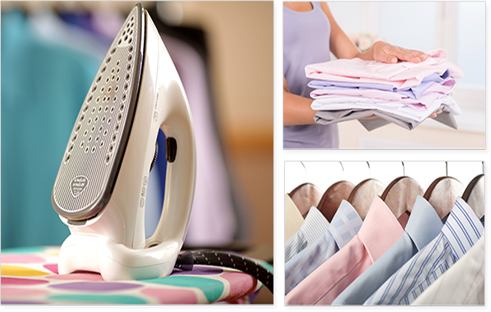

**OFF**

**20%**

***GET DISCOUNT***

***ON***

***FIRST ORDER***

***FREE PICK-UP & DELIVERY***