

Undergraduate project proposal

A systematic review of diagnostic and prognostic biomarkers of bladder cancer

By

Umar Muhammad

BASUG/UG/BHS/ANA/18/133

Supervisor: Dr. Umar Ahmad

Bauchi State University, Gadau, Nigeria

December 2021

**Abstract:**

Background: Diagnostic techniques presently used for bladder cancer mostly are urine cytology and cystoscopy. Cystoscopy is an invasive device and has low sensitivity for carcinoma in situ. Urine cytology is non-invasive, is a low-fee method, and has an excessive specificity however low sensitivity for low-grade urothelial tumors. Despite the look for urinary biomarkers for the early and non-invasive detection of bladder cancers, no biomarkers are used at the prevailing in every day scientific practice. Extracellular vesicles (EVs) had been currently studied as a promising supply of biomarkers due to their function in intercellular communiqué and tumor progression.

**Aims and objectives:**

To systematically review the role of diagnostic, and prognostic biomarkers for bladder cancer.

**Methods:**

A systematic review of the published literature will be performed.

**Results:**

Despite the fast-developing literature approximately the subject and the approval of numerous urinary biomarkers to be used in clinical practice, they have got now no longer reached the extent of proof for extensive utilization. Biomarkers can be utilized in different clinical scenarios, particularly to conquer the restrictions of modern-day diagnostic, predictive, and prognostic tools. They have been evaluated to discover bladder most cancers in asymptomatic populations or people with hematuria and in surveillance of disorder as adjuncts to cystoscopy. There is likewise a capability function as prognosticators of disorder recurrence, development and survival both in sufferers with non-invasive cancers and in people with superior ailment. Finally, they promise to be useful in predicting the reaction to nearby or systemic chemotherapy.

**Conclusions:**

Up to date, because of the shortage of brilliant potential trials, the extent of proof supplied via way of means of the modern literature stays low and, therefore, the capacity of biomarkers exceeds usage in medical practice.

Keyword: Bladder cancer, prognostic, diagnostic, biomarkers

**1.0 INTRODUCTION**

Bladder cancer is among the most prevalent and deadly bad tumors globally. It was reported that in 2008 about ten thousand three hundred and thirty-five people were examined with the presence of bladder cancer in the United states and it's the 7th ranking cancer in the U K. Regardless of the achievement in the area of bladder cancer which include early identification and better treatment in the form of developing surgical equipment, radiotherapy techniques with the chemotherapeutic agents, the tumors remain the vital illness. It's proved that early detection of cancer will improve the attributive, deduction and reduce reoccurrence. Hence multiple examinations have been routed to diagnose and identify molecular markers, which will help in early diagnosis, guide, and treatment identify accurate prognostication (Publications et al., 2013)

A biomarker can be defined as molecular compound that can show a biological state. A lot of biomarker had been identified and determined in different studies in relation to bladder cancer. A diagnostic biomarker is a molecule that shows the presence of cancer, such as the presence of tumors, grade, its stages or clinical division. While the prognostic biomarkers show the outcomes of the disease. Examples of prognostic biomarkers in clinical procedures include oncotype Dx and Mamma print gene panels, they used to normally detect the repetition of disease in breast cancer and give vital information to the clinicians and the patient with potential information regarding the improvement of the chemotherapy (Dancik, 2015)

A set of pathological and clinical parameters can be used to predict the risk stratification in bladder cancer, which includes the complete of growth, repetition rate, and their forms presence of cancer in situ. Although they are only limited to determined clinical outcomes (Nagata et al., 2016). New methods for advanced muscle-invasive bladder cancer and effect predictive biomarkers on response to them are yet to be distinguished. However, the determination of biomarkers for the improvement of target therapy and new a method for advanced bladder cancer has to be determined.

The application of molecular predictive biomarkers in advanced muscle-invasive bladder cancer and molecular biomarkers of poor prognosis in post cystectomy patient will be discussed.

Some molecules acting theories behind the bladder cancer had been prove, it’s important to understand the molecular pathways of carcinoma genesis in bladder cancer before examining the prognostic and diagnostic biomarkers of bladder cancer. The idea of "field cancerization" was introduced in 1953, which is the thesis of multicentre cancer origins. A total of cells in normal epithelium structure control common genetic or epigenetic rage, the same as that identify in bladder cancer which might improve a ground for multiple tumor genesis. However, the "clone origin" theory says that bladder cancer begin from the unaddressed spare of a single transformed cell which can grow independently with subsequent variable genetic modification (Nagata et al., 2016).

Recent molecular biomarkers approach shows a different sample from metachronous and synchronal allopathic tumors can arise from monoclonal origin by breakdown according to the pattern of X-chromosome inactivation, TP53 mutation, and loss of heterozygosis. However, a member of gene has been distinguished that succeeded the "2-hit" model which include the two prototype suppressor genes: the retinoblastoma 1 (RB1) and TP53 genes (Nagata et al., 2016)' It is now well proven that accumulation of genetic alterations will form the basis of normal cell progress in bladder cancer, which referred to the process of multistep cancer. Recent investigations demonstrate that non-muscle invasive bladder cancer has different pathways in carcinogenesis. A pathway involved mutation of FGF receptor 3, will give rise to low-grade non muscle-invasive papillary tumors that often again but seldom invade likely wise, muscle-invasive bladder cancer and carcinoma in situ exhibit mutation or deletion of the TP53, RB1, ERBB2, OR PTEN.

Replication of cell cycle genes is also present, especially cyclin D1 (CCND1), which is the most commonly developed gene in bladder cancer (Batista et al., 2020). Genetics of bladder cancer have been demonstrated in over 10 years, but the outcomes have not yet been transferred to clinical practice in a strong way, mainly for NMIBC. Several biomarkers test is approved by the united states. In the present study we aim to critically review available biomarkers in bladder cancer, with some emergence molecules or tests that are interesting for the prognostic and diagnostic of the patient with bladder cancer.

**2.0** **Literature review:**

**2.1 Bladder:**

The bladder is a muscular hollow organ located at the base of the pelvis. Its divided into fundus, body, neck, and apex. (Zhu et al., 2016) the median umbilical ligament keeps upward on the back of the anterior abdominal wall to the umbilicus, while the apex is subjected toward the upper part of the pubic symphysis. The peritoneum is conveyed by it from the apex up to the abdominal wall which forms the middle umbilical fold. The neck of the bladder is the side at the base of the trigone which envelops the internal urethral orifice that heads to the urethra (Lee & Kim, 2020).

In man, the neck of the urinary bladder is immediate to the prostate gland. The bladder is consisting of 3 openings. The two ureters step into the bladder at the ureteric aperture, and the urethra penetrate at the trigone of the bladder. These ureteric holes consist of mucosal flaps in front of them that perform as valves in helping the backflow of urine toward the ureter (Ng et al., n.d.).

Separating the urethral opening is an elevated area of tissue, which is called inter ureteric crest (Choi et al., 2016). Which make the upper border of the trigone, trigone is a smooth muscle that shapes the floor of the bladder over the urethra. It is a side of smooth tissue for the ready flow of urine toward and from the part of the bladder- in comparison to the irregular exterior by the rugae.

The bladder is situated beneath the peritoneal cavity close to the pelvic floor and end to the pubic symphysis. In man, it extends to the front of the rectum, which is separated by the recto-vesical pouch, which is supported by fibers of the levator ani and the prostate gland. It is situated in front of the uterus, which is separated by the vesicouterine pouch in the females, and supported by the elevator ani above the part of the vagina (Mei et al., 2020).



Adapted from shutterstock.com

**2.2 Blood supply:**

It receives blood from vesical arteries and drained toward the network of the vesical vein. The superior vesical artery provides blood to the upper portion of the bladder. The lower portion of the bladder is supplied by the inferior vesical artery; both of them are a branch of the internal iliac arteries. in women, the uterine and vaginal artery gives additional blood supply (Apolo et al., 2009)

**2.3 Lymphatic drainage:**

The drainage begins in a network of small vessels on the below lateral surface of the bladder, which unite and travel with the lateral ligament of the bladder toward the internal iliac veins. The lymph that was drained from the bladder commenced in a series of networks throughout the mucous, serous and muscular layers. They will put together and form three sets of vessels, which are; one set draining the top of the bladder; one near the trigone draining the bottom of the bladder; and another set draining the outer under surface of the bladder. They will joint and drain into the external iliac lymph nodes (Hamad et al., 2020).

**2.4 Nerve supply:**

The bladder acquires both the motor and sensory supply from sympathetic and parasympathetic innervations. (Editors et al., n.d.)the motor supply from the sympathetic fibers, usually they arise from the superior and inferior hypogastric plexuses and nerves, while from the sympathetic fibers, and they arise from the pelvic splanchnic nerves. Sensory innervations from the bladder, relating to irritation are transmitted through the parasympathetic nervous system. They travel through the sacral nerves to S2-S4. From there, the sensation will travel to the brain through the dorsal columns in the spinal cord. The urine come from the bladder through the urethra, via the single opening called the urinary meatus, where it will exit the body (Ku et al., 2016).

**2.5 Cancer**

Cancer is a serious disease caused by cells that are not normal, which can spread to one or many parts of the body. Bladder cancer usually occur due to the cancer of the urothelium, which are the cells that line portion of the bladder. Bladder cancer is mainly started at the age of 40, and it’s more common in males than in females, other causes factors include smoking and exposure to aromatic amines and aldehydes. The common symptoms in an affected person is the presence of blood in the urine. (Nagata et al., 2016)

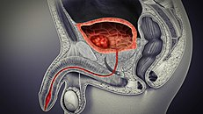

Adapted by Health central

**2.6 Biomarkers:**

Cancer biomarkers are biological molecules that are present in the tissue, blood, or body fluid that contribute in cancer prediction, diagnostic, prognostic of response to treatment and managing disease advancement (Oeyen et al., 2020)

Biomarkers are distinctive biological indicator of a disease condition (Publications et al., 2013). Biomarkers are frequently measured and evaluated using blood, urine or soft tissues to determine the normal biomarkers, pathogenic or pharmacologic responses to therapeutic intervention will be performed. Biomarkers are normally used in many scientific fields (Vis et al., 2021).

Nowadays digital biomarkers are a newly emerging field of biomarkers, usually collected by smart biosensors. Determination of cellular or imaging biomarkers that pass confirmation will serve as a method of assessing clinical outcomes. Determining the exact biomarker will help to optimize ideal treatment, and indicate liability of advantages from an explicit remedy. This will give a dual approach to both seeing trends in retrospective studies using biomarkers to detect outcomes. For examples, in metastatic colorectal cancer predictive biomarkers will served as a method of evaluating and improving patient existing rate and individual case synopsis. Examples of predicting biomarkers are genes such as PR, ER, and OTX1 in bladder cancer, BCR-ABL in chronic myeloid leukemia (Chou et al., 2015).

**2.7 Diagnosis:**

Diagnosis is the way of identifying a disease, nature, and causes of a certain phenomenon. Diagnosis is used in many different areas, with different logic and experience to assess the causes and the effect (Ku et al., 2016).

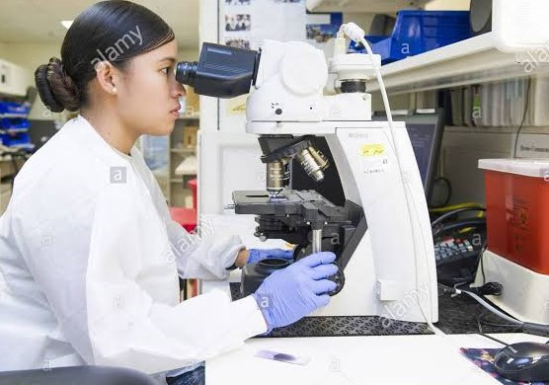

Adapted by alamy stock photo

**2.8 Prognostics:**

It refers to the determination of the exact cause of the diagnosed illness, disease, problems, etc., and foretell the outcomes of the treatment. (Quan et al., 2020).

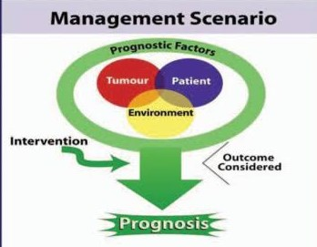

Adapted from Gospodarowicz et al.

**3.0 Methodology:**

**3.1 Study design:**

The study will be design using PICO (Population, Intervention, Comparison, and Outcomes). This will define the question by conducting scholarly databases.

**3.2 Literature search strategy:**

Search term: (((Diagnostic) OR (Prognostic)) AND ((Biomarkers) AND ((Bladder cancer)))

**3.2 Study selection:**

Will be a control randomized Trials that will include at least two independent reviewers.

**3.4 Selection criteria:**

**3.4.1 Inclusive criteria:**

The research will be conducted from the publication between 2001 till date, and it will include the affiliated field of research. It will also identify the manuscript that describe the review of diagnostic, prognostic, and biomarkers of bladder cancer.

**3.4.2Exclusion criteria:**

The research that was writing in other languages than English will be excluded, and the publication below 2001 will be excluded, and also meta-analysis will also be excluded.

**3.5 Target subject:**

Publication that include prognostic, diagnostic, and biomarkers of bladder cancer.

**3.6 Data extraction**:

Bladder cancer-related articles from the world will be analyzed from pubmed, Science direct, Google scholars, and NCBI. The search terms that will be used are 'Diagnostic ' OR 'Prognostic ' AND 'Bladder cancer ' AND 'Biomarkers '.

The search will include affiliation field and the full text. Also, duplicate and irrelevant articles will be manually removed.

**3.7 Outcomes measured:**

In line with the study aims, the Outcomes measures will be eligible if they are included in the Randomized Controlled Trials, and also if the Outcomes were not mentioned in the manuscript will be automatically removed.

**3.8 Data analysis**

Principal component analysis will be performed.

**3.9 Quality control:**

The quality control will consist of the going-over, redeem peer review and programming testing process of the publication if possible.

**3.10 Expected Results:**

The result might systematically review the diagnostic and prognostic biomarkers of bladder cancer.

**3.11 Discussion:**

Up to now, none of bladder cancer biomarkers were successfully identified which can be used to accurately detect non-invasive bladder cancer. Present efforts to combine the prognostic and diagnostic of bladder cancer biomarkers to improve the test accuracy also fail to be clinically assessed (Costa et al., 2016). We hope that, to systematically review the best method for diagnostic and prognostic of bladder cancer biomarkers.

**3.12 Conclusions:**

This review might be used to inform the scope of future prognostic, diagnostic, and biomarkers of bladder cancer.

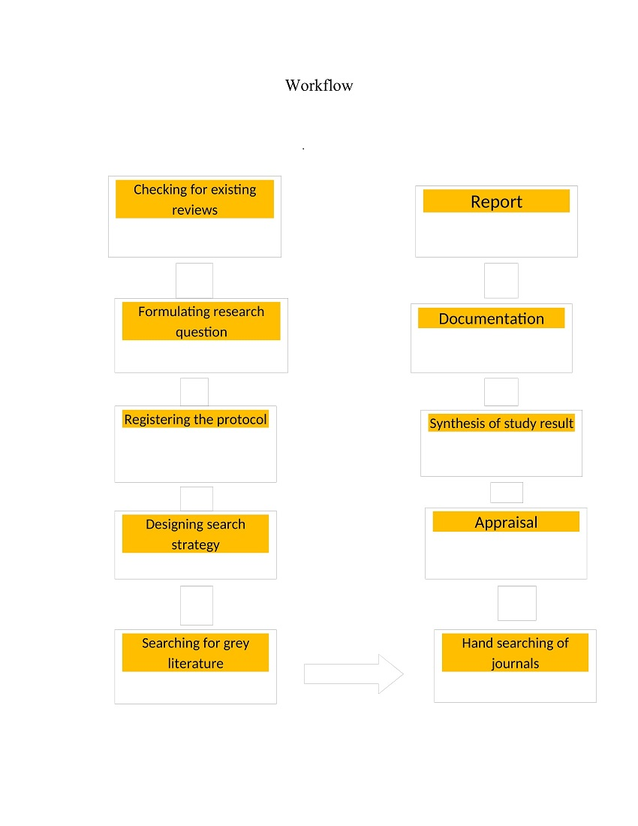

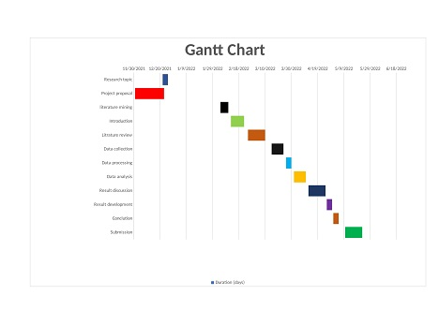

References

Apolo, A. B., Milowsky, M., & Bajorin, D. F. (2009). *Clinical states model for biomarkers in bladder cancer*. 977–992.

Batista, R., Vinagre, N., & Meireles, S. (2020). *Biomarkers for Bladder Cancer Diagnosis and Surveillance : A Comprehensive Review*. 1–19.

Choi, S., Shin, J. H., Lee, Y. R., Joo, H. K., Song, K. H., Na, Y. G., Chang, S. J., Lim, J. S., & Jeon, B. H. (2016). *Urinary APE1 / Ref-1 : A Potential Bladder Cancer Biomarker*. *2016*.

Chou, R., Gore, J. L., Buckley, D., Fu, R., Gustafson, K., Griffin, J. C., Grusing, S., & Selph, S. (2015). *R EVIEW A Systematic Review and Meta-analysis Annals of Internal Medicine Urinary Biomarkers for Diagnosis of Bladder Cancer*. *163*(12). https://doi.org/10.7326/M15-0997

Costa, J. J. D., Goldsmith, J. C., Wilson, J. S., Bryan, R. T., & Ward, D. G. (2016). *A Systematic Review of the Diagnostic and Prognostic Value of Urinary Protein Biomarkers in Urothelial Bladder Cancer*. *2*, 301–317. https://doi.org/10.3233/BLC-160054

Dancik, G. M. (2015). An online tool for evaluating diagnostic and prognostic gene expression biomarkers in bladder cancer. *BMC Urology*, 1–7. https://doi.org/10.1186/s12894-015-0056-z

Editors, G., Hyeon, J., Kim, W., Lerner, S. P., & Chun, F. (n.d.). *Diagnostic and Prognostic Markers in Bladder Cancer*.

Hamad, J., Mccloskey, H., Milowsky, M. I., Royce, T., & Smith, A. (2020). *Bladder preservation in muscle-invasive bladder cancer : a comprehensive review _______________________________________________*. *46*(2), 169–184. https://doi.org/10.1590/S1677-5538.IBJU.2020.99.01

Ku, J. H., Kim, W., Lerner, S. P., Chun, F., & Kluth, L. A. (2016). *Diagnostic and Prognostic Markers in Bladder Cancer*. *2016*, 2–4.

Lee, H., & Kim, S. H. (2020). *Review of non-invasive urinary biomarkers in bladder cancer*. *I*. https://doi.org/10.21037/tcr-20-1990

Mei, Y., Zheng, J., Xiang, P., Liu, C., & Fan, Y. (2020). *Prognostic value of the miR-200 family in bladder cancer*. *47*(May).

Nagata, M., Muto, S., & Horie, S. (2016). *Molecular Biomarkers in Bladder Cancer : Novel Potential Indicators of Prognosis and Treatment Outcomes*. *2016*.

Ng, K., Stenzl, A., Sharma, A., & Vasdev, N. (n.d.). *Urinary Biomarkers in Bladder Cancer*. 1–21.

Oeyen, E., Hoekx, L., Wachter, S. De, Baldewijns, M., Ameye, F., & Mertens, I. (2020). *Bladder Cancer Diagnosis and Follow-Up : The Current Status and Possible Role of Extracellular Vesicles*. https://doi.org/10.3390/ijms20040821

Publications, M. J., Miakhil, I., Parker, S. G., Kommu, S. S., & Nethercliffe, J. (2013). *A review of molecular biomarkers for bladder cancer*. *2*(3), 186–194.

Quan, J., Zhang, W., Yu, C., Bai, Y., Cui, J., Lv, J., & Zhang, Q. (2020). *Bioinformatic identification of prognostic indicators in bladder cancer*.

Vis, N., Ket, J. C. F., Hentschel, A. E., Toom, E. E. Van Der, Bosschieter, J., Heymans, M. W., Moorselaar, R. J. A. Van, Steenbergen, R. D. M., & Nieuwenhuijzen, J. A. (2021). *A systematic review on mutation markers for bladder cancer diagnosis in urine*. 12–27. https://doi.org/10.1111/bju.15137

Zhu, X., Qiao, Y., Liu, W., Wang, W., Shen, H., & Lu, Y. (2016). *CXCL5 is a potential diagnostic and prognostic marker for bladder cancer patients*. 4569–4577. https://doi.org/10.1007/s13277-015-4275-4