**Homework 7-3: Using a global data when DIC values are available.**

1. Estimate surface ocean pCO2 from DIC, AT, T, S and plot the result­­Hint: 1. Prepare an array for pCO2 with the same dimension as the data  
    2. Use for loop
2. Subtract 350 × 10-6 (atm) from the estimated pCO2 and plot the result
3. How does the plotted result compare with the following figure of air-sea heat exchange. Why are they similar or not similar? Positive value means ocean taking-up heat

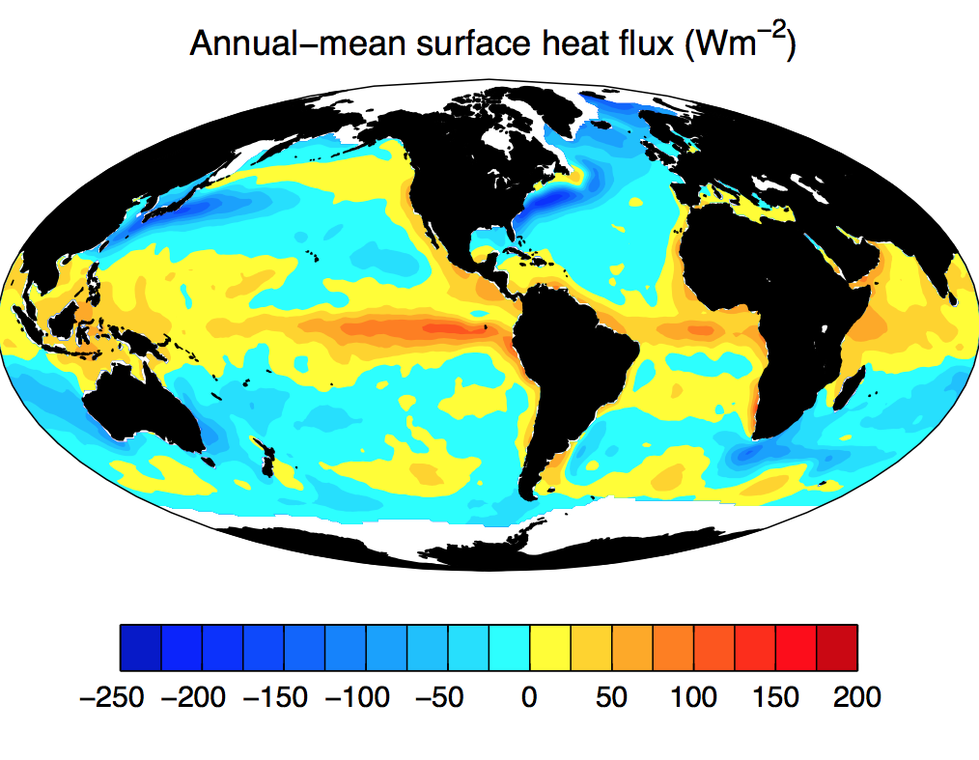

1. Submit a report with your code, figure and answer to the questions.

**Due Tuesday 10/31 2:00pm**