Page 1 of 2
Spider plot of mean of biomarker readouts

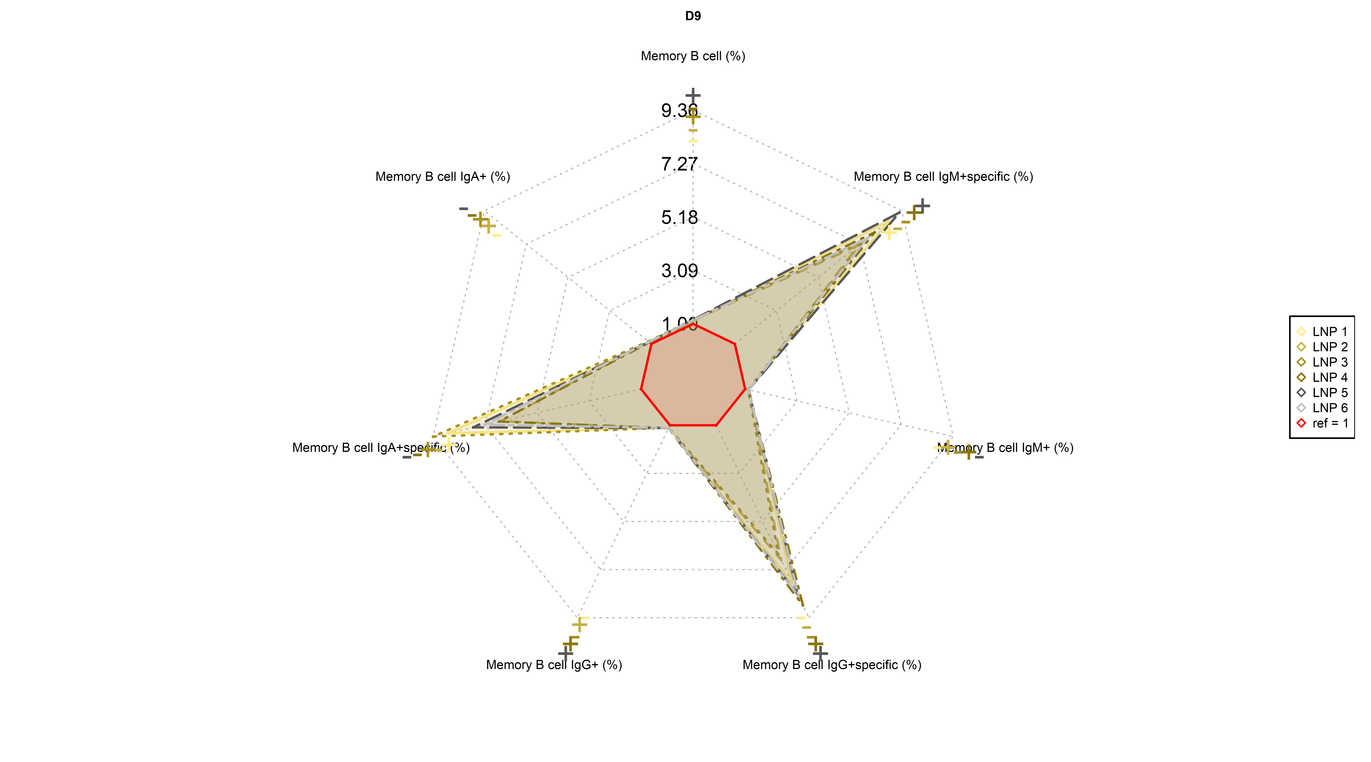

Study: Program: bio_spider.R Datasets=adbm Output:/C:/Users/e0340881/OneDrive - Sanofi/Desktop/BM/R custom package/VacBioTLF/bio_spider.rtf (058月2025 17:44)

Page 2 of 2
Spider plot of mean of biomarker readouts

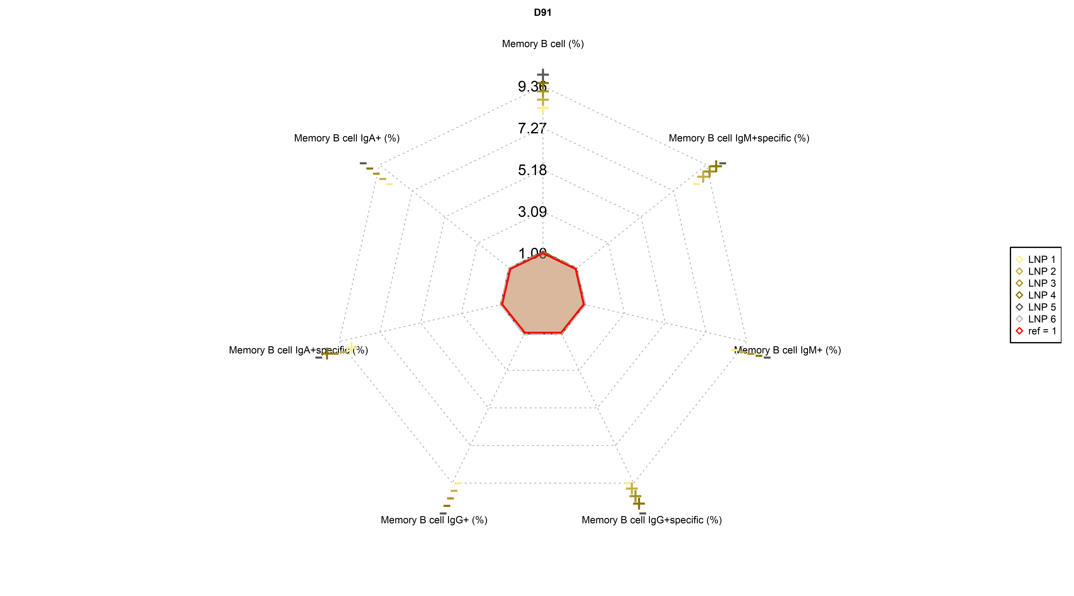

Study: Program: bio_spider.R Datasets=adbm Output:/C:/Users/e0340881/OneDrive - Sanofi/Desktop/BM/R custom package/VacBioTLF/bio_spider.rtf (058月2025 17:44)

