Assignment 3
Problem 1 (100 points):
In this homework, you will practice building a PyTorch Dataset and DataLoader for a real CSV dataset that contains:
- 5 numeric (integer) features
- 2 categorical features
- 1 multi-class label: A, B, C
You will complete a provided template by filling in missing code sections.
Please download the dataset “dataset.csv” and the code template “A1_template.py” from Brightspace. You only need to edit “A3_template.py” and fill in the missing parts. The template includes detailed comments to guide you step by step through the implementation. Once you complete the code successfully and run it, your output should look similar to mine. (I used a batch size of 4 in my example, but you are welcome to try different batch sizes.)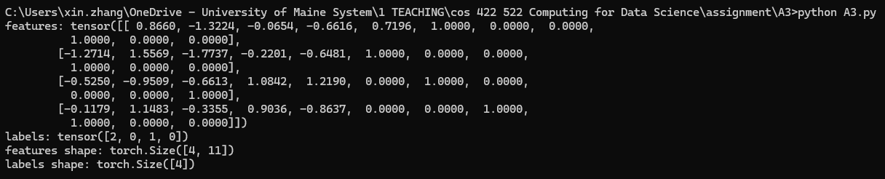

Requirement:
(1) You need to submit both your code file and screenshots showing the successful execution of your program.
(2) In your code, include clear comments explaining how you implemented the standardization, reproducible data splitting, and one-hot encoding.

