Guide to finding National Data Buoy Center Data (Abby’s version!)

This is a guide for anyone who needs data from National Data Buoy Center
- Specifically, I am gathering temp data from Orange Beach AL
- Shoutout Logan Turner for coming up with the R script!

- Go to this link: https://www.ndbc.noaa.gov/
- Click station list (or search the station ID if you know it)
- Pick site that is closest to sampling location and click on it
  - Data will therefore be based on the closest available buoy site
  - There is a section titled “Dauphin Island Sea Lab Stations” with many of the AL coast sites
  - 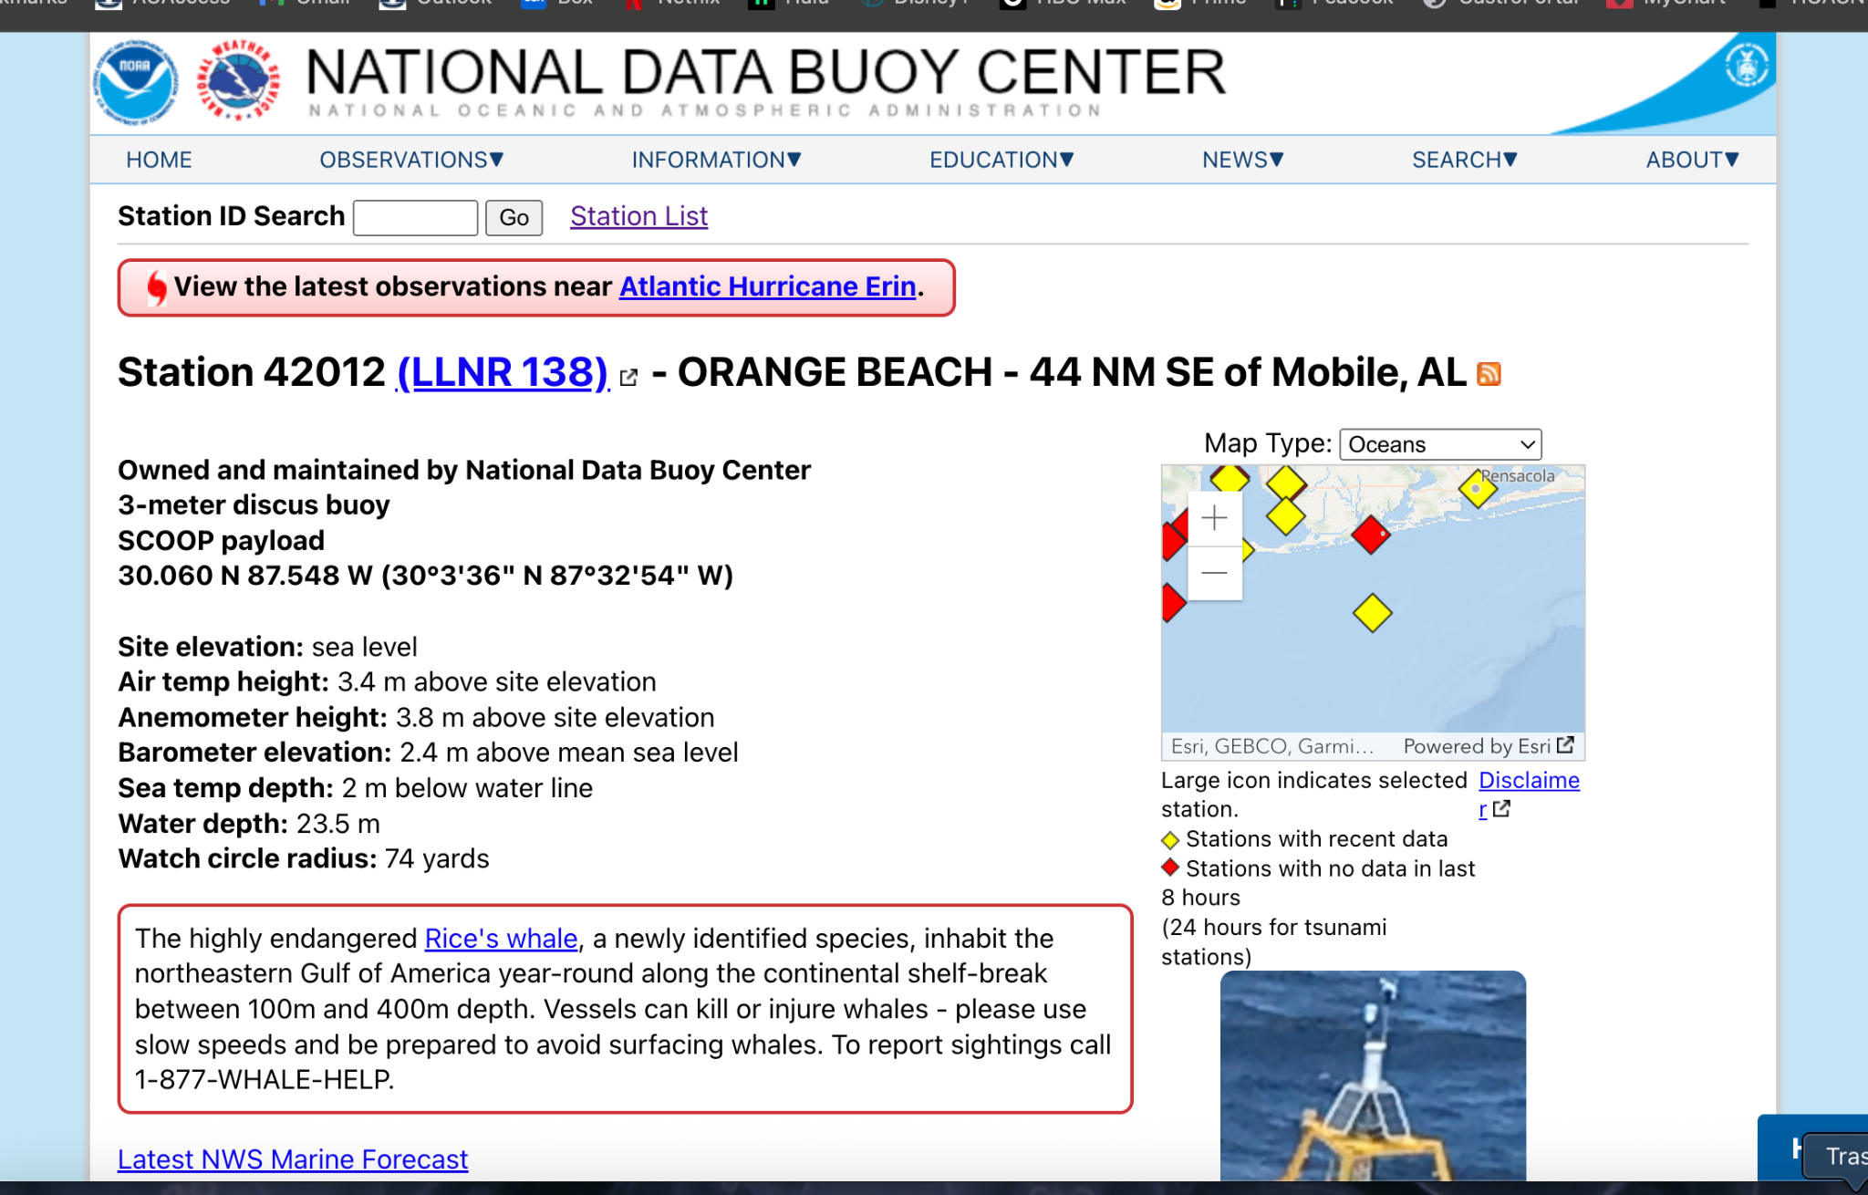
  - Page will look like the above
- Scroll down to the bottom, click “Historical Data and Climatic Summaries”
- Under Historical data bullet, there should be a standard meteorological data section with links to different years
  - I will be using 2021-2024 data but choose based on the available data
- Click on one of the years you are going to use
- I recommend Method 2! Open the linked .txt file in a new tab
  - This is now a web based platform containing all of that years data!
- Follow R code for each site and each year per site!
  - bouy_temp_data.R

Extra notes:
- If you see a 999 in the data, that is their version of NA
  - Make sure to remove the NAs from the dataset
- Make sure when using multiple years of data that the measuring time is the same - if not, may need to adjust code
- Surface water temp = column 15
- You can subset the data to get data per season - or find min and max and assume those temps came from winter and summer respectively
- Look over data to make sure there isnt anything weird!
  - Ex there were a lot of 999 in 2022 dataset BUT in this clump of 999 there was a reading that was an outlier that had to be removed

