1. **In your own words, specify the research question(s) (2 sentences or less). [2]**

Does risk taking behavior (Risk taking scores, sensation seeking scores) change when subjects are primed with a helmet compared to a baseball cap, both when the they don’t know about the helmet and when the equipment doesn’t help?

1. **What’s the design of the experiment? Include and explain IVs, DVs. If there is more than one experiment, please specify variables for each experiment. [4]**

The experiment was a between subjects design aimed at measuring risk taking behavior differences between cap and helmet conditions. The main independent variable was eye tracker mount type (cap vs helmet) and data was also collected about age and gender. The dependent variables were risk taking (measured by the Balloon Analogue Risk Task (BART) scores), anxiety (measured using the State-Trait Anxiety Inventory (STAI) Form Y-1), Sensation seeking scores (measured by Sensation- Seeking Scale Form V). The researchers also collected information about cycling frequency and helmet wearing frequency.

1. **What methods did you use to analyze the data? And why? (e.g. if ttest, specify type of t-test) [4]**

To analyze the risk taking (BART) scores, I computed means and standard deviations and then did a non-Welch independent t-test. I used an independent groups t-test because I am comparing means from two separate groups of individuals. In this case equal variance was assumed.

To analyze the sensation seeking scores, I first computed descriptive statistics (means and standard deviations) and then computed a Welch’s independent t test. I used Welch’s because there were not equal sample sizes or variance. I used an independent groups t-test because I am comparing means from two separate groups of individuals.

To see if gender had any effect on the risk taking (BART) scores, I computed descriptive statistics for each group and then did an independent groups t-test. I used an independent groups t-test because I am comparing means from two separate groups of individuals. In this case equal variance was assumed.

1. **Include your R script as a text file. (Optional: present plot or diagram as shown in paper if present) [10]**

Please find my script code here (Scroll to the bottom to see rendered markdown):

#load packages

library(tidyverse)

library(dplyr)

library(ggplot2)

#set wd -> didn't actually have to do this because I worked in a markdown

setwd("/Users/AbigailBergman/Desktop/Grad School/Winter Quarter 2019/Data Science/datascience_repo/week_01/hw_01")

#import data

bicycle <- read.csv("Bicycle.csv")

#Risk taking scores

helmet <- bicycle %>%

filter(Condition ==1)

hat <- bicycle %>%

filter(Condition == 2)

#overall descriptive stats

mean(bicycle$BART)

mean(bicycle$SSS_total)

#BART

mean(helmet$BART)

sd(helmet$BART)

mean(hat$BART)

sd(hat$BART)

#independent t test (not Welch's)

t.test(helmet$BART, hat$BART, var.equal = TRUE)

#SSS

mean(helmet$SSS_total)

sd(helmet$SSS_total)

mean(hat$SSS_total)

sd(hat$SSS_total)

#independent t test

t.test(helmet$SSS_total, hat$SSS_total)

#gender

male <- bicycle %>%

filter(Sex ==1)

female <- bicycle %>%

filter(Sex == 2)

mean(male$BART)

sd(male$BART)

mean(female$BART)

sd(female$BART)

#independent t test (not Welch's)

t.test(male$BART, female$BART, var.equal = TRUE)

#rename Condition

bicycle <- bicycle%>%

mutate(Condition = factor(Condition, levels=(c(1,2)), labels=(c("Helmet", "Cap"))))

#BART graphs (part a)

ggplot(hat, aes(BART)) +

geom_density(fill="green", alpha = .5)+

geom_rug() +

labs(title = "a", subtitle = "Cap", x = "BART score", y = "")+

geom_vline(aes(xintercept=mean(hat$BART)))+

geom_vline(aes(xintercept=35.6165), linetype ="dashed")+

ylim(c(0,.06))+xlim(c(-20,100))+

theme(panel.grid.major = element_blank(), panel.grid.minor = element_blank(),

panel.background = element_blank(), axis.line = element_line(colour = "black"),axis.text.y=element_blank(),

axis.ticks=element_blank(),

axis.title.y=element_blank())

ggplot(helmet, aes(BART)) +

geom_density(fill="green", alpha=.5)+

geom_rug()+

geom_vline(aes(xintercept=mean(helmet$BART)))+

labs(title = "a", subtitle = "Helmet", x = "Score", y = "")+

geom_vline(aes(xintercept=35.6165), linetype="dashed")+

ylim(c(0,.06))+xlim(c(-20,100))+

theme(panel.grid.major = element_blank(), panel.grid.minor = element_blank(),

panel.background = element_blank(), axis.line = element_line(colour = "black"),axis.text.y=element_blank(),

axis.ticks=element_blank(),

axis.title.y=element_blank())

#SSS graphs (part b)

ggplot(hat, aes(SSS_total)) +

geom_density(fill="green", alpha = .5)+

geom_rug() +

labs(title ="b", subtitle= "Cap", x = "SSS score", y = "")+

ylim(c(0,.1))+xlim(c(0,40))+

geom_vline(aes(xintercept=mean(hat$SSS_total)))+

geom_vline(aes(xintercept=20.95), linetype = "dashed")+

theme(panel.grid.major = element_blank(), panel.grid.minor = element_blank(),

panel.background = element_blank(), axis.line = element_line(colour = "black"),axis.text.y=element_blank(),

axis.ticks=element_blank(),

axis.title.y=element_blank())

ggplot(helmet, aes(SSS_total)) +

geom_density(fill="green", alpha=.5)+

geom_rug()+

labs(title ="b", subtitle = "Helmet", x = "SSS score", y = "") +

ylim(c(0,.1))+xlim(c(0,50))+

geom_vline(aes(xintercept=mean(helmet$SSS_total)))+

geom_vline(aes(xintercept=20.95), linetype="dashed")+

theme(panel.grid.major = element_blank(), panel.grid.minor = element_blank(),

panel.background = element_blank(), axis.line = element_line(colour = "black"),axis.text.y=element_blank(),

axis.ticks=element_blank(),

axis.title.y=element_blank())

Please find my rendered code below:

hw_01

Abby Bergman

1/8/2019

#load packages  
library(tidyverse)

## ── Attaching packages ─────────────────────────────────────────── tidyverse 1.2.1 ──

## ✔ ggplot2 3.1.0 ✔ purrr 0.2.5  
## ✔ tibble 1.4.2 ✔ dplyr 0.7.7  
## ✔ tidyr 0.8.2 ✔ stringr 1.3.1  
## ✔ readr 1.1.1 ✔ forcats 0.3.0

## ── Conflicts ────────────────────────────────────────────── tidyverse_conflicts() ──  
## ✖ dplyr::filter() masks stats::filter()  
## ✖ dplyr::lag() masks stats::lag()

library(dplyr)  
library(ggplot2)

#set wd -> didn't actually have to do this because I worked in a markdown  
setwd("/Users/AbigailBergman/Desktop/Grad School/Winter Quarter 2019/Data Science/datascience_repo/week_01/hw_01")  
  
#import data  
bicycle <- read.csv("Bicycle.csv")

#Risk taking scores  
helmet <- bicycle %>%  
 filter(Condition ==1)  
  
hat <- bicycle %>%  
 filter(Condition == 2)  
  
#overall descriptive stats  
mean(bicycle$BART)

## [1] 35.6165

mean(bicycle$SSS_total)

## [1] 20.95

#BART  
mean(helmet$BART)

## [1] 40.40308

sd(helmet$BART)

## [1] 18.17778

mean(hat$BART)

## [1] 31.06341

sd(hat$BART)

## [1] 13.29115

#independent t test (not Welch's)  
t.test(helmet$BART, hat$BART, var.equal = TRUE)

##   
## Two Sample t-test  
##   
## data: helmet$BART and hat$BART  
## t = 2.6326, df = 78, p-value = 0.01021  
## alternative hypothesis: true difference in means is not equal to 0  
## 95 percent confidence interval:  
## 2.276655 16.402669  
## sample estimates:  
## mean of x mean of y   
## 40.40308 31.06341

#SSS  
mean(helmet$SSS_total)

## [1] 23.23077

sd(helmet$SSS_total)

## [1] 6.997975

mean(hat$SSS_total)

## [1] 18.78049

sd(hat$SSS_total)

## [1] 5.086807

#independent t test  
t.test(helmet$SSS_total, hat$SSS_total)

##   
## Welch Two Sample t-test  
##   
## data: helmet$SSS_total and hat$SSS_total  
## t = 3.2399, df = 69.192, p-value = 0.001839  
## alternative hypothesis: true difference in means is not equal to 0  
## 95 percent confidence interval:  
## 1.710146 7.190416  
## sample estimates:  
## mean of x mean of y   
## 23.23077 18.78049

#gender  
male <- bicycle %>%  
 filter(Sex ==1)  
  
female <- bicycle %>%  
 filter(Sex == 2)  
  
mean(male$BART)

## [1] 34.65882

sd(male$BART)

## [1] 15.0565

mean(female$BART)

## [1] 36.32435

sd(female$BART)

## [1] 17.53145

#independent t test (not Welch's)  
t.test(male$BART, female$BART, var.equal = TRUE)

##   
## Two Sample t-test  
##   
## data: male$BART and female$BART  
## t = -0.44551, df = 78, p-value = 0.6572  
## alternative hypothesis: true difference in means is not equal to 0  
## 95 percent confidence interval:  
## -9.108180 5.777132  
## sample estimates:  
## mean of x mean of y   
## 34.65882 36.32435

#rename Condition  
bicycle <- bicycle%>%  
 mutate(Condition = factor(Condition, levels=(c(1,2)), labels=(c("Helmet", "Cap"))))

#Plot a  
#ggplot(bicycle, aes(BART))+  
 #facet_grid(Condition~.)+  
 #geom_density(fill="green", alpha = .5)+  
 #geom_rug() +  
 #labs(title = "BART scores for Helmet vs Cap", x = "BART score", y = "")+  
 #geom_vline(aes(xintercept=mean(BART)), linetype = "dashed")+  
 #ylim(c(0,.03))+xlim(c(-10,90))+  
 #theme(panel.grid.major = element_blank(), panel.grid.minor = element_blank(),  
#panel.background = element_blank(), axis.line = element_line(colour = "black"),axis.text.y=element_blank(),  
 #axis.ticks=element_blank(),  
 #axis.title.y=element_blank())  
  
ggplot(hat, aes(BART)) +  
 geom_density(fill="green", alpha = .5)+  
 geom_rug() +  
 labs(title = "a", subtitle = "Cap", x = "BART score", y = "")+  
 geom_vline(aes(xintercept=mean(hat$BART)))+  
 geom_vline(aes(xintercept=35.6165), linetype ="dashed")+  
 ylim(c(0,.06))+xlim(c(-20,100))+  
 theme(panel.grid.major = element_blank(), panel.grid.minor = element_blank(),  
panel.background = element_blank(), axis.line = element_line(colour = "black"),axis.text.y=element_blank(),  
 axis.ticks=element_blank(),  
 axis.title.y=element_blank())

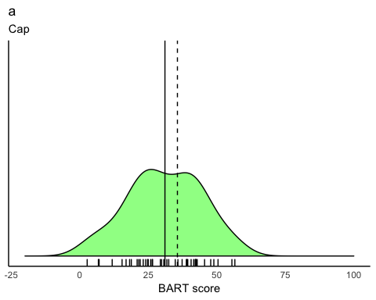

ggplot(helmet, aes(BART)) +  
 geom_density(fill="green", alpha=.5)+  
 geom_rug()+  
 geom_vline(aes(xintercept=mean(helmet$BART)))+  
 labs(title = "a", subtitle = "Helmet", x = "Score", y = "")+  
 geom_vline(aes(xintercept=35.6165), linetype="dashed")+  
 ylim(c(0,.06))+xlim(c(-20,100))+  
 theme(panel.grid.major = element_blank(), panel.grid.minor = element_blank(),  
panel.background = element_blank(), axis.line = element_line(colour = "black"),axis.text.y=element_blank(),  
 axis.ticks=element_blank(),  
 axis.title.y=element_blank())

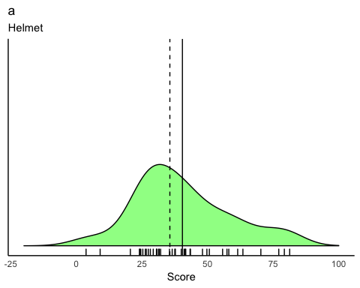

#plot b  
#ggplot(bicycle, aes(SSS_total))+  
 # facet_grid(Condition~.)+  
 # geom_density(fill="green", alpha = .5)+  
 # geom_rug() +  
 # labs(title = "SSS scores for Helmet vs Cap", x = "SSS score", y = "")+  
 # ylim(c(0,.08))+xlim(c(0,40))+  
 # geom_vline(aes(xintercept=mean(SSS_total)), linetype = "dashed")+  
 # theme(panel.grid.major = element_blank(), panel.grid.minor = element_blank(),  
#panel.background = element_blank(), axis.line = element_line(colour = "black"),axis.text.y=element_blank(),  
 # axis.ticks=element_blank(),  
 # axis.title.y=element_blank())  
  
ggplot(hat, aes(SSS_total)) +  
 geom_density(fill="green", alpha = .5)+  
 geom_rug() +  
 labs(title ="b", subtitle= "Cap", x = "SSS score", y = "")+  
 ylim(c(0,.1))+xlim(c(0,40))+  
 geom_vline(aes(xintercept=mean(hat$SSS_total)))+  
 geom_vline(aes(xintercept=20.95), linetype = "dashed")+  
 theme(panel.grid.major = element_blank(), panel.grid.minor = element_blank(),  
panel.background = element_blank(), axis.line = element_line(colour = "black"),axis.text.y=element_blank(),  
 axis.ticks=element_blank(),  
 axis.title.y=element_blank())

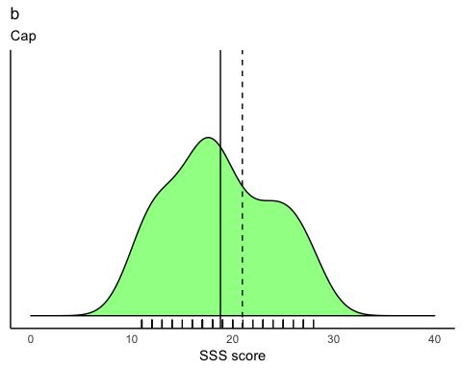

ggplot(helmet, aes(SSS_total)) +  
 geom_density(fill="green", alpha=.5)+  
 geom_rug()+  
 labs(title ="b", subtitle = "Helmet", x = "SSS score", y = "") +  
 ylim(c(0,.1))+xlim(c(0,50))+  
 geom_vline(aes(xintercept=mean(helmet$SSS_total)))+  
 geom_vline(aes(xintercept=20.95), linetype="dashed")+  
 theme(panel.grid.major = element_blank(), panel.grid.minor = element_blank(),  
panel.background = element_blank(), axis.line = element_line(colour = "black"),axis.text.y=element_blank(),  
 axis.ticks=element_blank(),  
 axis.title.y=element_blank())

