hw_02

Abby Bergman

1/15/2019

#libraries  
library(tidyverse)

## ── Attaching packages ───────────────────────────────────────────────────────── tidyverse 1.2.1 ──

## ✔ ggplot2 3.1.0 ✔ purrr 0.2.5  
## ✔ tibble 1.4.2 ✔ dplyr 0.7.7  
## ✔ tidyr 0.8.2 ✔ stringr 1.3.1  
## ✔ readr 1.1.1 ✔ forcats 0.3.0

## ── Conflicts ──────────────────────────────────────────────────────────── tidyverse_conflicts() ──  
## ✖ dplyr::filter() masks stats::filter()  
## ✖ dplyr::lag() masks stats::lag()

library(ggplot2)  
library(tidyr)  
library(dplyr)  
library(lubridate)

##   
## Attaching package: 'lubridate'

## The following object is masked from 'package:base':  
##   
## date

library(effsize)  
library(powerAnalysis)

study_02 <- read.csv("Study2.csv")  
study_01 <- read.csv("Study1.csv")  
  
study_01$date = paste('2015', study_01$month, study_01$date)  
  
study_01$date = as.Date(study_01$date, format = '%Y %B %d')  
  
outbreakDate = as.Date('2015 September 30', format = '%Y %B %d')

#change state senate race to string  
study_02$StateSenateRace = as.character(study_02$StateSenateRace)  
  
#exclude outliers  
exclude = c("Hawaii", "Rhode Island")  
study_02 = study_02[!(study_02$StateSenateRace %in% exclude),]

#Reproduce all 4 plots on page 599 using ggplot2  
#vector of days  
#day <- mday(study_01$date)  
  
sept <- study_01 %>%  
 filter(month == "September") %>%  
 mutate()  
oct <- study_01 %>%  
 filter(month == "October")  
  
sep24 = as.Date('2015-09-24', format = '%Y-%m-%d')  
sep30 = as.Date('2015-09-30', format = '%Y-%m-%d')  
  
sepweek <- sept %>%  
 filter(date >= '2015-09-24' & date <= '2015-09-30')  
  
oct1 = as.Date('2015-10-01', format = '%Y-%m-%d')  
oct7 = as.Date('2015-10-07', format = '%Y-%m-%d')  
  
octweek <- oct%>%  
 filter(date >='2015-10-01' & date<='2015-10-07')

#Reproduce all 4 plots on page 599 using ggplot2 (do not worry about axes units accuracy or title of plot)  
  
ggplot(data = sept, aes(x = date, y = VoterIntentionIndex))+  
 geom_point() +  
 labs(title = "a",   
 subtitle = "September",  
 y = "Voter-Intention-Index Score",   
 x = "Day") +  
 geom_smooth(method = lm, aes(color="red"), se=F)+  
 scale_y_continuous(breaks = c(-1,-.5,0,.5,1,1.5,2,2.5,3))+  
 theme(panel.grid.major = element_blank(), panel.grid.minor = element_blank(),  
panel.background = element_blank(), axis.line = element_line(colour = "black"),  
legend.position="none"  
 )

## Warning: Removed 21 rows containing non-finite values (stat_smooth).

## Warning: Removed 21 rows containing missing values (geom_point).

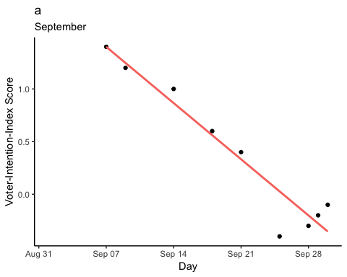

ggplot(data = oct, aes(x = date, y = VoterIntentionIndex))+  
 geom_point() +  
 labs(title = "a",   
 subtitle = "October",  
 y = "Voter-Intention-Index Score",   
 x = "Day") +  
 geom_smooth(method = lm, aes(color="red"), se=F)+  
 scale_y_continuous(breaks = c(-1,-.5,0,.5,1,1.5,2,2.5,3))+  
 theme(panel.grid.major = element_blank(), panel.grid.minor = element_blank(),  
panel.background = element_blank(), axis.line = element_line(colour = "black"),  
legend.position="none"  
 )

## Warning: Removed 17 rows containing non-finite values (stat_smooth).

## Warning: Removed 17 rows containing missing values (geom_point).

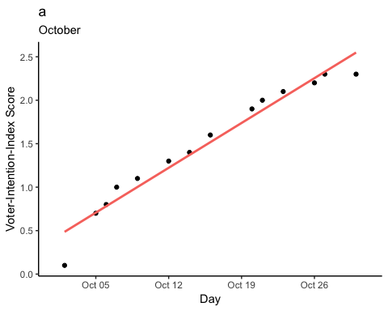

ggplot(data=sepweek, aes(x=date, y = VoterIntentionIndex))+  
 geom_jitter()+  
 geom_smooth(method = lm, aes(color = "red"), se=F)+  
 theme(panel.grid.major = element_blank(), panel.grid.minor = element_blank(),  
panel.background = element_blank(), axis.line = element_line(colour = "black"),  
legend.position="none"  
 )+  
 labs(title = "b", subtitle = "September")

## Warning: Removed 3 rows containing non-finite values (stat_smooth).

## Warning: Removed 3 rows containing missing values (geom_point).

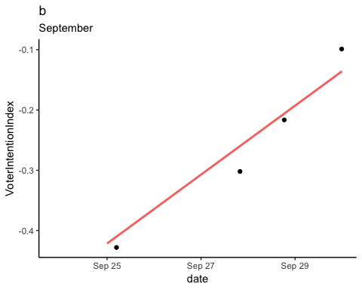

ggplot(data=octweek, aes(x=date, y = VoterIntentionIndex))+  
 geom_jitter()+  
 geom_smooth(method = lm, aes(color = "red"), se=F)+  
 theme(panel.grid.major = element_blank(), panel.grid.minor = element_blank(),  
panel.background = element_blank(), axis.line = element_line(colour = "black"),   
 legend.position="none")+  
 labs(title = "b", subtitle = "October")

## Warning: Removed 3 rows containing non-finite values (stat_smooth).  
  
## Warning: Removed 3 rows containing missing values (geom_point).

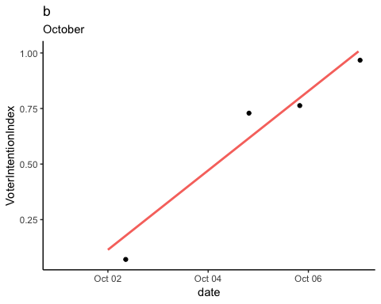

#Mean voter-intention difference score t test (bonus 1 pt for producing code for cohen d)  
  
t.test(study_02$StateSpecificVoterIntentionIndexDifferenceScore, mu = 0)

##   
## One Sample t-test  
##   
## data: study_02$StateSpecificVoterIntentionIndexDifferenceScore  
## t = 2.3365, df = 31, p-value = 0.0261  
## alternative hypothesis: true mean is not equal to 0  
## 95 percent confidence interval:  
## 0.1294591 1.9074159  
## sample estimates:  
## mean of x   
## 1.018438

#(d = cohen.d(), pooled = TRUE, na.rm = TRUE))

#State-specific voter-intention difference score between Republican vs. Democrat candidate (bonus 1 pt for producing code for cohen d)   
study_02$rep <- study_02$PollingDifferenceInFinalPollInSeptember > 0  
  
study_02$dem <- study_02$PollingDifferenceInFinalPollInSeptember < 0  
  
t.test(study_02$StateSpecificVoterIntentionIndexDifferenceScore[study_02$rep],  
 study_02$StateSpecificVoterIntentionIndexDifferenceScore[study_02$dem], var.equal = TRUE)

##   
## Two Sample t-test  
##   
## data: study_02$StateSpecificVoterIntentionIndexDifferenceScore[study_02$rep] and study_02$StateSpecificVoterIntentionIndexDifferenceScore[study_02$dem]  
## t = 2.427, df = 30, p-value = 0.02144  
## alternative hypothesis: true difference in means is not equal to 0  
## 95 percent confidence interval:  
## 0.3281352 3.8118648  
## sample estimates:  
## mean of x mean of y   
## 1.73 -0.34

cohen.d(study_02$StateSpecificVoterIntentionIndexDifferenceScore[study_02$rep],  
 study_02$StateSpecificVoterIntentionIndexDifferenceScore[study_02$dem], pooled = TRUE, na.rm = T)

##   
## Cohen's d  
##   
## d estimate: 0.9033137 (large)  
## 95 percent confidence interval:  
## lower upper   
## 0.1089832 1.6976441

#filtering by PVI (last paragraph)  
republican <- study_02 %>%  
 filter(PVI >= 0, PVI != 0)  
  
democrat <- study_02 %>%  
 filter(PVI <= 0, PVI != 0)  
  
t.test(republican$StateSpecificVoterIntentionIndexDifferenceScore,   
 democrat$StateSpecificVoterIntentionIndexDifferenceScore,   
 var.equal = TRUE)

##   
## Two Sample t-test  
##   
## data: republican$StateSpecificVoterIntentionIndexDifferenceScore and democrat$StateSpecificVoterIntentionIndexDifferenceScore  
## t = 3.0873, df = 29, p-value = 0.004418  
## alternative hypothesis: true difference in means is not equal to 0  
## 95 percent confidence interval:  
## 0.8195817 4.0367341  
## sample estimates:  
## mean of x mean of y   
## 1.843158 -0.585000

#Regression: difference score, PVI score, polling difference (do not worry about beta values, but your R2, p values should still match the article results).  
  
#y = StateSpecificVoterIntentionIndexDifferenceScore  
#x = PVI + PollingDifferenceInFinalPollInSeptember  
  
fitpoll = lm(StateSpecificVoterIntentionIndexDifferenceScore ~ PVI + PollingDifferenceInFinalPollInSeptember , data = study_02)  
fitpoll

##   
## Call:  
## lm(formula = StateSpecificVoterIntentionIndexDifferenceScore ~   
## PVI + PollingDifferenceInFinalPollInSeptember, data = study_02)  
##   
## Coefficients:  
## (Intercept)   
## 0.338251   
## PVI   
## 0.138099   
## PollingDifferenceInFinalPollInSeptember   
## -0.008727

summary(fitpoll)

##   
## Call:  
## lm(formula = StateSpecificVoterIntentionIndexDifferenceScore ~   
## PVI + PollingDifferenceInFinalPollInSeptember, data = study_02)  
##   
## Residuals:  
## Min 1Q Median 3Q Max   
## -4.6622 -1.5346 0.2057 1.5409 4.1313   
##   
## Coefficients:  
## Estimate Std. Error t value  
## (Intercept) 0.338251 0.469067 0.721  
## PVI 0.138099 0.075527 1.828  
## PollingDifferenceInFinalPollInSeptember -0.008727 0.038861 -0.225  
## Pr(>|t|)   
## (Intercept) 0.4766   
## PVI 0.0778 .  
## PollingDifferenceInFinalPollInSeptember 0.8239   
## ---  
## Signif. codes: 0 '***' 0.001 '**' 0.01 '*' 0.05 '.' 0.1 ' ' 1  
##   
## Residual standard error: 2.262 on 29 degrees of freedom  
## (2 observations deleted due to missingness)  
## Multiple R-squared: 0.2126, Adjusted R-squared: 0.1583   
## F-statistic: 3.914 on 2 and 29 DF, p-value: 0.03127

confint(fitpoll)

## 2.5 % 97.5 %  
## (Intercept) -0.62109977 1.29760114  
## PVI -0.01637161 0.29256975  
## PollingDifferenceInFinalPollInSeptember -0.08820671 0.07075338

```