To prove that highly efficient filters do not negatively impact the heating and cooling system performance, the energy consumption was measured while different types of filters were tested. The energy consumption of the HVAC system will increase if the system is under stress. Three different types of filters were tested: fiberglass, 3M MERV 8, and 3M MPR 1900. The 3M filters were tested both clean and dirty to show that even when these filters are at end of life, the system will still not undergo any additional stress. Each of these five filter types had one replicate for a total of ten unique samples in this study. The system was ran in a simulated heating season, with an outdoor temperature of 40.0°F, and in a cooling season, with an outdoor temperature of 95.0°F. The same filters were used in the system during the heating and the cooling simulations.

Due to the automation of the test design, filters were tested for various amounts of time. For this analysis, we choose to analysis only the first two hours of use.

Figure 1:

The average pressure drop of each filter was calculated for when the pressure drop value was not zero. This corresponds to when the systems fan was running.

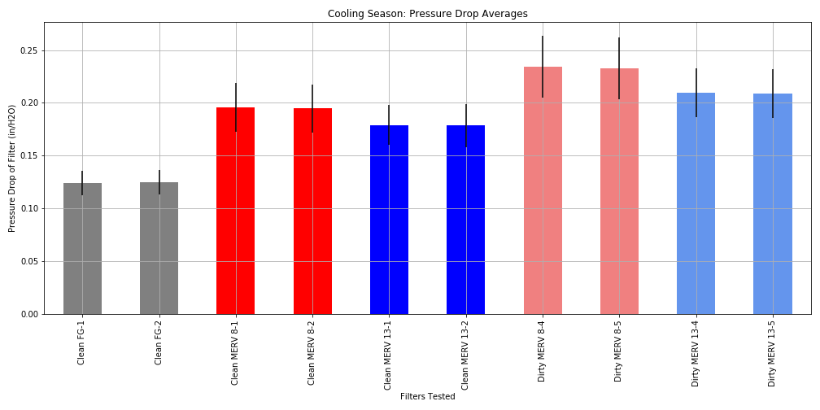

The fan power and the compressor power were measured separately and then combined to calculate the total HVAC power.

Figure :

Similarly to the power, the energy of the compressor and the fan were measured separately, then combined to get the total HVAC energy. The total energy was calculated by summing over the first two hours of run time to get the total power consumption for each filter tested.

Table 1:



