k

Failure Analysis Report

For

Champlain Towers South

(Surfside Condo Collapse)

Prepared By:

Abigail Paulus

Context

On June 24, 2021, the Champlain Towers South Condominium Complex collapsed killing 98 people. This made it the third deadliest building engineering failure in the United States, tied with the Knickerbocker Theater. Due to faulty designs, lackadaisical construction, and several failed attempts to mend what was found flawed by inspectors in 2018, the condos collapse was inevitable. Now, in 2023, with several investigations still ongoing, definite conclusions to the cause of the collapse are still being explored with preliminary findings of the building’s pool deck failure, being stated by Glenn Bell of National Institute of Standards and Technology (NIST) in what him and his team are calling a ‘leading failure hypothesis’(Allen).

What was the Failure?

Originally, a theory that circulated was that the buildings collapse was due to land subsidence, stating how the area where it was build showed these signs in the 1990s; this was soon after disproven by the author of the original study stating that ‘land subsidence in and of itself likely would not cause a building’s collapse’ (Tejedor). In a scientific report compiled by students, part of an Oceana and Costal Management journal, the study uses InSar satellites that ‘provide the long wavelength (>50km) characterization of coastal subsidence, but are limited in detecting shorter wavelength subsidence,’ which would be caused by sediment compaction (Fiaschi and Wdowinski). Recordings show that in Miami, ‘subsidence is limited to several small areas…built on reclaimed wetlands’ and ‘[Miami’s] record indicates no measurable subsidence’ only occurring ‘locally and at very low rates.’ This, comparatively, is ‘significantly slower’ to a place like Mexico City, ‘subsiding at a rate of 15 inches per year,’ which would not give probable cause towards the collapse (Tejedor).

Early investigations post-collapse examined video footage on the underground parking garage, where it was shown minutes before the collapse how water was pouring from above. This water seeped throughout the building onto the porous, concrete pillars, leaking into the concrete. Areas where concrete slabs were poured around the pillars also didn’t provide the support that was needed when the concrete would cure (Glanz, Singhvi and Baker). These failures of the construction, in combination with the lack of maintenance led to several compromised portions of the building. This, along with the construction of the Eighty Seven Park Condo next door, could have triggered the collapse. Engineers are also still looking into possible other triggers, like a crash in the parking garage, that might have damaged the structural integrity leading the Surfside Condo to its breaking point.

Fig 1

Water damage on parking garage ceiling

The Reason it Failed

An inspection conducted by Morabito Consultants, led by Frank Morabito, detailed issues that arose as far back as 2018, reviewing ‘the existing 12 story plus penthouse 135-unit residential building, below-grade parking garage and at-grade exterior entrance drive, pool and recreation area.’ The report describes: cracks in the concrete balconies and deterioration, cracks in the stucco exterior, several cracks in walls and pavers surrounding the pool deck, water drainage issues, cracking and spalling of concrete columns, and water damage in the parking garage roof. It was detailed by Morabito Consultants that these problems originally were not serious enough to cause a complete shutdown but needed to be repaired in a timely manner. (F. Morabito). This wasn’t the case and water damage was starting to destroy the buildings integrity. Water damage was commonly found, especially on the pool deck, and reported by the residents. Water would leak down into the concrete, ruining the integrity of the steel inside. Problems with steel was also found several times during post-inspections. The columns on the west side, which was the side that didn’t collapse, had thicker columns withstanding the initial collapse, apart from what was done for the east side. Thinner columns included excessive steel reinforcement, which violated codes to give the concrete enough space to give the strength. Columns were also found with inadequate amounts of steel. Original plans for the ground-level deck called for ‘steel rods to be buried three-quarters of an inch below the surface of the structural slab,’ but the concrete pour was too shallow, and another pour could have caused delamination.

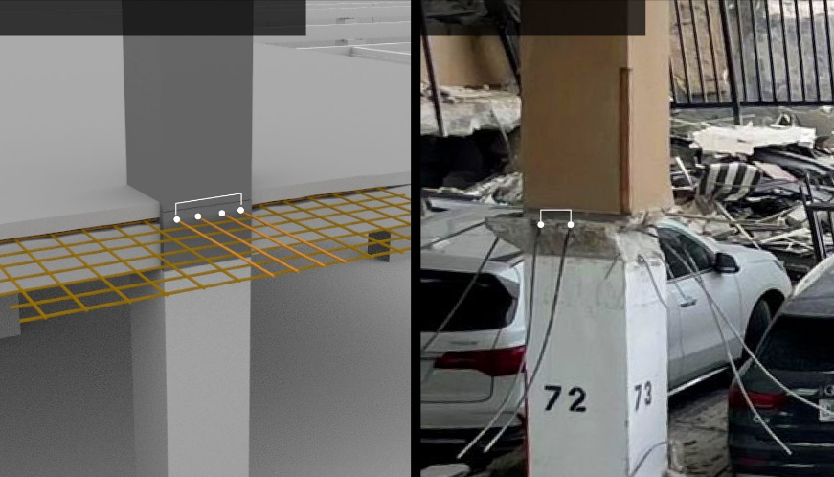

Fig 2

Spalling on a parking garage columnFig 3

Under supported columns without enough steel Fig 4

Exposed Rebar on the Balconies

Who was at Fault and Why?

During the construction of the building, workers failed to adhere to the plans made that would ensure the building was up to code. The overuse of rebar in the vertical columns and the underuse of rebar in the floor slabs are errors that became integral to support of the building. Simple mistakes, like using exposed rebar to support the balconies, were common throughout the inspections pre and post collapse. Blame would most likely be placed on construction workers.

In a class-action lawsuit, victims of the collapse believe that ‘architects Stantec, engineers Florida Civil and a drilling vibration monitoring firm called Geosonics acted negligently during construction of [Eighty Seven Park].’ This aligns with some engineers and investigators reasoning of the buildings collapse being partially due to the construction of the building next door. Levels of vibration from the construction was above the safe threshold standards, set by the Federal Transit Administration to prevent damage to concrete (Nehamas). This was then settled for nearly $1 billion in May of 2022 (Associated Press).

The Lack of Competence Leading to the Failure

Throughout the 70s into the 80s, Florida was a staple for new developments along with the implementation of AC. Many high rises and condos were built during this time and along with it came regulations enacted by Miami-Dade County. Although Florida has some of the strictest among the states, to counteract hurricanes, flooding, and rain, since the collapse of the Surfside Condos it has been revealed that regulations were unevenly enforced by local authorities or not enforced at all. ‘Fourteen structures were supposed to submit 40-year inspection reports in 2020,’ and ‘Six of those never responded to notices,’ where if they failed to submit reports, they would be fined. This wasn’t the case as the city failed to recognize these findings until after the collapse. Patterns of misconduct can go back to when the Champlain towers were first constructed. During the 80s and 90s, there were several cases that documented careless work, mostly found in inspections of single-family homes and bribes from building developers to building officials. This all has contributed to the blunders that led to the misfortune of the collapse (Gamio, Playford and LaForgia).

From the reports in 2018, the damage that was being found, like the ‘Hairline cracks in the pool deck. Newly painted walls that chipped easily. Water pooling in the garage,’ were paid through monthly maintenance fees that were only growing as more problems started to arise. The condo board concluded that all of the repairs would be estimated to cost $15 million, in which residents would need to pay between $80,000 to $200,000 each to fix. The condo board, which consist of people with no experience in engineering fields, finance, or property management, are volunteers who are elected into their position. These people with no experience would be expected to be the ones who get to make executive decisions for the entirety of the condo. Ross Prieto, who was the chief building official of the Town of Surfside, was a city inspector who reassured residents that the condo was in good condition in November of 2018 after the inspection conducted by Frank P. Morabito. Against engineers concerns of the buildings structural shape, Prieto, invited to a meeting, said ‘the building is in very good shape.’ While trying to get repairs for the 40-year recertification project done, both the board president and vice president resigned as they said, ‘they were frustrated by last-minute objections that kept derailing progress on repairs.’ These large financial hurdles would eventually delay the process for several years, with ongoing protest from residents that would note the damage they’ve observed, that would now never occur (Mazzei, de Freytas-Tamura and Bogel-Burroughs).

Possible Corrective Actions

The Florida House in February of 2022 passed a bill that would ‘require statewide recertification of any condo building above three stories high,’ requiring ‘recertification after 30 years, or 25 years if the building is within 3 miles (5 kilometers) of the coast, and every 10 years thereafter.’ Compared to the 40 year recertification process, this new bill is more restrictive, attempting to prevent potential trageties. The bill would also require that ‘condominium associations have sufficient reserves to pay for major repairs and conduct a study of the reserves every decade,’ and ‘provide inspection reports to owners, and if structural repairs are needed, work must begin within a year of the report (Associated Press). These laws both should help reduce the amount of condo failures and prevent corruption that occurs when recertifying.

Conclusion

Several ill-advised decisions, from poor construction to failing to comply with standards, led to the collapse of the Surfside Condo. If complaints of failures were swiftly repaired, proper enforcement of local regulations were occurring, and the building was properly constructed with proper amounts of rebar and concrete pours in the first place, this engineering disaster could have been prevented and lives wouldn’t have been lost. Although it will take several years for any conclusive reports on the condos collapse, several initiatives to improve safety standards have been approved. Effects would lead to several new government regulations leading to stricter recertifications and stronger enforcement of those who failed.

References

Singhvi, Anjali, et al. The Surfside Condo Was Flawed and Failing. Here’s a Look Inside. Sept 1 ,2021. <https://www.nytimes.com/interactive/2021/09/01/us/miami-building-collapse.html>.

Morabito, Frank P. "MINIMUM INSPECTION PROCEDURAL GUIDELINES FOR BUILDING’S STRUCTURAL RECERTIFICATION." Inspection. 2018. <https://www.townofsurfsidefl.gov/docs/default-source/default-document-library/town-clerk-documents/champlain-towers-south-public-records/8777-collins-ave---unverified-inspection-report.pdf?sfvrsn=8c2a1194_2>.

Morabito Consultants. "Champlain Towers South Condominium Structural Field Survey Report." 2018 <https://www.townofsurfsidefl.gov/docs/default-source/default-document-library/town-clerk-documents/champlain-towers-south-public-records/8777-collins-ave---structural-field-survey-report.pdf>.

Morabito, Frank. "Email Related 2018 Structural Field Survey Report." 2018 <https://www.townofsurfsidefl.gov/docs/default-source/default-document-library/town-clerk-documents/champlain-towers-south-public-records/email-records/email-related-2018-structural-field-survey-report.pdf?sfvrsn=aa311194_2>.

Tejedor, Chrystian. "FIU professor: Collapsed Surfside building showed signs of subsidence in ‘90s." (n.d.). <https://news.fiu.edu/2021/fiu-professor-collapsed-surfside-building-showed-signs-of-subsidence-in-90s-era-space-radar-data>.

Fiaschi, Simone and Shimon Wdowinski. "Local land subsidence in Miami Beach (FL) and Norfolk (VA) and its contribution to flooding hazard in coastal communities along the U.S. Atlantic coast." September 26, 2019 <https://faculty.fiu.edu/~swdowins/publications/Fiaschi-Wdowinski-OCM-2020.pdf>.

Lu, Xinzheng, et al. "A preliminary analysis and discussion of the condominium building collapse in surfside, Florida, US, June 24, 2021." June 24, 2021 <https://link.springer.com/article/10.1007/s11709-021-0766-0>.

Blanchard, Ryan L. "An Investigation and Analysis of the 2021 Surfside Condo Collapse." 2022. <https://scholarworks.uno.edu/cgi/viewcontent.cgi?article=4245&context=td>.

Mazzei, Patricia, et al. "Inside the Tumultuous Years Before the Florida Condo Collapse." July 3, 2021 <https://www.nytimes.com/2021/07/03/us/miami-florida-surfside-collapse.html>.

Gamio, Lazaro, Adam Playford and Michael LaForgia. "Lax Enforcement Let South Florida Towers Skirt Inspections for Years." July 4,2021 <https://www.nytimes.com/2021/07/04/us/south-florida-condo-maintenance-violations.html >.

Glanz, James, Anjali Singhvi and Mike Baker. "Possible Failure Point Emerges in Miami-Area Building Collapse." June 27, 2021 <https://www.nytimes.com/2021/06/27/us/miami-building-investigation-clues.html>.

Allen, Greg. “A Florida condo tower's collapse may have begun on its pool deck.” <https://www.npr.org/2023/06/15/1182502745/surfside-florida-condominium-collapse-investigation>.

Nehamas, Nicholas. “Surfside collapse victims sue Eighty Seven Park condo association and construction firms.” March 8, 2022 <https://www.miamiherald.com/news/special-reports/surfside-investigation/article259163263.html#storylink=cpy>.

Associated Press. “A nearly $1 billion settlement is reached in a Surfside condo collapse lawsuit” May 11, 2022< https://www.npr.org/2022/05/11/1098429031/nearly-1-billion-settlement-surfside-condo-collapse-lawsuit >.