STAT 345 Midterm Project

Abby Schmidt

# Minnesota Timberwolves Shot Analysis

## Brief Report

* Function created that generates a single team shot chart for any given season.
* Charts over the past 20 years are displayed but charts can be generated for seasons dating back to 1997.
* Shot locations have changed significantly over time:
  + Shots taken beyond the 3pt arc increased
  + Mid-range shots taken decreased
  + Currently, the majority of shots taken occur in the paint or beyond the arc.
* Majority of made shots also occur in the paint or beyond the arc.
* Suggested that these two areas remain the main shooting hot spots for optimal success.

## Minnesota Timberwolves 2020-21 shot data

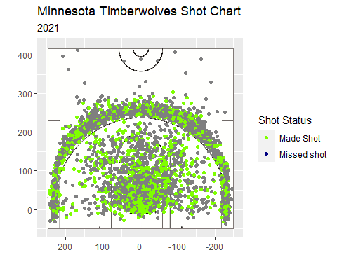

## Minnesota Timberwolves 2017-18 shot data

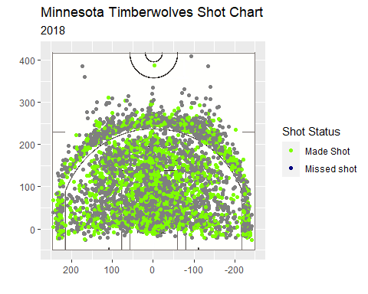

## Minnesota Timberwolves 2014-15 shot data

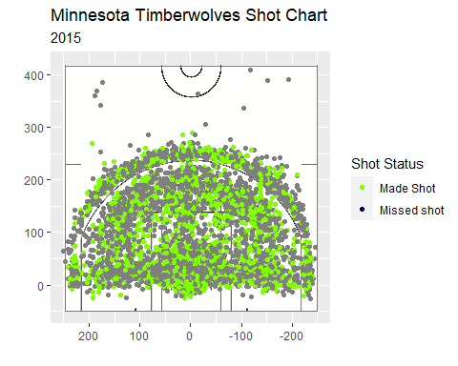

## Minnesota Timberwolves 2011-12 shot data

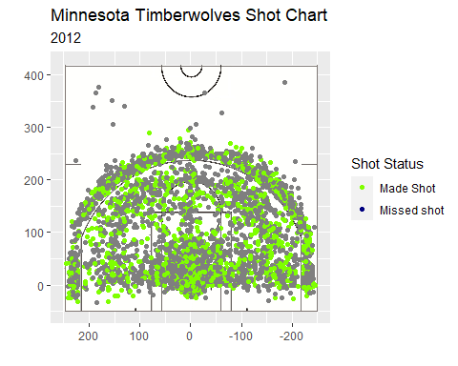

## Minnesota Timberwolves 2008-09 shot data

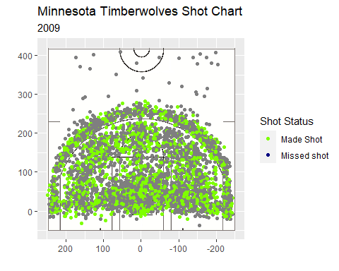

## Minnesota Timberwolves 2005-06 shot data

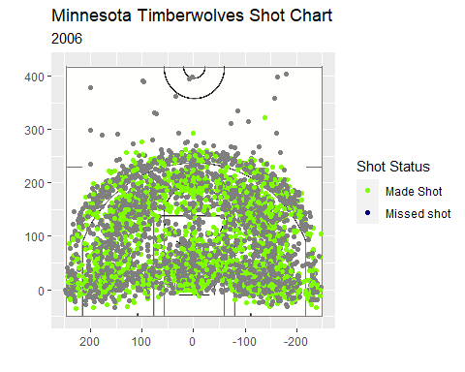

## Minnesota Timberwolves 2002-03 shot data

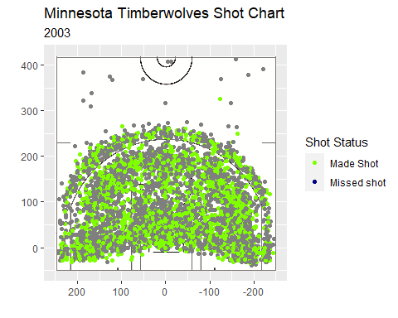

## Detailed Report

All shot data was generated using the ‘nbastatR’ Github package. Functions from the ‘grid’ and ‘jpeg’ packages were used to read in an NBA half-court image and scale it appropriately in order to be overlaid on the generated plots. A function (‘shot.chart’) was then created to generate a shot chart for any season from 1997 to 2021. This function takes the input of year and uses it to extract the shot data for that particular season. It then extracts only the columns needed to generate a shot chart: “typeEvent” (miss/made), “locationX”, and “locationY”. The package ‘ggplot2’ takes in this data to create a shot chart where individual shots are plotted using the location data (inches) on top of the half-court image. The x and y axis limits were set to mimic the dimensions of an NBA half-court (inches). Shots were depicted as made or missed using the teams colors of neon green and dark blue for analytical purposes.

The ‘shot.chart’ function was used to generate shot charts for the past 20 years in order to analyze the Timberwolves shot patterns overtime. It was found that shot locations changed dramatically from 2001 to 2021. For example, first glance shows that mid range shots taken has steadily decreased over the years as 3pt shots became more popular. The generated shot charts depict that the large majority of the team’s shots are taken beyond the arc or within the lane with undetectable changes in the concentrations of made/missed shots. Therefore, they should continue to make these regions their shooting hot spots for optimal success.

## Above and Beyond

More aspects of the shot data were explored in order to conduct a more thorough analysis. I decided against exploring a different data set because there were too many stories to be told given the shot data. Therefore, I created three additional functions that each explore a different aspect of the shot data in order to gain a better understanding of they Timberwolves shot tendencies.

The first function (‘shot.chart.region’) generates a team shot chart for any given season, using color to highlight the seven shot regions and shape to distinguish between made and missed shots. This function is fundamentally the same as ‘shot.chart’ but uses the additional column “zoneBasic” in order to display the different shot regions. This function allows for regional shot tendencies to be examined in order to conclude the team’s most accurate places to take shots, ultimately determining regions to focus on and regions that need improvement.

## Minnesota Timberwolves 2017-18 shot data

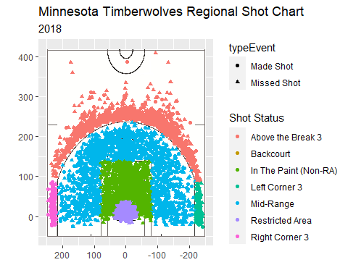

The second function (‘shot.chart.clutch’) generates a team shot chart of all shots taken within the last minute of a quarter for any given season. This function also uses color to highlight the seven shooting regions and shape to distinguish between made and missed shots. This function is a modified version of the ‘shot.chart.region’ function that additionally filters shots based on “minutesRemaining”. It allows for ‘clutch’ shots to be examined in order to determine which regions are optimal shot locations when time is running out, resulting in winning more close games.

## Minnesota Timberwolves 2017-18 shot data

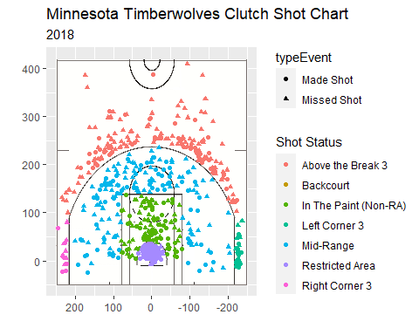

The third function (‘shot.chart.clutch.player’) generates an individual player shot chart of all ‘clutch’ shots taken within the last minute of a quarter of any participating season. This function is a modified version of the previous where is takes in both year and player in order to produce chart with color highlighting the shooting regions and shape indicating whether the shot was made or missed. This function allows the ‘clutch’ analysis of the individual player and ultimately tells us who we want to take shots when time is running out, as well as where they should take these ‘clutch’ shots.

## Minnesota Timberwolves 2017-18 shot data

