Team Aldebaran

Project Name: Carpe Diem

Concept 1: Abby

<https://www.figma.com/file/MTyXdKqDHornhd86U0qzMb/Design-Gallery-Concept?node-id=0%3A1>

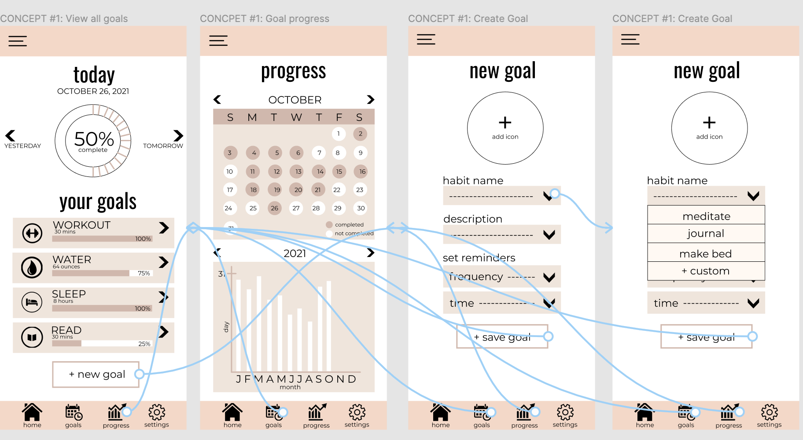

Concept 2: Kayla

<https://www.figma.com/proto/xGyNVTVjfEY8yHARl7ggWn/Goals-concept?node-id=2%3A2&scaling=scale-down&page-id=0%3A1&starting-point-node-id=2%3A2>

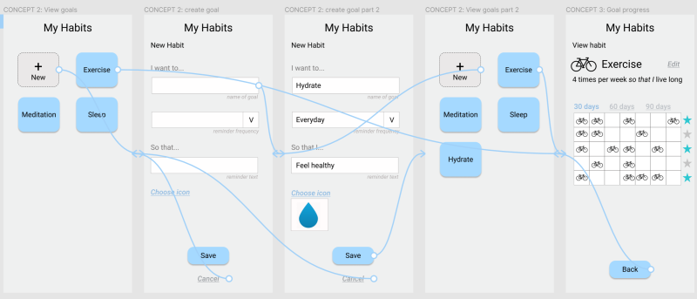

Concept 3: Hannah

<https://www.figma.com/proto/qHCSIjBgfHJBbVLI9JQZCt/CS-352-App-Design-Draft?node-id=2%3A4&scaling=scale-down&page-id=0%3A1>

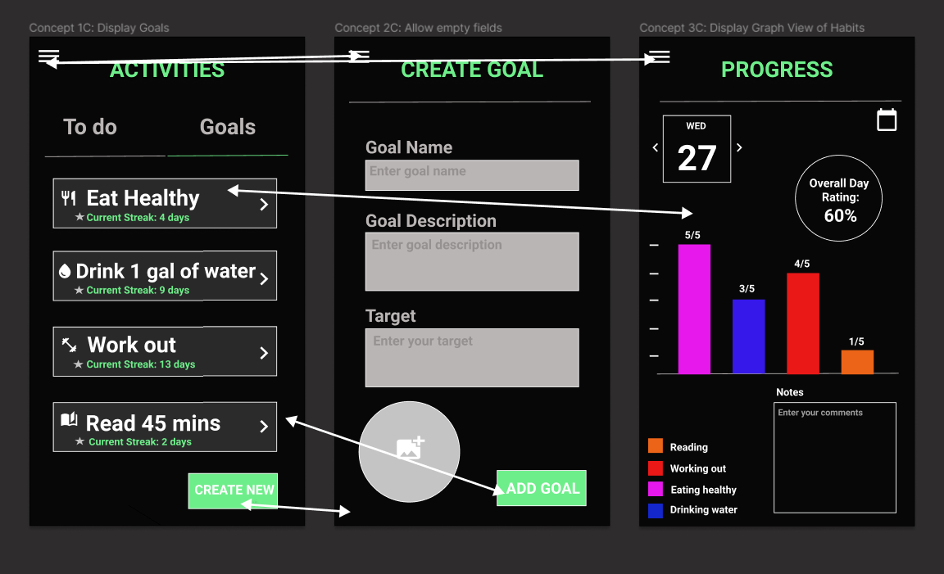

View all goals

Concept 1a: displays progress of goals for the day in percentages

Concept 1b: displays habits

Concept 1c: displays goals with current streaks

Create goal

Concept 2a: all drop down bar/predefined options

Concept 2b: allows empty fields with drop down of reminder frequency

Concept 2c: allows all empty fields

Goal progress

Concept 3a: shows calendar view of all habits in a month and yearly summary

Concept 3b: shows calendar view of a specific habit in a month

Concept 3c: shows graph view of each habit in a day