**Written by Haiying Yang**

Steps:

**Training the surrogate forward model**

1. First, open the data generation folder, forward_NN_periodic_BC_training_data

2. Run the Module1_R3_GSO_R.m file (line 21 sets the training data size, line 22 sets the test data size)

3. Then run the Module_2_1_actual_model_R3_target.m file

4. Put the training data previously generated in the forward_NN_periodic_BC_training_data folder into the current GA_forward_NN folder.

The required files are:

phi_final_testing.txt

phi_final_training.txt

phi_final_training_test.txt

phi_target_3_3_testing.txt

phi_target_3_3_training.txt

phi_target_3_3_training_test.txt

Th_large_testing.txt

Th_large_training.txt

Th_large_training_test.txt

5. Open the GA_forward_NN folder, open main.py, and click "run" to run.

6. Place f_best.txt and progress_forwardnn.txt generated in the GA_forward_NN folder into the plot_and_optimized_nn folder, then open plotting_figures_R1_optimal_index.py and click "run" to run.

7. After the operation is completed, the screen will appear, forward nn optimal value index: X (any possible number)

8. Then click on the variable explorer in the figures below. All variables will appear. Open the variable nn_parameter_data, find row X-1, and record the values ​​in column 0, column 1, and column 2. They correspond to the number of hidden layers, the number of nodes, and the number of iterations respectively. Write them down and save them in the optimized_nn.docx file that exists in the plot_and_optimized_nn folder.

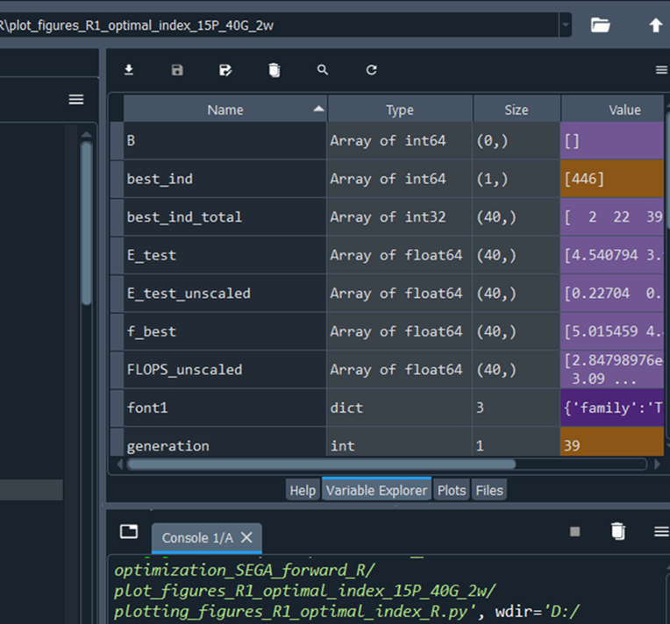

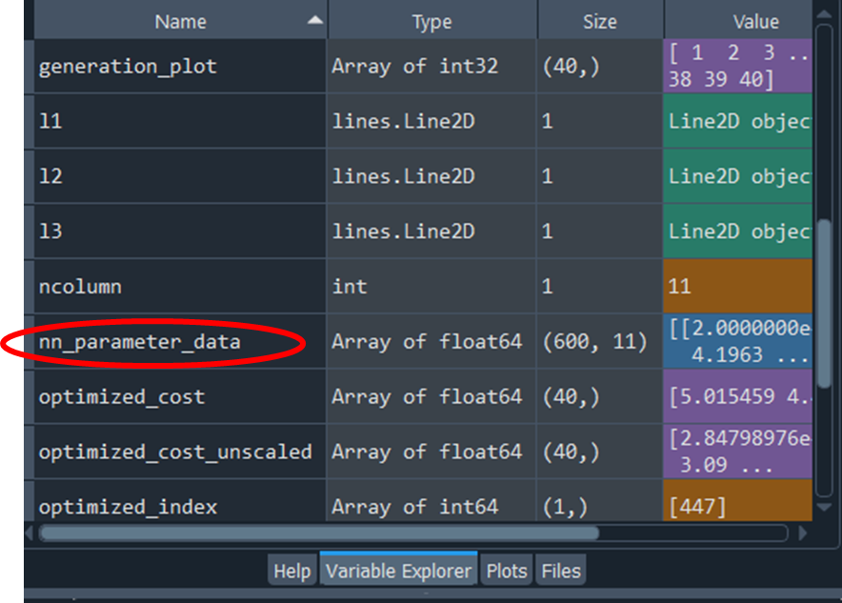

9. After that, open the GA_forward_NN folder and find the file named net_paramsX.pkl. This file is the optimized network. Put this file into the plot_and_optimized_nn folder and change its file name to net_params1.pkl.

**Testing the trained surrogate forward model**

10. Open the forward_NN_periodic_BC_new_testing_data folder,

Run the Module1_R3_GSO_R.m file (line 21 sets the training data size, line 22 sets the test data size, the size does not need to be changed.)

11. Run the Module_2_1_actual_model_R3_target.m file

12. Place the following files generated in the forward_NN_periodic_BC_new_testing_data folder into the test_output_trained_surrogate_forward_model folder.

Th_large_testing.txt，

phi_target_3_3_testing.txt，

phi_final_testing.txt

Then put net_params1.pkl in the plot_and_optimized_nn folder into the test_output_trained_surrogate_forward_model folder

Run output_trained_surrogate_forward_model_R.py.

**Training the controller**

13. Open the controller_data_generation folder,

First run the Module1_R3_GSO_R.m file (line 21 sets the training data size and line 22 sets the test data size).

Then run the Module_2_1_actual_model_R3_target_inverse.m file.

Place the following files into the controller_train folder.

phi_final_training_inverse.txt

phi_final_training_test_inverse.txt

phi_target_3_3_training.txt

phi_target_3_3_training_test.txt

14. Open the testing_data_genration_R_inverse folder and run the testing_data_for_inverse_nn.m file. Place phi_final_testing_inverse.txt and phi_target_3_3_testing.txt into the controller_train folder.

15. Then put net_params1.pkl in the plot_and_optimized_nn folder into the controller_train folder.

16. Open the optimized_nn.docx file in the plot_and_optimized_nn folder. Set the hyperparameters to the corresponding locations in the nn_adam_inverse_R_1305_16_R2_PFM_1.py file in the controller_train folder.

Line 24 EPOCHS_2 is the number of iterations

Line 27 HIDDEN_DIM_2 is the number of nodes,

Line 28 NUM_LAYERS_2 is the total number of layers, which equals to the number of hidden layers + 2.

Line 32, set EPOCHS_1 equal to EPOCHS_2

Line 35, set HIDDEN_DIM_1 equal to HIDDEN_DIM_2

Line 36, set NUM_LAYERS_1 equal to NUM_LAYERS_2

After that, run the nn_adam_inverse_R_1305_16_R2_PFM_1.py file.

17. Place the Th_out_phi_target_testing.txt file generated in the controller_train folder into the Th_to_PFM folder. And run the Th_inputting_into_PFM_R2.m file.

18. Put the phi_final_testing_PFM.txt generated in the Th_to_PFM folder into the microstructure_comparison folder, put the phi_final_testing_inverse.txt in the controller_train folder into the microstructure_comparison folder, and put the phi_final_net_out_1_testing.txt in the controller_train folder into microstructure_comparison. folder.

Run final_microstructure_comparison.m to get the comparison figures.