Warrior’s Snuggery: A modding guide

# Introduction

Welcome to the modding guide of Warrior’s Snuggery. In here, you will find a brief summary of modding and how to do it. Please notice that most knowledge will come by doing practice, not by reading this guide. That’s why it does not investigate every feature but only the basics.

Table of Contents

1. Introduction 1

2. Quick Oversight 1

3. Example 3

4. Rules and Documentation 3

# Quick Oversight

|  |  |
| --- | --- |
| Part | Directory |
| Characters (also called Actors) | “rules” |
| Weapons | “rules” |
| Particles | “rules” |
| Spells | “rules” |
| Terrain (Map tiles) | “rules” |
| Pieces (Map parts) | “maps/maps” |
| Map | “maps” |
| Images | “misc” |

Table 1: Parts of the game and their source.

Basically, in Warrior’s Snuggery, most of the game can be changed. Table 1 depicts the different aspects of the game and where to find their definitions.

All text files are built up in a specific way. In the first tab, an ID or name is given. In the second tabs, raw properties are given to the object. In the third tabs that sometimes have to exist in certain properties, exact values are set. See Graph 1 and Graph 2 for details.

|  |
| --- |
| 1=  Sprite=sand  OverlapHeight=7  EdgeSprite=sand_edges  CornerSprite=sand_corners  Speed=1,1 |

Graph 1: Example of a tile.

|  |
| --- |
| slime_small=  Part@Sprite=  Name=slime_mini  Dimensions=4,4  Random=true  Condition=ALL  UseAsPreview=true  […]  Part@Mobility=  Speed=13  Acceleration=6  Deceleration=3  Part@Health=  MaxHealth=200  […] |

Graph 2: Example of an actor.

Of course, there are different data types and constants. Those are listed up in Table 2 and Table 3. It is important to know them since they will be used in modding all the time. In order to understand the scales in the game, you can look at Graph 3.

|  |  |  |
| --- | --- | --- |
| Name | Value | Description |
| Tile size (pixel) | 24 pixel | Tile size in pixel. |
| Tile size (ingame) | 1024 units | Tile size in ingame units. one Pixel are $128/3 ≈ 43$ units. |
| Time | 60 ticks / second | Time unit ingame. One tick is 1/60 second. |

Table 2: Constants of Warrior’s Snuggery

|  |  |  |
| --- | --- | --- |
| Type | Example | Description |
| CPos | Offset=0,0,512 | Vector. (x,y,z) in game size. |
| MPos | Position=1,1 | Vector. (x,y) in tiles. |
| Color | Color=128,128,128,255 | Color. (r,g,b,a) from 0 – 255. |
| Integer | Health=1200 | Number. |
| Float | Probability=0,324 | Decimal. |
| String | Text=Hahahahaha! | Text. |
| Enum (varies) | CollectableType=MONEY | Specific predefined values. |

Table 3: Data types of Warrior’s Snuggery

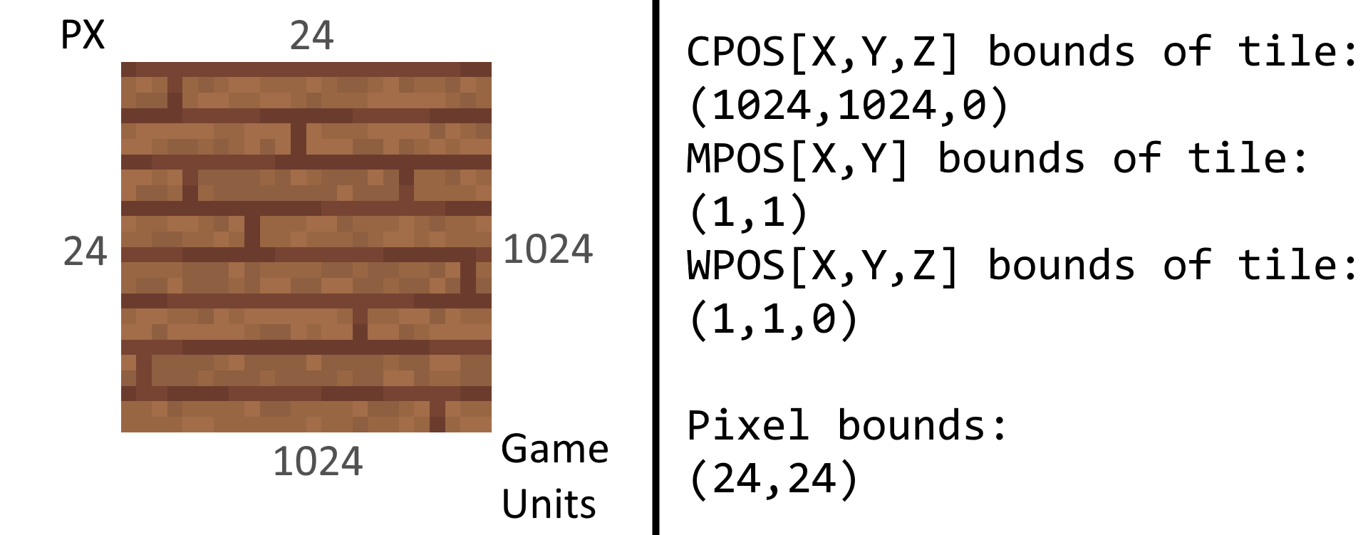  
Graph 3: Scales in the game

# Example

In the following part, we will add another actor to the game. On the left side of the table, the original code is given. On the right side, each line will be explained briefly.

|  |  |
| --- | --- |
| heal=  **Part@AnimatedSprite=**  Name=crab  Dimensions=24,24  Facings=16  Condition=ALL  Offset=0,-128,0  UseAsPreview=true  **Part@ParticleForce=**  ForceType=FORCE  Strength=2  MaxRange=10240  MinRange=0  **Part@World=**  CanTrigger=yes  ShowDamage=yes  **Part@Weapon=**  Type=lazer  **Part@Mobility=**  Speed=100  Acceleration=2  Deceleration=3  **Part@Health=**  MaxHealth=1000  **Part@Regeneration=**  Amount=1  Time=5  TimeAfterHit=20  **Part@Physics=**  Shape=Circle  Size=300,300,200  **Part@Playable=**  Playable=yes  Cost=20  **Part@SpawnOnDamage=**  Probability=0,7  Count=10  Name=blood1  Type=PARTICLE  **Part@SpawnOnMove=**  Count=1  Name=puff1  Type=PARTICLE  Tick=3  **Part@RevealsShroud=**  Range=6  Interval=0 | **Name of the actor.**  **Actor has an animated sprite.**  Name of the animation  Dimensions of a single frame  Facings of the animation  Condition: when does the anim play?  Offset relative to the object  Use as preview in the editor  **Actor applies forces to particles.**  Simple force, which means attraction  Strength of the force  Maximum range  Minimum range  **Basic information for the world.**  Can trigger collectables  Damage taken will be displayed  **Actor carries a weapon.**  Weapon type  **Actor can move.**  Speed  How fast the acceleration is  How fast the deceleration is  **Actor can be killed and has health.**  Maximum health to get  **Actor regenerates health.**  Amount of HP to regenerate  Regeneration interval  Regeneration interval after being damaged  **Actor has physical body.**  Shape of the physical body  Bounds of the physical body  **Actor is playable.**  Assure that it’s playable  How much switching to the actor costs  **Actor spawns stuff when being damaged.**  Probability to spawn stuff  How much of the stuff should be spawned  Name of the stuff  Type of the stuff  **Actor spawns stuff when moving.**  How much of the stuff should be spawned  Name of the stuff  Type of the stuff  Interval between spawning the stuff.  **Actor reveals shroud.**  Range of the reveal effect  How fast the shroud should be updated |

# Rules and Documentation

Rules can be generated by the *DocWriter*. There you can specify what rules documentation you want to generate, and the program will output a file with all information and descriptions. Please note that some of them might have missing information. In that case, please notify abc013.