Shashank Kumar Pandey

RDBMS ASSIGNMENT

Required Tables

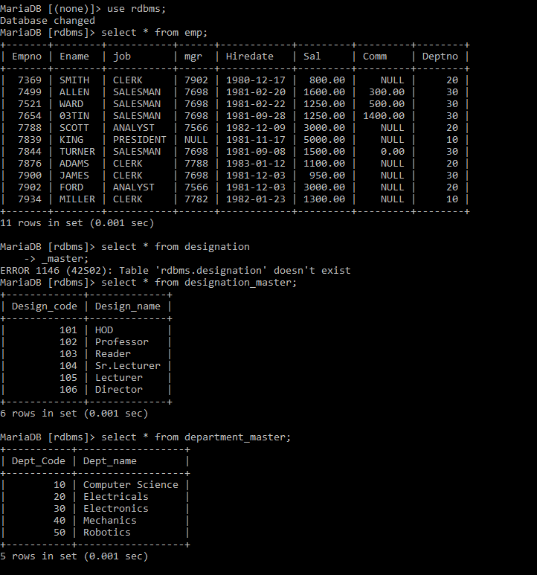

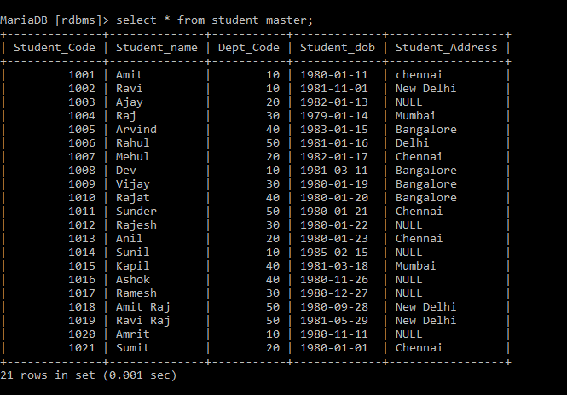

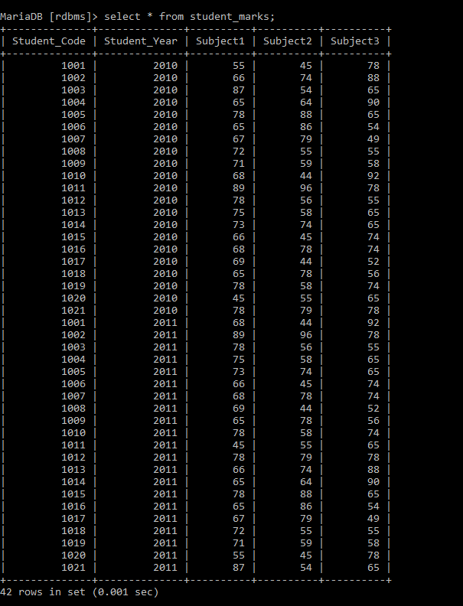

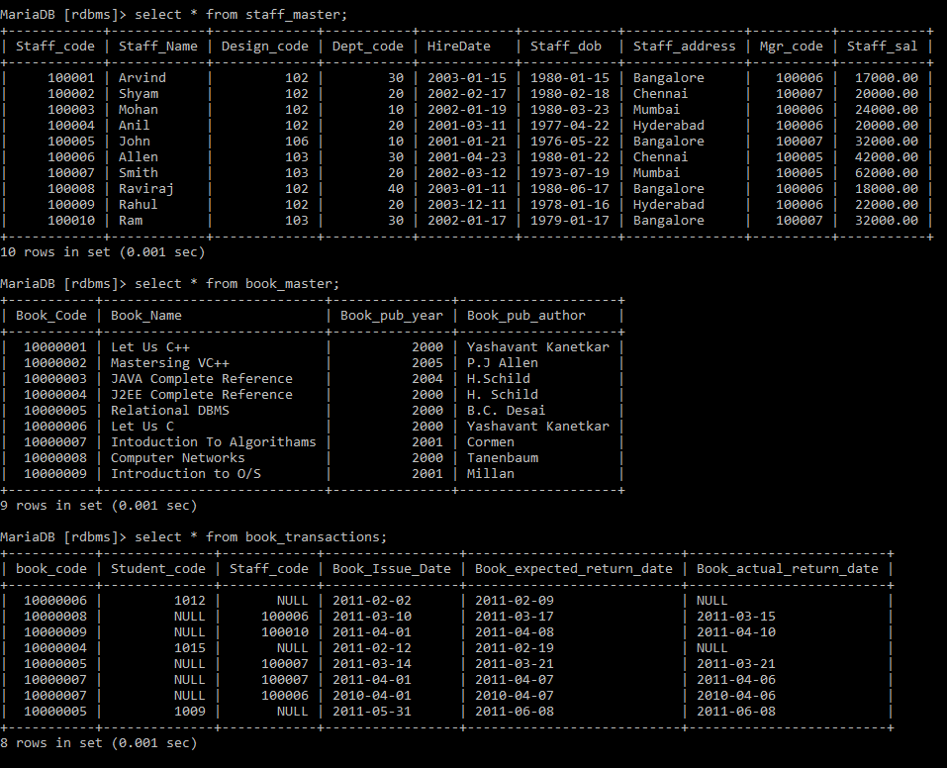

Queries:

1.1: Data Query Language

1. List the Name and Designation code of the staff who have joined before Jan 2003 and whose salary range is between 12000 and 25000. Display the columns with user defined Column headers. Hint: Use As clause along with other operators

MariaDB [rdbms]> select staff_name"Staff Name",design_code"Designation" from staff_master where (hiredate<'2003-01-01') AND staff_sal between 12000 and 25000;

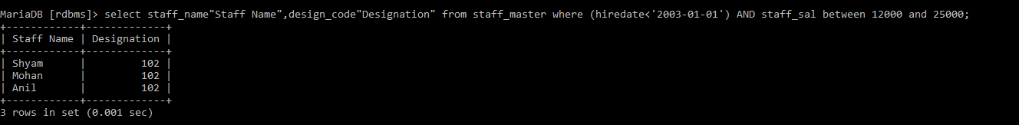

2. List the staff code, name, and department number of the staff who have experience of 18 or more years and sort them based on their experience.

MariaDB [rdbms]> SELECT STAFF_CODE,STAFF_NAME,DEPT_CODE FROM staff_master WHERE floor((datediff(curdate(),hiredate))/365)>=18 order by hiredate desc;

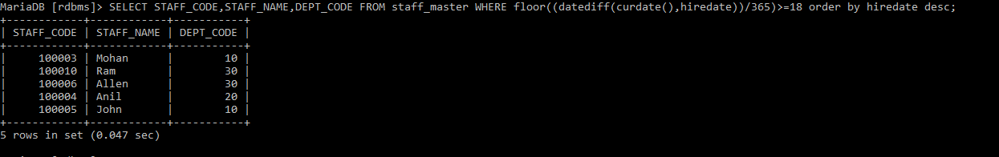

3. Display the staff details who do not have manager. Hint: Use is null

MariaDB [rdbms]> select * from staff_master where mgr_code is NULL;



4. Display the Book details that were published during the period of 2001 to 2004. Also display book details with Book name having the character ‘&’ anywhere.

MariaDB [rdbms]> SELECT * FROM BOOK_MASTER WHERE BOOK_PUB_YEAR BETWEEN 2001 AND 2004 AND BOOK_NAME LIKE '%[&]%';



5. List the names of the staff having ‘_’ character in their name.

MariaDB [rdbms]> select staff_name from staff_master where staff_name like '%_%';

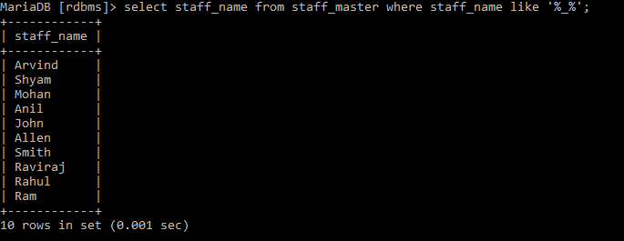

**2.1: Single Row Functions:**

1. Create a query which will display Staff Name, Salary of each staff. Format the salary to be 15 characters long and left padded with ‘$’.

MariaDB [rdbms]> select staff_name,lpad(staff_sal,15,'$') from staff_master;

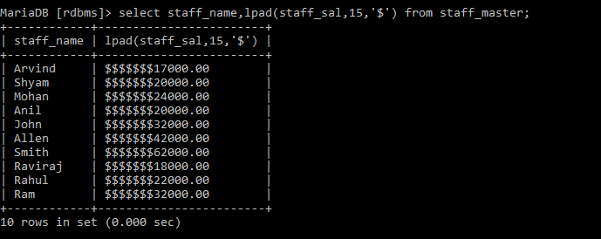

2. Display name and date of birth of students where date of birth must be displayed in the format similar to “January, 12 1981” for those who were born on Saturday or Sunday

MariaDB [rdbms]> select Student_name,date_format(Student_dob,"%M,%d %Y") AS Date_of_birth from student_master where dayname(student_Dob)='saturday' or dayname(student_dob)='Sunday';

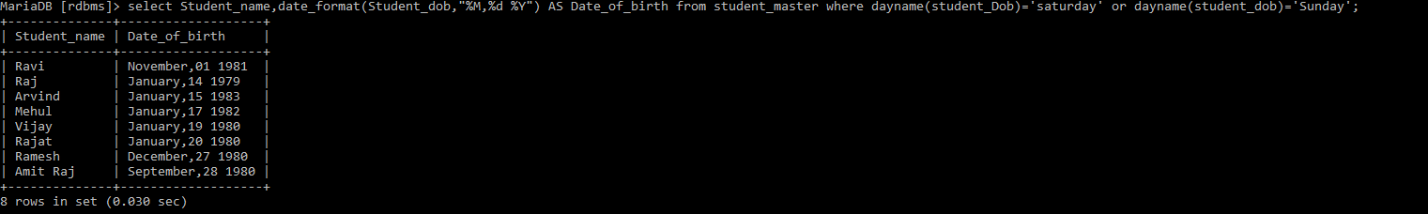

3. Display each Staff name and number of months they worked for the organization. Label the column as ‘Months Worked’. Order your result by number of months employed. Also Round the number of months to closest whole number.

MariaDB [rdbms]> SELECT STAFF_NAME,ROUND((datediff(CURDATE(),HIREDATE)/365)*12) AS MONTHS_WORKED FROM STAFF_MASTER order by months_worked;

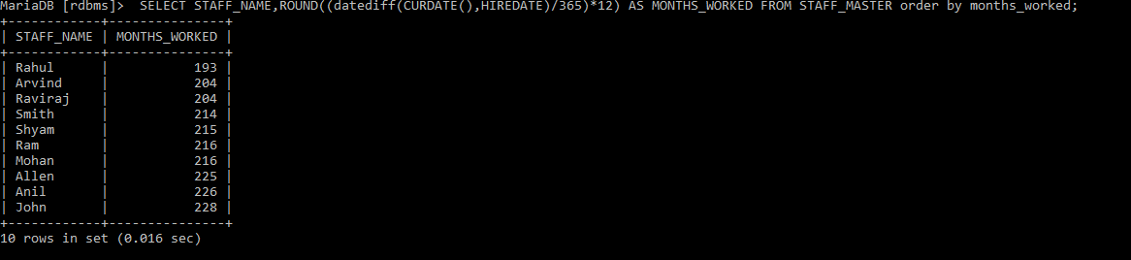

4. List the details of the staff who have joined in first half of December month (irrespective of the year).

MariaDB [rdbms]> SELECT * FROM STAFF_MASTER WHERE date_format(HIREDATE,'%d') BETWEEN 1 AND 15 AND date_format(HIREDATE,'%M') LIKE '%DECEMBER%' ;

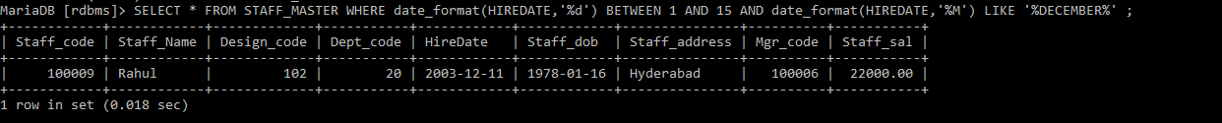

5. Write a query that displays Staff Name, Salary, and Grade of all staff. Grade depends on the following table.

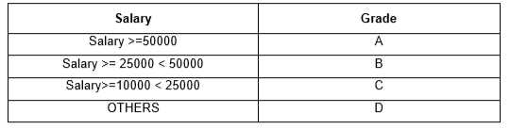

MariaDB [rdbms]> SELECT STAFF_NAME,STAFF_SAL ,

-> CASE

-> WHEN STAFF_SAL >=50000 THEN 'A'

-> WHEN STAFF_SAL >25000 AND STAFF_SAL<50000 THEN 'B'

-> WHEN STAFF_SAL >10000 AND STAFF_SAL<25000 THEN 'C'

-> else 'D'

-> end from staff_master;

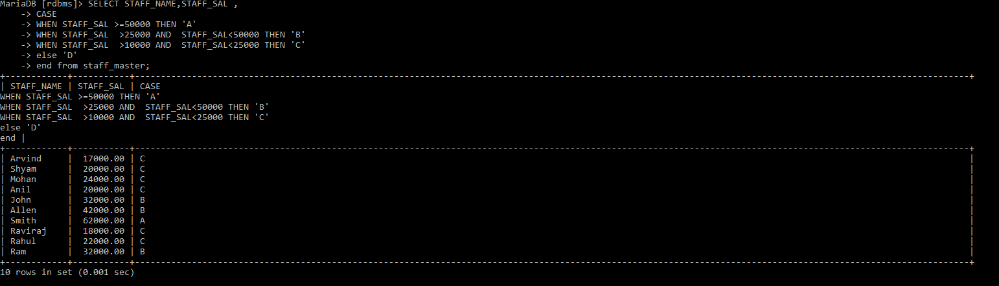

6. Display the Staff Name, Hire date and day of the week on which staff was hired. Label the column as DAY. Order the result by the day of the week starting with Monday. Hint :Use to_char with hiredate and formats ‘DY’ and ’D’

MariaDB [rdbms]> select staff_name,hiredate,dayname(hiredate) as DAY from staff_master order by (

-> case dayofweek(hiredate)

-> when 1 then 7

-> else dayofweek(hiredate)-1

-> end);

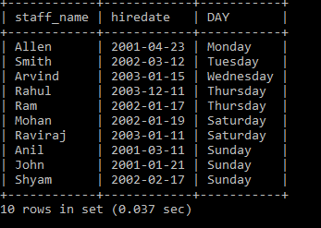

7.Write a query to find the position of third occurrence of ‘i’ in the given word ‘Mississippi’

select length(substring_index('Mississippi','i',3))+1 from dual;

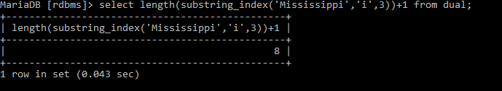

8. Write a query to find the pay date for the month. Pay date is the last Friday of the month. Display the date in the format “Twenty Eighth of January, 2002”. Label the heading as PAY DATE. Hint: use to_char, next_day and last_day functions.

9. Display Student code, Name and Dept Name. Display “Electricals” if dept code = 20, “Electronics” if Dept code =30 and “Others” for all other Dept codes in the Dept Name column. Hint : Use Decode

MariaDB [rdbms]> select student_code,student_name,

-> case

-> when dept_code=20 then 'Electricals'

-> when dept_code=30 then 'Electronics'

-> else

-> 'Others'

-> end from student_master;

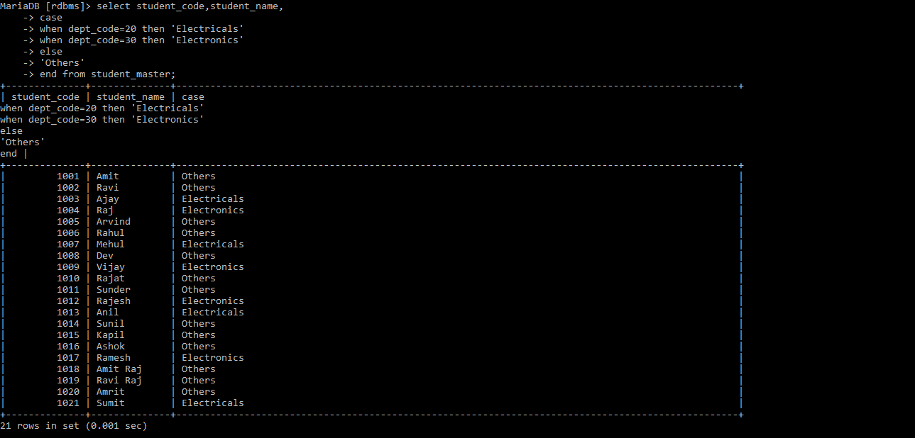

**2.2: Group Functions:**

1. Display the Highest, Lowest, Total & Average salary of all staff. Label the columns Maximum, Minimum, Total and Average respectively for each Department code. Also round the result to the nearest whole number.

MariaDB [rdbms]> select max(staff_sal) as Maximum,min(staff_sal) as Minimum,sum(staff_sal) as Total ,round(avg(staff_sal)) as Average from staff_master group by dept_code;

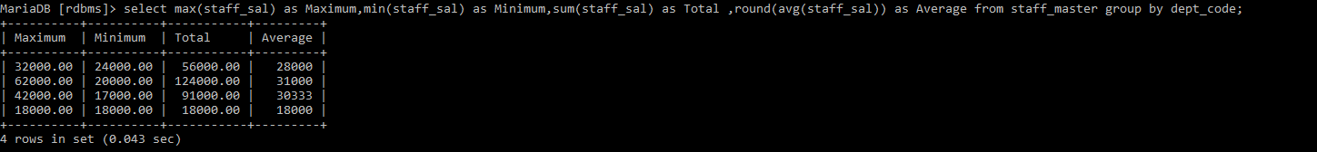

2. Display Department code and number of managers working in that department. Label the column as ‘Total Number of Managers’ for each department.

MariaDB [rdbms]> select deptno,count(job) as Total_Number_Of_Managers from emp where job="MANAGER" group by deptno;

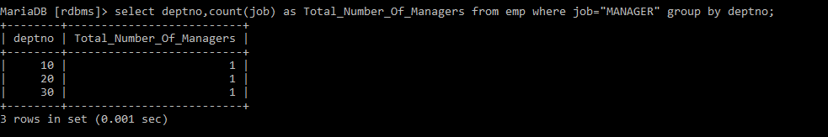

3. Get the Department number, and sum of Salary of all non-managers where the sum is greater than 20000.

MariaDB [rdbms]> select deptno,sum(sal) as sum from emp where job not like "manager" group by deptno having sum(sal)>20000;



**3.1: Joins and Subqueries**

1. Write a query which displays Staff Name, Department Code, Department Name, and Salary for all staff who earns more than 20000.

MariaDB [rdbms]> select s.staff_name,d.dept_code,d.dept_name,s.staff_sal from staff_master s,department_master d where s.dept_code=d.dept_code and staff_sal>20000;

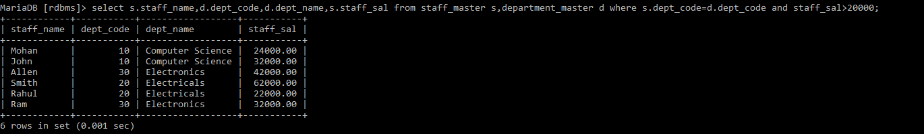

2. Display Staff Code, Staff Name, Department Name, and his manager’s number and name. Label the columns Staff#, Staff, Mgr#, Manager

MariaDB [rdbms]> select s.staff_code as "staff#",s.staff_name as "Staff",d.dept_name,s.mgr_code as "Mgr#",ss.staff_name as Manager from staff_master s,staff_master ss,department_master d where s.mgr_code=ss.staff_code and s.dept_code=d.dept_code;

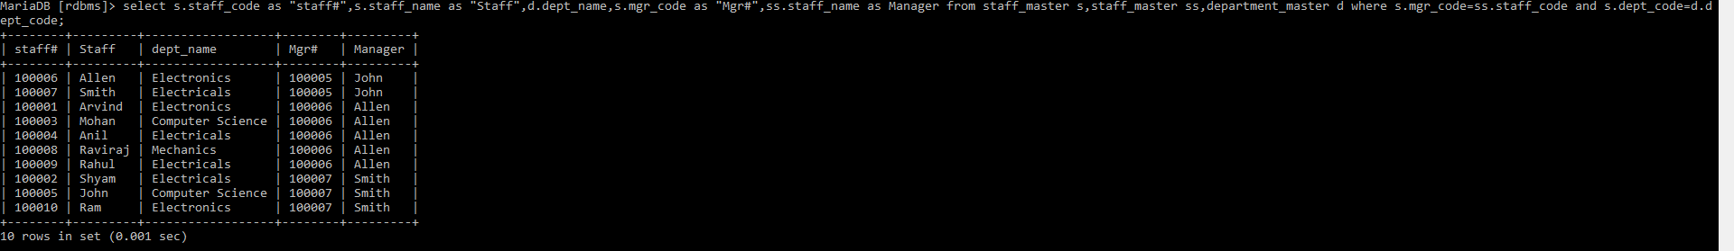

3. Create a query that will display Student Code, Student Name, Book Code, and Book Name for all students whose expected book return date is today.

MariaDB [rdbms]> select s.student_code,s.student_name,b.book_code,b.book_name from student_master s,book_transactions bb,book_master b where s.student_code=bb.student_code and bb.book_code and bb.book_expected_return_date=curdate();



4. Create a query that will display Staff Code, Staff Name, Department Name, Designation name, Book Code, Book Name, and Issue Date for only those staff who have taken any book in last 30 days. . If required, make changes to the table to create such a scenario.

MariaDB [rdbms]> insert into book_transactions values(10000006,1012,100001,'2020-01-04','2020-01-21',NULL);

Query OK, 1 row affected (0.027 sec)

MariaDB [rdbms]> select s.staff_code,s.staff_name,d.dept_name,dd.design_name,b.book_code,bb.book_name,b.book_issue_date from staff_master s,designation_master dd,department_master d,book_transactions b,book_master bb where s.design_code=dd.design_code and s.dept_code=d.dept_code and s.staff_code=b.staff_code and b.book_code=bb.book_code and datediff(curdate(),book_issue_date) between 0 and 30;

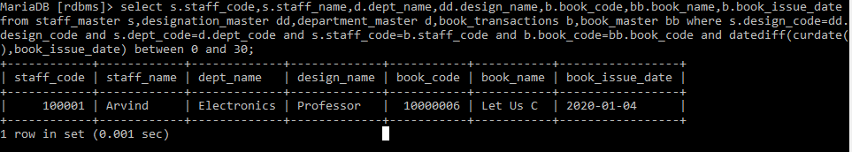

5. Generate a report which contains the following information.

Staff Code, Staff Name, Designation Name, Department, Book Code, Book Name,

Author, Fine For the staff who has not returned the book. Fine will be calculated as Rs. 5 per day.

Fine = 5 * (No. of days = Current Date – Expected return date). Include records in the table to suit this problem statement

MariaDB [rdbms]> select s.staff_code,s.staff_name,d1.dept_name,d2.design_name,b.book_code,b1.book_name,b1.book_pub_author,b.book_issue_date,datediff(b.book_actual_return_date,b.book_expected_return_date)*5 as fine,datediff(b.book_expected_return_date,b.book_actual_return_date) as datediff from department_master d1,designation_master d2,book_master b1,staff_master s inner join book_transactions b on

-> s.staff_code=b.staff_code where s.dept_code=d1.dept_code and s.design_code=d2.design_code and b.book_code=b1.book_code

-> and(datediff(curdate(),b.book_expected_return_date))>0 and datediff(b.book_expected_return_date,b.book_actual_return_date)<0;



6. List Staff Code, Staff Name, and Salary for those who are getting less than the average salary of organization.

MariaDB [rdbms]> select staff_code,staff_name,staff_sal from staff_master where staff_sal<(select avg(staff_sal) from staff_master);

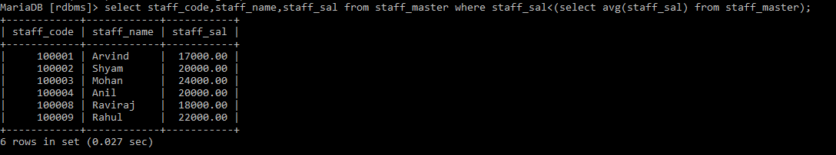

7. Display Author Name, Book Name for those authors who wrote more than one book.

MariaDB [rdbms]> SELECT book_pub_author as "Author Name",BOOK_NAME as "Book Name" FROM BOOK_MASTER where book_pub_author in(select book_pub_author from book_master HAVING COUNT(book_pub_author)>1);

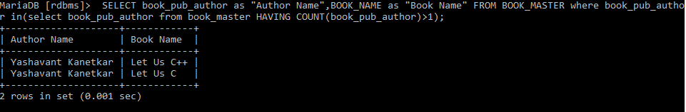

8. Display Staff Code, Staff Name, and Department Name for those who have taken more than one book.

MariaDB [rdbms]> select s.staff_code,s.staff_name,d.dept_name from staff_master s,department_master d,book_transactions b where s.dept_code=d.dept_code and s.staff_code =b.staff_code group by s.staff_code having count(*)>1;

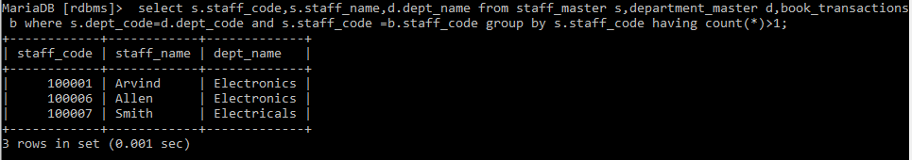

9. Display the Student Code, Student Name, and Department Name for that department in which there are maximum number of student studying.

select s.student_code,s.student_name,d.dept_name from student_master s,department_master d where s.dept_code=d.dept_code and d.dept_code=(select dept_code from student_master group by dept_code order by count(dept_code) desc limit 1);

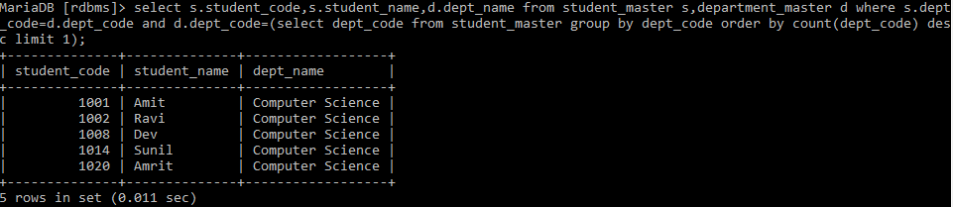

10. Display Staff Code, Staff Name, Department Name, and Designation name for those who have joined in last 3 months.

MariaDB [rdbms]> select s.staff_code,s.staff_name,d.dept_name,dd.design_name from staff_master s,department_master d,Designation_master dd where s.dept_code=d.dept_code and s.design_code=dd.design_code and datediff(curdate(),hiredate)<92;



11. Display the Manager Name and the total strength of his/her team.

MariaDB [rdbms]> select ss.staff_name as "Manager",count(ss.staff_name) from staff_master as s,staff_master ss,department_master as d where s.mgr_code=ss.staff_code and s.dept_code=d.dept_code group by manager;

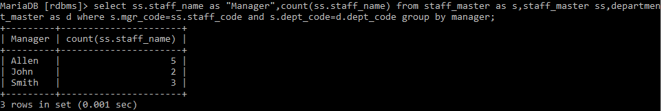

12. Display the details of books that have not been returned and expected return date was last Monday. Book name should be displayed in proper case.. Hint: You can change /add records so that the expected return date suits this problem statement

MariaDB [rdbms]> select b.book_code,b.book_name,b.book_pub_year,b.book_pub_author from book_master b inner join book_transactions bb where b.book_code=bb.book_code and bb.book_expected_return_date=date_sub(curdate(),interval weekday(curdate())day);



13. Write a query to display number of people in each Department. Output should display Department Code, Department Name and Number of People.

MariaDB [rdbms]> select s.dept_code,d.dept_name,count(s.staff_name) as Number_Of_People from staff_master s,department_master d where s.dept_code=d.dept_code group by dept_code;

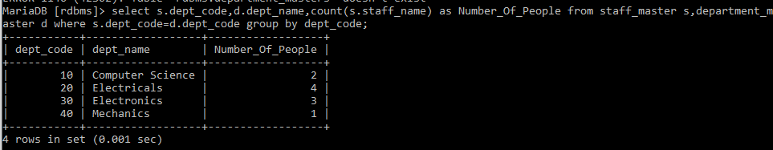

**4.1: Database Objects**

1. Create the Customer table with the following columns.

CustomerId int(5)

Cust_Name varchar(20)

Address1 Varchar(30)

Address2 Varchar(30

MariaDB [rdbms]> create table Customer(CustomerId int(5),Cust_name varchar(20),Address1 varchar(30),Address varchar(30));

Query OK, 0 rows affected (0.292 sec)

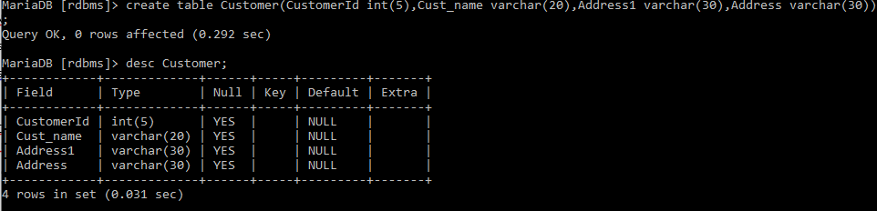

2. Modify the Customer table Cust_Name column of datatype with Varchar2(30), rename the column to CustomerName and it should not accept Nulls.

MariaDB [rdbms]> alter table customer change Cust_name CustomerName varchar(30) not null;

Query OK, 0 rows affected (0.286 sec)

Records: 0 Duplicates: 0 Warnings: 0

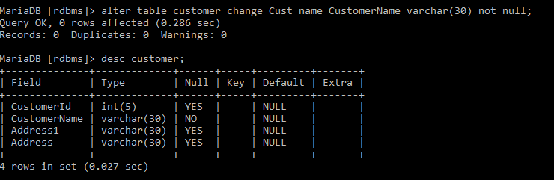

3. a) Add the following Columns to the Customer table.

Gender Varchar(1)

Age int(3)

PhoneNo int(10)

MariaDB [rdbms]> alter table customer add column Gender varchar(1);

Query OK, 0 rows affected (0.105 sec)

Records: 0 Duplicates: 0 Warnings: 0

MariaDB [rdbms]> alter table customer add column Age int(3);

Query OK, 0 rows affected (0.040 sec)

Records: 0 Duplicates: 0 Warnings: 0

MariaDB [rdbms]> alter table customer add column PhoneNo int(10);

Query OK, 0 rows affected (0.109 sec)

Records: 0 Duplicates: 0 Warnings: 0

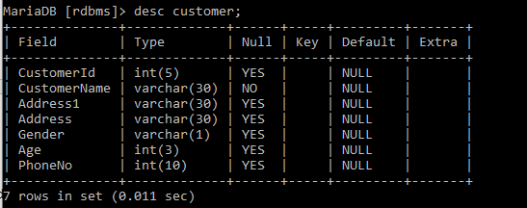

b) Rename the Customer table to Cust_Table

MariaDB [rdbms]> Rename table Customer to Cust_Table;

Query OK, 0 rows affected (0.489 sec)

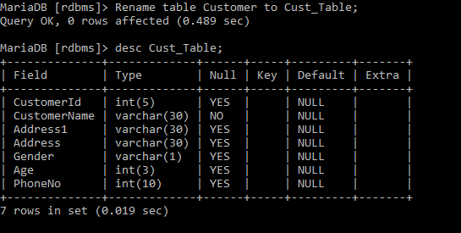

4. Insert rows with the following data in to the Customer table.

Insert into customer values: (1000, ‘Allen’, ‘#115 Chicago’, ‘#115 Chicago’, ‘M’, ‘25, 7878776’)

In similar manner, add the below records to the Customer table:

1001, George, #116 France, #116 France, M, 25, 434524

1002, Becker, #114 New York, #114 New York, M, 45, 431525

MariaDB [rdbms]> Insert into cust_table values(1000, 'Allen', '#115 Chicago', '#115 Chicago','M', 25, 7878776);

Query OK, 1 row affected (0.043 sec)

MariaDB [rdbms]> Insert into cust_table values(1001, 'George', '#116 France', '#116 France', 'M', 25, 43452);

Query OK, 1 row affected (0.021 sec)

MariaDB [rdbms]> Insert into cust_table values(1002, 'Becker', '#114 New York', '#114 New York', 'M', 45, 431525);

Query OK, 1 row affected (0.011 sec)

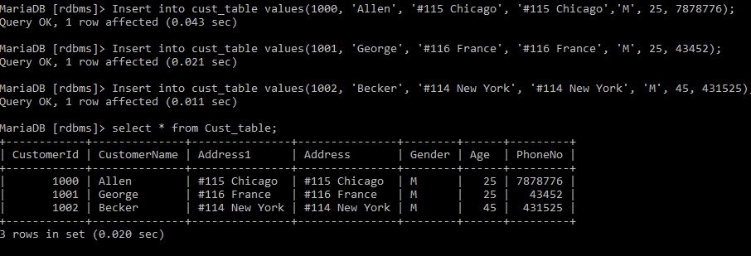

5. Add the Primary key constraint for Customerld with the name Custld_Prim.

MariaDB [rdbms]> alter table Cust_Table add constraint CustId_Prim Primary Key(CustomerId);

Query OK, 0 rows affected, 1 warning (0.443 sec)

Records: 0 Duplicates: 0 Warnings: 1



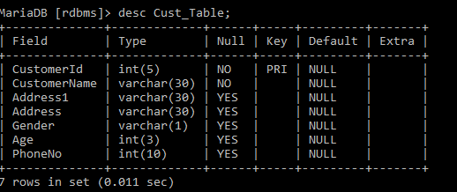

6. Insert the row given below in the Customer table and see the message generated by the Oracle server.

1002, John, #114 Chicago, #114 Chicago, M, 45, 439525

MariaDB [rdbms]> Insert into cust_table values(1002, 'John', '#114 Chicago', '#114 Chicago','M', 45, 439525 );

ERROR 1062 (23000): Duplicate entry '1002' for key 'PRIMARY'



7. Disable the constraint on CustomerId, and insert the following data:

1002, Becker, #114 New York, #114 New york , M, 45, 431525

1003, Nanapatekar, #115 India, #115 India , M, 45, 431525

MariaDB [rdbms]> alter table Cust_Table drop Primary key;

Query OK, 3 rows affected (0.451 sec)

Records: 3 Duplicates: 0 Warnings: 0

MariaDB [rdbms]> Insert into cust_table values(1002, 'John', '#114 Chicago', '#114 Chicago','M', 45, 439525 );

Query OK, 1 row affected (0.035 sec)

MariaDB [rdbms]> Insert into cust_table values(1003, 'Nanapatekar', '#115 India', '#115 India','M', 45, 431525 );

Query OK, 1 row affected (0.025 sec)

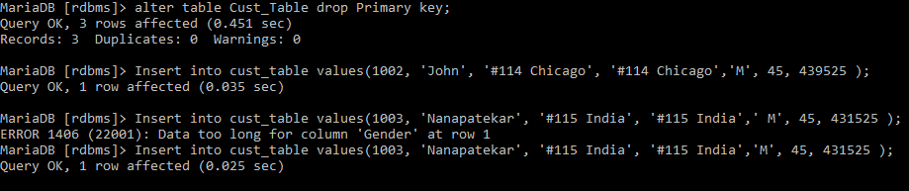

8. Enable the constraint on CustomerId of the Customer table, and see the message generated by the Oracle server.

MariaDB [rdbms]> alter table Cust_Table add constraint CustId_Prim Primary Key(CustomerId);

ERROR 1062 (23000): Duplicate entry '1002' for key 'PRIMARY'



9. Drop the constraint Custld_Prim on CustomerId and insert the following Data. Alter Customer table, drop constraint Custid_Prim.

1002, Becker, #114 New York, #114 New york , M, 45, 431525, 15000.50

1003, Nanapatekar, #115 India, #115 India , M, 45, 431525, 20000.50

MariaDB [rdbms]> Insert into cust_table values(1002, 'Becker', '#114 New York', '#114 New york' , 'M', 45, 431525);

Query OK, 1 row affected (0.029 sec)

MariaDB [rdbms]> Insert into cust_table values(1003, 'Nanapatekar', '#115 India', '#115 India' , 'M', 45, 431525);

Query OK, 1 row affected (0.023 sec)

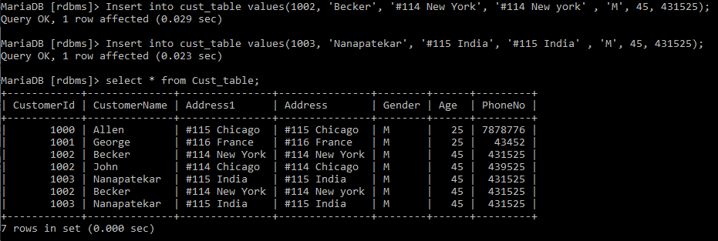

10.Delete all the existing rows from Customer table, and let the structure remain itself using TRUNCATE statement.

MariaDB [rdbms]> truncate table cust_table;

Query OK, 0 rows affected (0.211 sec)

MariaDB [rdbms]> select * from Cust_table;

Empty set (0.000 sec)

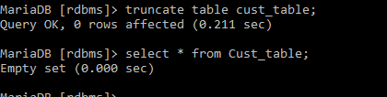

11. In the Customer table, add a column E_mail.

MariaDB [rdbms]> alter table Cust_table add column E_mail varchar(30);

Query OK, 0 rows affected (0.059 sec)

Records: 0 Duplicates: 0 Warnings: 0



12. Drop the E_mail column from Customer table

MariaDB [rdbms]> Alter table Cust_Table Drop column E_Mail;

Query OK, 0 rows affected (0.053 sec)

Records: 0 Duplicates: 0 Warnings: 0



13. Create the Suppliers table based on the structure of the Customer table. Include only the CustomerId, CustomerName, Address1, Address2, and phoneno columns.

Name the columns in the new table as SuppID, SName, Addr1, Addr2, and Contactno respectively.

MariaDB [rdbms]> Create table Suppliers_Table as

-> (select CustomerId as SuppID, Customername as Sname, Address1 as Addr1, Address as Addr2, PhoneNo as Contactno

-> from Cust_Table);

Query OK, 0 rows affected (0.158 sec)

Records: 0 Duplicates: 0 Warnings: 0



14. Drop the above table and recreate the following table with the name CustomerMaster.

CustomerId int(5) Primary key(Name of constraint is CustId_PK)

CustomerName Varchar(30) Not Null

Addressl Varchar(30) Not Null

Address2 Varchar(30)

Gender Varchar(l)

Age int(3)

PhoneNo int(10)

MariaDB [rdbms]> drop table Suppliers_Table;

Query OK, 0 rows affected (0.071 sec)

MariaDB [rdbms]> Create table CustomerMaster

-> (

-> CustomerId int(5),

-> CustomerName varchar(30) not null,

-> Address1 varchar(30) not null,

-> Address2 varchar(30),

-> Gender varchar(1),

-> Age int(3),

-> PhoneNo int(10),

-> constraint CustId_PK primary key (CustomerId)

-> );

Query OK, 0 rows affected, 1 warning (0.152 sec)

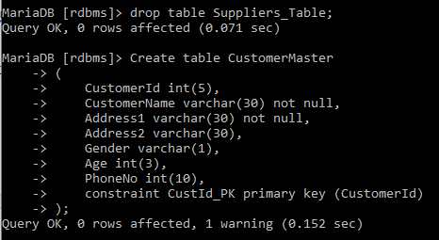

15. Create the AccountsMaster table with the following Columns. Use auto generate to generate Account number

Customerld int(5)

AccountNumber int(10,2) Primary key(Name of constraint is Acc_PK)

AccountType Char(3)

LedgerBalance int(10,2) Not Null

MariaDB [rdbms]> Create table AccountMaster

-> (

-> CustomerID int(5),

-> AccountNumber int(10) Auto_Increment,

-> AccountType varchar(3),

-> LedgerBalance numeric(10, 2) not null,

-> constraint Acc_PK primary key(AccountNumber)

-> );

Query OK, 0 rows affected, 1 warning (0.108 sec)

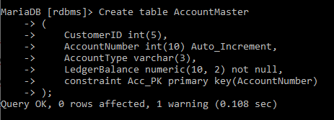

16. Relate AccountsMaster table and CustomerMaster table through Customerld column with the constraint name Cust_acc.

MariaDB [rdbms]> alter table accountmaster add constraint Cust_acc foreign key(customerid) references customermaster(customerid);

Query OK, 0 rows affected (0.380 sec)

Records: 0 Duplicates: 0 Warnings: 0



17. Insert the following rows to the CustomerMaster table:

1000, Allen, #115 Chicago, #115 Chicago, M, 25, 7878776

1001, George, #116 France, #116 France, M, 25, 434524

1002, Becker, #114 New York, #114 New York, M, 45, 431525

MariaDB [rdbms]> insert into cust_table

-> values

-> (1000, "Allen", "115 Chicago", "115 Chicago", "M", 25, 7878776);

Query OK, 1 row affected (0.024 sec)

MariaDB [rdbms]> insert into cust_table

-> values

-> (1001, "George", "116 France", "116 France", "M", 25, 434524);

Query OK, 1 row affected (0.035 sec)

MariaDB [rdbms]> insert into cust_table

-> values

-> (1002, "Becker", "114 New York", "114 New York", "M", 45, 431525);

Query OK, 1 row affected (0.020 sec)

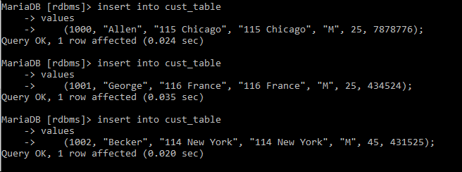

18. Modify the AccountMaster table with the Check constraint to ensure AccountType should be either NRI or IND.

MariaDB [rdbms]> alter table accountmaster add CONSTRAINT Account_check check (AccountType='IND' or AccountType='NRI');

Query OK, 0 rows affected (0.446 sec)

Records: 0 Duplicates: 0 Warnings: 0



19. Modify the AccountsMaster table keeping a Check constraint with the name Balance_Check for the Minimum Balance which should be greater than 5000.

MariaDB [rdbms]> alter table accountmaster add constraint Balance_Check check (LedgerBalance > 5000);

Query OK, 0 rows affected (0.476 sec)

Records: 0 Duplicates: 0 Warnings: 0



20. Modify the AccountsMaster table such that if Customer is deleted from Customer table then all his details should be deleted from AccountsMaster table.

MariaDB [rdbms]> alter table accountmaster drop foreign key Cust_acc;

Query OK, 0 rows affected (0.064 sec)

Records: 0 Duplicates: 0 Warnings: 0

MariaDB [rdbms]> alter table accountmaster add constraint Cust_acc foreign key(CustomerId) references Cust_table(CustomerId) on delete cascade;



21. Create Backup copy for the AccountsMaster table with the name ‘AccountDetails’

MariaDB [rdbms]> Create table AccountDetails as

-> (select *

-> from AccountMaster);

Query OK, 0 rows affected (0.190 sec)

Records: 0 Duplicates: 0 Warnings: 0

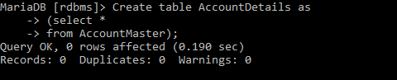

22. Create a view ‘Acc_view’ with columns Customerld, CustomerName, AccountNumber, AccountType, and LedgerBalance from AccountsMaster. In the view Acc_view, the column names should be CustomerCode, AccountHolderName, AccountNumber, Type, and Balance for the respective columns from AccountsMaster table.

MariaDB [rdbms]> Create view Acc_View

-> (

-> CustomerCode,

-> AccountHolderName,

-> AccountNumber,

-> Type,

-> Balance

-> )

-> as

-> select a.CustomerId, b.customername, a.AccountNumber, a.AccountType, a.ledgerbalance

-> from AccountMaster a, customermaster b

-> where a.customerid=b.customerid;

Query OK, 0 rows affected (0.097 sec)

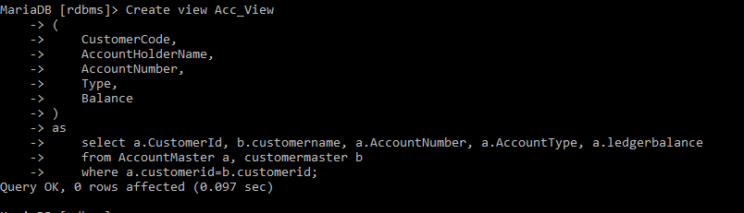

23. Create a view on AccountsMaster table with name vAccs_Dtls. This view should list all customers whose AccountType is ‘IND’ and their balance amount should not be less than 10000. Using this view any DML operation should not violate the view conditions.

MariaDB [rdbms]> Create view vAccs_Dtls

-> as

-> select a.CustomerId, b.customername, a.AccountNumber, a.AccountType, a.ledgerbalance

-> from AccountMaster a, customermaster b

-> where a.customerid=b.customerid and a.AccountType="IND" and a.ledgerbalance<10000;

Query OK, 0 rows affected (0.046 sec)

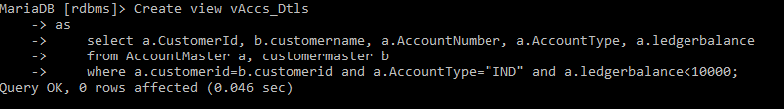

24. Create a view accsvw10 which will not allow DML statement against it.

MariaDB [rdbms]> Create view acccsvw10

-> as select * from AccountMaster with check option;

Query OK, 0 rows affected (0.029 sec)



25. Insert three sample rows by using the above auto generate in Department_Masters table

MariaDB [rdbms]> alter table department_master alter dept_code set default '00';

Query OK, 0 rows affected (0.045 sec)

Records: 0 Duplicates: 0 Warnings: 0

MariaDB [rdbms]> alter table department_master modify dept_code int (2) not null auto_increment; insert into department_master(dept_name)

ERROR 1075 (42000): Incorrect table definition; there can be only one auto column and it must be defined as a key

-> values("IT");

Query OK, 1 row affected (0.019 sec)

MariaDB [rdbms]> insert into department_master(dept_name)values("ECE");

Query OK, 1 row affected (0.015 sec)

MariaDB [rdbms]> insert into department_master(dept_name)values("Aerospace");

Query OK, 1 row affected (0.036 sec)

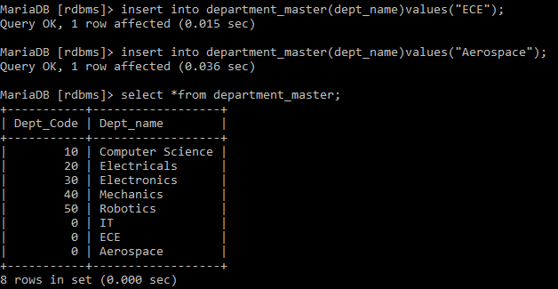

**5.1: Data Manipulation Language**

1. Create Employee table with same structure as EMP table.

MariaDB [rdbms]> CREATE TABLE Emp

-> (

-> EMPNO int(4) NOT NULL,

-> ENAME varchar(10),

-> JOB varchar(9),

-> MGR int(4),

-> HIREDATE DATE,

-> SAL numeric(7, 2),

-> COMM numeric(7, 2),

-> DEPTNO int(2)

-> );

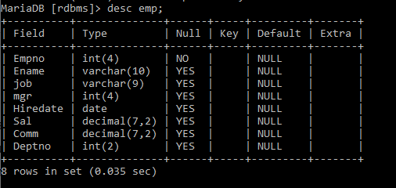

2. Write a query to populate Employee table using EMP table’s empno, ename, sal, deptno columns.

insert into emp (empno, ename, sal, deptno) values (7369,'SMITH',800,20);

insert into emp (empno, ename, sal, deptno) values (7499,'ALLEN',1600,30);

insert into emp (empno, ename, sal, deptno) values (7521,'WARD',1250,30);

insert into emp (empno, ename, sal, deptno) values (7566,'JONES',2975,20);

insert into emp (empno, ename, sal, deptno) values (7654,'MARTIN',1250,30);

insert into emp (empno, ename, sal, deptno) values (7698,'BLAKE',2850,30);

insert into emp (empno, ename, sal, deptno) values (7782,'CLARK',2450,10);

insert into emp (empno, ename, sal, deptno) values (7788,'SCOTT',3000,20);

insert into emp (empno, ename, sal, deptno) values (7839,'KING',5000,10);

insert into emp (empno, ename, sal, deptno) values (7844,'TURNER',1500,30);

insert into emp (empno, ename, sal, deptno) values (7876,'ADAMS',1100,20);

insert into emp (empno, ename, sal, deptno) values (7900,'JAMES',950,30);

insert into emp (empno, ename, sal, deptno) values (7902,'FORD',3000,20);

insert into emp (empno, ename, sal, deptno) values (7934,'MILLER',1300,10);

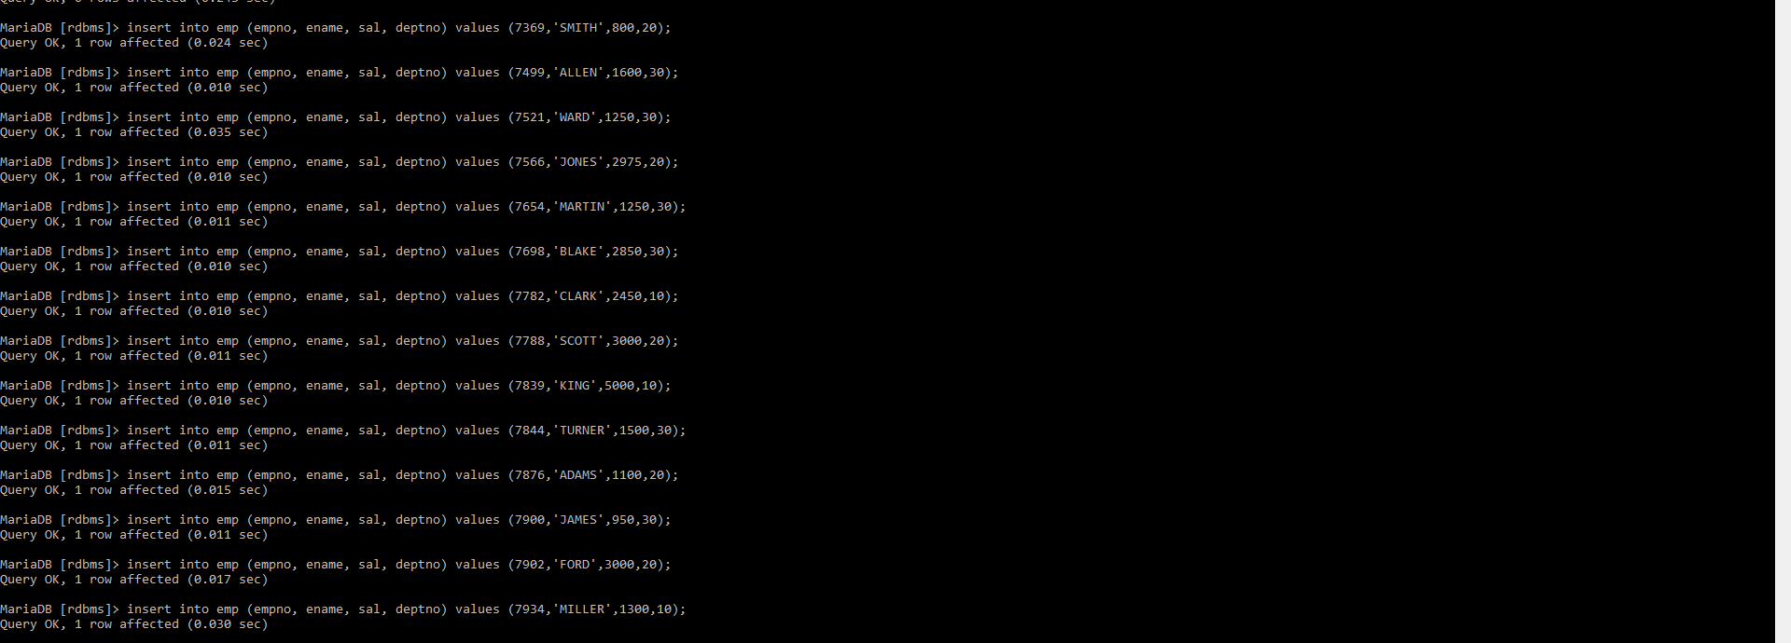

3. Write a query to change the job and deptno of employee whose empno is 7698 to the job and deptno of employee having empno 7788.

MariaDB [rdbms]> update emp set job=(select job from emp where empno=7788), deptno=(select deptno from emp where empno=7788) where empno=7698;

Query OK, 1 row affected (0.073 sec)

Rows matched: 1 Changed: 1 Warnings: 0



4. Delete the details of department whose department name is ‘SALES’.

MariaDB [rdbms]> delete from department_master where dept_name='Sales';

Query OK, 0 rows affected (0.019 sec)



5. Write a query to change the deptno of employee with empno 7788 to that of employee having empno 7698.

MariaDB [rdbms]> update emp set job=(select job from emp where empno=7698), deptno=(select deptno from emp where empno=7698) where empno=7788;

Query OK, 0 rows affected (0.001 sec)

Rows matched: 1 Changed: 0 Warnings: 0



6. Insert the following rows to the Employee table through parameter substitution.

• 1000,Allen, Clerk,1001,12-jan-01, 3000, 2,10

• 1001,George, analyst, null, 08 Sep 92, 5000,0, 10

• 1002, Becker, Manager, 1000, 4 Nov 92, 2800,4, 20

• 1003, 'Bill', Clerk, 1002, 4 Nov 92,3000, 0, 20

MariaDB [rdbms]> insert into emp values (1000,'Allen','Clerk',1001,'2001-01-12',3000,2,10);

Query OK, 1 row affected (0.020 sec)

MariaDB [rdbms]> insert into emp values (1001,'George','Analyst',null,'1992-09-08',5000,0,10);

Query OK, 1 row affected (0.030 sec)

MariaDB [rdbms]> insert into emp values (1002,'Becker','Manager',1000,'1992-11-04',2800,4,20);

Query OK, 1 row affected (0.010 sec)

MariaDB [rdbms]> insert into emp values (1003,'Bill','Clerk',1002,'1992-11-04',3000,0,20);

Query OK, 1 row affected (0.011 sec)

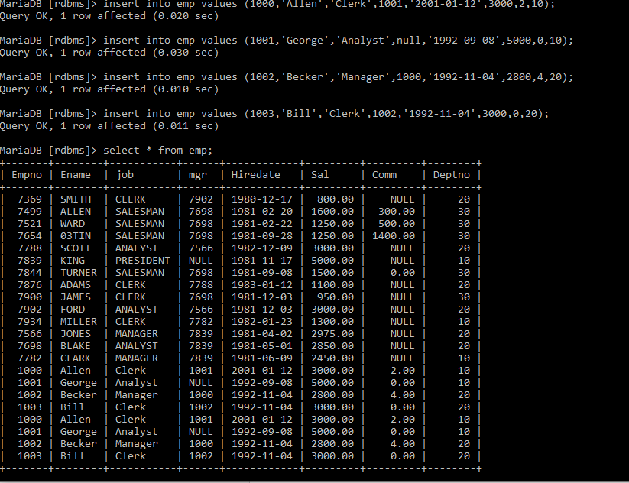

**6.1: Transaction Control Language Statements**

1. Insert rows with the following data into the Customer table. 6000, John, #115 Chicago, #115 Chicago, M, 25, 7878776, 10000 • 6001, Jack, #116 France, #116 France, M, 25, 434524, 20000 • 6002, James, #114 New York, #114 New York, M, 45, 431525, 15000.50

Use parameter substitution.

Create or replace table customermaster(customerid INT(5),customername varchar(30),Address1 varchar(30),Address2 varchar(30),Gender varchar(1),Age INT(3),phoneno INT(10),sales numeric(10,2));

insert into customermaster (customerid, customername ,address1 ,address2, gender, age, phoneno,sales) values ( 6001, 'John','#115 Chicago', '#115 Chicago', 'M',25, 7878776, 10000);

insert into customermaster (customerid, customername ,address1 ,address2, gender, age, phoneno,sales) values ( 6001, 'Jack','#116 France', '#116 France ', 'M', 25, 434524, 20000);

insert into customermaster (customerid, customername ,address1 ,address2, gender, age, phoneno,sales) values ( 6002, 'James','#114 New York', '#114 New York', 'M', 45, 431525, 15000.50 );

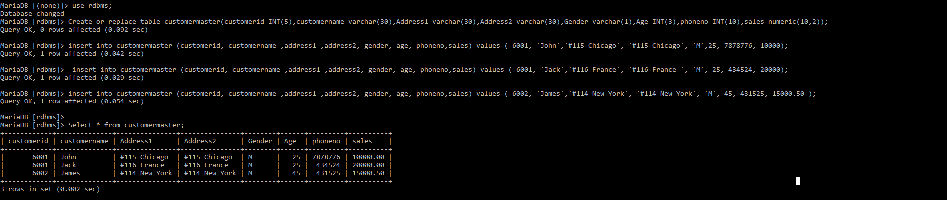

2. Create a Savepoint named ‘SP1’ after third record in the Customer table

MariaDB [rdbms]> Select * from customermaster;

Empty set (0.143 sec)



3. Insert the below row in the Customer table.

6003, John, #114 Chicago, #114 Chicago, M, 45, 439525, 19000.60

insert into customermaster (customerid, customername ,address1 ,address2, gender, age, phoneno,sales) values ( 6003, 'John','#114 Chicago', '#114 Chicago', 'M',45, 439525, 19000.60);

Select * from customermaster;

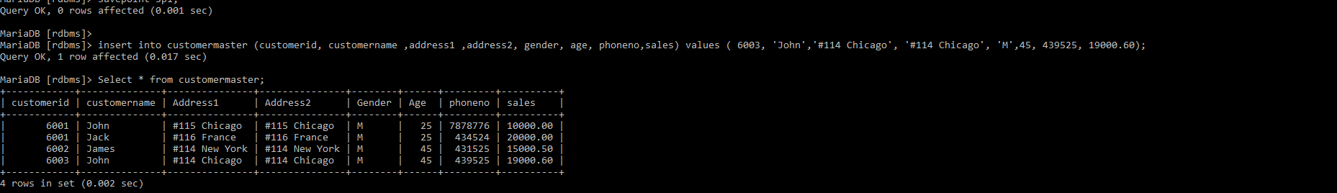

4. Execute rollback statement in such a way that whatever manipulations done before Savepoint sp1 are permanently implemented, and the ones after Savepoint SP1 are not stored as a part of the Customer table.

rollback to sp1;

Select * from customermaster;

