Shashank Kumar Pandey

RDBMS ASSIGNMENT

Required Tables

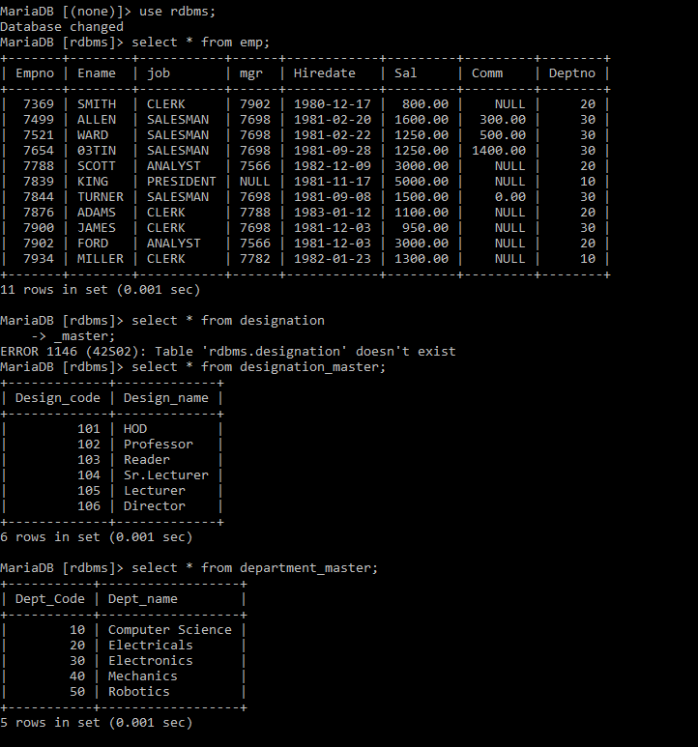

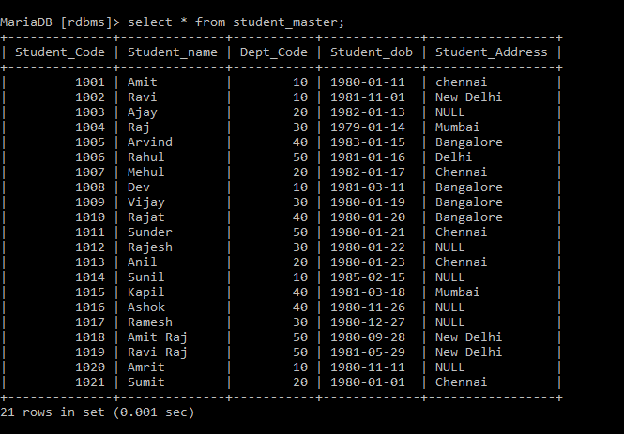

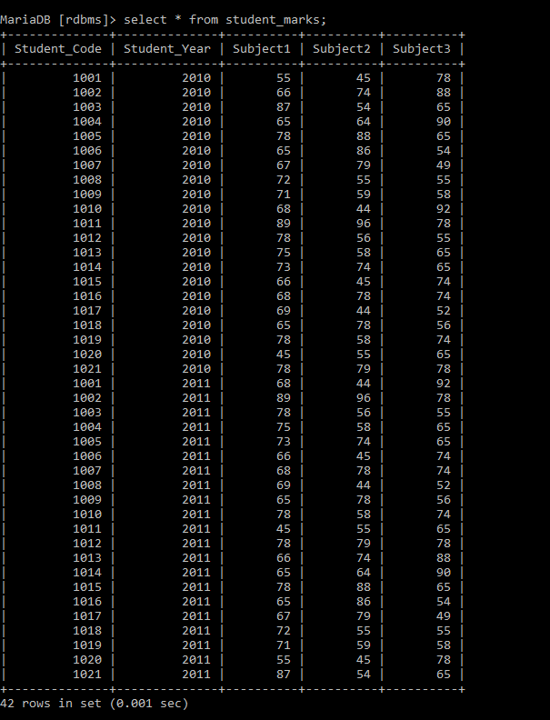

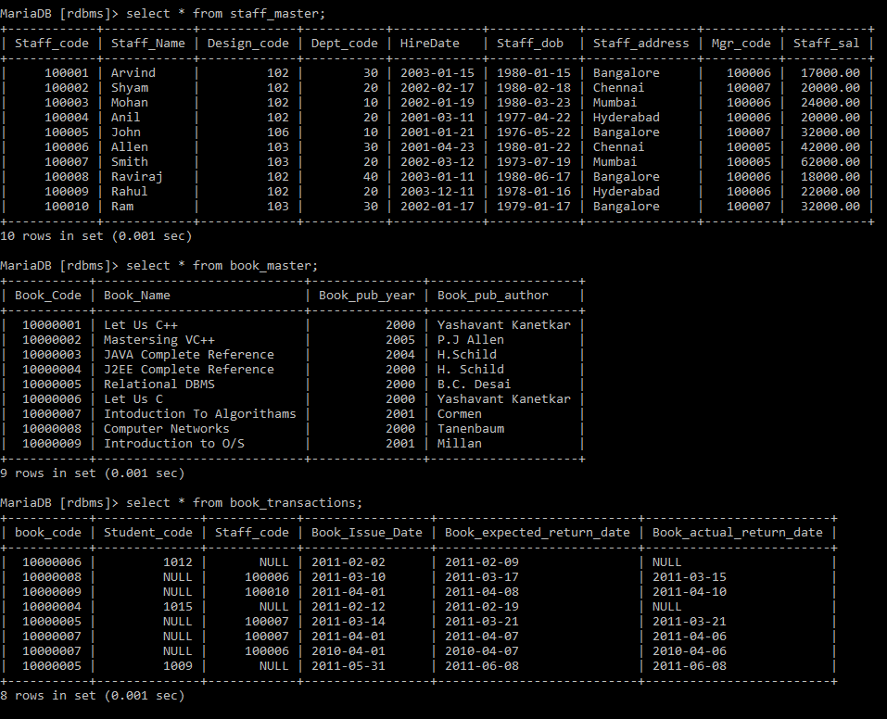

Queries:

1.1: Data Query Language

1. List the Name and Designation code of the staff who have joined before Jan 2003 and whose salary range is between 12000 and 25000. Display the columns with user defined Column headers. Hint: Use As clause along with other operators

MariaDB [rdbms]> select staff_name"Staff Name",design_code"Designation" from staff_master where (hiredate<'2003-01-01') AND staff_sal between 12000 and 25000;

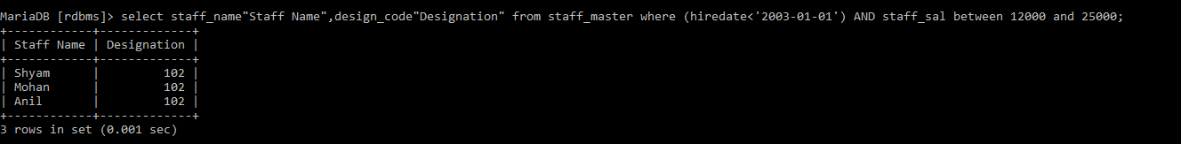

2. List the staff code, name, and department number of the staff who have experience of 18 or more years and sort them based on their experience.

MariaDB [rdbms]> SELECT STAFF_CODE,STAFF_NAME,DEPT_CODE FROM staff_master WHERE floor((datediff(curdate(),hiredate))/365)>=18 order by hiredate desc;

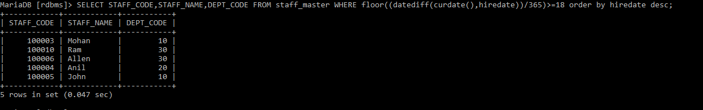

3. Display the staff details who do not have manager. Hint: Use is null

MariaDB [rdbms]> select * from staff_master where mgr_code is NULL;



4. Display the Book details that were published during the period of 2001 to 2004. Also display book details with Book name having the character ‘&’ anywhere.

MariaDB [rdbms]> SELECT * FROM BOOK_MASTER WHERE BOOK_PUB_YEAR BETWEEN 2001 AND 2004 AND BOOK_NAME LIKE '%[&]%';



5. List the names of the staff having ‘_’ character in their name.

MariaDB [rdbms]> select staff_name from staff_master where staff_name like '%_%';

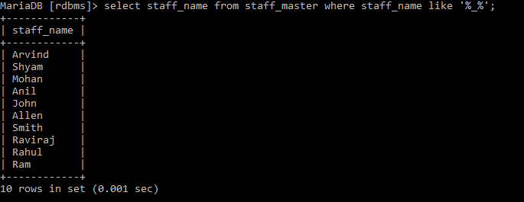

**2.1: Single Row Functions:**

1. Create a query which will display Staff Name, Salary of each staff. Format the salary to be 15 characters long and left padded with ‘$’.

MariaDB [rdbms]> select staff_name,lpad(staff_sal,15,'$') from staff_master;

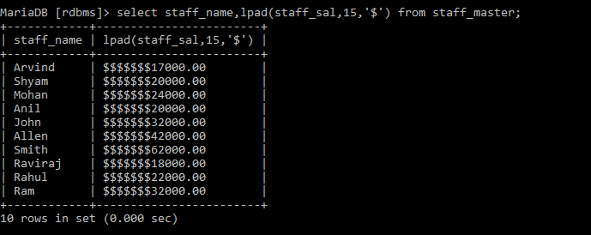

2. Display name and date of birth of students where date of birth must be displayed in the format similar to “January, 12 1981” for those who were born on Saturday or Sunday

MariaDB [rdbms]> select Student_name,date_format(Student_dob,"%M,%d %Y") AS Date_of_birth from student_master where dayname(student_Dob)='saturday' or dayname(student_dob)='Sunday';

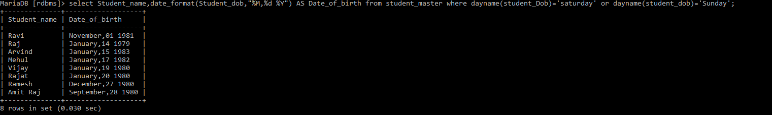

3. Display each Staff name and number of months they worked for the organization. Label the column as ‘Months Worked’. Order your result by number of months employed. Also Round the number of months to closest whole number.

MariaDB [rdbms]> SELECT STAFF_NAME,ROUND((datediff(CURDATE(),HIREDATE)/365)*12) AS MONTHS_WORKED FROM STAFF_MASTER order by months_worked;

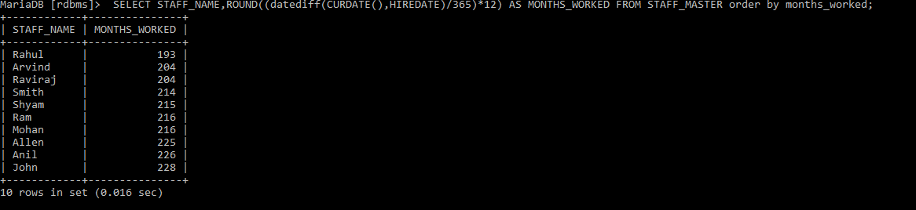

4. List the details of the staff who have joined in first half of December month (irrespective of the year).

MariaDB [rdbms]> SELECT * FROM STAFF_MASTER WHERE date_format(HIREDATE,'%d') BETWEEN 1 AND 15 AND date_format(HIREDATE,'%M') LIKE '%DECEMBER%' ;

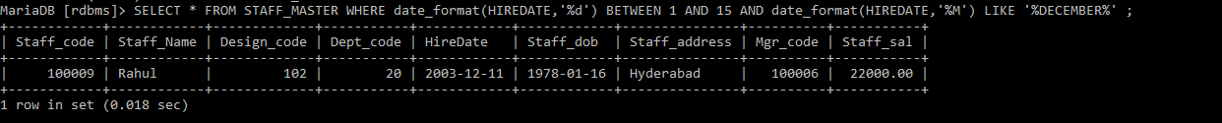

5. Write a query that displays Staff Name, Salary, and Grade of all staff. Grade depends on the following table.

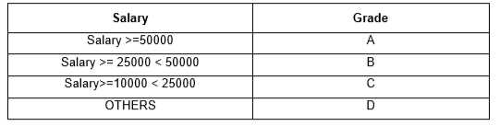

MariaDB [rdbms]> SELECT STAFF_NAME,STAFF_SAL ,

-> CASE

-> WHEN STAFF_SAL >=50000 THEN 'A'

-> WHEN STAFF_SAL >25000 AND STAFF_SAL<50000 THEN 'B'

-> WHEN STAFF_SAL >10000 AND STAFF_SAL<25000 THEN 'C'

-> else 'D'

-> end from staff_master;

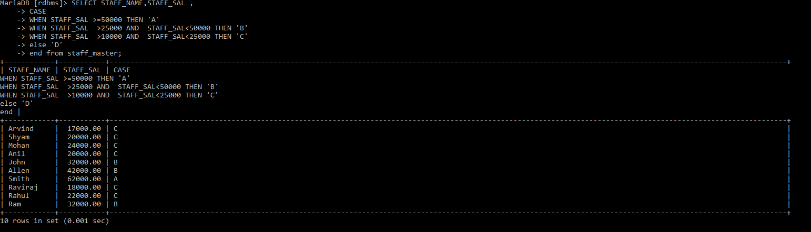

6. Display the Staff Name, Hire date and day of the week on which staff was hired. Label the column as DAY. Order the result by the day of the week starting with Monday. Hint :Use to_char with hiredate and formats ‘DY’ and ’D’

MariaDB [rdbms]> select staff_name,hiredate,dayname(hiredate) as DAY from staff_master order by (

-> case dayofweek(hiredate)

-> when 1 then 7

-> else dayofweek(hiredate)-1

-> end);

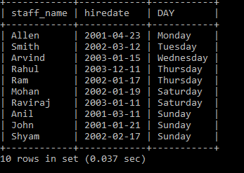

7.Write a query to find the position of third occurrence of ‘i’ in the given word ‘Mississippi’

select length(substring_index('Mississippi','i',3))+1 from dual;

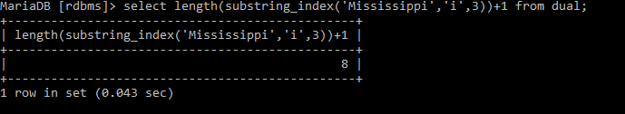

8. Write a query to find the pay date for the month. Pay date is the last Friday of the month. Display the date in the format “Twenty Eighth of January, 2002”. Label the heading as PAY DATE. Hint: use to_char, next_day and last_day functions.

9. Display Student code, Name and Dept Name. Display “Electricals” if dept code = 20, “Electronics” if Dept code =30 and “Others” for all other Dept codes in the Dept Name column. Hint : Use Decode

MariaDB [rdbms]> select student_code,student_name,

-> case

-> when dept_code=20 then 'Electricals'

-> when dept_code=30 then 'Electronics'

-> else

-> 'Others'

-> end from student_master;

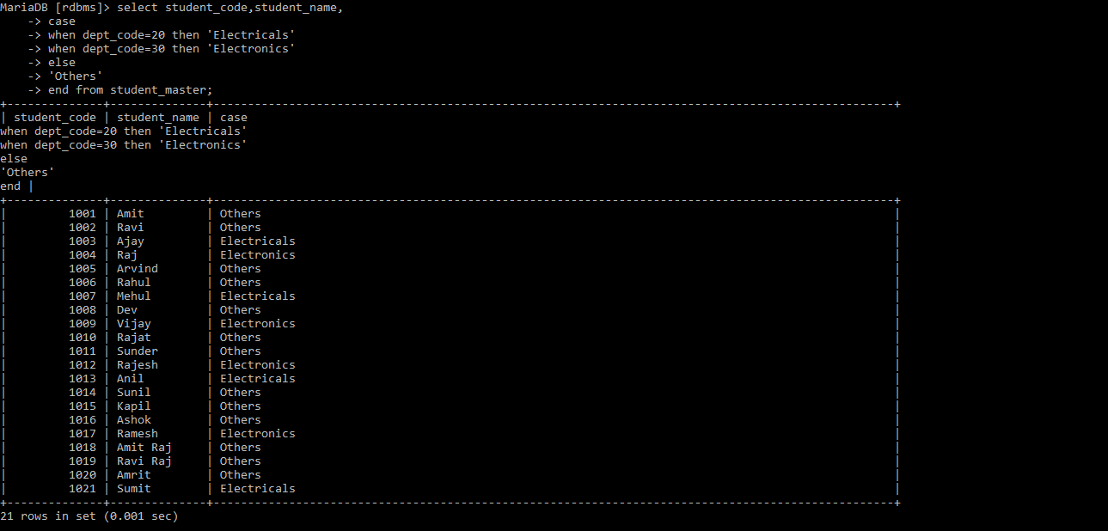

**2.2: Group Functions:**

1. Display the Highest, Lowest, Total & Average salary of all staff. Label the columns Maximum, Minimum, Total and Average respectively for each Department code. Also round the result to the nearest whole number.

MariaDB [rdbms]> select max(staff_sal) as Maximum,min(staff_sal) as Minimum,sum(staff_sal) as Total ,round(avg(staff_sal)) as Average from staff_master group by dept_code;

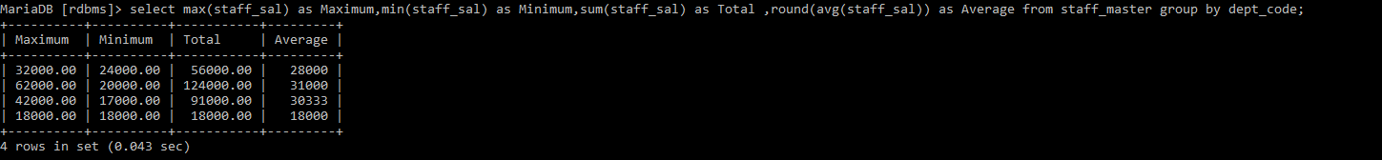

2. Display Department code and number of managers working in that department. Label the column as ‘Total Number of Managers’ for each department.

MariaDB [rdbms]> select deptno,count(job) as Total_Number_Of_Managers from emp where job="MANAGER" group by deptno;

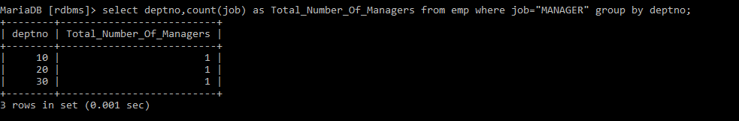

3. Get the Department number, and sum of Salary of all non-managers where the sum is greater than 20000.

MariaDB [rdbms]> select deptno,sum(sal) as sum from emp where job not like "manager" group by deptno having sum(sal)>20000;



**3.1: Joins and Subqueries**

1. Write a query which displays Staff Name, Department Code, Department Name, and Salary for all staff who earns more than 20000.

MariaDB [rdbms]> select s.staff_name,d.dept_code,d.dept_name,s.staff_sal from staff_master s,department_master d where s.dept_code=d.dept_code and staff_sal>20000;

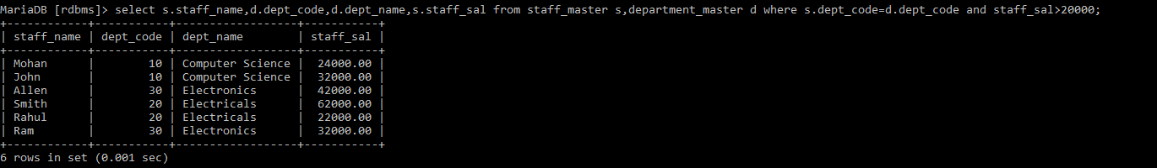

2. Display Staff Code, Staff Name, Department Name, and his manager’s number and name. Label the columns Staff#, Staff, Mgr#, Manager

MariaDB [rdbms]> select s.staff_code as "staff#",s.staff_name as "Staff",d.dept_name,s.mgr_code as "Mgr#",ss.staff_name as Manager from staff_master s,staff_master ss,department_master d where s.mgr_code=ss.staff_code and s.dept_code=d.dept_code;

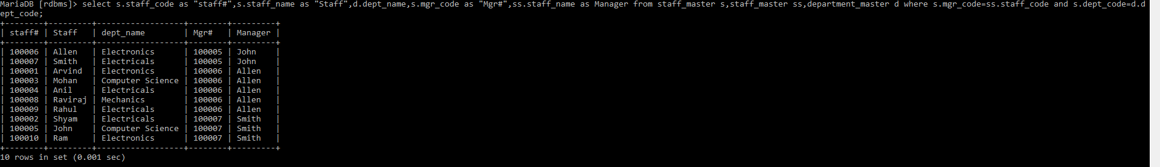

3. Create a query that will display Student Code, Student Name, Book Code, and Book Name for all students whose expected book return date is today.

MariaDB [rdbms]> select s.student_code,s.student_name,b.book_code,b.book_name from student_master s,book_transactions bb,book_master b where s.student_code=bb.student_code and bb.book_code and bb.book_expected_return_date=curdate();



4. Create a query that will display Staff Code, Staff Name, Department Name, Designation name, Book Code, Book Name, and Issue Date for only those staff who have taken any book in last 30 days. . If required, make changes to the table to create such a scenario.

MariaDB [rdbms]> insert into book_transactions values(10000006,1012,100001,'2020-01-04','2020-01-21',NULL);

Query OK, 1 row affected (0.027 sec)

MariaDB [rdbms]> select s.staff_code,s.staff_name,d.dept_name,dd.design_name,b.book_code,bb.book_name,b.book_issue_date from staff_master s,designation_master dd,department_master d,book_transactions b,book_master bb where s.design_code=dd.design_code and s.dept_code=d.dept_code and s.staff_code=b.staff_code and b.book_code=bb.book_code and datediff(curdate(),book_issue_date) between 0 and 30;

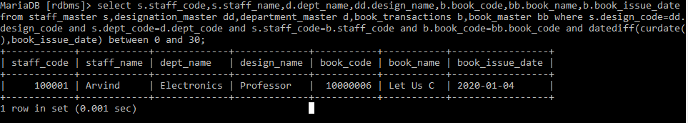

5. Generate a report which contains the following information.

Staff Code, Staff Name, Designation Name, Department, Book Code, Book Name,

Author, Fine For the staff who has not returned the book. Fine will be calculated as Rs. 5 per day.

Fine = 5 * (No. of days = Current Date – Expected return date). Include records in the table to suit this problem statement

MariaDB [rdbms]> select s.staff_code,s.staff_name,d1.dept_name,d2.design_name,b.book_code,b1.book_name,b1.book_pub_author,b.book_issue_date,datediff(b.book_actual_return_date,b.book_expected_return_date)*5 as fine,datediff(b.book_expected_return_date,b.book_actual_return_date) as datediff from department_master d1,designation_master d2,book_master b1,staff_master s inner join book_transactions b on

-> s.staff_code=b.staff_code where s.dept_code=d1.dept_code and s.design_code=d2.design_code and b.book_code=b1.book_code

-> and(datediff(curdate(),b.book_expected_return_date))>0 and datediff(b.book_expected_return_date,b.book_actual_return_date)<0;



6. List Staff Code, Staff Name, and Salary for those who are getting less than the average salary of organization.

MariaDB [rdbms]> select staff_code,staff_name,staff_sal from staff_master where staff_sal<(select avg(staff_sal) from staff_master);

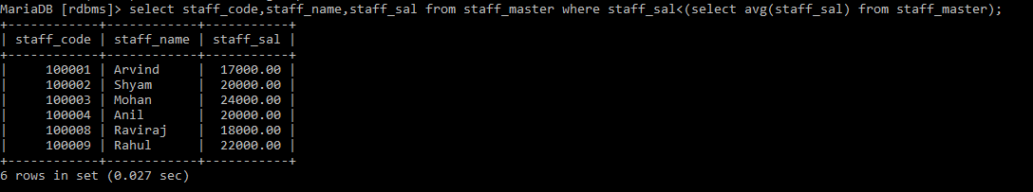

7. Display Author Name, Book Name for those authors who wrote more than one book.

MariaDB [rdbms]> SELECT book_pub_author as "Author Name",BOOK_NAME as "Book Name" FROM BOOK_MASTER where book_pub_author in(select book_pub_author from book_master HAVING COUNT(book_pub_author)>1);

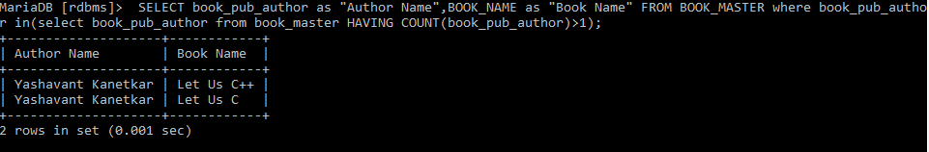

8. Display Staff Code, Staff Name, and Department Name for those who have taken more than one book.

MariaDB [rdbms]> select s.staff_code,s.staff_name,d.dept_name from staff_master s,department_master d,book_transactions b where s.dept_code=d.dept_code and s.staff_code =b.staff_code group by s.staff_code having count(*)>1;

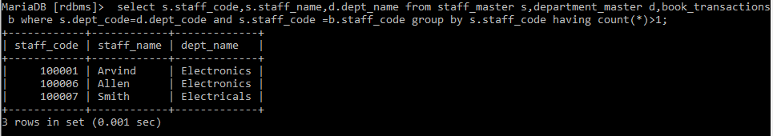

9. Display the Student Code, Student Name, and Department Name for that department in which there are maximum number of student studying.

select s.student_code,s.student_name,d.dept_name from student_master s,department_master d where s.dept_code=d.dept_code and d.dept_code=(select dept_code from student_master group by dept_code order by count(dept_code) desc limit 1);

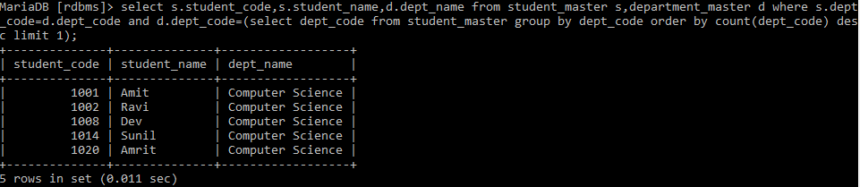

10. Display Staff Code, Staff Name, Department Name, and Designation name for those who have joined in last 3 months.

MariaDB [rdbms]> select s.staff_code,s.staff_name,d.dept_name,dd.design_name from staff_master s,department_master d,Designation_master dd where s.dept_code=d.dept_code and s.design_code=dd.design_code and datediff(curdate(),hiredate)<92;



11. Display the Manager Name and the total strength of his/her team.

MariaDB [rdbms]> select ss.staff_name as "Manager",count(ss.staff_name) from staff_master as s,staff_master ss,department_master as d where s.mgr_code=ss.staff_code and s.dept_code=d.dept_code group by manager;

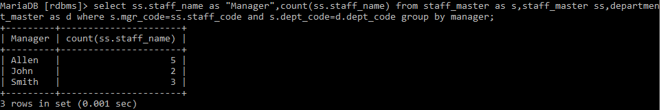

12. Display the details of books that have not been returned and expected return date was last Monday. Book name should be displayed in proper case.. Hint: You can change /add records so that the expected return date suits this problem statement

MariaDB [rdbms]> select b.book_code,b.book_name,b.book_pub_year,b.book_pub_author from book_master b inner join book_transactions bb where b.book_code=bb.book_code and bb.book_expected_return_date=date_sub(curdate(),interval weekday(curdate())day);



13. Write a query to display number of people in each Department. Output should display Department Code, Department Name and Number of People.

MariaDB [rdbms]> select s.dept_code,d.dept_name,count(s.staff_name) as Number_Of_People from staff_master s,department_master d where s.dept_code=d.dept_code group by dept_code;

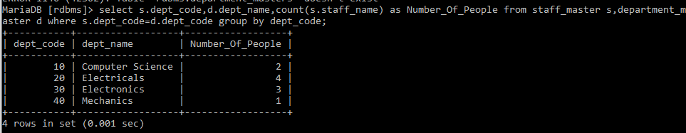

**4.1: Database Objects**