RIB2’S SPARKLE AND PRESTIGE CLEANERS

Rib2’S sparkle and prestige cleaners is a website mainly for providing cleaning services ranging from deep cleaning, residential cleaning, commercial cleaning, post construction, carpet and upholstery and move in or move out to its clients.
WEBSITE SPECIFICATION
WEBSITE OBJECTIVE: Ribs2’s Sparkle and Prestige Cleaners’ s main objective is to provide a high level of clean, hygienic, presentable and sanitized spaces for clients. They focus on promoting health, enhancing the aesthetic appeal of environments ensuring customer satisfaction for retention and generating profit through reliable services.
WEBSITE GOALS

- Exceptional client experience (customer service): Focus on building long-term trust by providing reliable, consistent and high-quality cleaning services that improve client’s quality of life.
- Superior Hygiene and sanitation: Ensuring all surfaces meet strict, healthy standards of cleanliness to remove dirt, germs and bacteria particularly through sanitation and disinfection.
- Sustainability and green practices: Implementing environmentally friendly products, techniques and energy/water conversation to meet modern demand for eco-friendly cleaning.
- Employee Reliability and development: Cultivating a professional team focused on honesty, integrity and safety.
- Business Growth and Sustainability: Increasing revenue expanding the client base and expanding service areas (e.g., Residential to commercial).
- Increase Customer Acquisition: Attracting new customers and turning them into loyal clients.

TARGET AUDIENCE
The website is designed to cater for different audiences with a variation of needs wants and technical capabilities in order to create an effective user experience which would meet the needs and wants of the audience. It is important to understand the target audience.

  - Primary Target Audience
  - Demographics Technical Amplitude
- Busy professionals | High income individuals who value time over money and need weekly or bi-weekly standard cleaning. | Online booking systems as uses mobile phones frequently.
Families with children | Parents looking for safe eco-friendly cleaning solutions and deep cleans before and after holidays. | Basic to intermediate, uses mobile phones.
Property renters/sellers | Individuals needing “move-in/move-out” services to secure security deposits or prepare a home for real estate listings. | Online booking systems to organize appointments. Intermediate to advanced.
Small Offices | Businesses requiring basic janitorial tasks like trash removal and restroom sanitation. | Intermediate to advanced.
Construction Firms | Contractors needing post-construction clean up to remove dust and debris before handing over a building. | Intermediate, seeks detailed specifications, compare services.
TYPE OF WEBSITE
Rib2’s Sparkle and Prestige Cleaners is mainly a business website, service-based website designed to show what services are offered, explain pricing or packages and allow customers to book or contact. It is also a small business website as it introduces the business, builds trust and attracts customers. Lastly it is a marketing website used to promote the brand, show before and after images, display testimonials and reviews to convince visitors to choose our service.
INFORMATION TAXONOMY AND DESIGN
INFORMATION ARCHITECTURE
The website follows a hierarchical information architecture that organizes content into logical categories. This structure ensures that users can find information efficiently within three clicks, following the standard web usability guideline. The architecture is designed to guide users from general information to specific details progressively.
Website Pages
1.HOME (services overview, about us, our work)
2.ABOUT (who we are, fun fact, mission, vision, why choose us, our team)
3. Services (residential cleaning, commercial cleaning, deep cleaning, post-construction, move-in/move-out, carpet and upholstery)
4.Gallery (client testimonials)
SITE MAP STRUCTURE

-Home
-About
-Services
-Gallery
-Contact

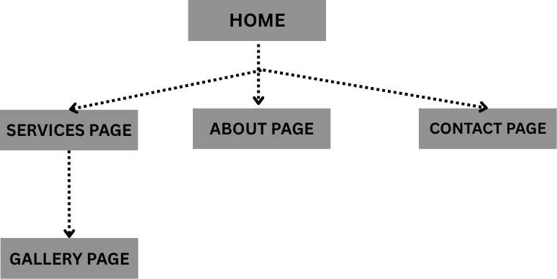

CONTENT TAXONOMY
Content is organized into a hierarchical taxonomy that categorizes information by its type and purpose so it’s easy to find, understand and mange different content elements.
1.HOME (services overview, about us, our work)
2.ABOUT (who we are, fun fact, mission, vision, why choose us, our team)
3. Services (residential cleaning, commercial cleaning, deep cleaning, post-construction, move-in/move-out, carpet and upholstery)
4.Gallery (Client testimonials)
5.Contact (phone number, email address, location, business hours, get in touch, book us, find us)
TECHINICAL BRIEF
Technologies used
The website uses front-end, back-end and supporting technologies to make it functional, attractive and easy for customers to book services.
HTML5- structures the website (pages like home, services, contact)
CSS- Styles the website and responsive design/layouts (colours, layout, fonts)
JAVA SCRIPT- Adds interactivity (forms, buttons, animations)
BOOTSTRAP 5.3- Frontend framework for responsive grid layout and components.
SOFTWARE TOOLS AND RESOURCES
Different software tools were used throughout the development process in order to edit, create and test the website. These tools were selected based on industry standards and educational appropriateness for first year students.

Development Tools
Visual studio code- A code writing, debugging and managing tool for computer programs and websites for HTML, CSS, GitHub and JavaScript.

Google chrome tools-Help developers create, test, debug and improve websites and web applications.

GitHub/GitHub Pages-Used by developers to create, test, debug and improve websites and web applications.

Graphics and Design Tools

Canva- A cloud-based graphic design platform used to create visual content quickly and easily.

Wireframe tools- Wireframe tools are graphics and design tools used to create the basic structure and layout of websites, mobile apps, and software interfaces before full development begins.

Pinterest- A visual discovery and inspiration platform that is widely used as a graphics and design tool for collecting, organizing, and sharing creative ideas.

References
- W3Schools for JavaScript tutorial: https://www.w3schools.com/js/:
- Web fundamentals, responsive web design basics: https://developers.google.com/articles/usability-101-introduction-to-usability/
- W3C web Accessibility initiative. Web Accessibility Tutorials: https://www.w3.org/WAI/tutorials/
- Bootstrap documentation. Get started With Bootstrap 5.3: https://getbootstrap.com/docs/5.3/getting-started

Page Design Template
