房志剛-1103105345-W01-20170323

結果

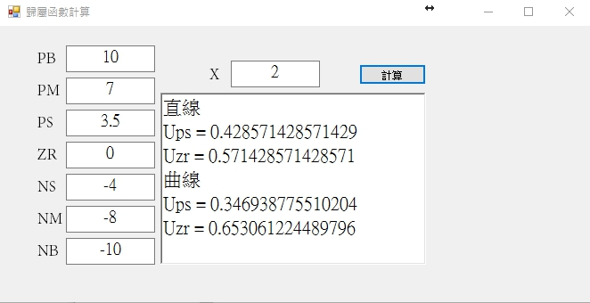

程式碼

private void Form1_Load(object sender, EventArgs e)

{

}

private void button_submit_Click(object sender, EventArgs e)

{

if (CheckRange())

{

CalculateMF();

}

else

{

MessageBox.Show("數值範圍錯誤", "錯誤");

}

}

private bool CheckRange()

{

try

{

if (Convert.ToDouble(textBox_PB.Text) < Convert.ToDouble(textBox_PM.Text))

return false;

if (Convert.ToDouble(textBox_PM.Text) < Convert.ToDouble(textBox_PS.Text))

return false;

if (Convert.ToDouble(textBox_PS.Text) < Convert.ToDouble(textBox_ZR.Text))

return false;

if (Convert.ToDouble(textBox_ZR.Text) < Convert.ToDouble(textBox_NS.Text))

return false;

if (Convert.ToDouble(textBox_NS.Text) < Convert.ToDouble(textBox_NM.Text))

return false;

if (Convert.ToDouble(textBox_NM.Text) < Convert.ToDouble(textBox_NB.Text))

return false;

if (Convert.ToDouble(textBox_PB.Text) == Convert.ToDouble(textBox_X.Text))

return false;

if (Convert.ToDouble(textBox_PM.Text) == Convert.ToDouble(textBox_X.Text))

return false;

if (Convert.ToDouble(textBox_PS.Text) == Convert.ToDouble(textBox_X.Text))

return false;

if (Convert.ToDouble(textBox_ZR.Text) == Convert.ToDouble(textBox_X.Text))

return false;

if (Convert.ToDouble(textBox_NS.Text) == Convert.ToDouble(textBox_X.Text))

return false;

if (Convert.ToDouble(textBox_NM.Text) == Convert.ToDouble(textBox_X.Text))

return false;

if (Convert.ToDouble(textBox_NB.Text) == Convert.ToDouble(textBox_X.Text))

return false;

}

catch (Exception e)

{

return false;

}

return true;

}

private void CalculateMF()

{

int Scope = -1;

List<Double> num = new List<double>();

Double PB = Convert.ToDouble(textBox_PB.Text);

Double PM = Convert.ToDouble(textBox_PM.Text);

Double PS = Convert.ToDouble(textBox_PS.Text);

Double ZR = Convert.ToDouble(textBox_ZR.Text);

Double NS = Convert.ToDouble(textBox_NB.Text);

Double NM = Convert.ToDouble(textBox_NM.Text);

Double NB = Convert.ToDouble(textBox_NB.Text);

Double X = Convert.ToDouble(textBox_X.Text);

num.Add(PB);

num.Add(PM);

num.Add(PS);

num.Add(ZR);

num.Add(NS);

num.Add(NM);

num.Add(NB);

Double line_a = 0, line_b = 0, curve_a = 0, curve_b = 0;

for (int i = 0; i < num.Count - 1; i++)

{

if (num[i] > X && num[i + 1] < X)

{

Scope = i + 1;

line_a = (num[i] - X) / (num[i] - num[i + 1]);

line_b = (X - num[i + 1]) / (num[i] - num[i + 1]);

Double tmp = 0;

if ((num[i] + num[i + 1]) <= X)

{

tmp = Math.Pow((X - num[i]) / (num[i] - num[i + 1]), 2) * 2;

}

else

{

tmp = Math.Pow((X - num[i + 1]) / (num[i] - num[i + 1]), 2) * 2;

}

curve_a = 1 - tmp;

curve_b = tmp;

}

}

if (Scope == -1)

{

if (X > PB)

{

Scope = 0;

line_a = 1;

line_b = 0;

curve_a = 1;

curve_b = 0;

}

else

{

Scope = 9;

line_a = 0;

line_b = 1;

curve_a = 1;

curve_b = 0;

}

}

String A, B;

switch (Scope)

{

case 0: //X > PB

A = "pb";

B = "pb";

break;

case 1: // PB > X > PM

A = "pb";

B = "pm";

break;

case 2: // PM > X > PS

A = "pm";

B = "ps";

break;

case 3: // PS > X > ZR

A = "ps";

B = "zr";

break;

case 4: // ZR > X > NS

A = "zr";

B = "ns";

break;

case 5: // NS > X > NM

A = "ns";

B = "nm";

break;

case 6: // NM > X > NB

A = "nm";

B = "nb";

break;

default: //NB > X

A = "nb";

B = "nb";

break;

}

richTextBox_out.Clear();

richTextBox_out.Text = richTextBox_out.Text + "直線" + Environment.NewLine;

richTextBox_out.Text = richTextBox_out.Text + "U" + A + " = " + line_a + Environment.NewLine;

richTextBox_out.Text = richTextBox_out.Text + "U" + B + " = " + line_b + Environment.NewLine;

richTextBox_out.Text = richTextBox_out.Text + "曲線" + Environment.NewLine;

richTextBox_out.Text = richTextBox_out.Text + "U" + A + " = " + curve_a + Environment.NewLine;

richTextBox_out.Text = richTextBox_out.Text + "U" + B + " = " + curve_b;

}