房志剛-1103105345-W06-20170504

結果:

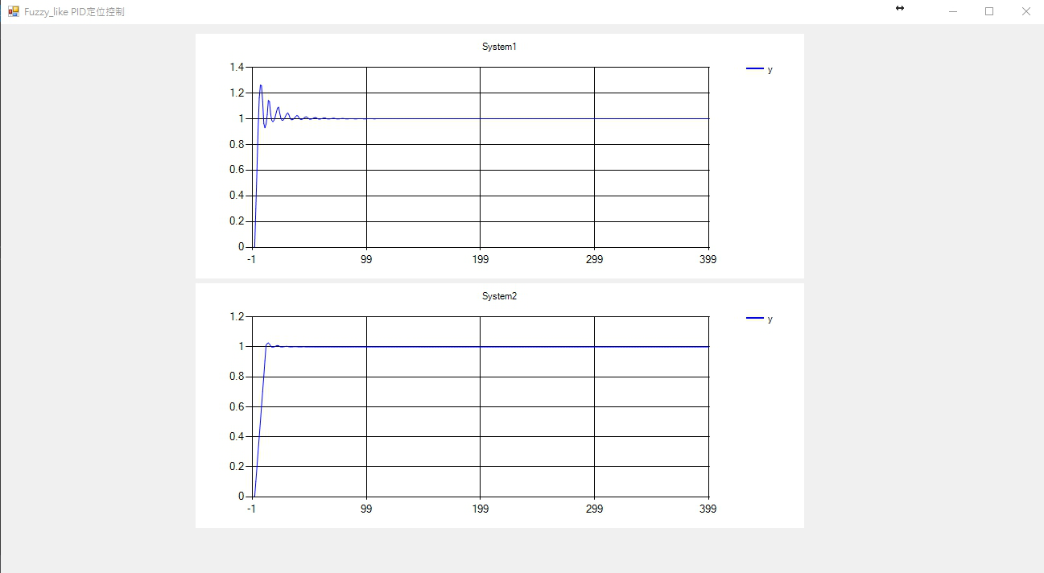

程式碼:

public partial class Form1 : Form

{

public Form1()

{

InitializeComponent();

}

public class E

{

public Double e = 0;

public Double e_dot = 0;

public E(Double e, Double e_dot)

{

this.e = e;

this.e_dot = e_dot;

}

public E()

{

this.e = 0;

this.e_dot = 0;

}

}

public class X

{

public Double x1 = 0;

public Double x2 = 0;

public X(Double e, Double e_dot)

{

this.x1 = e;

this.x2 = e_dot;

}

public X()

{

this.x1 = 0;

this.x2 = 0;

}

}

public class Fuzzy

{

private static String[,] table ={

{ "NB", "NB", "NB", "NS", "PB" } ,

{ "NB", "NS", "NS", "PS", "PB" } ,

{ "NB", "NS", "ZE", "PS", "PB" } ,

{ "NB", "NS", "PS", "PS", "PB" } ,

{ "NB", "NS", "PB", "PB", "PB" } };

private static Double[] Single_pole = { -10, -5, 0, 5, 10 };

private static Double[] Y1 = { 1, 0, 1, 0, 1 };

private static Double[] Y2 = { 0, 1, 0, 1, 0 };

private static Double[] num = { -1, -0.22, 0, 0.22, 1 };

private static Double[] FF = { -1, -0.07, 0, 0.07, 1 };

private static double D = 1;

public static Double Convert_Function(String str)

{

switch (str)

{

case "NB":

return Single_pole[0];

case "NS":

return Single_pole[1];

case "ZE":

return Single_pole[2];

case "PS":

return Single_pole[3];

case "PB":

return Single_pole[4];

default:

return Single_pole[0];

}

}

public static Double get_table(int i, int j)

{

return Convert_Function(table[i, j]);

}

public static int Rank_D_A(Double x)

{

Double[] distanse = new Double[5];

for (int i = 0; i < 5; i++)

{

distanse[i] = Math.Abs(x - num[i]);

}

Double min = distanse[0];

int index = 0;

for (int i = 1; i < 5; i++)

{

if (distanse[i] < min)

{

min = distanse[i];

index = i;

}

}

if (index == 4) return 3;

return (index);

}

public static int Rank_D_B(Double x)

{

Double[] distanse = new Double[5];

for (int i = 0; i < 5; i++)

{

distanse[i] = Math.Abs(x - FF[i]);

}

Double min = distanse[0];

int index = 0;

for (int i = 1; i < 5; i++)

{

if (distanse[i] < min)

{

min = distanse[i];

index = i;

}

}

if (index == 4) return 3;

return (index);

}

public static E FuzzyControlA(Double y, Double e)

{

Double e_next, e_dot_next;

e_next = D - y;

e_dot_next = e_next - e;

return new E(e_next, e_dot_next);

}

public static X FuzzyControl_X(Double x1, Double x2, Double u)

{

Double x1_next, x2_next;

x1_next = (x1 + 0.01 * x2 + 0.01 * u);

x2_next = 0.1 * x1 + 0.97 * x2;

return new X(x1_next, x2_next);

}

public static Double CalculateA(Double e, Double e_dot, Double u_previos)

{

int zone_e = -1, zone_e_dot = -1;

Double u1, u2, u3, u4;

zone_e = Rank_D_A(e);

zone_e_dot = Rank_D_A(e_dot);

if (Y1[zone_e] > Y1[zone_e + 1])

{

u1 = Math.Abs(e - num[zone_e + 1]) / Math.Abs(num[zone_e] - num[zone_e + 1]);

u2 = 1 - u1;

}

else

{

u1 = 1 - Math.Abs(e - num[zone_e]) / Math.Abs(num[zone_e] - num[zone_e + 1]);

u2 = 1 - u1;

}

if (Y2[zone_e_dot] > Y2[zone_e_dot + 1])

{

u3 = Math.Abs(e_dot - num[zone_e_dot + 1]) / Math.Abs(num[zone_e_dot] - num[zone_e_dot + 1]);

u4 = 1 - u3;

}

else

{

u3 = 1 - Math.Abs(e_dot - num[zone_e_dot]) / Math.Abs(num[zone_e_dot] - num[zone_e_dot + 1]);

u4 = 1 - u3;

}

Double u13 = (u1 * u3), u23 = (u2 * u3), u14 = (u1 * u4), u24 = (u2 * u4);

Double u = ((u13 * get_table(zone_e_dot, zone_e) + u23 * get_table(zone_e_dot, zone_e + 1) + u14 * get_table(zone_e_dot + 1, zone_e) + u24 * get_table(zone_e_dot + 1, zone_e + 1)) / (u13 + u23 + u14 + u24));

u = u + u_previos;

if (u >= 10.0) u = 10.0;

else if (u <= -10.0) u = -10.0;

//if (u < 0.0) u = u * -1.0;

return u;

}

public static Double CalculateB(Double e, Double e_dot, Double u_previos)

{

int zone_e = -1, zone_e_dot = -1;

Double u1, u2, u3, u4;

zone_e = Rank_D_B(e);

zone_e_dot = Rank_D_B(e_dot);

if (Y1[zone_e] > Y1[zone_e + 1])

{

u1 = Math.Abs(e - FF[zone_e + 1]) / Math.Abs(FF[zone_e] - FF[zone_e + 1]);

u2 = 1 - u1;

}

else

{

u1 = 1 - Math.Abs(e - FF[zone_e]) / Math.Abs(FF[zone_e] - FF[zone_e + 1]);

u2 = 1 - u1;

}

if (Y2[zone_e_dot] > Y2[zone_e_dot + 1])

{

u3 = Math.Abs(e_dot - FF[zone_e_dot + 1]) / Math.Abs(FF[zone_e_dot] - FF[zone_e_dot + 1]);

u4 = 1 - u3;

}

else

{

u3 = 1 - Math.Abs(e_dot - FF[zone_e_dot]) / Math.Abs(FF[zone_e_dot] - FF[zone_e_dot + 1]);

u4 = 1 - u3;

}

Double u13 = (u1 * u3), u23 = (u2 * u3), u14 = (u1 * u4), u24 = (u2 * u4);

Double u = ((u13 * get_table(zone_e_dot, zone_e) + u23 * get_table(zone_e_dot, zone_e + 1) + u14 * get_table(zone_e_dot + 1, zone_e) + u24 * get_table(zone_e_dot + 1, zone_e + 1)) / (u13 + u23 + u14 + u24));

u = u + u_previos;

if (u > 10.0) u = 10.0;

else if (u < -10.0) u = -10.0;

//if (u < 0.0) u = u * -1.0;

return u;

}

public static Double CalculateNextY(Double y, Double u)

{

return (1.01 * y + 0.01 * Math.Pow(y, 2) + 0.03 * u);

}

public static Double CalculateNextY(Double x)

{

return x;

}

}

public static Double D = 1;

private void Form1_Load(object sender, EventArgs e)

{

Text = "Fuzzy_like PID定位控制";

System1(chart1);

System2(chart2);

}

private void System1(Chart chart)

{

Double[] Y = new Double[500];

Double[] U = new Double[500];

E[] e = new E[500];

e[0] = new E(1, 0);

Y[0] = 0;

U[0] = 0;

Double[] E_ = new Double[500];

Double[] E_dot = new Double[500];

E_[0] = e[0].e;

E_dot[0] = e[0].e_dot;

for (int i = 1; i < 400; i++)

{

Y[i] = Fuzzy.CalculateNextY(Y[i - 1], U[i - 1]);

e[i] = Fuzzy.FuzzyControlA(Y[i], e[i - 1].e);

U[i] = Fuzzy.CalculateA(e[i].e, e[i].e_dot, U[i - 1]);

E_[i] = e[i].e;

E_dot[i] = e[i].e_dot;

}

//標題 最大數值

Series series1 = new Series("y", 1);

Series series2 = new Series("e", 1);

Series series3 = new Series("e_dot", 1);

Series series4 = new Series("u", 1);

//設定線條顏色

series1.Color = Color.Blue;

series2.Color = Color.Red;

series3.Color = Color.Green;

series4.Color = Color.Yellow;

//折線圖

series1.ChartType = SeriesChartType.Line;

series2.ChartType = SeriesChartType.Line;

series3.ChartType = SeriesChartType.Line;

series4.ChartType = SeriesChartType.Line;

//將數值新增至序列

for (int index = 0; index < 400; index++)

{

series1.Points.AddXY(index, Y[index]);

series2.Points.AddXY(index, E_[index]);

series3.Points.AddXY(index, E_dot[index]);

series4.Points.AddXY(index, U[index]);

}

//將序列新增到圖上

chart.Series.Add(series1);

//this.chart1.Series.Add(series2);

//this.chart1.Series.Add(series3);

//this.chart1.Series.Add(series4);

//series1.IsValueShownAsLabel = true;

//series2.IsValueShownAsLabel = true;

//標題

chart.Titles.Add("System1");

}

private void System2(Chart chart)

{

Double[] Y = new Double[500];

Double[] U = new Double[500];

E[] e = new E[500];

X[] x = new X[500];

e[0] = new E(1, 0);

x[0] = new X(0, 0);

Y[0] = 0;

U[0] = 0;

Double[] E_ = new Double[500];

Double[] E_dot = new Double[500];

E_[0] = e[0].e;

E_dot[0] = e[0].e_dot;

for (int i = 1; i < 400; i++)

{

x[i] = Fuzzy.FuzzyControl_X(x[i - 1].x1, x[i - 1].x2, U[i - 1]);

Y[i] = Fuzzy.CalculateNextY(x[i].x1);

e[i] = Fuzzy.FuzzyControlA(Y[i], e[i - 1].e);

U[i] = Fuzzy.CalculateB(e[i].e, e[i].e_dot, U[i - 1]);

E_[i] = e[i].e;

E_dot[i] = e[i].e_dot;

}

//標題 最大數值

Series series1 = new Series("y", 1);

Series series2 = new Series("e", 1);

Series series3 = new Series("e_dot", 1);

Series series4 = new Series("u", 1);

//設定線條顏色

series1.Color = Color.Blue;

series2.Color = Color.Red;

series3.Color = Color.Green;

series4.Color = Color.Yellow;

//折線圖

series1.ChartType = SeriesChartType.Line;

series2.ChartType = SeriesChartType.Line;

series3.ChartType = SeriesChartType.Line;

series4.ChartType = SeriesChartType.Line;

//將數值新增至序列

for (int index = 0; index < 400; index++)

{

series1.Points.AddXY(index, Y[index]);

series2.Points.AddXY(index, E_[index]);

series3.Points.AddXY(index, E_dot[index]);

series4.Points.AddXY(index, U[index]);

}

//將序列新增到圖上

chart.Series.Add(series1);

//chart.Series.Add(series2);

//chart.Series.Add(series3);

//chart.Series.Add(series4);

//series1.IsValueShownAsLabel = true;

//series2.IsValueShownAsLabel = true;

//標題

chart.Titles.Add("System2");

}

}