Extended Essay Plan

**Student Name**: Abraham Cheung

**EE Subject and Supervisor Name**: Geography, Mr. Victor Lam

**Finalised Research Question**: What is the relationship between the distribution of parking spaces and the local traffic in urban areas of Hong Kong?

# Abstract/Introduction

Geographical context: traffic congestion has long been a central urban issue that affects many citizens in Hong Kong, increasing average journey delay times and causing much frustration among road users.

Traffic congestion is a phenomenon in which the specific road section’s demand has exceeded its design road capacity.

Other than encouraging the use of public transport, a major way to free up the road inventory to solve traffic congestion are parking spaces, which essentially removes cars from the road inventory, hence relieving traffic congestion. With the increase of parking spaces, drivers are no longer forced to unload/load goods/people on the kerbside, which normally occupy lanes and causes a significant decrease in road capacity.

However, infinitely adding more car parks in the area might not always have a positive effect on solving traffic congestion, rather the opposite effect, as drivers may spend more time cruising around the area in search for car parks offering parking spaces at a lower price.

Hence, this study will aim to address the issue and create a more robust understanding on the relationship between the distribution of parking spaces on traffic congestion.

# Hypotheses

## Hypothesis 1

: The relative magnitude of traffic congestion will increase as the accessibility to parking spaces increases.

: The relative magnitude of traffic congestion will decrease as the accessibility to parking spaces increases.

## Hypothesis 2

: The relative magnitude of traffic congestion will decrease as the clustering of parking spaces increases.

: The relative magnitude of traffic congestion will increase as the clustering of parking spaces increases.

# Study Area

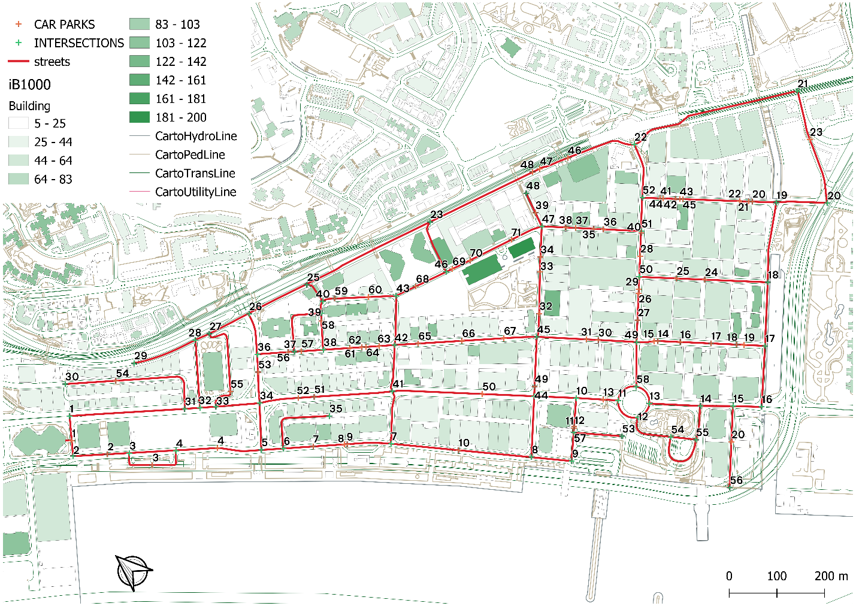Regarding the study area, I have chosen an area enclosed within Kwun Tong Road, Wai Yip Street and Wai Fai Street in Kwun Tong (studied streets are in yellow). This area has been chosen because it is renowned for its poor traffic performance during peak traffic hours, especially along Kwun Tong Rd, where many arterial roads merge that causes traffic issues, especially at intersections 22, 23 and 26. Below is a map of the area:

Source: *iB1000 Maps by LandsD*

The color on the buildings denote its height (white: 0m, green: 200m), which serves as a rough indicator on the traffic demand of the location, which will be further explored in the independent variable section.

# Methodology

## Quantification of Dependent Variable

Dependent Variable is the relative magnitude of traffic congestion, or the traffic congestion index.

### Primary Methods

According to Bovy and Saloman[1], traffic congestion can be defined as a state of traffic characterised by high densities (*k*) and low speeds (*v*).

The density referred in this definition is the total sum of the vehicle’s length divided by the length of the road segment. However, this is historically trivial to obtain, as satellite imagery will have to be used and extensively analysed. A research[2] indicated that time occupancy, which is defined by the percentage of time occupied by the vehicle, over the total survey time, are closely related to density, by the equation:

where is the average length of the vehicles surveyed, and the the length of the survey area.

However, as the study only requires a relative traffic congestion index, and that time occupancy and density are directly proportional to each other as demonstrated above, time occupancy will be used as a proxy indicator.

Hence, to obtain the time occupancy of the road, a simple website will be created. When a vehicle enters or passes a certain set line, the key on the computer will be pressed down to start a stopwatch and released/stopped when the vehicle exits the set line. By summing up all times where the line has been occupied by the vehicle and incorporating with the total survey time, the occupancy at that survey location can be calculated.

The sample size is aimed at 30, with a 10-minute length of survey per location. Such surveys will be performed on Mondays to Fridays, at peak hours, during 9-10am and 6-7pm, to ensure that the effects of traffic congestion are the most apparent, as well to ensure data reliability and to minimise uncertainty.

### Secondary Methods

To minimise the potential errors incurred within the study, secondary data collection methods will be used. To recall, one of the major characteristics of traffic congestion is low vehicular velocity and high density. As neither density nor time occupancy can be retrieved through online sources, Bing Maps API[3] will be utilised to obtain vehicular velocity. Although such data is aggregated through the signals of mobile devices and may not provide data of high fidelity, it will be used to supplement the primary data.

Below is a demonstration on how the vehicular speed can be retrieved:

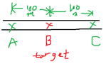

1. To find the vehicle speed at B, find two points A, C that are colinear and 50m away from B.
2. Get the time needed to travel from A to C.
3. Speed can then be determined using the formula .

Another fundamental concept is the velocity-density diagram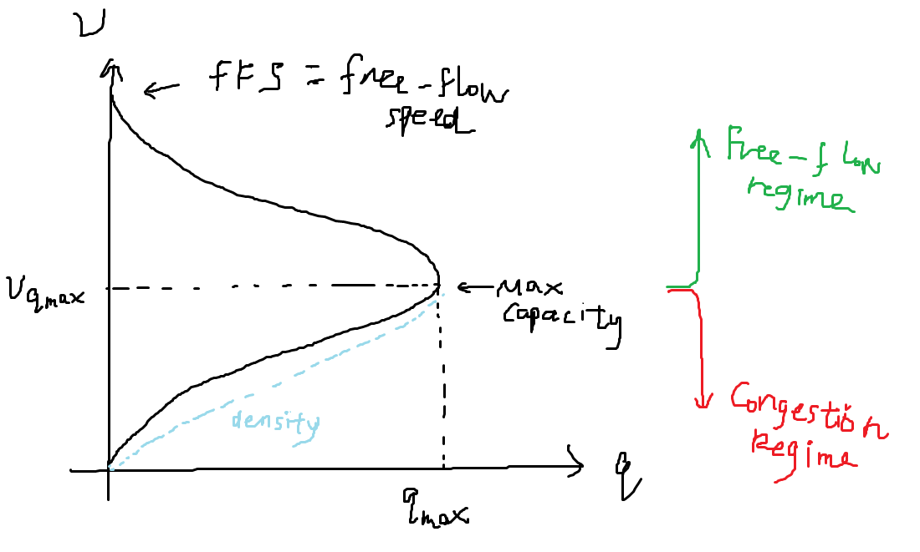.

This demonstrates that when the density is very low, this allows vehicles to travel at any speed they intend to. The measure of this called the free-flow speed, which is an integral parameter for traffic analysis. As the Bing Maps API offers the free-flow speed, by dividing the observed speed with the free-flow speed, a measure of traffic congestion can be determined.

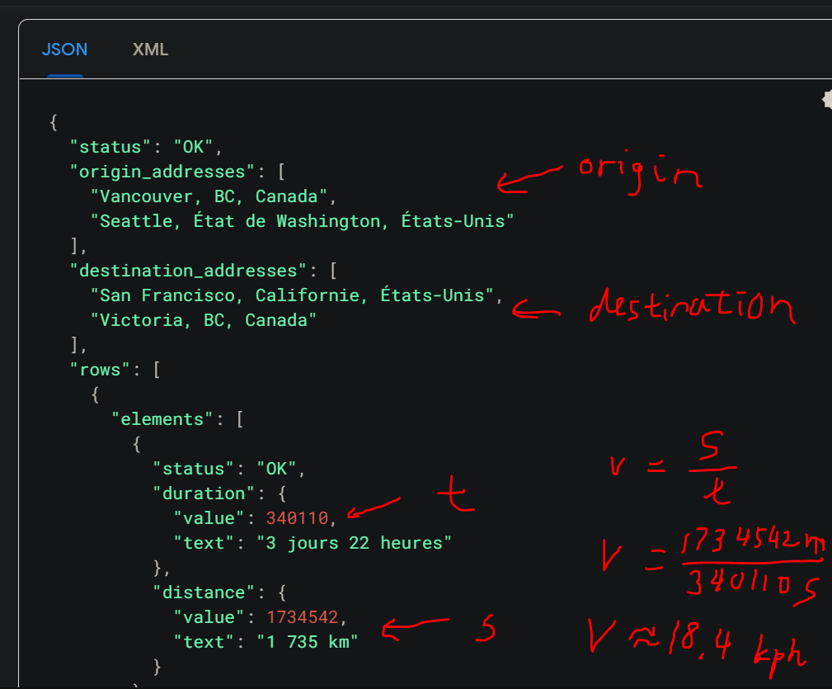Furthermore, Google Maps Distance Matrix API also offers a similar API and may be used in the future because Google is a larger corporation and potentially holds more accurate information. However, there are some implementation challenges that are yet to be solved, so Bing Maps API will be used for the moment.

The above is a sample calculation using Google’s Distance Matrix API[4].

## Quantification of Independent Variable

The independent variable of this study is the distribution of parking spaces, in which the hypotheses further divide this into the accessibility and clustering of parking spaces.

Firstly, in order to process the distribution of parking spaces, a list of parking spaces are first extracted through via the HKeMobility website:

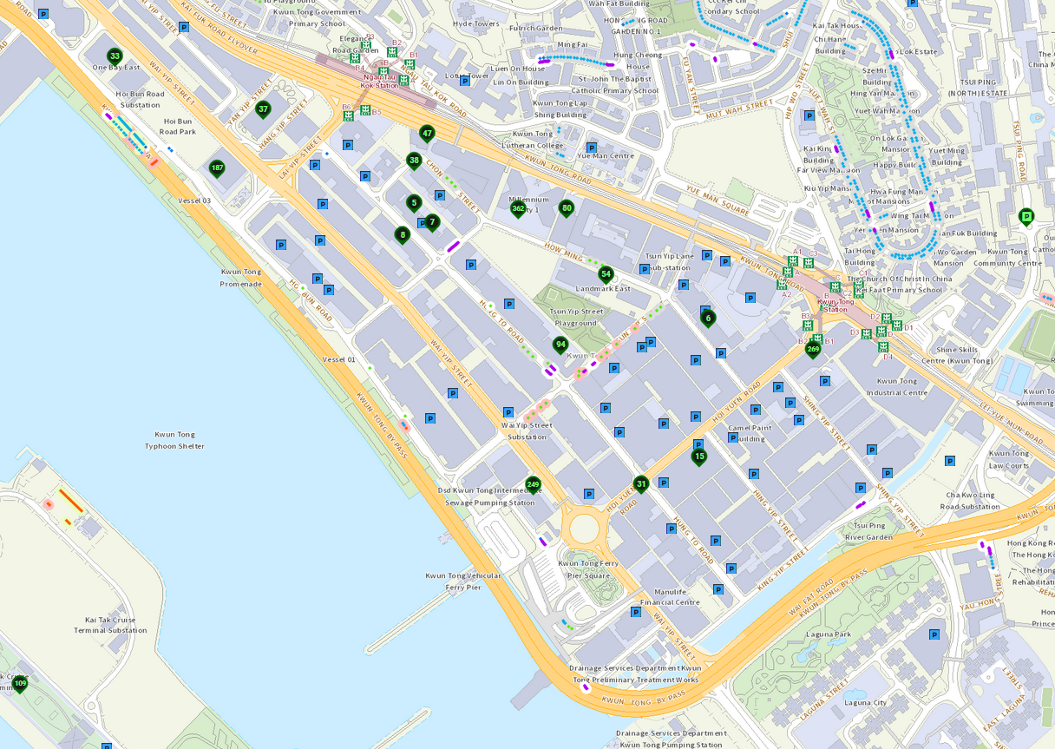Source: HKeMobility[5]

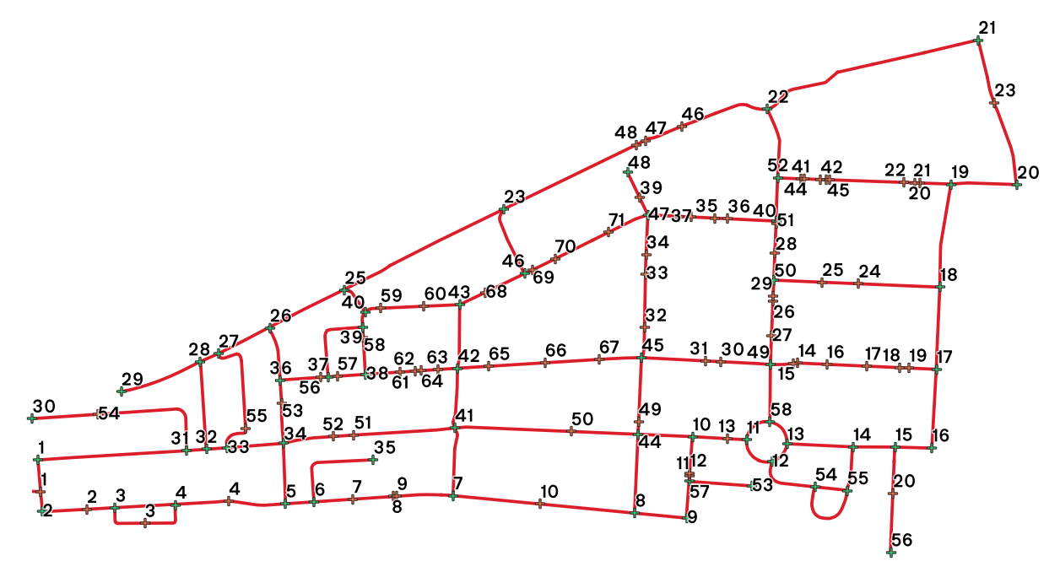A digital copy of the iB1000 map, which stores map data in a machine-readable format is downloaded via HKMS2.0[6]. It is then processed through QGIS[7], an open-source GIS (Geographic Information System) platform used to create, manipulate and remove elements on maps. According to the StreetCentreLines database table, the streets and intersections are marked down. Combining the parking data from HKeMobility, such a node graph is created below:

# Measurement of parking space availability

The advantages of presenting the data in such a way is because it allows calculations to be performed against such a node graph using Python.

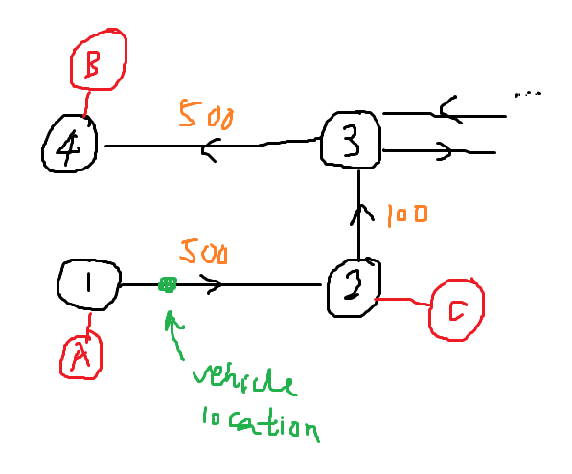As the hypotheses aims to relate the magnitude of traffic congestion (dependent variable) with the accessibility and clustering of the parking spaces (independent variable), to determine a “score” or “index” of accessibility and clustering of parking spaces *at that specific point*, it is useful to create machine-readable graph to be able to run algorithms on it. This model is a “road network” consisting of nodes (which acts as intersections), with lines connecting each node (acting as roads), as demonstrated below:

## Accessibility of parking spaces (UPDATED)

The method used is called two-step floating catchment area (Ga2SFCA)[8], which is typically used to measure the spatial accessibility of healthcare facilities, emergency shelters a

nd others.

Generally, the accessibility () of any given spot on a node graph is:

Specifically,

Where is the supply of the facility , and is the demand, or population at every demand node . The distance decay function is given by:

Where is the maximum catchment size.

## Clustering of parking spaces (UPDATED)

Clustering Coefficient for weighted directed networks[9]

~~City Clustering Algorithm~~

~~https://core.ac.uk/download/pdf/33751302.pdf~~

~~Spatial autoregressive (SAR) Probit Models~~[10]

## Accessibility of parking spaces

In this case, the index of accessibility of parking spaces can be determined by the

The reason for this is because the accessibility is high when the driving distance is low, and when the number of parking spaces is high. With this fact, such Equation 2 will be able to quantify the accessibility numerically.

## Clustering of parking spaces

Unfortunately, more research still has to go into the determination of a function to quantify the clustering of parking spaces. One of the potential functions is the *k*-nearest neighbours algorithm (*k*-NN).

## Parking spaces

Because the parking space cannot be found, a proxy indicator will be used, which is the gross-floor area of the building that owns the parking space. As the HKPSG clearly states that residential developments are required to provide at least *n* parking spaces per gross floor area, therefore the number of parking spaces can then be determined from the building’s number of storeys (can be obtained via the BMIS) and the area (from the iB1000 map), detailed below.

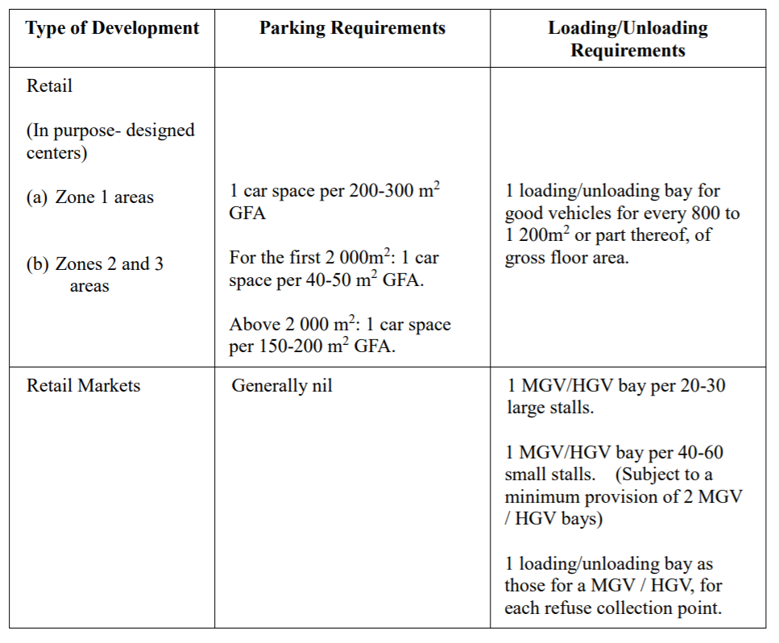Source: HKPSG[11]

# Evaluation

# Conclusion

# References

1. Bovy, P.H.L. and Salomon, I. (2002) Congestion in Europe: measurements, patterns and policies, in E. Stern, I. Salomon and P.H.L. Bovy (eds.), Travel Behaviour: spatial patterns, congestion and modelling, Cheltenham: Edward Elgar
2. <https://ieeexplore.ieee.org/stamp/stamp.jsp?arnumber=8946555> (10.1109/ACCESS.2019.2963273)
3. https://docs.microsoft.com/en-us/rest/api/maps/traffic/gettrafficflowsegment
4. https://developers.google.com/maps/documentation/distance-matrix/overview
5. https://www.hkemobility.gov.hk/
6. https://www.hkmapservice.gov.hk/OneStopSystem/map-search
7. https://www.qgis.org/
8. doi.org/10.1186/s12939-020-01280-7
9. doi.org/10.1017/nws.2014.26
10. doi.org/10.1177/0739456X20908945
11. https://www.pland.gov.hk/pland_en/tech_doc/hkpsg/sum/pdf/sum_ch8_en.pdf