Introduction

How is it related to daily life?

What are the advantages for understanding this concept?

Past research:

Different methodology? Different range? Mixed results?

K is different from each researcher?

Show their graphs and/or formula

Framework

Derive the formula from the definition

Relationship between IV and DV?

What are the assumptions of this derivation?

What are the physics concept in the microscopic view?

Do not give false claims

Pilot Study

Can your range of IV give a good range of DVs? How many percent?

Why use the choice of CVs?

What problems did you find? How did you solve it?

Variables

Type of variable, symbol, variable name, description

Include justification of the range

What is the definition, especially the DV?

How to measure this variable?

How do you make sure that the CVs are constant?

Include 3 CVs, but don’t put variables you cannot control.

Apparatus

Use 2/3 columns

Include precision!

Procedure

Use <ol>

7 intervals of IV and each repeated with 3 times

What are the precautions? Fluctuations? Alignment?

Ethical, safety and environmental concerns

Protective gear? Warning signs?

Things fracturing/cracking/breaking? Slippery? Chemicals?

Be more authoritative and specific

Do not over-exaggerate safety issues! (electrocution due to batteries)

Waste reduction? Waste Handling? Will it be safe to dispose the waste?

Qualitative Observation

Describe the trend, any violations/contradiction with the assumptions? (welp -)

Any fluctuations in measurements?

Are CVs changing?

Raw Data Table

IV on left, DV on right, uncertainties can be separate

Justification of absolute error

If possible, use uncertainty specified by Vernier

If there is a fluctuation in the reading, measure the max. and min. over a period of time.

Discard the d.p. when relevant

Processed Data Table

How would you linearise the data?

Show sample calculations, especially for uncertainties.

Uncertainties can be on another column

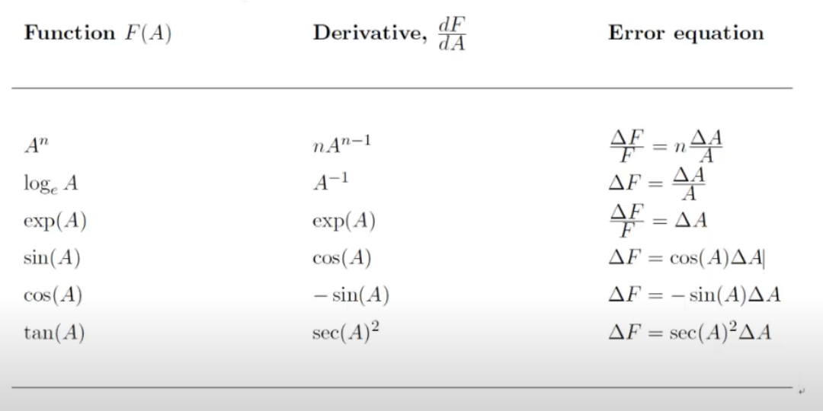

$$s=\sqrt{{\left(\frac{∂f}{∂x}s_{x}\right)}^{2}+{\left(\frac{∂f}{∂y}s_{y}\right)}^{2}+ ...}$$

Graph

Include both x and y error bars. If the error bar is too small to be observed, **mention** the magnitude and explain it.

Find the linearized graph, and draw the max/min gradient lines

1/7 anomalies are acceptable – if you declare it, then explain *why* there is such an anomaly

LOBF should pass through all error bars.

Explore the possibility of a different LOBF (exponential), but you are expected to stick with the framework/literature result

Are there any unreasonable results (e.g. refractive index = negative, >6)

Conclusion

What is the best mathematical model that describes the relationship between IV and DV? Linear (y=kx+c), proportional (y=kx), inverse (y=k/x), negative linear (y=-kx+c)?

What is the physical meaning of the:

* Slope uncertainty
* X-intercept uncertainty
* Y-intercept uncertainty

Does the max/min line cover the origin? If not, why?

DO NOT say **prove**, you can only **verify** or **validate** something

DO NOT claim the magnitude of random error by intuitive feeling. Instead, justify if you *could* fit other regression lines instead of linear (i.e. if error bar large, you can put exponential, polynomial regression, but if error bar small, you can only fit a linear regression line.)

Comparison with the literature

Try your best to include (1), (2) and (3)

1. Formula / derived framework
   1. What are the literature values of the CVs?

For example, F=GMm/r2, measure the mass of M and m

If you cannot measure G, then research from **trustworthy** sources

* 1. Calculate the literature DV with literature CVs (include the error propagation for literature DVs too!)
  2. Plot the literature DV and experimental DV, including errors.
  3. Analysis:
     1. Does the literature LOBF lie within your experimental max/min line?
     2. Is there any offset in x, y, or slope?
     3. Consider and suggest the physical reasons for this over/under-estimation.

1. Microscopic view (Kinetic Theory)
   1. Qualitatively, does it match the general trend? (Increasing/decreasing)
   2. Is there a side effect when the bounds are exceeded? Beyond the limit of proportionality – is it possible to use the kinetic model that explains this discrepancy?
2. Other researcher’s experimental results
   1. Do not use high-school reports, random websites, blogs etc.
   2. Pay attention to the range of IVs, CVs, assumption and methodology
   3. Exact mathematical relationship/model between x and y
   4. Compare their values and yours (slope/DV)
3. Simulation (only if desperate)
   1. You cannot generate error bars

Use **physical** concepts, not mathematical!

Sources of error and limitation

Show it in tables instead of paragraphs!

|  |  |  |
| --- | --- | --- |
| Source of error | Significance and evidence | Improvements |
|  |  |  |

Explore **methodological** and **procedural** issues!

* Methodological (RQ-specific!)
  + design
* Procedural
  + Use more precise instruments
  + Repeat more times

Always put the most significant at the first

Check your assumptions: are they valid/violated? Does your DV ***only*** depend on your IV? Does your CV change?

Random Error: (suggested to talk about it if the result varies >10%) DO NOT blame the equipment for the precision, it is your methodological problem.

Systematic Error: What is the direction of the effect? Example, when measuring the diameter of sphere, did you measure the actual diameter, or a chord of it?

Improvement and Extension

DO NOT suggest something you *could* have done **at the beginning**. You could just have avoided that easily, for example, you could add sound proof materials to avoid error in sound intensity, or sand the copper wire.

Put realistic extensions! (battery without internal resistance, more precise equipment, perform equipment in vacuum)

You cannot avoid the absolute error, but only the percentage error. (If the magnitude of the DV is large, then the %error is reduced)

Wider IV range? Doing it faster/slower?

Common Mistakes

* Time = 6.89s, absolute uncertainty is 0.01s – should be ~250ms because of human reaction time
* Do not use the bench power supply value! Use a voltmeter and measure it externally with a tool. Be skeptical and find evidence!
* Each slotted mass is 100g. False. Measure it with scale!
* Mass of X is 5.67g, so absolute uncertainty is 0.01g, false, because there might be a fluctuation.
* Solve:

1. Discard the last d.p.
2. Take average of max/min.

* 9.81m/s2 might vary across locations.
* Vernier accelerometer is 0.39m/s2, so uncertainty is 0.01m/s2
  + Check the absolute uncertainty on the manufacturer’s website!
* Video analysis – shooting angle, positional uncertainty (if basketball diameter=24cm, then uncertainty is ~12cm.)
* “it increases proportionally”. Include “directly”, “inversely” or “exponentially”! Do not confuse with “linear”!
* Do not exclude other possibilities of LOBF other than linear regression. If your error bar is huge, you can literally fit any LOBF!
* “the measurement tool at my school is not precise enough” NO NEVER BLAME YOUR EQUIPMENT, you can only change %percentage error.