Comp 3512

Assignment 2

**James Bergeron, Joseph Balatbat,Sonia Pitrolia**

First team meeting held March 1, 2015. A review of the following movie sites was conducted between February 27th and March 1st 2015:

1. [www.imdb.com](http://WWW.IMDB.COM)
2. www.themoviedb.org
3. <https://www.yahoo.com/movies>
4. [www.rottentomatoes.com](http://www.rottentomatoes.com/)
5. [www.tribute.ca](http://www.tribute.ca)
6. [http://www.calgarymovies.com](http://www.calgarymovies.com/)
7. [http://www.calgaryfilm.com](http://www.calgaryfilm.com/)
8. [http://www.cinemaclock.com](http://www.cinemaclock.com/)
9. [http://filmratings.com](http://filmratings.com/)
10. [http://www.mpaa.org](http://www.mpaa.org/)
11. <http://prod.mpa-canada.org>

The contents of Yahoo imbd, rotten tomatoes, cinema clock and mpaa.org were compared in detail for ideas on how to structure headers, footers, home page, about us page, single movie and person page, and the browse page. The ideas that used that we feel were more associated to one site design will be cited in the citations section of the about us page. Trying to take the best of the competitive approaches, the assignment requirements and our personal preferences, we came up with straw man layouts for the following web site pages:

* Home page
* About Us
* Error Message
* Single Movie Description
* Single Person Description
* Browsing the Movies Page

These layouts are presented on the following page.

The group agreed to meet bi-weekly on Wednesday and Sunday mornings. Contact information was shared, a google drive was set up for sharing documents, a GitHub repository was established and tested.and a directory and file structure was agreed upon.

There were a number of features that the group decided not to implement unless time permitted. These included: advertising, visitor comments, rotating latest news, iter alia.

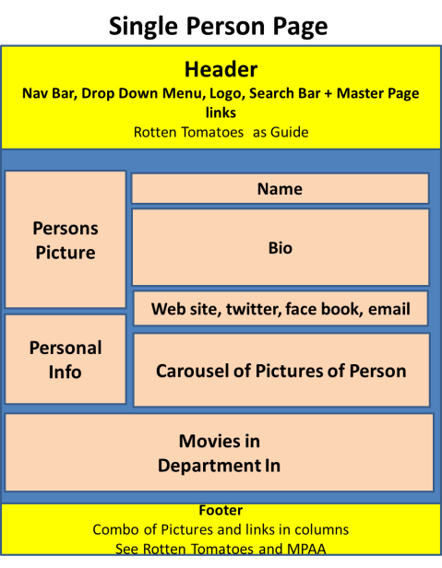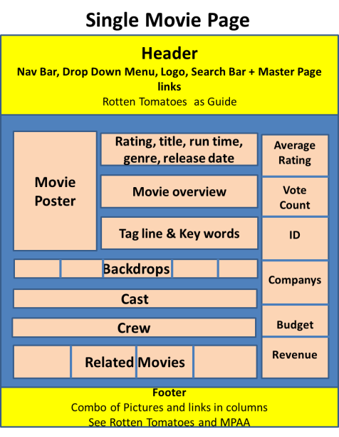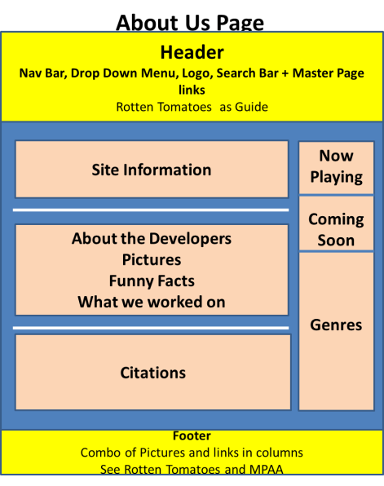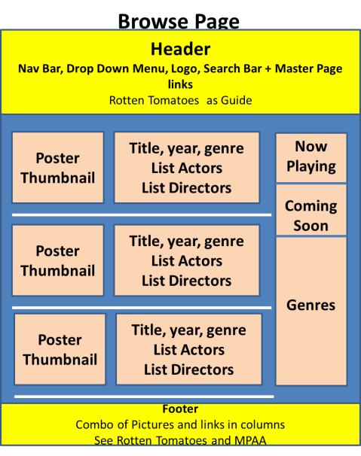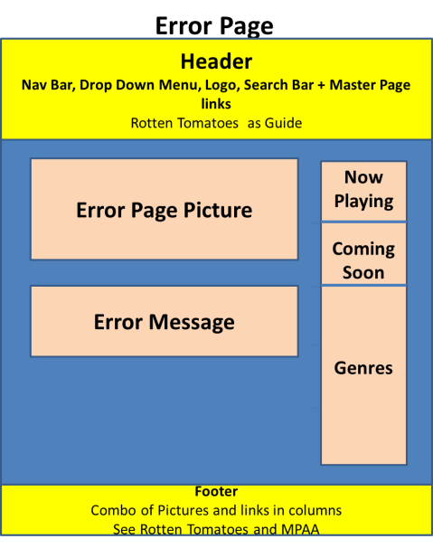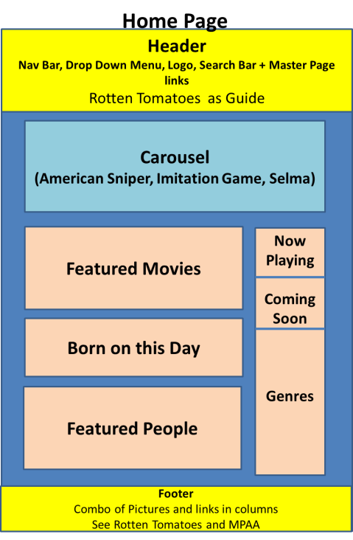**Straw man Web Site Pages**

The following file structure for development was agreed to

* + <assign2>
    - default.asp
    - error.asp
    - about.asp
    - readMe.docx
    - <sMovie>
      * sMovie.asp
      * other.asp
    - <sPerson>
      * sPerson.asp
      * other.asp
    - <browse>
      * browse.asp
      * other.asp

The following to do’s were agreed upon for the Wednesday March 3rd meeting:

* + Sonia – Single Movie Template
  + Joseph – GitHub (done) & Header
  + James – Documentation & About Us

End of March 1st Meeting Notes