SBA-7

Pooja R-211478

1 .Write a program that prompts the user to input a positive integer. It should then output a message indicating whether the number is a prime number.

import java.util.\*;

public class Prime {

public static void main(String args[])

{

int num,b=1,c;

Scanner s=new Scanner(System.in);

System.out.println("Enter A Number");

num =s.nextInt();

b=1;

c=0;

while(b<= num)

{

if((num%b)==0)

c=c+1;

b++;

}

if(c==2)

System.out.println(num +" is a prime number");

else

System.out.println(num +" is not a prime number");

}

}

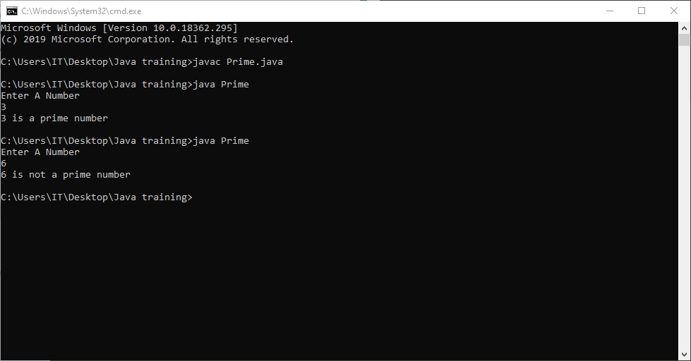

2. Write a program that prompts the user to input a positive integer. It should then print the multiplication table of that number.

import java.util.\*;

public class MultiplicationTable {

public static void main(String[] args)

{

Scanner s = new Scanner(System.in);

System.out.print("Enter number:");

int n=s.nextInt();

for(int i=1; i <= 10; i++)

{

System.out.println(n+" \* "+i+" = "+n\*i);

}

}

}

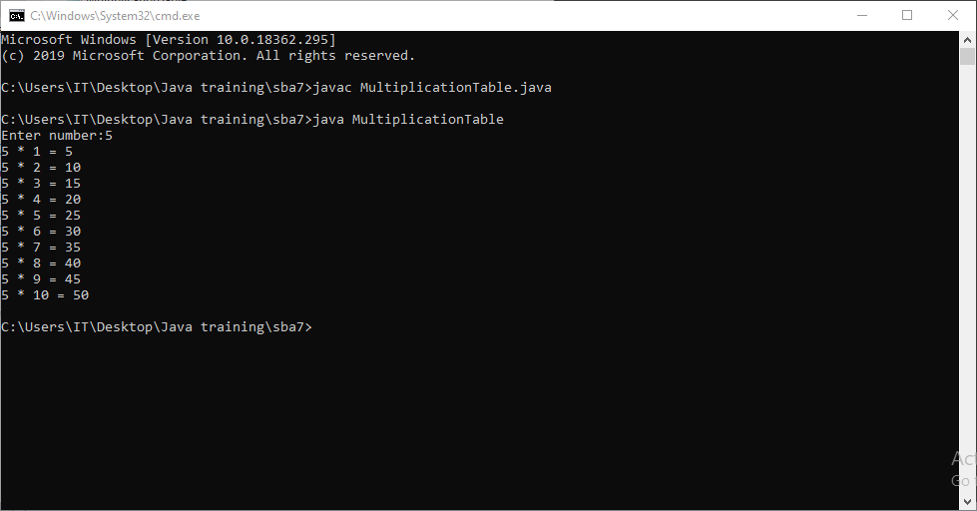

3. A student will not be allowed to sit in exam if his/her attendance is less than 75%.

Take following input from user

Number of classes held

Number of classes attended.

And print

Percentage of class attended

Is student is allowed to sit in exam or not.

import java.util.\*;

public class Exam {

public static void main(String[] args)

{

Scanner s=new Scanner(System.in);

System.out.println(" Enter the number of classes held");

int x=s.nextInt();

System.out.println(" Enter the number of class you attended");

int a=s.nextInt();

float percentage = (a\*100)/x;

System.out.println("Your percentage of attendence is:" +percentage);

if(percentage<75)

{

System.out.println( " you can't attend the exam");

}

else

{

System.out.println(" you can attend the exam");

}

}

}

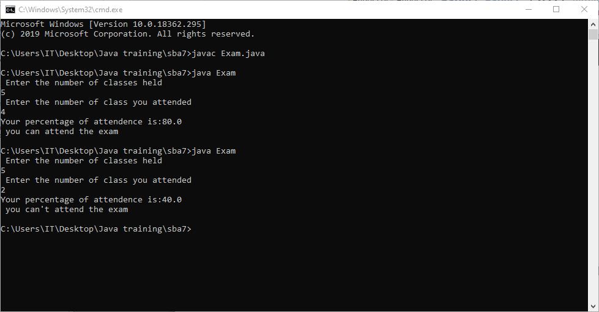

4. A company decided to give bonus of 5% to employee if his/her year of service is more than 5 years.

Ask user for their salary and year of service and print the net bonus amount. Note- create a method Employee Bonus to calculate the bonus and return it.

import java.util.\*;

public class BonusEmployee {

static int year, salary, newsalary;

static double bonus;

static double Employeebonus() {

double res = (int) (salary \* .05);

return res;

}

public static void main(String[] args) {

// TODO Auto-generated method stub

Scanner scanner = new Scanner(System.in);

System.out.println("Enter your year of service");

year = scanner.nextInt();

System.out.println("Enter your salary");

salary = scanner.nextInt();

if (year > 5) {

bonus = Employeebonus();

System.out.println("your bonus amount is " + bonus);

System.out.println("your salary is" + (salary + bonus));

} else {

System.out.println("you are not eligible for bonus salary is " + salary);

}

}

}

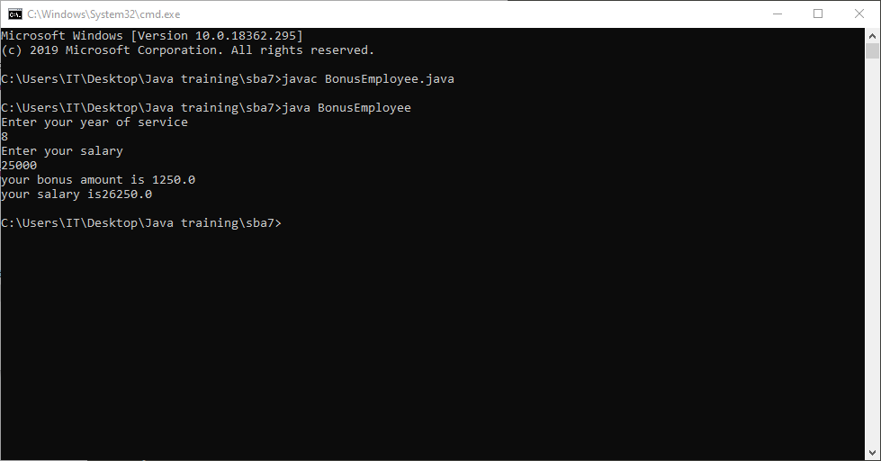

5. Write a program to input the following details:

i) Employee Name

ii) Employee Salary

iii) Employee Year of joining

Calculate the Loyalty bonus of the Employee's by

1. if the year of their joining is on or before than 2017,and their Salary is more than 30000/-,then the bonus will be 22% of the salary.
2. if the year of their joining is on or before than 2017,and their Salary is less than 30000/-,then the bonus will be 33% of the salary.
3. If the year of their joining is on or before than 2012,then the bonus will be 40% of the salary.
4. if the year of their joining is after 2017,and their Salary is less than 30000/-,then the bonus will be 15% of the salary.
5. if the year of their joining is after 2017,and their Salary is more than 30000/then the bonus will be 10% of the salary.

import java.util.\*;

public class Loyalty {

public static int CalBonus(int sal, int yr)

{

int bon=0;

if(yr<=2017 && sal>30000)

{

bon = (sal\*22)/100;

}

else if(yr<=2017 && sal<30000)

{

bon = (sal\*33)/100;

}

else if(yr<=2012)

{

bon = (sal\*40)/100;

}

else if(yr>2017 && sal<30000)

{

bon = (sal\*15)/100;

}

else if(yr>2017 && sal>30000)

{

bon = (sal\*10)/100;

}

return bon;

}

public static void main(String[] args) {

// TODO Auto-generated method stub

Scanner sc = new Scanner(System.in);

System.out.println("Enter your name: ");

String name = sc.next();

System.out.println("Enter your salary: ");

int sal1 = sc.nextInt();

System.out.println("Enter your year of joining: ");

int yr1 = sc.nextInt();

int result = CalBonus(sal1,yr1);

System.out.println("The Loyality Bonus of "+name+" is "+result);

}

}

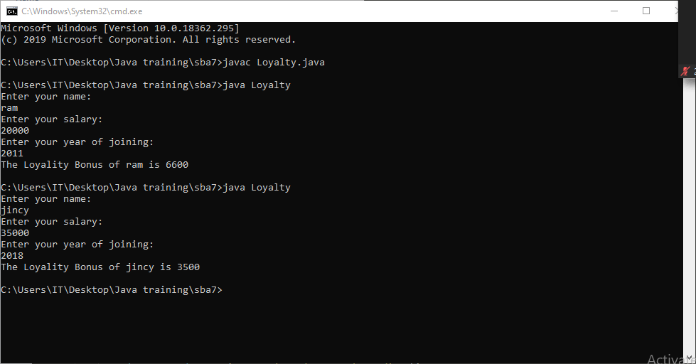

6. Write a program to check for the occurrence of a particular character in a string and display how many times it has occurred.

note: take the String and the character to be checked as a input from the user.

import java.util.Scanner;

public class StrOccurence {

public static void main(String[] args) {

// TODO Auto-generated method stub

Scanner sc= new Scanner(System.in);

System.out.print("Enter the string : ");

String str1= sc.nextLine();

System.out.print("Enter the character : ");

char c = sc.next().charAt(0);

int count=0;

for(int i=0;i<str1.length();i++)

{

if(str1.charAt(i)==c)

{

count++;

}

}

System.out.print(c+" is present" + " " + "" + count + " "+ "times");

}

}

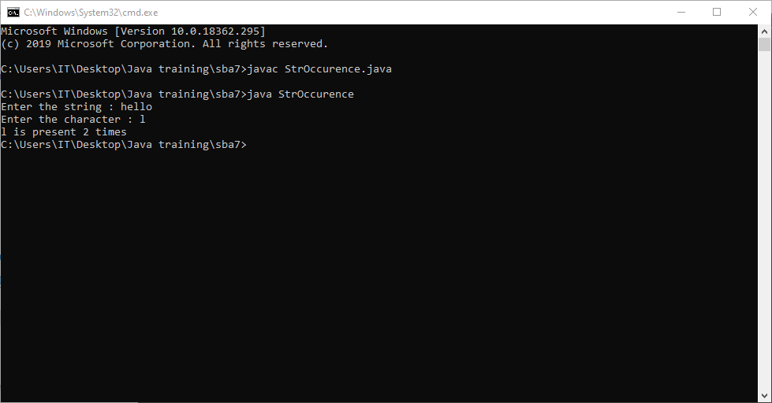

7. Write a program to implement nested try-catch block for NULL Pointer exception and Number Format Exception

public class Pgm1 {

public static void main(String[] args) {

// TODO Auto-generated method stub

try

{

try

{

String abc=null;

System.out.println(abc.length());

}

catch(NullPointerException e)

{

System.out.println("Null Pointer Exception");

}

catch(NumberFormatException e)

{

System.out.println("Number Format Exception");

}

int a = Integer.parseInt("");

}

catch(NumberFormatException e)

{

System.out.println("Number Format Exception");

}

catch(NullPointerException e)

{

System.out.println("Null Pointer Exception");

}

}

}

