SBA-8

Pooja R-211478

1. Program to take input of two integer arrays from the user and to find the sum of both the arrays.

Sort the elements of the resultant array in ascending order using selection sort.

import java.util.*;

public class SelectionSortSumAscending {

void sort(int arr3[]) {

int n = arr3.length;

for (int i = 0; i < n-1; i++)

{

int min = i;

for (int j = i+1; j < n; j++)

{

if (arr3[j] < arr3[min])

min = j;

}

int temp = arr3[min];

arr3[min] = arr3[i];

arr3[i] = temp;

}

}

void printArray(int arr[])

{

int n = arr.length;

for (int i=0; i<n; ++i)

System.out.print(arr[i]+" ");

System.out.println();

}

public static void main(String[] args) {

// TODO Auto-generated method stub

int n,i,sum=0;

System.out.println("Enter the size of the array");

Scanner sc = new Scanner(System.in);

n = sc.nextInt();

int[] arr1 = new int[n];

int[] arr2 = new int[n];

int[] arr3 = new int[n];

System.out.println("Enter the elements of the array-1");

for(i=0;i<n;i++)

{

arr1[i]= sc.nextInt();

}

System.out.println("Enter the elemtns of the array-2");

for(i=0;i<n;i++)

{

arr2[i]= sc.nextInt();

}

for(i=0;i<n;i++)

{

arr3[i]= arr1[i]+arr2[i];

}

System.out.println("The sum of elements of the array is:");

for(i=0;i<n;i++)

{

System.out.print(arr3[i]+",");

}

System.out.println(" ");

SelectionSorting ob = new SelectionSorting();

ob.sort(arr3);

System.out.println("Sorted array");

ob.printArray(arr3);

}

}

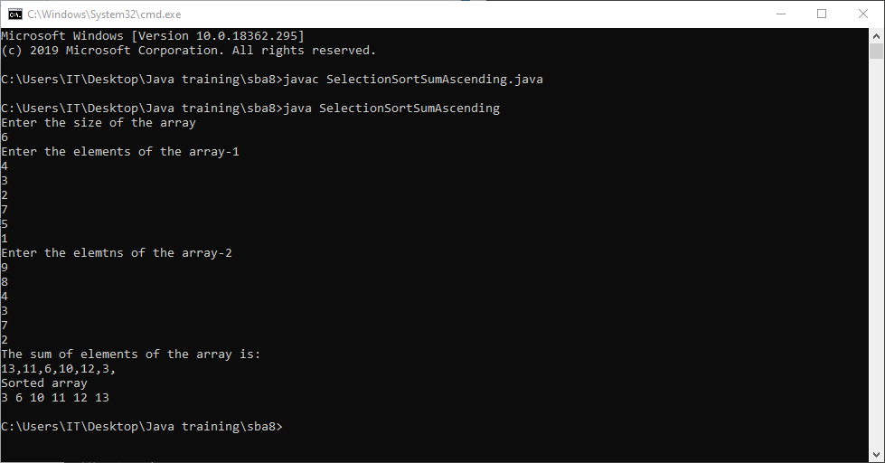

2. Program to take input of two arrays and store the similar elements into the resultant array.

Sort the resultant array in ascending order using bubble sort.

NOTE: there must at least be 6 similar elements.

Similar elements= the elements occurring in both the arrays.

import java.util.ArrayList;

import java.util.Arrays;

import java.util.Scanner;

public class ArrayTwoSort {

public static void main(String[] args) {

// TODO Auto-generated method stub

Scanner sc = new Scanner(System.in);

System.out.println("Enter the array size");

int size = sc.nextInt();

int[] arr1 = new int[size];

int[] arr2 = new int[size];

ArrayList<Integer> arr3 = new ArrayList<Integer>();

System.out.println("Enter the elements for array 1: ");

for(int i=0;i<size;i++)

{

arr1[i] = sc.nextInt();

}

System.out.println("Enter the elements for array 2: ");

for(int i=0;i<size;i++)

{

arr2[i] = sc.nextInt();

}

for(int i=0;i<size;i++)

{

for(int j=0;j<size;j++)

{

if(arr1[i]==arr2[j])

{

arr3.add(arr1[i]);

break;

}

}

}

int len = arr3.size();

Integer[] res = new Integer[len];

res = arr3.toArray(res);

System.out.println();

System.out.println("The resultant array before sorting : ");

System.out.println(Arrays.toString(res));

for(int i=0;i<len-1;i++)

{

for(int j=0;j<len-i-1;j++)

{

if(res[j] > res[j+1])

{

int temp = res[j];

res[j] = res[j+1];

res[j+1] = temp;

}

}

}

System.out.println();

System.out.println("After sorting: ");

System.out.println(Arrays.toString(res));

sc.close();

}

}

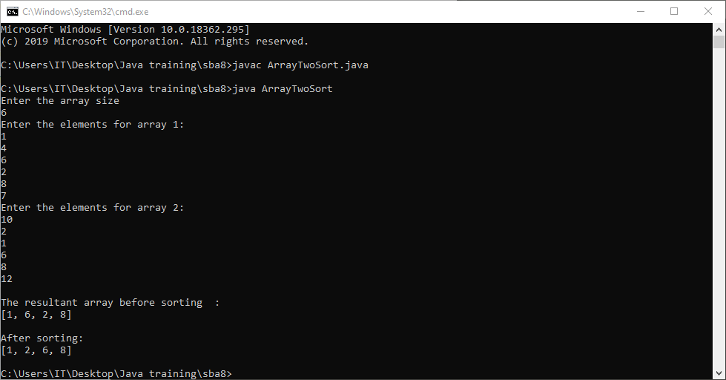

3. Program to take input two arrays and store the dissimilar elements into a resultant array. Sort the resultant array in a descending order using bubble sort. Dissimilar elements= the elements not occurring in both the arrays. (unique elements)

import java.util.*;

import java.util.Arrays;

public class Sba5 {

public static void main(String[] args)

{

System.out.println("Enter the array size:");

Scanner sc=new Scanner(System.in);

int size=sc.nextInt();

System.out.println("Enter the array 1 elements:");

int[] arr1=new int[size];

for(int i=0;i<size;i++)

{

arr1[i]=sc.nextInt();

}

System.out.println("Enter the array 2 elements:");

int[] arr2=new int[size];

for(int i=0;i<size;i++)

{

arr2[i]=sc.nextInt();

}

System.out.println("Disimilar elements :");

ArrayList<Integer> arr3=new ArrayList<Integer>();

int flag=0;

for(int i=0;i<size;i++)

{

for(int j=0;j<size;j++)

{

if(arr1[i]==arr2[j])

flag=1;

}

if(flag==0)

{

arr3.add(arr1[i]);

}

flag=0;

}

for(int i=0;i<size;i++)

{

for(int j=0;j<size;j++)

{

if(arr2[i]==arr1[j])

flag=1;

}

if(flag==0)

{

arr3.add(arr2[i]);

}

flag=0;

}

System.out.println(arr3);

int len=arr3.size();

Integer[] arr4=new Integer[len];

arr4=arr3.toArray(arr4);

for(int i=0;i<len;i++)

{

for(int j=0;j<len-1-i;j++)

{

if(arr4[j+1]>arr4[j])

{

int temp=arr4[j+1];

arr4[j+1]=arr4[j];

arr4[j]=temp;

}

}

}

System.out.println("after bubble sort is:");

for(int i=0;i<len;i++)

{

System.out.println(arr4[i]);

}

}

}

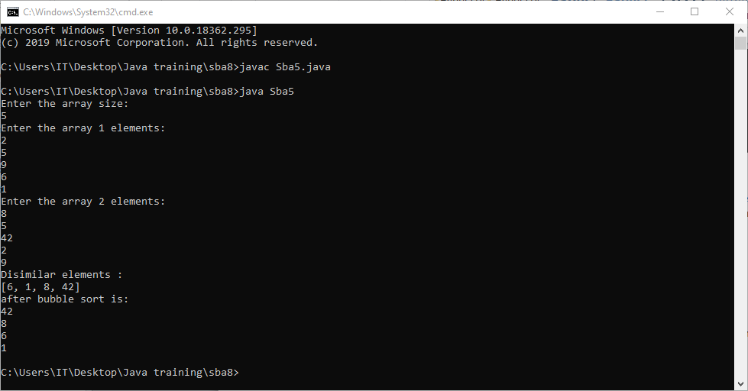

4. Implement Array List and add, remove, elements in the Array List and perform sorting of the elements using the iterator.

import java.util.ArrayList;

import java.util.Collections;

public class ArrayListEx {

public static void main(String[] args)

{

ArrayList<String>list=new ArrayList<String>();

list.add("Volkswagen");

list.add("Toyota");

list.add("Audi");

list.add("Mercedez");

list.add("BMW");

list.add("Hyundai");

System.out.println("The elements in ArrayLists are: "+list);

list.remove(5);

System.out.println("The contents of list after removing the element at 5th position is: "+list);

Collections.sort(list);

System.out.println("After sorting the list: "+list);

}

}

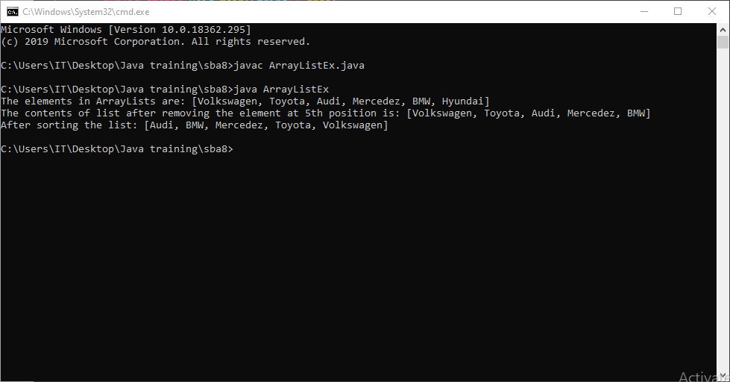

5. Implement Linked List and add, remove, elements in the Linked List and perform sorting of the elements using the iterator.

import java.util.LinkedList;

import java.util.ListIterator;

public class LinkedListEx {

public static void main(String[] args)

{

LinkedList<String>list=new LinkedList<String>();

list.add("Red");

list.add("Italy");

list.add("Blue");

list.add("London");

list.add("Paris");

System.out.println("Linkedlist: "+list);

ListIterator list_iter=list.listIterator(2);

System.out.println("The list is as follows: ");

while(list_iter.hasNext()) {

System.out.println(list_iter.next());

}

}

}

