POOJA R-211478
SBA-1
1.Create an array of 10 elements and print them using the for each loop.
package com.ust;
public class ArrayExample {
public static void main(String[] args)
{
int arr[]= {10,20,30,40,50,60,70,80,90,100};
System.out.println("The array elements are printed using for each loop");
for(int var:arr)
{
System.out.println(var);
}
}
}
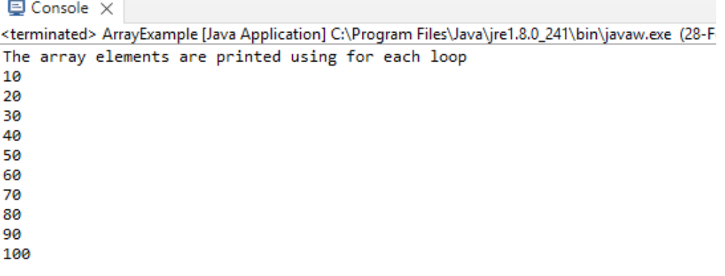

- 2. Take the number input from the console and add all the positive numbers. (not to consider the negative number if entered)
- package com.ust;
- import java.util.Scanner;
public class Question2 {
public static void main(String[] args)
{
System.out.println("Enter the Number of elements :");
Scanner sc =new Scanner(System.in);
int num;
num=sc.nextInt();
int[] a= new int[num];
System.out.println("Enter the elements :");
for (int i = 0; i < num; i++)
{
a[i]=sc.nextInt();
}
int sum=0;
for (int i = 0; i < num; i++)
{
if(a[i] >=0)
sum=sum+a[i];
}
System.out.println("The sum of positive numbers are " +sum);
}
}
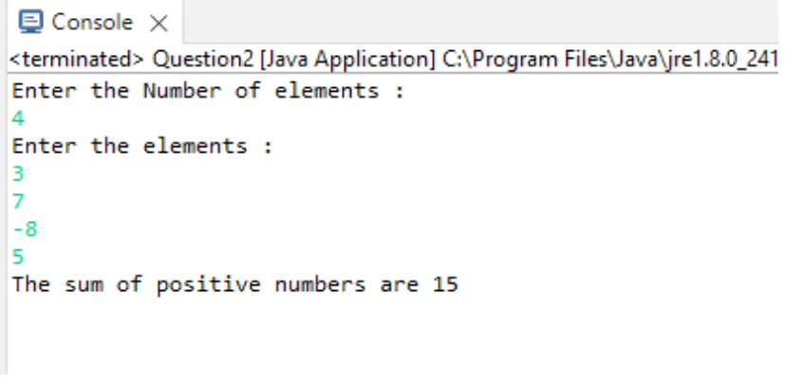
- 3. Create a labeled break and write a simple logic and execute the program.
- package com.ust;
public class Question3 {
public static void main(String[] args)
{
outerforloop:
for(int i=1;i<=3;i++)
{
innerforloop;
for(int j=1;j<=3;j++)
{
if(i==2&&j==2)
{
break outerforloop;
}
System.out.println(i+ " , " +j);
}
}
}
}

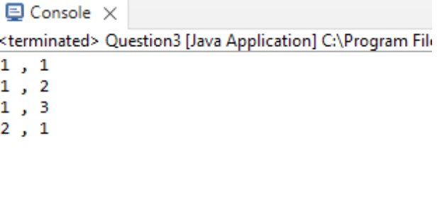
- 4.Do the addition of around 10 even numbers, but use the continue statement in the logic.
- package com.ust;
public class Question4 {
public static void main(String[] args)
{
int count=0;
int sum=0;
loop1:
for(int i=1;i<50;i++)
{
if(i%2!=0)
{
continue;
}
else if(i%2==0)
{
sum+=i;
count++;
if(count==10)
{
break loop1;
}
}
}
System.out.println("The sum of 10 even numbers is " +sum);
}
}
