**Business Intelligence Lab**

**Assignment 4**

**NAME: Harshwardhan Pradip Zurunge**

**SRN: 202202094**

**DIV: F**

**ROLL no: 16**

**Title:** Create a report using i) Crosstab ii) Charts iii) Graphs

**List:**

It is used to show columns of information, such as product list or customer list. A list report shows data in rows and columns. You can apply a filter, summary, or calculation to manipulate the data that appears in the report.

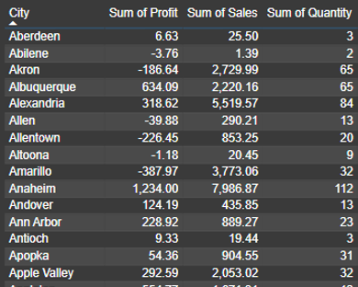

They are nothing but matrix elements from visualizations. I have selected City, profits, sales, year and country. It gives me numeric data per column. On clicking this table again it takes you to a new window and shows a detailed report.

**Rows** represent categories of one variable**(city).**

**Columns** represent categories of another variable**(sum of profit, sum of**

**sales, sum of quantity)**.

* **Cells** show the frequency (count) or percentage of data points that fall into the corresponding row and

column categories.

* The table of cities with three metrics: **Sum of Profit, Sum of Sales, and Sum of Quantity**.
* Here are some key insights:

1. **Highest Profit:** Anaheim.
2. **Lowest Profit:** Amarillo.
3. **Highest Sales:** Anaheim.
4. **Lowest Sales:** Abilene.
5. **Highest Quantity Sold:** Alexandria.
6. **Negative Profit Cities:** Akron, Allen, Allentown, Amarillo, Abilene, Altoona.

**Features of CrossTab:**

1. **Compares Categorical Data:** Ideal for understanding relationships between categorical variables (like

gender, age groups, preferences, etc.).

1. **Summarizes Data:** Helps summarize large datasets to see patterns or trends.
2. **Shows Relationships:** Reveals associations or dependencies between variables.

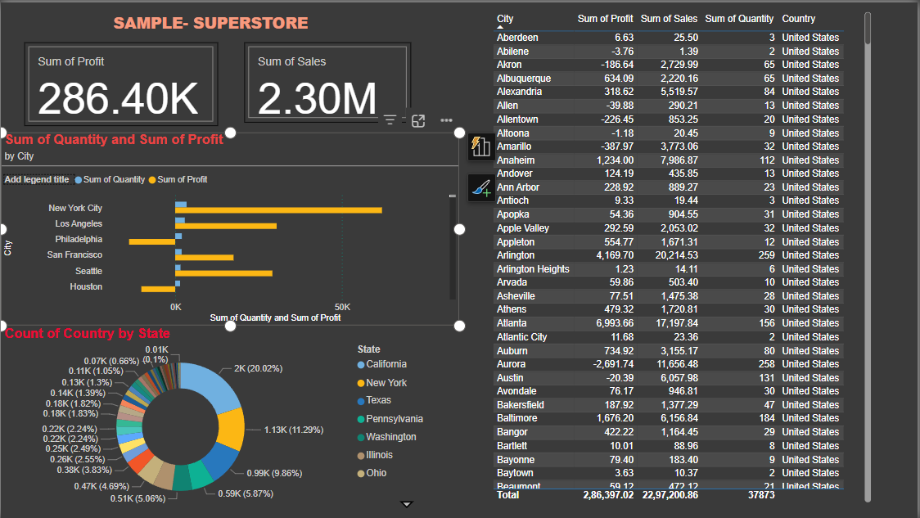**Charts: Column Charts:**

I have selected profits, sales, year and country. This gives me a column chart of sales, profits and year for each country. The Y axis has a country.

The table presents data for different cities in the **United States**

with four key metrics:

1. Sum of Profit
2. Sum of Sales
3. Sum of Quantity
4. Country

**Key Insights:**

* Highest Profit: Atlanta
* Lowest Profit: Aurora
* Highest Sales: Arlington
* Lowest Sales: Abilene
* Highest Quantity Sold: Arlington
* Total Profit: $2,86,397.02
* Total Sales: $22,97,200.86
* Total Quantity: 37,873

Some cities, like Aurora and Amarillo, have high sales but negative profits, indicating potential issues with

cost or pricing. Meanwhile, Atlanta and Arlington stand out as high-performing cities in both profit and sales.

**Donut Graph (Count of Country by state)**

**Doughnut charts:**

I have selected the donut element from visualizations and then added profit and country fields to get profit per country data in the form of a doughnut . It shows different colors for different countries like france,, germany canada etc.The color for each country is specified on the dashboard.On the doughnut each colored region has some values Like for eg 3M for the blue colored shaded region,this indicates the product’s profit. It has a profit of 3 Million. Same goes for the rest.

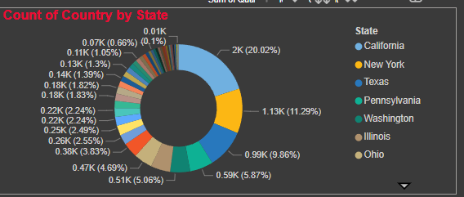**Pie and Donut Charts:**

**Pie Chart:** Shows proportions as slices of a circle.

**Donut Chart:** Similar to a pie chart but with a hole in the center **(state,sales)**

**Use Case:** Display percentage distributions **(Count of Country by state)**

The **donut chart** represents the **Count of Country by State**, with different states contributing varying proportions.

**Key Insights:**

* Top State: California (20.02%) has the highest count.
* Second Highest: New York (11.29%).
* Third Highest: Texas (9.86%).
* Other Significant States: Pennsylvania, Washington, Illinois, and Ohio have notable shares.
* The remaining states contribute smaller portions, with percentages decreasing gradually.

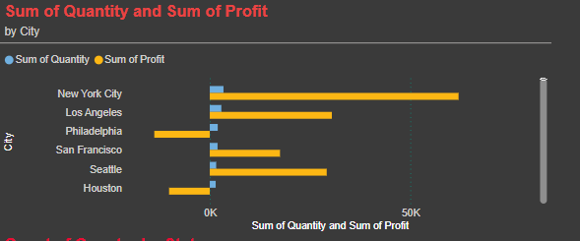

**Bar and Column Charts:**

* **Bar Chart:** Displays data using horizontal bars.
* **Column Chart:** Displays data using vertical columns.
* **Use Case:** Compare categories (e.g., **sum of Quantity, Sum of Profit**).

**Key Insights:**

* New York City is the most profitable by a significant margin.
* Los Angeles and Seattle also demonstrate strong profitability.
* Philadelphia and Houston show negative profits, indicating potential areas of concern.
* San Francisco has a relatively low profit compared to its quantity, suggesting pricing or cost structure issues.
* Overall, there's not a direct linear correlation between quantity and profit, highlighting the importance of factors like pricing, costs, and product mix.
* The chart effectively compares profit and quantity across different cities, making it easy to identify high and low performers

**OVERALL DASHBOARD**

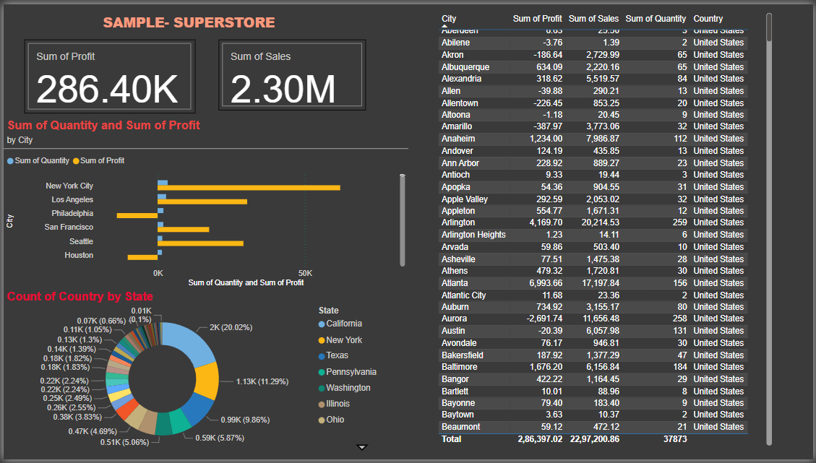

**Conclusion: In this way, we have studied the concept of List, Crosstab and Chart Reports.**