

**Activity based**

**BUSINESS INTELLIGENCE**

**Assignment 5**

**Submitted to Vishwakarma University, Pune**

**By**

**NAME: Harshwardhan Pradip Zurunge**

**ROLL NO:16**

**SRN:202202094**

**Third Year Engineering**

**Department of Computer Engineering**

**Faculty of Science and Technology**

**Academic Year**

**2024-2025**

Final Output for The Assignment:

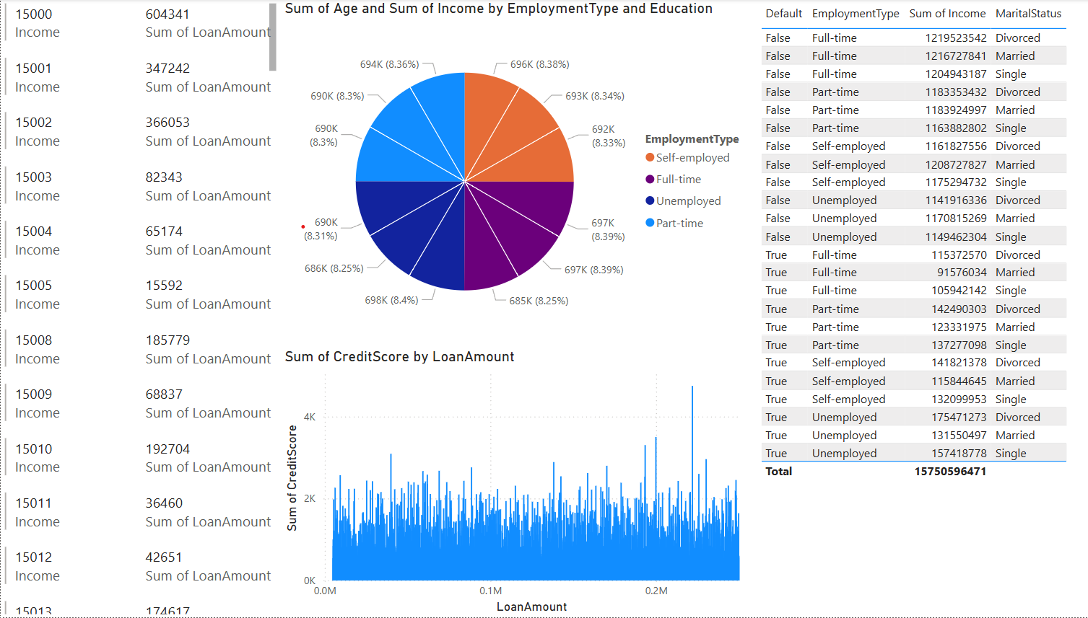

Filter on all Pages:

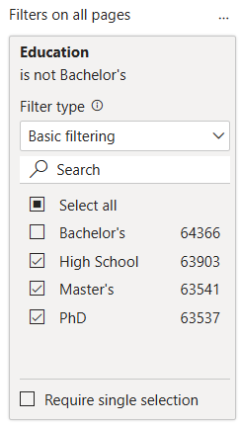

All type of entities includes the above visualization:

1. Multi row Card:

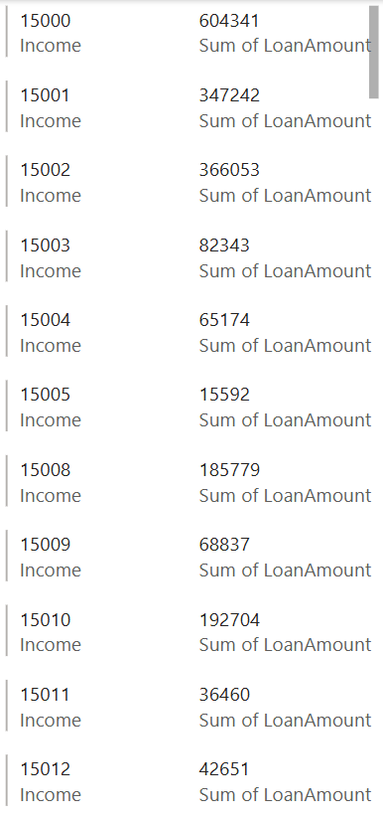

Insights of multi-row card visualization:

1. Income Categories: The numbers on the left (e.g., 15000, 15001, etc.) likely represent income categories.
2. Loan Amounts: The middle column represents the total loan amount corresponding to each income category.
3. Pattern Observation: Higher income values seem to correspond to larger loan amounts.
4. Possible Use Case: This could be useful for analysing loan distribution across
5. Table:

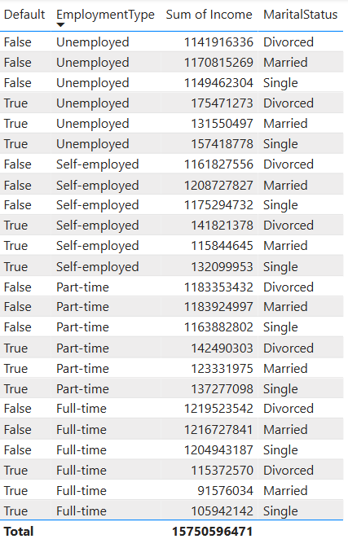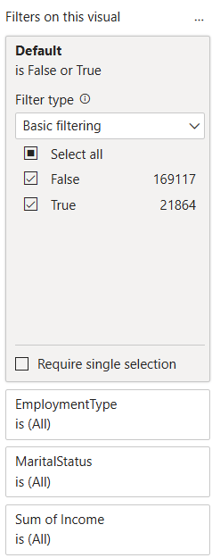

Insights from table:

1. Employment Type & Income:
   * Full-time employees generally have higher total incomes.
   * Self-employed and part-time workers have varying incomes but lower overall totals than full-time employees.
   * Unemployed individuals still have significant recorded incomes, which may need further clarification.
2. Default Status Analysis:
   * The "Default" column indicates whether a person has defaulted on something (likely a loan).
   * Both True and False values appear across all employment types, suggesting that defaults are not limited to a specific job category.
3. Marital Status Impact:
   * No clear pattern emerges at first glance regarding marital status and income.
   * Income distribution among Divorced, Married, and Single categories seems fairly balanced across employment types.
4. Total Income:
   * The total recorded sum of income is 157,505,964,71.
   * This can be useful for financial analysis, especially for loan approvals, credit risk assessments, or income segmentation.
5. Staked column chart:

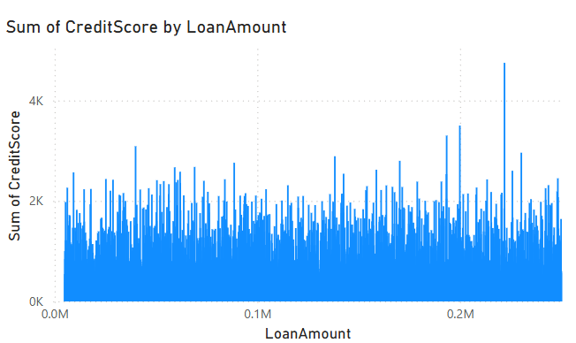

Insights:

1. Relationship Between Credit Score and Loan Amount:
   * The sum of the credit score fluctuates across different loan amounts without a clear trend.
   * There are spikes in credit scores at various loan amounts, indicating that some loan ranges have significantly higher credit scores.
2. Loan Amount Distribution:
   * Loan amounts appear to be widely distributed, with values ranging from 0 to over 0.2M (200,000).
   * The spread suggests a diverse dataset, including both low and high loan amounts.
3. Credit Score Variation:
   * Credit scores are mostly concentrated between 1K to 3K, with occasional spikes above 4K.
   * The variation indicates that higher loan amounts do not necessarily have higher credit scores.
4. Potential Analysis:
   * You could analyze whether higher loan amounts are associated with lower credit scores (riskier borrowers).
   * A trendline or correlation analysis might help determine if there’s a pattern in credit score distribution across loan amounts.

4. Pie chart:

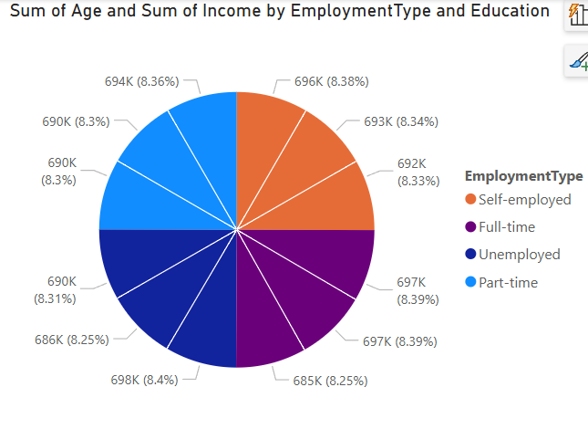

Insights from the pie chart:

1. Even Distribution:
   * The chart shows the sum of age and sum of income across different employment types and education levels.
   * Each segment has nearly equal percentages (around 8.3%–8.4%), indicating that no single category dominates significantly.
2. Employment Type Representation:
   * The chart includes Self-employed, Full-time, Unemployed, and Part-time categories.
   * Each category contributes almost equally to the total, suggesting a balanced dataset.
3. Possible Interpretation:
   * If this chart represents a workforce or financial distribution, it shows that different employment types have similar contributions in terms of age and income.
   * It may indicate a well-distributed workforce across employment types, regardless of education level.
4. Further Analysis:
   * To get deeper insights, you could compare the average income per employment type rather than the total sum.
   * Analysing trends in education levels alongside employment types might provide additional clarity on workforce characteristics.

Conclusion:

The analysis of income, loan amounts, credit scores, employment types, and marital status provides key insights into financial and demographic patterns. The distribution of loan amounts and credit scores does not show a clear correlation, indicating diverse borrower profiles. Employment type and marital status play a role in income distribution, but defaults are observed across all categories. The pie chart analysis suggests an even contribution of different employment types to total income and age. Overall, the data highlights a well-balanced workforce distribution with variations in financial behaviour, which can be further explored for risk assessment and financial decision-making.