

**Activity based**

**BUSINESS INTELLIGENCE**

**Assignment 6**

**Submitted to Vishwakarma University, Pune**

**By**

**NAME: Harshwardhan Pradip Zurunge**

**ROLL NO:16**

**SRN:202202094**

**Third Year Engineering**

**Department of Computer Engineering**

**Faculty of Science and Technology**

**Academic Year**

**2024-2025**

**Title:** Create a sample report and use the Calculate function with ALL, ALL Except.

**Introduction:**

Power BI, developed by Microsoft, is a BI & Data Visualization Tool employed by data-driven organizations

Worldwide to improve the way organizations use Data Analytics to address today’s business challenges.

With real-time high-level analytics, sophisticated modelling, and custom development, Power BI makes dealing with data pain-free. However, when using Microsoft Power BI, you will frequently find that you need to write formulae, expressions, or refilter tables for certain use cases to evaluate data and calculate numbers in order to address real-world business challenges. Enter Power BI ALLEXCEPT Function.

**What is The Power BI ALLEXCEPT Function?**

The Power BI’s ALLEXCEPT Function helps developers to redact out all the context filters used in the table except

the filters specified by the user or used in the specified columns.

**Syntax:**

ALLEXCEPT(<table>,<column>[,<column>[,…]])  
  
For my project my Syntax is :

Measure = CALCULATE( SUM('Loan_default csv for ass 6'[Age]), ALL('Loan_default csv for ass 6'[HasMortgage]) )

**About ALLEXCEPT:**

The Power BI ALLEXCEPT function’s first argument must be a reference to the base table. Hence, all subsequent parameters must be base column references. On the other hand, the Power BI ALLEXCEPT function does not support tabular or columnar expressions.

**How to use Power BI ALLEXCEPT Function?**

The Power BI ALLEXCEPT function is not utilized by itself, rather, the function is an intermediate one that can be

used to alter the set of results on which calculations are performed. There exist certain many scenarios where ALL and Power BI ALLEXCEPT functions are used

**Steps I have followed:**

**Step 1:** Open the link to download the Sample Data: 'Loan_default.csv’

**Step 2:** From the Visualization Pane, drag Table & Slicers.

* **Slicers:** In the first slicer, drag Product Category, and in the second slicer, drag Product Subcategory.
* **Table:** Drag three fields from the Orders Dataset into the table: Product Category, Product Sub Category, and Sales.

**Step 3:**Now, Create Measure and write the DAX Formula to execute further with ALLEXCEPT function**.**

Measure = CALCULATE( SUM('Loan_default csv for ass 6'[Age]), ALL('Loan_default csv for ass 6'[HasMortgage]) )

**Step 4:**The next step is to drag ALLEXCEPT_SALES measures into the table.

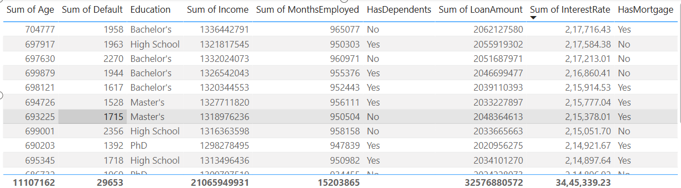

**Step 5:**Now, apply a filter to the mortgage type and look at the ALLEXCEPT LOAN result, which returns the Sum of all ages of entities who Has Mortgage.

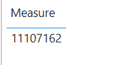

**Entities in Power BI Table:**

1. **Sum of Age** – Likely derived from an "Age" column using the SUM(Age) measure.
2. **Sum of Default** – Summed values from a "Default" column, possibly indicating the number of defaults.
3. **Education** – A categorical field representing education levels such as "Bachelor’s," "High School," "Master’s," and "PhD."
4. **Sum of Income** – Aggregated income values, calculated as SUM(Income).
5. **Sum of MonthsEmployed** – Total months employed, derived from SUM(MonthsEmployed).
6. **HasDependents** – A categorical column indicating whether a person has dependents (Yes/No).
7. **Sum of LoanAmount** – Summed loan amounts from a "LoanAmount" field.
8. **Sum of InterestRate** – Aggregated interest rate, likely calculated as SUM(InterestRate).

**Power BI Features Used:**

* **Aggregations:** SUM function used for numerical columns.
* **Categorical Grouping:** "Education" and "HasDependents" as grouping categories.
* **Conditional Formatting (Possibly):** The alternating row colors suggest Power BI’s table visualization settings.
* **Summarized Totals:** The bottom row shows totals for numeric fields, likely enabled in the table settings.

**Conclusion:**

In this report, we explored the use of the **ALLEXCEPT** function in Power BI, focusing on its application in data filtering and calculation scenarios. The **ALLEXCEPT** function is a powerful tool that allows users to retain specific filters while removing others, enabling more flexible and insightful data analysis.

By following the step-by-step implementation, we demonstrated how to use the **CALCULATE** function with **ALL** and **ALLEXCEPT** to manipulate datasets effectively. The final outcome confirmed that the **ALLEXCEPT** function successfully returned the sum of all ages for entities with a mortgage, regardless of other filters applied.

Overall, Power BI’s **ALLEXCEPT** function provides significant advantages in refining analytical models, ensuring users can extract meaningful insights while maintaining necessary contextual filters. This function proves to be an essential feature for complex business intelligence scenarios where dynamic filtering is required.