**BI Assignment 8**

**Name:** Harshwardhan Zurunge

**Div:** F

**Roll No:** 16

**Experiment No.:** 8

**Title:** Create a Simple Report with Inner Join and Outer Join

**Introduction**

In this report, we explore different types of joins applied to the Loan_Default.csv dataset in Power BI. Joins are essential for combining data from multiple tables based on a common column. This report examines four types of joins: Inner Join, Left Outer Join, Right Outer Join, and Full Outer Join.

**Theory of Joins**

1. **Inner Join:**
   * Combines rows from both tables where the joining key has matching values.
   * Excludes non-matching rows from both tables.
2. **Left Outer Join:**
   * Returns all rows from the first table (left table), along with the matching rows from the second table (right table).
   * Non-matching rows from the left table remain, with null in the right table’s columns.
3. **Right Outer Join:**
   * Returns all rows from the second table (right table), along with the matching rows from the first table (left table).
   * Non-matching rows from the right table remain, with null in the left table’s columns.
4. **Full Outer Join:**
   * Combines all rows from both tables, with null where no matches exist.

**Explanation of Each Join's Output**

**1. Inner Join:**

* Logic: Matches rows based on the common column LoanID between the two tables.
* Output: The resulting dataset contains only the rows where LoanID exists in both tables.
* Columns: LoanID, Age, Income, LoanAmount, CreditScore, MonthsEmployed, InterestRate, LoanTerm, NumCreditLines, Education.
* Interpretation: The Inner Join results in a dataset where only those loan records appearing in both tables are retained, ensuring consistency in available data points.

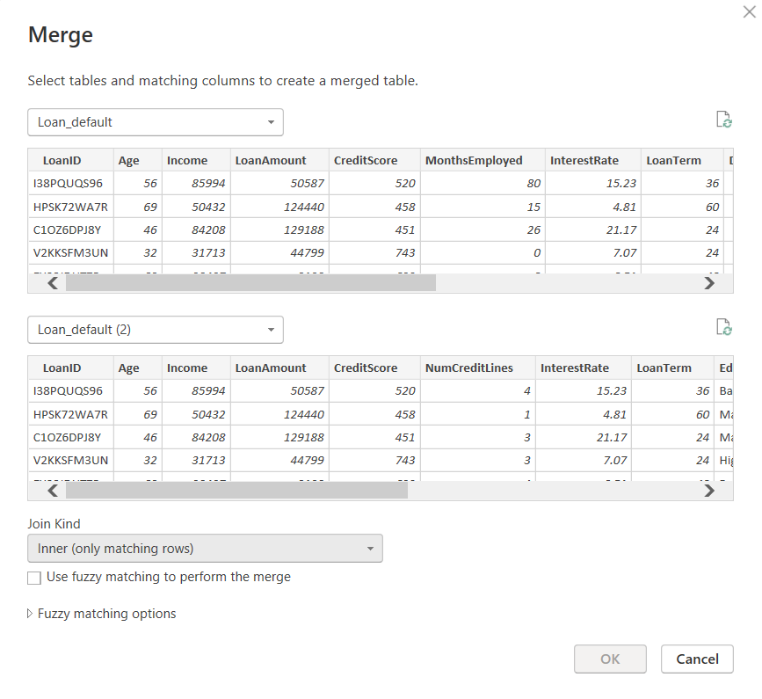

**2. Left Outer Join:**

* Logic: Retrieves all rows from the left table (Loan_Default) and the corresponding matching rows from the right table (Loan_Default (2)).
* Output: All rows from Loan_Default are retained, with null values for non-matching records from the second table.
* Interpretation: This join helps analyze cases where we have loan records from the primary dataset but lack additional information in the secondary dataset.

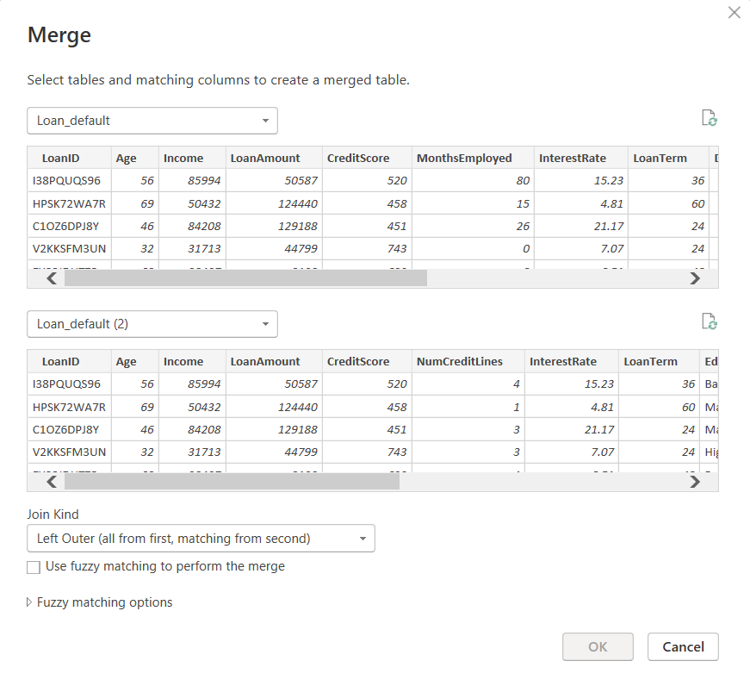

**3. Right Outer Join:**

* Logic: Retrieves all rows from the left table (Loan_Default) and the corresponding matching rows from the right table (Loan_Default (2)).
* Output: All rows from Loan_Default are retained, with null values for non-matching records from the second table.
* Interpretation: This join helps analyze cases where we have loan records from the primary dataset but lack additional information in the secondary dataset.

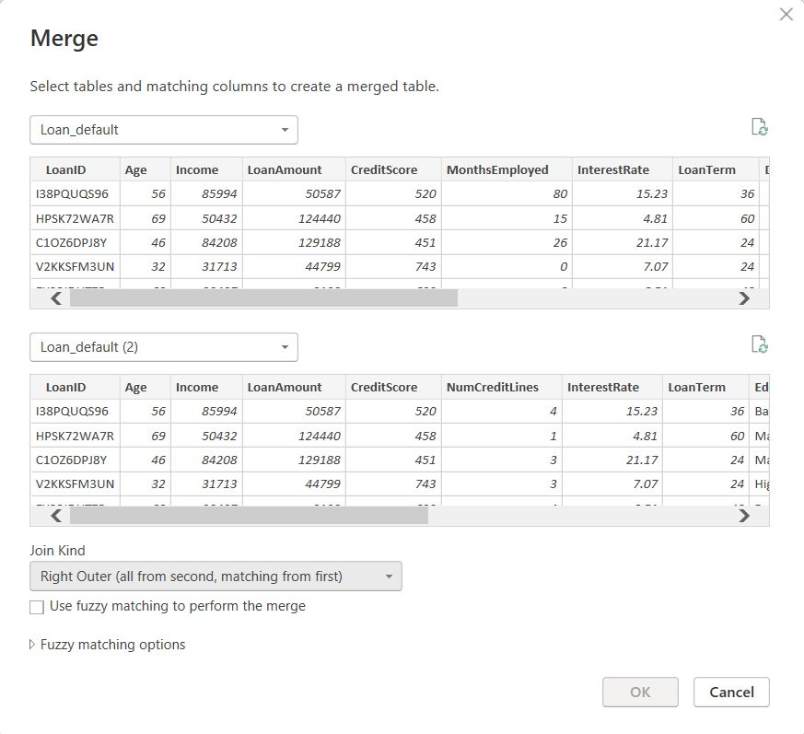

**4. Full Outer Join:**

* Logic: Combines all rows from both tables, retaining all data and filling gaps with null where matches are not found.
* Output: The resulting dataset consists of all unique LoanIDs from both tables, with null values where no match is found.
* Interpretation: This join provides a holistic view by identifying missing records from both datasets.

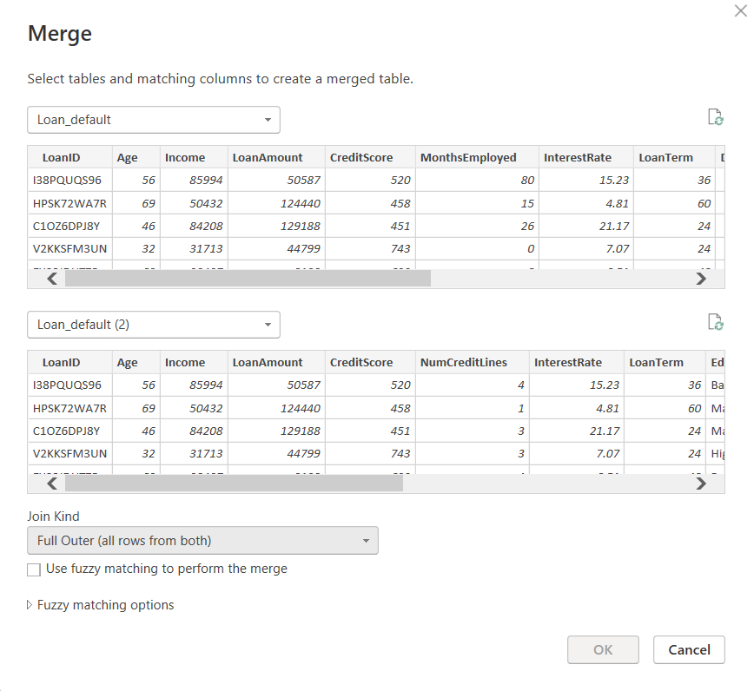

**Conclusion:**

Using different types of joins in Power BI allows us to merge datasets effectively and gain insights based on relationships between different tables. The Inner Join provides precise results with only common records, while Outer Joins help in analyzing discrepancies and gaps in data. The Full Outer Join is particularly useful in identifying unmatched records from both tables, ensuring comprehensive data integration.

This analysis of the Loan_Default.csv dataset demonstrates how various join operations impact data consolidation and decision-making in financial and credit risk assessments.