**Activity based**

**Project Report on**

**Business Intelligence**

**C2P2 Project Module - I**

**Submitted to Vishwakarma University, Pune**

**Under the Initiative of**

**Contemporary Curriculum, Pedagogy, and Practice (C2P2)**

**By**

**Harshwardhan Pradip Zurunge**

**PRN No :2280030805**

**Roll No :16**

**Div: F**

**Third Year Engineering**

**Faculty In-charge:- Prof. Tareek Pattewar**

**Date of Project 1: - 28/03/25**

**Department of Computer Engineering**

**Faculty of Science and Technology**

**Academic Year**

**2024-2025 Term-II**

**Business Intelligence: Project I**

**Project Name: Dashboard for educations university department data**

**Problem Statement:**

**Create a Dashboard educations university department data.**

**Introduction:**

This project aims to develop an interactive **Business Intelligence (BI) dashboard** that consolidates and visualizes university department data, providing key stakeholders with real-time insights. The dashboard will enable university administrators, faculty, and decision-makers to monitor student demographics, academic performance, budget distribution, and other critical metrics. By leveraging **Power BI**, this solution will facilitate data-driven decision-making, improve resource allocation, and enhance the overall efficiency of university departments.

**Related Study:**

Business Intelligence (BI) dashboards are essential for data visualization, performance monitoring, and decision-making in universities. Studies highlight their impact on various aspects, including student performance tracking, faculty management, financial planning, and resource allocation.

1. BI in Higher Education – Aljawarneh et al. (2021) emphasize BI’s role in strategic planning, student success prediction, and course optimization.
2. Academic Performance Monitoring – Rienties et al. (2019) highlight how BI dashboards improve student engagement analysis, faculty effectiveness, and curriculum design.
3. University Resource Management – Chaudhuri et al. (2020) discuss how BI aids in budgeting, fund allocation, and infrastructure planning.
4. Predictive Analytics in Education – Siemens et al. (2018) showcase BI’s ability to forecast student performance trends and enable early interventions.
5. Power BI for Academic Analysis – Recent studies confirm Power BI’s effectiveness in integrating LMS, ERP, and student databases, enhancing real-time insights.

**Flowchart:**

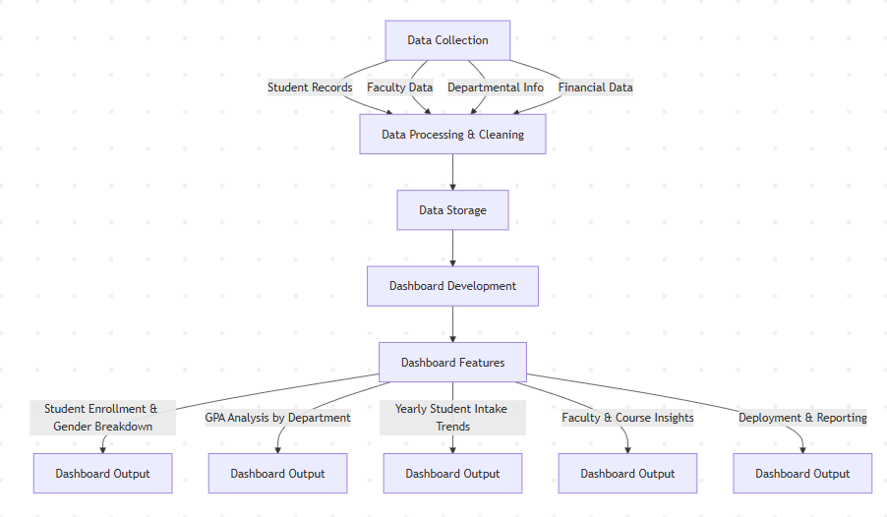

**1. Data Collection**

The process begins with **gathering relevant university data** from multiple sources:

* **Student Records** – Includes enrollment details, demographics, academic performance, and attendance.
* **Faculty Data** – Covers faculty profiles, courses handled, research output, and workload.
* **Departmental Info** – Contains information about different university departments, courses offered, and academic programs.
* **Financial Data** – Includes budget allocation, expenses, and funding sources.

**2. Data Processing & Cleaning**

Before using the collected data, it needs to be **processed and cleaned** to ensure accuracy and consistency. This step includes:

* Removing duplicate or inconsistent records.
* Handling missing or erroneous data.
* Standardizing data formats for integration.

**3. Data Storage**

After cleaning, the structured data is stored in a **centralized database or data warehouse**. This storage enables efficient retrieval and processing when developing the dashboard.

**4. Dashboard Development**

This phase focuses on building an **interactive dashboard** to visualize university data effectively. The development process involves:

* Designing an intuitive user interface.
* Implementing data visualization techniques.
* Ensuring real-time or scheduled updates.

**5. Dashboard Features**

The dashboard includes several key analytical features to provide valuable insights:

* **Student Enrollment & Gender Breakdown** – Analyzes student distribution by department and gender.
* **GPA Analysis by Department** – Provides an overview of academic performance across departments.
* **Yearly Student Intake Trends** – Tracks student admissions over time to identify trends.
* **Faculty & Course Insights** – Displays faculty workload, course popularity, and teaching effectiveness.
* **Deployment & Reporting** – Ensures that dashboard insights are accessible to administrators, faculty, and decision-makers.

**6. Dashboard Output**

Each dashboard feature **generates insights and visual reports** for university administrators, faculty members, and other stakeholders. These outputs help in:

* **Decision-making** – Understanding enrollment patterns, faculty efficiency, and financial planning.
* **Academic performance monitoring** – Identifying struggling students and improving course effectiveness.
* **Resource allocation** – Optimizing department budgets and faculty assignments.

**Algorithm:**

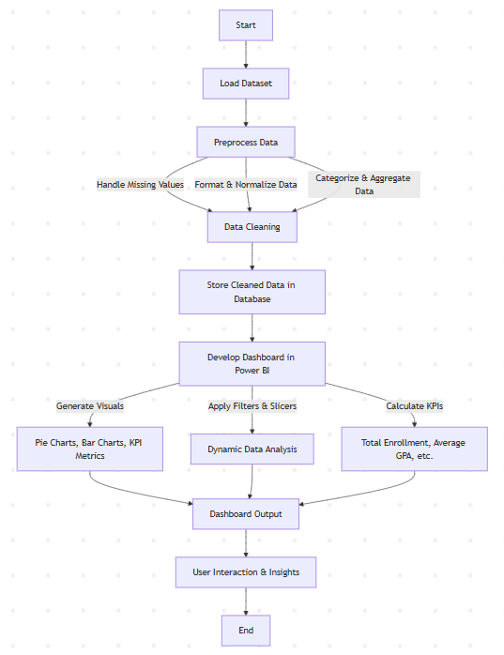

This algorithm provides a structured pipeline from data collection to dashboard deployment, ensuring effective visualization of university department statistics, student trends, and faculty insights.

**Step 1: Data Collection**

1. Extract student, faculty, and department-related data from databases (e.g., enrollment records, GPA, gender distribution).
2. Retrieve financial and other university-related datasets if applicable.
3. Ensure all required fields such as Department Name, Student ID, Enrollment Year, GPA, Gender, Course Data, and Faculty Information are available.

**Step 2: Data Processing & Cleaning**

1. Handle Missing Values:
   * Replace NULL values with meaningful defaults (e.g., 0 for GPA, "Unknown" for department).
   * Remove duplicate records.
2. Standardize Data:
   * Convert categorical values into a standard format (e.g., "Comp Sci" → "Computer Science").
   * Normalize numerical fields (e.g., GPA should be between 0 and 4).
3. Filter & Transform Data:
   * Aggregate GPA and student enrollment by department.
   * Count male and female students for gender analysis.
   * Compute total yearly student intake per department.

**Step 3: Data Storage**

1. Store the cleaned and processed data in a structured format (e.g., SQL database, CSV files, or a Power BI dataset).
2. Optimize indexing for fast retrieval of records (especially for large datasets).
3. Use relationships between tables to ensure efficient querying (e.g., Student_ID linked to Enrollment_Year and Department).

**Step 4: Dashboard Development**

1. Define key performance indicators (KPIs) such as:
   * Total Enrollment
   * Average GPA
   * Student Distribution by Department and Gender
   * Yearly Enrollment Trends
   * Course Popularity
   * Faculty & Course Insights
2. Select Visualization Types for Each KPI:
   * Pie Charts for gender distribution and enrollment per department.
   * Bar Charts for GPA analysis by department and student count.
   * Donut Charts for total yearly student intake.
   * Gauge Charts for GPA and enrollment metrics.
   * Stacked Column Charts for department-wise student and faculty counts.

**Step 5: Data Binding & Interactivity**

1. Connect the dashboard to the processed dataset in Power BI.
2. Enable slicers and filters:
   * Allow users to filter by department, year, or gender.
   * Provide drill-down options for deeper analysis.
3. Create dynamic measures (DAX formulas in Power BI):
   * Total Enrollment = SUM(Enrollment_Year)
   * Average GPA = AVERAGE(GPA)
   * Students Per Year = DISTINCTCOUNT(Student_ID)

**Step 6: Deployment & Reporting**

1. Test the dashboard for correctness and performance (check data accuracy, refresh rate).
2. Schedule periodic data refreshes to keep visualizations updated.
3. Deploy the dashboard for stakeholders, ensuring:
   * Role-based access control.
   * Export functionality (PDF, Excel).
   * Integration with university decision-making systems.

**Mathematical Model :**

1.Total female students:

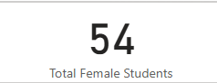

Formula:

Total Female Students = CALCULATE(COUNT(Students[Student_ID]), Students[Gender] = "Female")

The given **DAX (Data Analysis Expressions) formula** calculates the total number of female students in the dataset.

Average gpa:

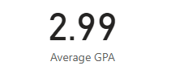

Formula:

Average GPA = AVERAGE(Students[GPA])

This **DAX (Data Analysis Expressions) formula** calculates the **average GPA** of students in the dataset.

Students Enrolled Per Year

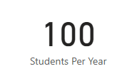

Formula:

Students Per Year = COUNTROWS(Students)

This **DAX (Data Analysis Expressions) formula** calculates the **total number of students** in the dataset by counting the number of rows in the Students table.

**Dashboard**

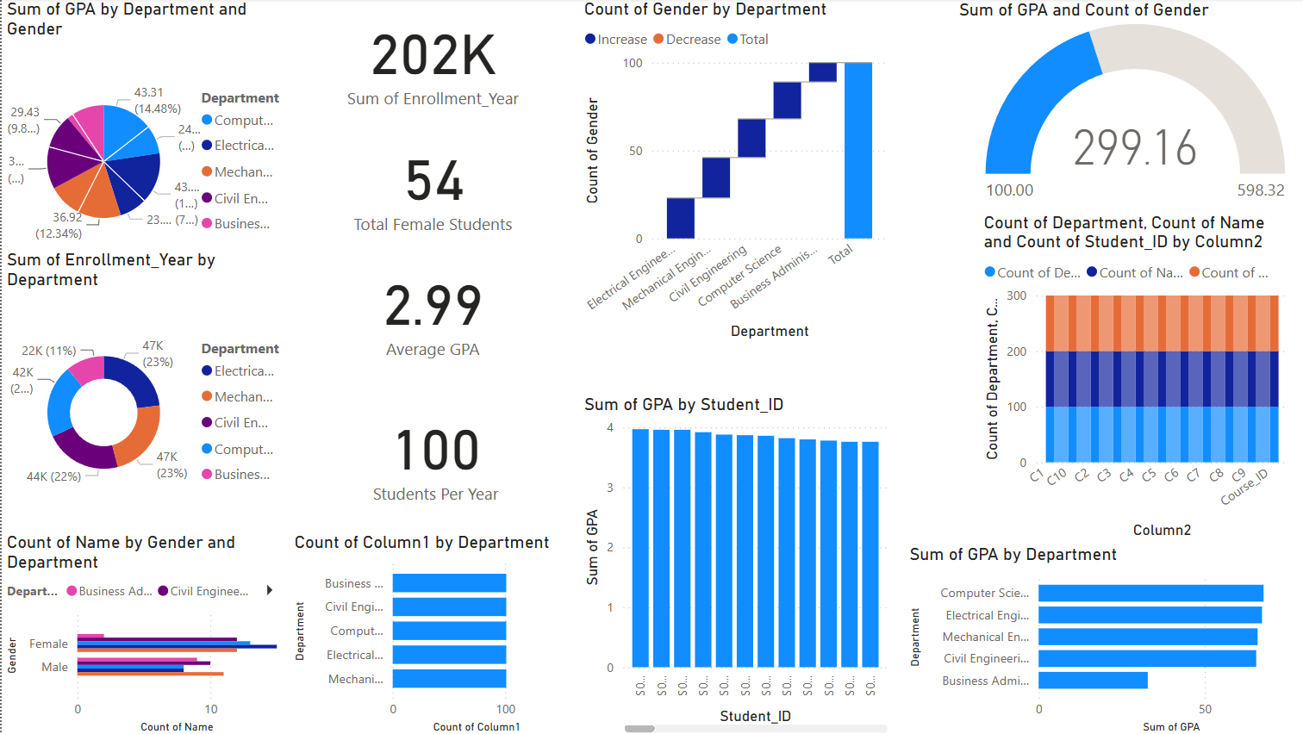

The dashboard provides a comprehensive overview of university enrollment and student performance metrics. The total enrollment stands at 202K, with an average GPA of 2.99 and 54 female students recorded. Department-wise distributions show Computer Science and Civil Engineering having the highest student enrollments. The GPA analysis highlights variations across departments, with Business Administration showing lower GPA scores compared to technical fields. The gender distribution indicates diversity across disciplines, while student count per course (Column2) remains consistent. These insights can help institutions optimize academic strategies and improve student engagement.

**Insights**

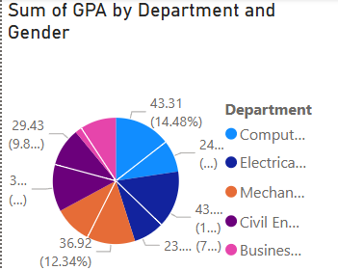**Pie chart:**

The pie chart illustrates the sum of GPAs across different departments, highlighting the academic performance distribution. The Computer Science department contributes the highest (14.48%), followed by other departments like Mechanical, Electrical, Civil, and Business Administration. The chart helps identify departments with strong or weak performance, aiding in institutional decision-making and student support initiatives. Additionally, it provides insights into gender representation and diversity in various fields, helping universities assess trends and implement targeted improvements.

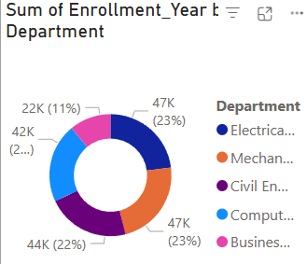**Donut chart:**

The donut chart represents the sum of student enrollments per year across various departments. The Electrical and Mechanical Engineering departments each have the highest enrollment (23%), followed by Computer Science (22%), Civil Engineering (20%), and Business Administration (11%). This visualization helps in understanding department-wise student distribution, identifying popular fields of study, and assessing trends in enrollment. Such insights can assist in resource allocation, faculty planning, and curriculum development to align with student demand and institutional goals.

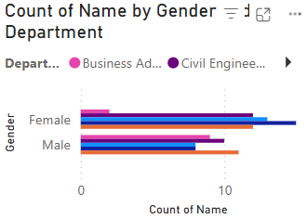**Bar chart:**

The bar chart illustrates the distribution of students by gender across different departments. It shows that male students generally have a higher count compared to female students in most departments. However, the variation between genders is not extreme, indicating a relatively balanced enrollment. The Civil Engineering department has a significant male representation, whereas Business Administration shows a more even gender distribution. These insights help in analyzing gender diversity across academic programs, aiding institutions in promoting inclusivity and encouraging equal participation in all fields of study.

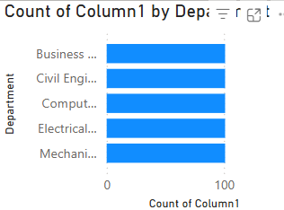

**Bar Chart:**

The bar chart presents an equal distribution across all departments, with each having the same count for the measured parameter (Column1). This indicates a balanced representation among departments, suggesting uniform enrollment, participation, or another metric being analyzed. Such consistency could imply equal opportunities or standardized admission criteria across different academic disciplines.

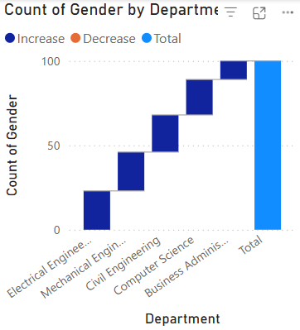The waterfall chart illustrates the count of gender distribution across various departments, showing an incremental increase as departments are added. Each department contributes to the overall total, with no apparent decreases. The final bar represents the total gender count, indicating a cumulative sum. This visualization helps in understanding gender representation trends across different fields, highlighting variations in enrollment or participation among departments.

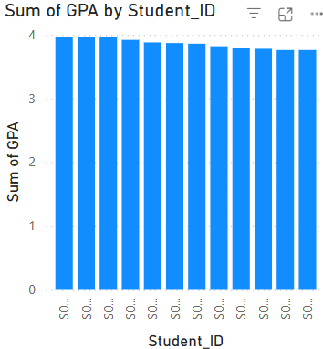

The bar chart displays the sum of GPA for individual students, where most students have a consistently high GPA, close to the maximum possible value. The uniformity in GPA distribution suggests strong academic performance among students, with little variation. This visualization helps in identifying overall student performance trends and potential outliers who may require additional academic support.

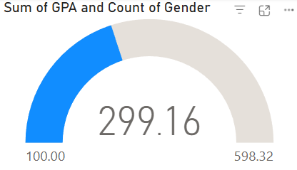The gauge chart represents the sum of GPA in relation to the total count of gender-based data points. The value of 299.16 indicates that the cumulative GPA is nearly halfway toward the maximum reference value of 598.32, with 100.00 marking a lower threshold. The blue segment highlights the current achieved value, showing significant academic performance within the dataset. This visualization effectively conveys progress toward the maximum possible sum, allowing for quick assessment of student performance distribution.

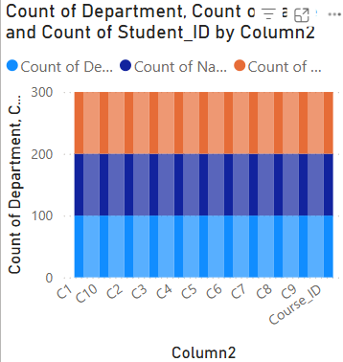

The stacked bar chart represents the count of departments, names, and student IDs across different course categories (Column2). Each bar is segmented into three different counts, showing a balanced distribution among various courses. The total count across courses remains fairly consistent, indicating uniform enrollment or categorization across different course IDs.

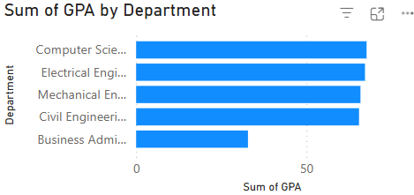The bar chart displays the sum of GPA across different departments. The Computer Science department has the highest GPA sum, followed closely by Electrical, Mechanical, and Civil Engineering departments, which have nearly similar values. The Business Administration department has the lowest total GPA among all. This indicates that students in technical fields tend to have a higher cumulative GPA compared to Business Administration. The insights can help in analyzing academic performance trends across different departments.

**Reference**

The dataset utilized for this analysis, titled 'University Department Data,' was obtained from Kaggle, a well-known platform for open data sharing and machine learning research. This dataset contains structured information on various university departments, including student GPA, enrollment details, and demographic attributes. The data was preprocessed and visualized using Power BI to extract meaningful insights related to academic performance trends, department-wise distributions, and gender-based analyses. The findings derived from this dataset provide valuable insights into student performance and institutional trends.

**Conclusion**

The analysis of the university department dataset provided valuable insights into student performance, enrollment trends, and department-wise distributions. Visualizations created using Power BI highlighted key patterns, such as variations in GPA across departments, gender-based distributions, and enrollment statistics. These findings can assist academic institutions in identifying areas for improvement, optimizing resource allocation, and enhancing student performance. The study also demonstrated the effectiveness of data visualization in deriving meaningful insights from structured datasets, emphasizing the importance of data-driven decision-making in the education sector.