**Activity based**

**Project Report on**

**Business Intelligence**

**C2P2 Project Module - II**

**Submitted to Vishwakarma University, Pune**

**Under the Initiative of**

**Contemporary Curriculum, Pedagogy, and Practice (C2P2)**

**By**

**Harshwardhan Pradip Zurunge**

**PRN No :2280030805**

**Roll No :16**

**Div: F**

**Third Year Engineering**

**Faculty In-charge:- Prof. Tareek Pattewar**

**Date of Project 2: - 11/04/25**

**Department of Computer Engineering**

**Faculty of Science and Technology**

**Academic Year**

**2024-2025 Term-II**

**Business Intelligence: Project II**

**Project Name: Scorecard for educations university department data**

**Problem Statement:**

Create a Scorecard for educations university department data.

**Introduction:**

The quality of higher education is influenced by various measurable factors including student performance, class size, faculty resources, and research productivity. To ensure continuous improvement and strategic planning, it is essential to track these key performance indicators (KPIs) systematically.

This project involves the creation of a dynamic scorecard using Power BI to visualize and assess university department data. The scorecard monitors progress toward departmental goals and helps stakeholders take timely, data-driven actions.

**Related Study:**

Academic institutions worldwide have adopted **data dashboards** and **scorecards** as a part of their strategic management tools. These include:

* **NIRF (India)** and **QS Rankings**, which rely on indicators like faculty-student ratio, research impact, and student outcomes.
* **Balanced Scorecard Models** customized for education to align teaching, research, and administrative efficiency with institutional goals.

Inspired by these frameworks, this project scorecard focuses on:

* GPA improvement
* Managing class size
* Enhancing student pass rate
* Boosting research productivity
* Increasing research funding

**Flowchart:**

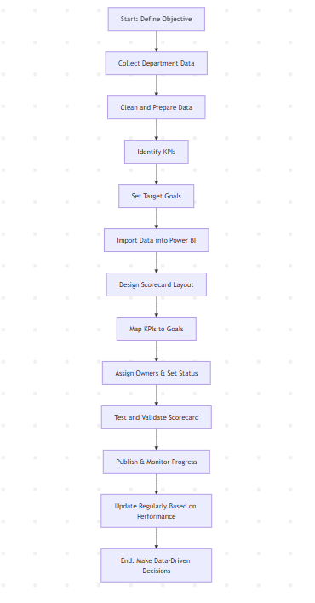**1. Start: Define Objective**

The process begins by clearly stating **why the scorecard is being created** — in this case, to **analyze university department performance** and track key academic and research outcomes.

**2. Collect Department Data**

Gather all necessary raw data including:

* Student records (GPA, pass rate)
* Faculty numbers
* Course enrollments
* Research projects and funding details

**3. Clean and Prepare Data**

Ensure data accuracy and consistency by:

* Removing duplicates
* Handling missing values
* Formatting fields (e.g., converting ₹350,991 to 350.99K)

**4. Identify KPIs**

Select **key performance indicators (KPIs)** that align with institutional goals. Examples:

* Average GPA
* Pass Rate %
* Faculty: Student Ratio
* Research Funding

**5. Set Target Goals**

Define what success looks like for each KPI:

* Avg GPA target: 3.20
* Pass Rate target: 85%
* Research funding target: ₹400K

**6. Import Data into Power BI**

Upload the cleaned dataset into Power BI to begin designing the visual components of your scorecard.

**7. Design Scorecard Layout**

Create a **user-friendly visual layout** using Power BI Scorecard tools:

* Use cards, progress bars, and color-coded statuses (On track, At risk, etc.)

**8. Map KPIs to Goals**

Link each KPI to its corresponding strategic goal:

* GPA → Improve Academic Performance
* Research Projects → Enhance Research Output

**9. Assign Owners & Set Status**

Designate responsibility for each goal (e.g., Harshwardhan Zurunge), and set the initial status: Not Started, On Track, Completed, etc.

**10. Test and Validate Scorecard**

Check if all metrics are calculated correctly, and if the visuals are displaying accurate and updated progress.

**11. Publish & Monitor Progress**

Make the scorecard available to stakeholders and monitor changes over time.

**12. Update Regularly Based on Performance**

Regularly refresh data and update statuses to reflect progress or delays in achieving goals.

**13. End: Make Data-Driven Decisions**

Use insights from the scorecard to take actions such as:

* Improving curriculum
* Investing in research
* Hiring more faculty
* Enhancing student support systems

**Scorecard:**

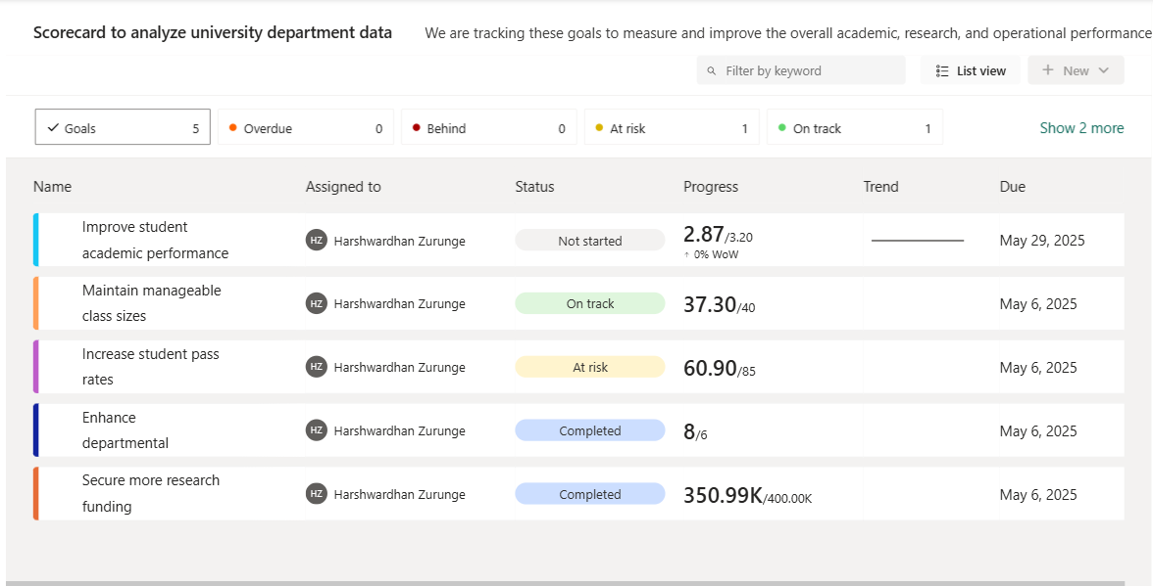

**Insights:**



**Improve Student Academic Performance**

The current average GPA across departments stands at 2.87, against a set target of 3.20, indicating a performance gap of 0.33 points. The progress status is currently marked as "Not Started", and there has been no week-over-week improvement (0% WoW), suggesting that no actionable strategies have been implemented yet toward this goal. With the deadline set for May 29, 2025, there is still an adequate window to initiate interventions, but proactive steps are critical at this stage.

To bridge the performance gap, it is essential to:

* Identify academic pain points across departments
* Enhance support mechanisms such as tutoring sessions, remedial classes, and mentorship programs
* Promote continuous internal assessments to track student progress
* Involve faculty in personalized student academic development plans



**Maintain Manageable Class Sizes**

The current average number of students per course is 37.30, which is well within the defined target threshold of ≤ 40 students per class. The goal is marked as "On Track", indicating effective management of class size distribution across departments. Maintaining class sizes below the upper limit contributes to better student engagement, increased faculty-student interaction, and improved learning outcomes.

This achievement reflects well on the academic planning and scheduling process, suggesting that departments are efficiently allocating faculty resources and balancing enrollments. To ensure continued success, it’s important to:

* Regularly monitor class sizes during enrollment periods
* Adjust teaching loads and course offerings based on demand
* Invest in infrastructure and faculty where class sizes are approaching the threshold



**Increase Student Pass Rates**

The current student pass rate stands at 60.90 out of a targeted 85, categorizing this goal as "At Risk". This significant gap highlights an area requiring urgent attention. Although progress has been made, the pace and consistency of improvement are insufficient to meet the desired academic standards.

This status may stem from factors such as:

* High academic workload or curriculum complexity
* Inadequate support systems for struggling students
* Low engagement levels in key subjects
* Insufficient assessment feedback cycles

To address this, it is recommended that departments:

* Implement targeted remedial programs and mentoring
* Offer academic counseling and workshops on study strategies
* Enhance early warning systems to identify students at risk of failing
* Encourage formative assessments for continuous improvement



**Enhance Departmental**

The goal to enhance departmental operations has been marked as Completed, with progress exceeding expectations — 8 achievements logged against a target of 6. This overachievement indicates a highly proactive and efficient implementation of departmental initiatives.

Key contributors to this success may include:

* Streamlined internal processes and workflows
* Effective use of departmental resources and collaboration
* Timely execution of improvement plans and upgrades
* Strong leadership and goal ownership by the assigned team

The success of this goal not only reflects operational excellence but also sets a positive benchmark for other ongoing objectives. Continuous documentation of best practices and sharing insights across departments will be crucial for maintaining this momentum and encouraging a culture of excellence across the university.



**Secure More Research Funding**

The goal of securing more research funding has been marked as Completed, with an impressive achievement of ₹350.99K out of a target ₹400.00K by the due date of May 6, 2025. Although slightly below the target, the substantial amount raised (approximately 88% of the target) demonstrates a strong and strategic approach to fundraising.

Key highlights include:

* Effective proposal submissions and grant applications
* Enhanced collaboration with research partners and external funding bodies
* Active participation in conferences, symposiums, and academic events
* Utilization of past success stories and performance metrics to attract funds

This progress reflects the department's commitment to research excellence and innovation. To fully meet and surpass future targets, exploring diversified funding sources and strengthening industry-academia collaborations will be critical.

**Reference:**

1. Power BI documentation – Scorecards & Goals
2. University ERP Dataset (simulated, uploaded)
3. NIRF Ranking Parameters (Ministry of Education, India)
4. Kaplan & Norton’s Balanced Scorecard Framework
5. Case studies of institutional dashboards in global universities

**Conclusion:**

This scorecard provides a clear visual representation of university department performance and highlights areas requiring attention. Goals such as academic improvement and research funding are tracked in real-time, allowing timely intervention and planning. By integrating data analysis with KPI tracking, the institution can drive continuous improvement, transparency, and excellence in higher education.