ECE – 496A

SENIOR DESIGN PROPOSAL

SMART AND SECURE HOME

STUDENTS:

____________

Giorgi Solomnishvili

Lasha Butkhuzi

Reziko Tsirgvava

Mikheil Makharadze

Aleksi Aleksandria

12/11/2020

Contents

Executive Summary 3

Solution 3

Budget & Timeline 8

Responsibilities 10

Conclusion 12

# Executive Summary

In the 21st century, Safety and Security have become one of the most critical and precise commodities, which are very hard and expensive to come by. Our team at SDSU_Georgia decided to dedicate our time and funding to researching sophisticated and relatively inexpensive solutions to the Residential Area's Safety and Security.

There are three main goals our project aims to accomplish.

* We are going to manage secure access to a residential area. We are going to implement a two-step verification front gate. If a person wants to gain access to the residential area, he/she should know the correct password, and his/her face should be recognized as the face of an authorized person.
* We are going to create a module that can identify humans intelligently. The module will determine if a person approaching the residential area is a tenant, a friend of tenants, or a stranger.
* We are going to design hardware to control the safety of the residential area. The hardware will be able to detect several kinds of hazards and generate the appropriate response.

# Solution

We will make it possible for the owner to monitor his/her home's safety and security from any place in the world. To implement that, we will create an IoT server that connects the mobile application to devices in the residential area. At home, we will install several sensors that can detect an intruder, fire, and gas leak. Furthermore, we will install an electric lock that opens if the correct password is entered and the person has the authorization to get into the residential area. Figure 1 represents the block diagram for our project.

Figure 1

**IoT Server and Connectivity**

As mentioned above, the IoT server can connect mobile applications and devices at home. We are going to run this server on raspberry pi.

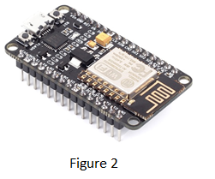The server requires to be run on the Linux operating system. We will use the ESP8266 module (Figure 2) to connect sensors to the IoT server. ESP8266 and IoT server can communicate using the MQTT protocol. Eclipse Paho provides us with useful libraries for MQTT communication. ESP8266 can connect to the access point and send or request information to the server. We plan to use ESP8266 to receive information for sensors and send them to the IoT cloud. The cloud will send this information to the application.

**Hazard Detection**

We are going to install sensors that can detect an intruder, fire, and gas leak.

**Intruder (Motion) Detection:**

Our design will be able to detect a motion in the home. We plan to use a Microwave sensor and Passive infrared (PIR) to detect the motion.

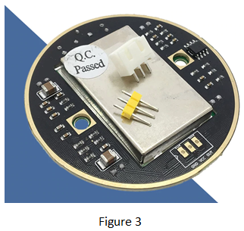Microwave sensors (Figure 3) detects motion by utilizing electromagnetic radiation. The sensor can emit electromagnetic waves and capture reflected waves. The sensor can measure the time wave took to reach an object and come back to the source. Microwave sensor uses the doppler effect and projected microwaves to detect the motion.

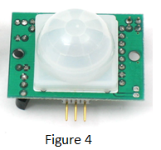

PIR sensor detects (Figure 4) motion by detecting the heat and rapid heat change in a residential area. This rapid change of heat indicates that someone is moving into the home.

If nobody is supposed to be at home and the motion is detected, this means that we have an intruder. There is an excellent chance that this intruder is a thief. The house will go into lockdown mode, the owner and the police will be notified about the intruder.

**Gas Leak Detector:**

Our design will be able to detect the gas leak. We plan to use an MQ gas sensor (Figure 5), also known as "Chemiresistor."

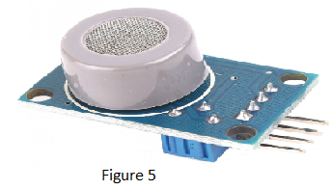Chemiresistive materials change their electric resistance in response to the change in the chemical composition of the environment. The research indicates that MQ can detect a change in Methane concentration, Carbon dioxide, and hydrocarbon gas-liquid. The concentration of the elements mentioned above increases when there is a gas leak. Thus, the MQ sensor enables us to monitor the concentration of chemical components of natural gas. The owner and the gas supplier will be notified about the gas leak.

**Fire Detector:**

We will use IR Distance Sensor to detect the smoke, which is the precursor of the fire.

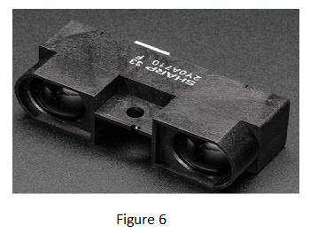IR distance Sensor emits IR wave. They bounce off the objects and are sent back to the IR sensor. This sensor can measure the distance between itself and the object. We are going to install this sensor on the ceiling. In case of fire, the IR sensor will detect approaching smoke and generates an alert for fire. The owner and the firefighters will be notified about the fire.

In addition to that, we plan to install HDC1080 CO2 Temperature and Humidity VOCs Air Quality Sensor (Figure 7).

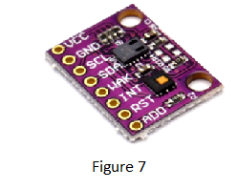This sensor enables us to monitor not only temperature and Humidity, but also Volatile Organic Compounds (VOCs) such as carbon-based (organic) chemicals (compounds). VOC has the potential to harm human health. This sensor will generate an alert if the concentration of VOCs increases. Also, it will allow us to monitor the change of temperature and Humidity during the fire. Such information might be interesting for certain kinds of researches.

**GSM Module:**

We will use the GSM module to send alert notifications to the police, firefighting unit, or gas supplier. GSM is a wireless modem created to describe the protocols for second-generation (2G) digital cellular networks used by mobile phones and is now the default global standard for mobile communications. This modem requires a sim card and can make calls or send SMS. The module can be programmed by sending AT commands to it.

**Action Devices**

We will install two kinds of action devices – Fire Extinguisher and Password Protected Gate with an electric lock.

**Fire Extinguisher:**

Our design can detect fire and call a firefighting unit for help, but that is not enough. 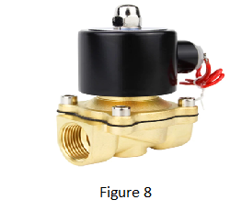

We want our design to contain and, if possible, eliminate the fire on its own. To accomplish this task, we are going to install solenoid valves on the ceiling. These valves will be connected to water reservoirs and release water in case of fire.

**Password Protected Gate:**

We will install an electric lock that does not unlock itself unless the correct combination is entered. This combination will change every 12 or 24 hours, and the new combination will be sent to the owner.

**Face Recognition**

We are going to have a unit that can recognize the faces of people at the front door. The owner will give individuals authorization so that the front door will open for them as they show up at the gate. For the owner to provide a person an authorization, we need to have a reference picture. The reference picture should go through the Facial Recognition Process, consisting of three phases: Face Detection, Pre-processing of the image, and Training.

**Phase 1 - Face Detection:**

Our program divides the image into several boxes. Each of those boxes contains nine neighboring pixels. The program converts the image into grayscale. Now we have only black and white pixels. The program determines gradients in each box. The arrows are placed along the gradients. Thus, the program creates the shape of objects. Figure 9 shows a reference picture and the shape of the face. Once the face is detected, it is cropped from the reference image and is ready for the second phase.

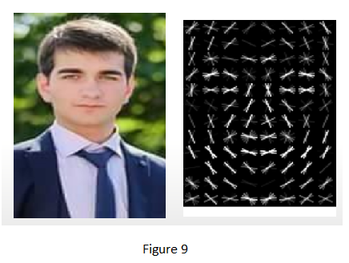

**Phase 2 – Pre-Processing:**

During the second phase, the face is being pre-processed. The program looks for facial landmarks that are unique to every human being. Figure 10 shows the position of those landmarks and landmarks of the reference face.

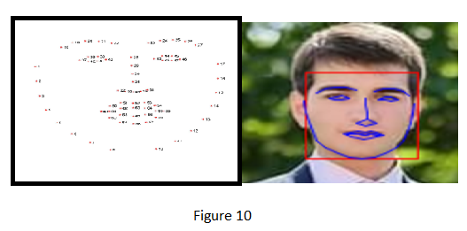

**Phase 3 – Training:**

During the third phase, facial landmarks are stored and assigned with the name of the person. See Figure 11.

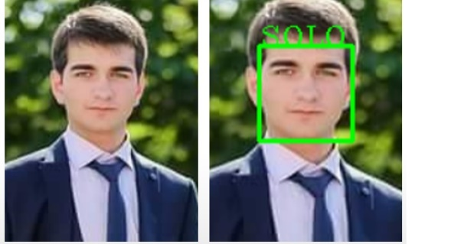In the future, when this person – SOLO, looks into the camera, he will be identified as an authorized person, and the owner of the house will be notified that SOLO has arrived. See Figure 12

Figure 11

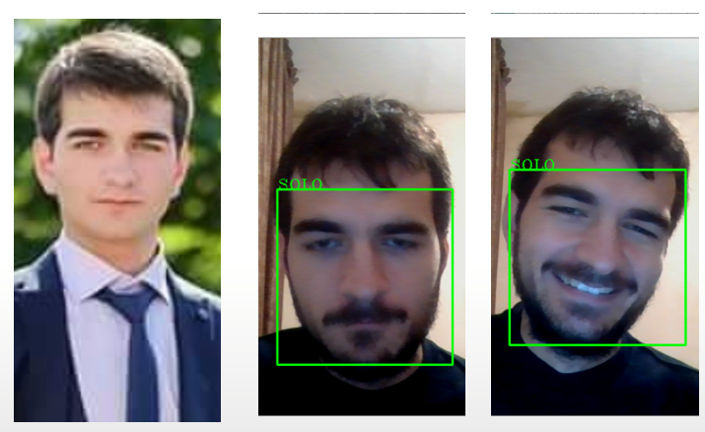

Figure 12

# Budget & Timeline

Our budget is 600$. According to our estimations, we need to spend 460$ on sensors and components. Shipping is estimated to cost 100$. That leaves us with 40$, which is reserved for other materials, such as jumper wires and unforeseen expenses. The following is finances in detail.

IoT Server and Connectivity Components – 68$

* Raspberry Pi 4
* Renting Virtual Comp
* EP8266
* GSM SIM800C

Recognition – 197$

* Pi Camera 3x
* Raspberry Pi 4
* Arducam Multi-Camera Adapter Module

Power Management – 30$

* 12 Volt Power Supply;
* 12V DC 10A Adapter
* Relay with 5V control 5x

Action Devices – 75$

* Electronic Lock
* Solenoid Valve 12V

Sensors – 85$

* Microwave Sensor with Doppler radar
* PIR motion sensor
* Motion Light Sensor
* HDC1080 CCS811
* IR Distance Sensor
* Photoelectric smoke detector
* Gas sensor MQ

Monitoring – 5$

* LCD Screen
* I2C LCD module
* Budget – 600$
* Spent – 460$
* Shipping – 100$
* Other Materials – 40$

We understand that we chose to do a massive project that requires a significant amount of time and energy. We expect to finish this project by the end of March. Table 1 shows the Schedule.

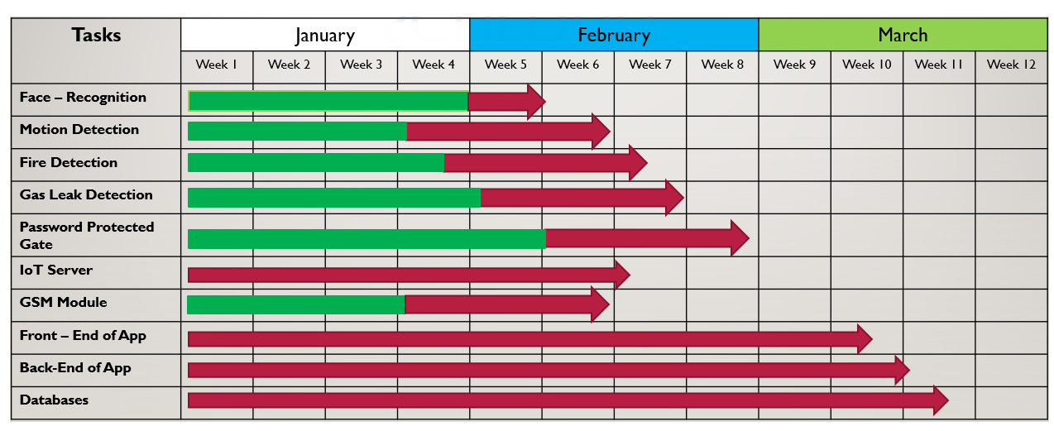

Table 1

On the table, there are two kinds of arrows. The red arrows represent tasks we have not started working on yet. Green – Red arrows represent partially completed tasks, or we have a perfect idea of how to complete them.

Face – recognition is almost completed. We need to run it on Raspberry Pi.

Motion Detection is partially completed. We know the components we are going to use. We wait for finances to order them. The same can be said about fire and gas leak detection, password-protected gate, and GSM Module.

We have not started working on mobile applications and IoT servers yet.

# Responsibilities

Our team consists of five members: Giorgi Solomnishvili, Lasha Butkhuzi, Reziko Tsirgvava, Mikheil Makharadze, and Aleksi Aleksandria. We distributed tasks that are required to complete to make our design work. Table 2 shows the distribution of tasks related to the project, and table 3 shows the distribution of administrative tasks.

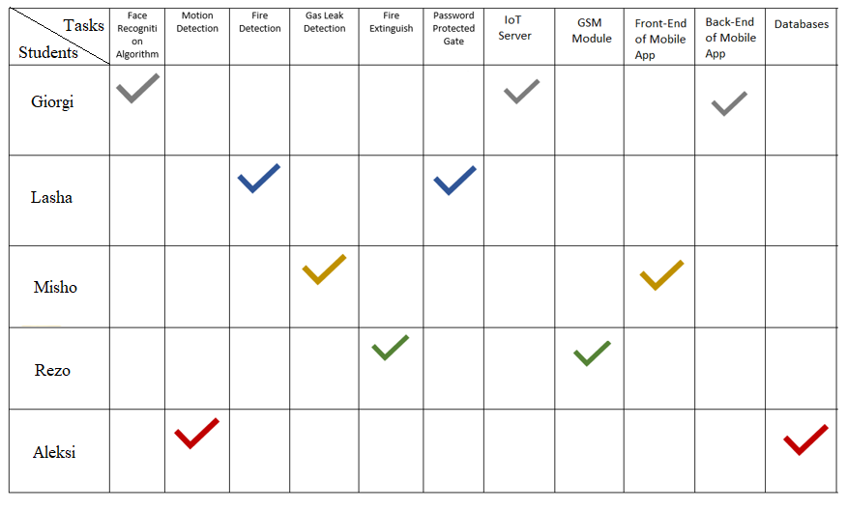

Table 2

|  |  |
| --- | --- |
| **Responsibilities** | **Students** |
| Project/schedule manage | Giorgi Solomnishvili |
| Meeting leader is a rotating assignment. | Rotating |
| Editor for the project report | Giorgi Solomnishvili |
| Editor for the team presentations | Reziko Tsirgvava |
| Editor for the web site | Mikheil Makharadze |
| Editor for the team poster | Lasha Butkhuzi |
| Technical Illustrator | Aleksi Aleksandria |
| Parts procurement | Lasha Butkhuzi |
| Technical | Mikheil Makharadze |
| Exhibit manager | Aleksi Aleksandria |
| Budget manager | Reziko Tsirgvava |

Table 3

# Conclusion

In conclusion, our project will improve the safety and security of any home where it is installed. We understand that we chose to do a massive undertaking that requires a significant amount of time and energy, but we are determined students. We will do our best to complete a project that is worthy of the reputation of SDSU.