每年发生事件数量：

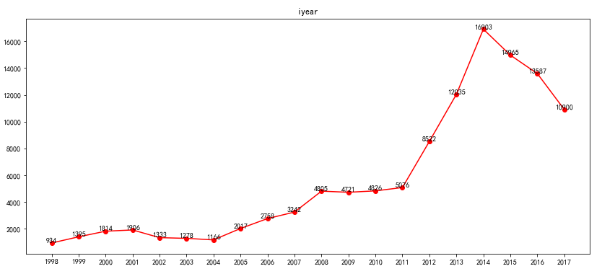

每月发生事件数量：

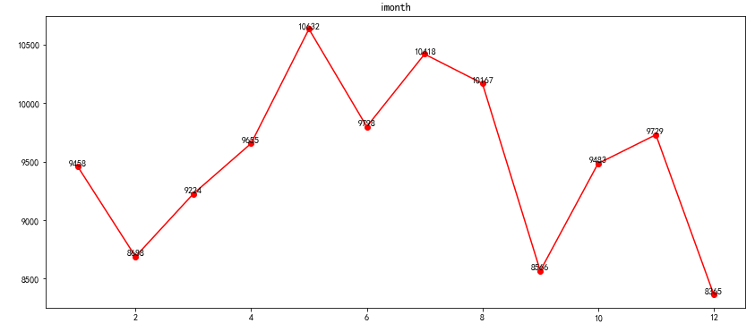

发生袭击比较多的国家：

|  |  |
| --- | --- |
| Iraq | 24494 |
| Pakistan | 12627 |
| Afghanistan | 12617 |
| India | 9091 |
| Philippines | 4969 |
| Somalia | 3978 |
| Nigeria | 3846 |
| Thailand | 3631 |
| Yemen | 3264 |
| Colombia | 2313 |

发生袭击比较多的城市：

|  |  |
| --- | --- |
| Baghdad | 7545 |
| Mosul | 2262 |
| Karachi | 1552 |
| Mogadishu | 1486 |
| Kirkuk | 921 |
| Benghazi | 837 |
| Quetta | 787 |
| Baqubah | 744 |
| Peshawar | 726 |
| Kabul | 670 |

发生袭击比较多的地区：

|  |  |
| --- | --- |
| iddle East & North Africa | 41640 |
| South Asia | 37573 |
| Sub-Saharan Africa | 13274 |
| Southeast Asia | 9701 |
| Eastern Europe | 4256 |
| Western Europe | 3577 |
| South America | 2750 |
| North America | 741 |
| Central Asia | 277 |
| East Asia | 211 |

袭击形式（其他）：

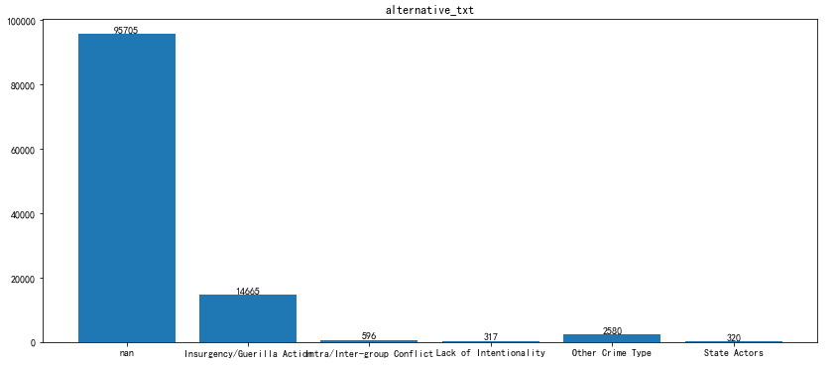

袭击成功/失败：99781/14402

声称负责/未声称负责：18655/94094

攻击类型：

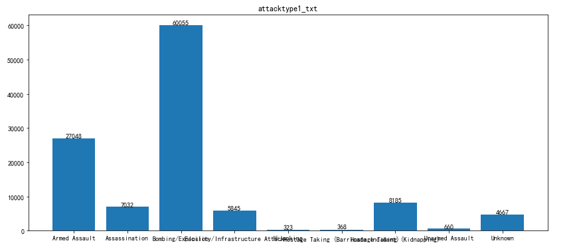

受害者：

|  |  |
| --- | --- |
| Private Citizens & Property | 31278 |
| Military | 18764 |
| Police | 16871 |
| Government (General) | 12537 |
| Business | 9280 |
| Transportation | 3265 |
| Religious Figures/Institutions | 3171 |
| Educational Institution | 3001 |
| Utilities | 2364 |

恐怖组织：

|  |  |
| --- | --- |
| Taliban | 7474 |
| Islamic State of Iraq and the Levant (ISIL) | 5612 |
| Al-Shabaab | 3288 |
| Boko Haram | 2418 |
| Communist Party of India - Maoist (CPI-Maoist) | 1878 |
| New People's Army (NPA) | 1800 |
| Maoists | 1619 |
| Tehrik-i-Taliban Pakistan (TTP) | 1351 |
| Revolutionary Armed Forces of Colombia (FARC) | 1331 |

武器类型：

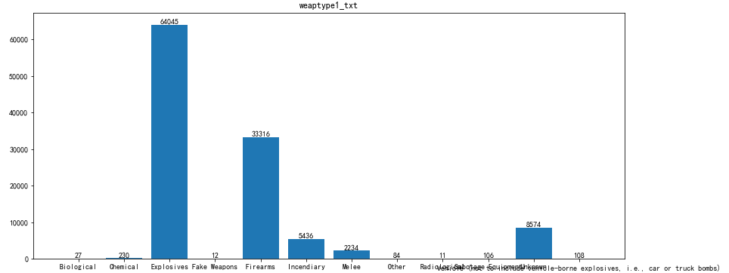

|  |  |
| --- | --- |
| Explosives | 64045 |
| Firearms | 33316 |
| Incendiary | 5436 |
| Melee | 2234 |
| Chemical | 230 |
| Vehicle | 108 |
| Sabotage Equipment | 106 |
| Other | 84 |

死亡人数频率分布直方图：

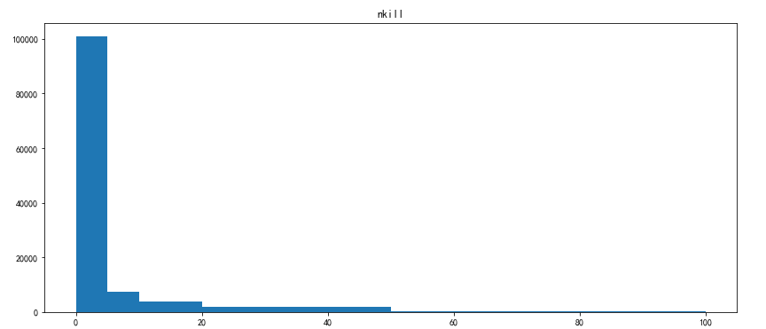

受伤人数频率分布直方图：

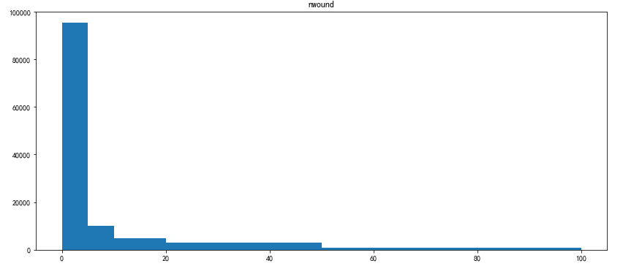

财产损害程度：

3.0 33180

4.0 13040

2.0 612

1.0 4