Advanced Casting
With
Mac Brown and Gary Borger
Advanced Casting
Advanced Casting means gaining Advanced Understanding in order to achieve Advanced Control of the fly rod and line. And this means examining every aspect of casting from the grip, to the casting method, to loop control, to shooting line, to hauling, to mends, to curves, and beyond.
Advanced Casting MUST be based on well-established, fundamental skills that allow the caster to readily move from basic understandings into advanced control of the rod and line. Advance casting MUST be based on the Whole Arm Casting Method because it offers the greatest range of variations of any of the casting Methods. Advanced Casting ALSO requires absolute wrist control, which is best achieved with the Three Point Grip. You will learn both Whole Arm Casting and The Three Point Grip in detail. Develop them through careful, intentional practice so you can readily and easily move into all aspects of Advanced Casting.

Advanced casting” often include tactics that should be in the basic casting group. None-the less, based purely on empirical observations, advanced casting skills encompasses these
- Definitions of, and differences between, “Casting,” and “Mending.”
- Concept of “Control,” and the job of fly caster (directing the rod tip).
- Truly understanding the First (and only) Rule of Fly Casting.
- The Three Point Grip.
- Difference between “Casting Method” and “Casting Style.”
- Whole Arm Casting.
- A.L.E.
- HS/HL
- Loop Control and Analysis.
- Across the Head Casting.
- Creep and Drift.
- Layback.
- In-the-Air Mending Tactics.
- Side Arm Roll Cast.
- All aspects of Spey Casting with Single-Handed Rod, both standard Spey and Sidearm Spey.
- Extended Bow and Arrow.
- “Minor” Casts which include: Reached Casts, Long Distance Roll Casts, Straight Out Roll Cast, Steeple Cast, Madison Cast, Puddle Cast, Underloop Cast, Parachute Cast, Pendulum Cast, Squat Cast.
- Shooting line on the Backcast.
- Single Shoot, Double Shoot, Triple Shoot.
- Single Haul, Double Haul, Triple Haul.
- “C” Pickup, Dancing Line Pickup, Wiggle Pickup, Snap Pickup.
- Thrust Cast.
- Lift and Point on Shoot.
- Casting on the Surface of the Water.
- All five Methods of Curve Casting.
- How to evaluate The Casting Stroke.
- Line Loop Analysis

Origins of Modern Casting
Fly Fishing is about 2,000 years old. For the first 1,850 years it was pole and string technology—that is, the “rod” was in fact a “pole” cut from the forest. The line was knotted horsehair tied to the tip of the pole. There was not much “casting” as we know it today. Casting, as is currently done, originated about 1850 when Samuel Phillipe developed the 6-strip cane rod construction method, and William Mitchell introduced Tonkin cane into the mix (which allowed lightweight, single-hand rods to be built); modern fixed rod guides evolved; and braiding machines were built to manufacture 90 foot long, knotless, tapered silk fly lines. These three elements allowed the caster to do something that could not be done for the first 1,850 years of fly fishing—and that is, to shoot line.
Purpose of Casting
The purpose of casting immediately became to energize the line so that it could shoot. This necessitated the evolution of the line loop, and the need to direct the line as straight as possible in order to achieve the most efficient use of casting energy.

Two Rules of Fly Casting
The two rules of casting became evident from the very beginning. Rule 1: What the rod tip does, the line does. Rule 2: Don’t forget rule 1.

Control, Pantomime Method, and Smart Phone
Control is the key word in all casting, and doubly so for Advanced Casting. Advanced casting is really about advanced control of the rod to give the caster advanced control of the line. However, advanced control is not possible without practice.
When practicing, use the Pantomime Method (see below) as much as possible, until all movements are clearly imprinted. Use a smartphone to video your casting. Evaluate all casting videos honestly, perfecting arm and hand movements until they achieve what is needed to yield the advanced control desired.

Casting Methods. Three casting Methods rapidly evolved:
1. Wrist Casting in which all the energy of the cast was supplied by the wrist alone.
2. Forearm Casting in which the forearm and wrist were both used to lift and energize the line. Wrist Casting and Forearm Casting both have limited uses in modern fly fishing.
3. Whole Arm Casting in which the entire arm—wrist, forearm, elbow, upper arm and shoulder all come into play to cast the line. Whole Arm Casting evolved from distance tournament casting. By 1899 Whole Arm Casting was the Method for achieving truly long casts; Walter Mansfield, then President of the Golden Gate Casting Club in San Francisco, CA, set a world record distance cast of 133 feet (average of 3 casts). That record stood for 35 years until Marvin Hedge introduced the Double Haul at the casting games in St. Louis, MO, in August of 1934. Whole Arm Casting is the most Advanced Casting Method because it gives the fly rodder the widest range of rod movements, and thereby gives the most control of the line.

The Grip
Wrist Casting was the first Method that fly casters used to energize the line. It uses a Thumb-on-Top Grip. When casters adopted the Forearm Method, they continued to use the Thumb-on-Top Grip, but found it necessary to not allow the wrist to bend rearward too far. Very quickly the casting mantra became: “Don’t bend the wrist.” In fact, a Whole Arm Casting Method was developed in England for tournament accuracy in which the wrist was not bent at all. The casting hand was raised to the center of the forehead. This is the style that was used by American, Frank Steele, to cast the first, perfect score in the dry fly accuracy event in 1932.
George Selwyn Marriott, who was a close friend and tutor of Frederick Halford (who is considered the Father of Dry Fly Fishing) used a Three Point Grip because he claimed it allowed him more precision (more control) in casting. Marriott is called the “Prince of Fly Fishers,” and was perhaps the finest fly fisher and fly caster that England ever produced. He could cast 30 yards, cast under his leg and behind his back, hit a 1-inch target at 20 yards, and out fish all other anglers, hands down.
The Three Point Grip is most certainly a component of Advanced Casting because it allows the fly fisher to fully bend the wrist when casting. Thus, the wrist becomes an essential part of casting and not a component that must be constantly kept under strict control. In addition, because the index finger is up on the rod handle, it allows the fly fisher to more accurately point the rod, and thereby make more precise casts (Figure 1).

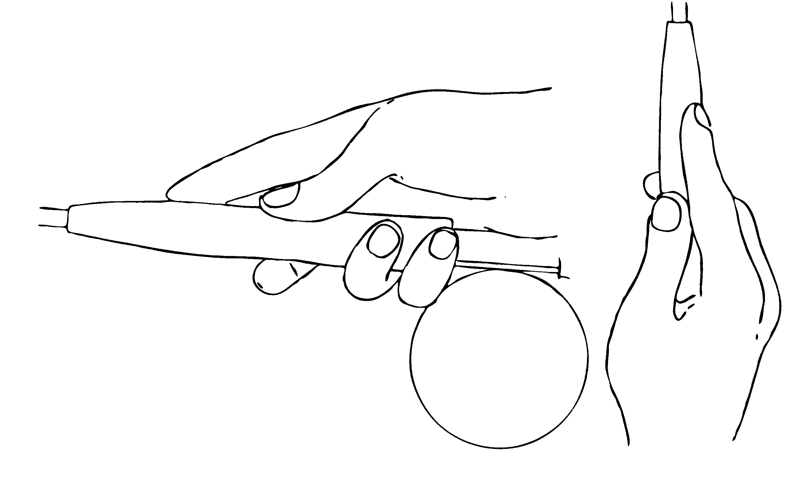
Figure 1. The Three Point Grip

Pantomime Casting
The Pantomime technique for teaching casting was the brainchild of Mel Krieger in 1975. He originated it for teaching the Double Haul, but it quickly became THE technique for teaching all fly casting. It is done by making the casting motions without the rod, in order to slowly develop the needed muscle movements, before using the rod and line. The true secret to developing casting tactics readily and easily is to practice them pantomime until they are perfectly learned.

A.L.E.
Casting is defined as those arm/hand movements that energize the line and send it to target. A.L.E. is an acronym developed by Jason Borger in the mid 1990s to describe the necessary three phases of rod movement during the cast (either back cast or forward cast). A = Acceleration; the rod starts from a stopped position, and smoothly accelerates the tip in as straight a line as possible. L = Loop Formation; the rod tip is flicked out of the line plane to form the line loop. The flick of the rod tip greatly increases the acceleration of the rod tip (and hence the line). Loop size depends upon the distance the rod tip is flicked out of the line plane (Figure 2). E = Energy Transfer; at the end of the casting stroke (either back cast or forward cast) the rod is stopped dead-still to transfer all energies to the line.

The Line Loop
The line loop is the shape the fly line assumes when cast properly. It is shaped like a “U” lying on its side with the “nose” of the loop directed toward the target. The line from the rod tip to the nose of the loop is called the “Rod Leg.” The line from the fly to the nose of the loop is called the “Fly Leg.” Other features of the loop are shown in the drawing (Figure 3). Loop analysis is a key to true Advanced Casting; this will be covered in detail in the class.

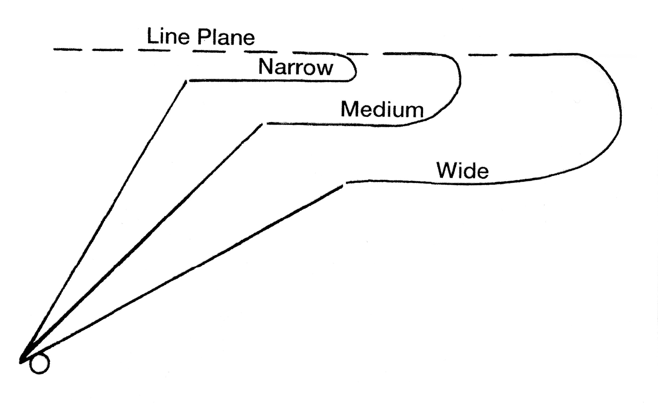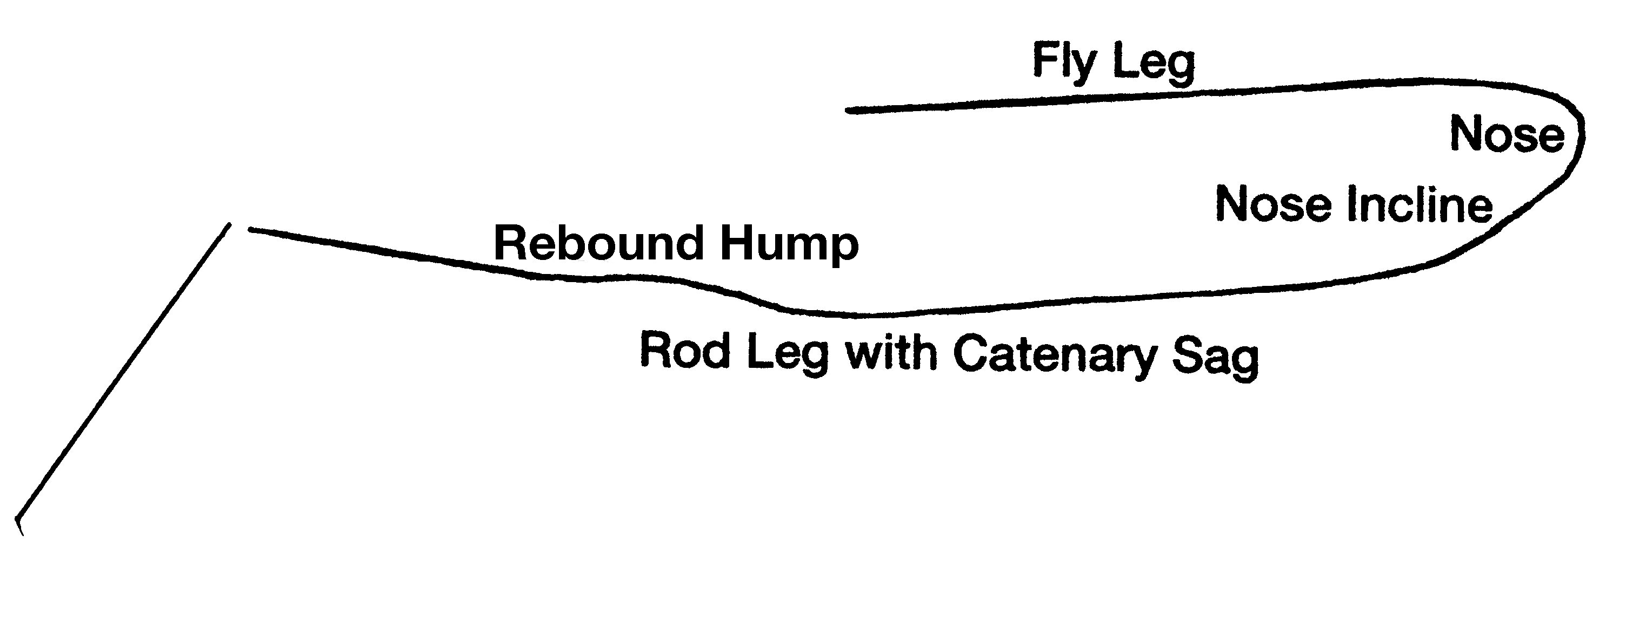

Figure 2. Loop Size Figure 3. Loop Terminology

Casting from the butt of the rod (throwing a wide loop) produces a very fast loop that quickly morphs into a Wide Power Loop that flies very fast and very far (Figure 4).
A “V” loop is produced when the rod tip literally describes a “V” (Figure 5). This is done with the Thrust Cast. The “V” loop is a very high-speed loop that cuts into the wind like a knife.
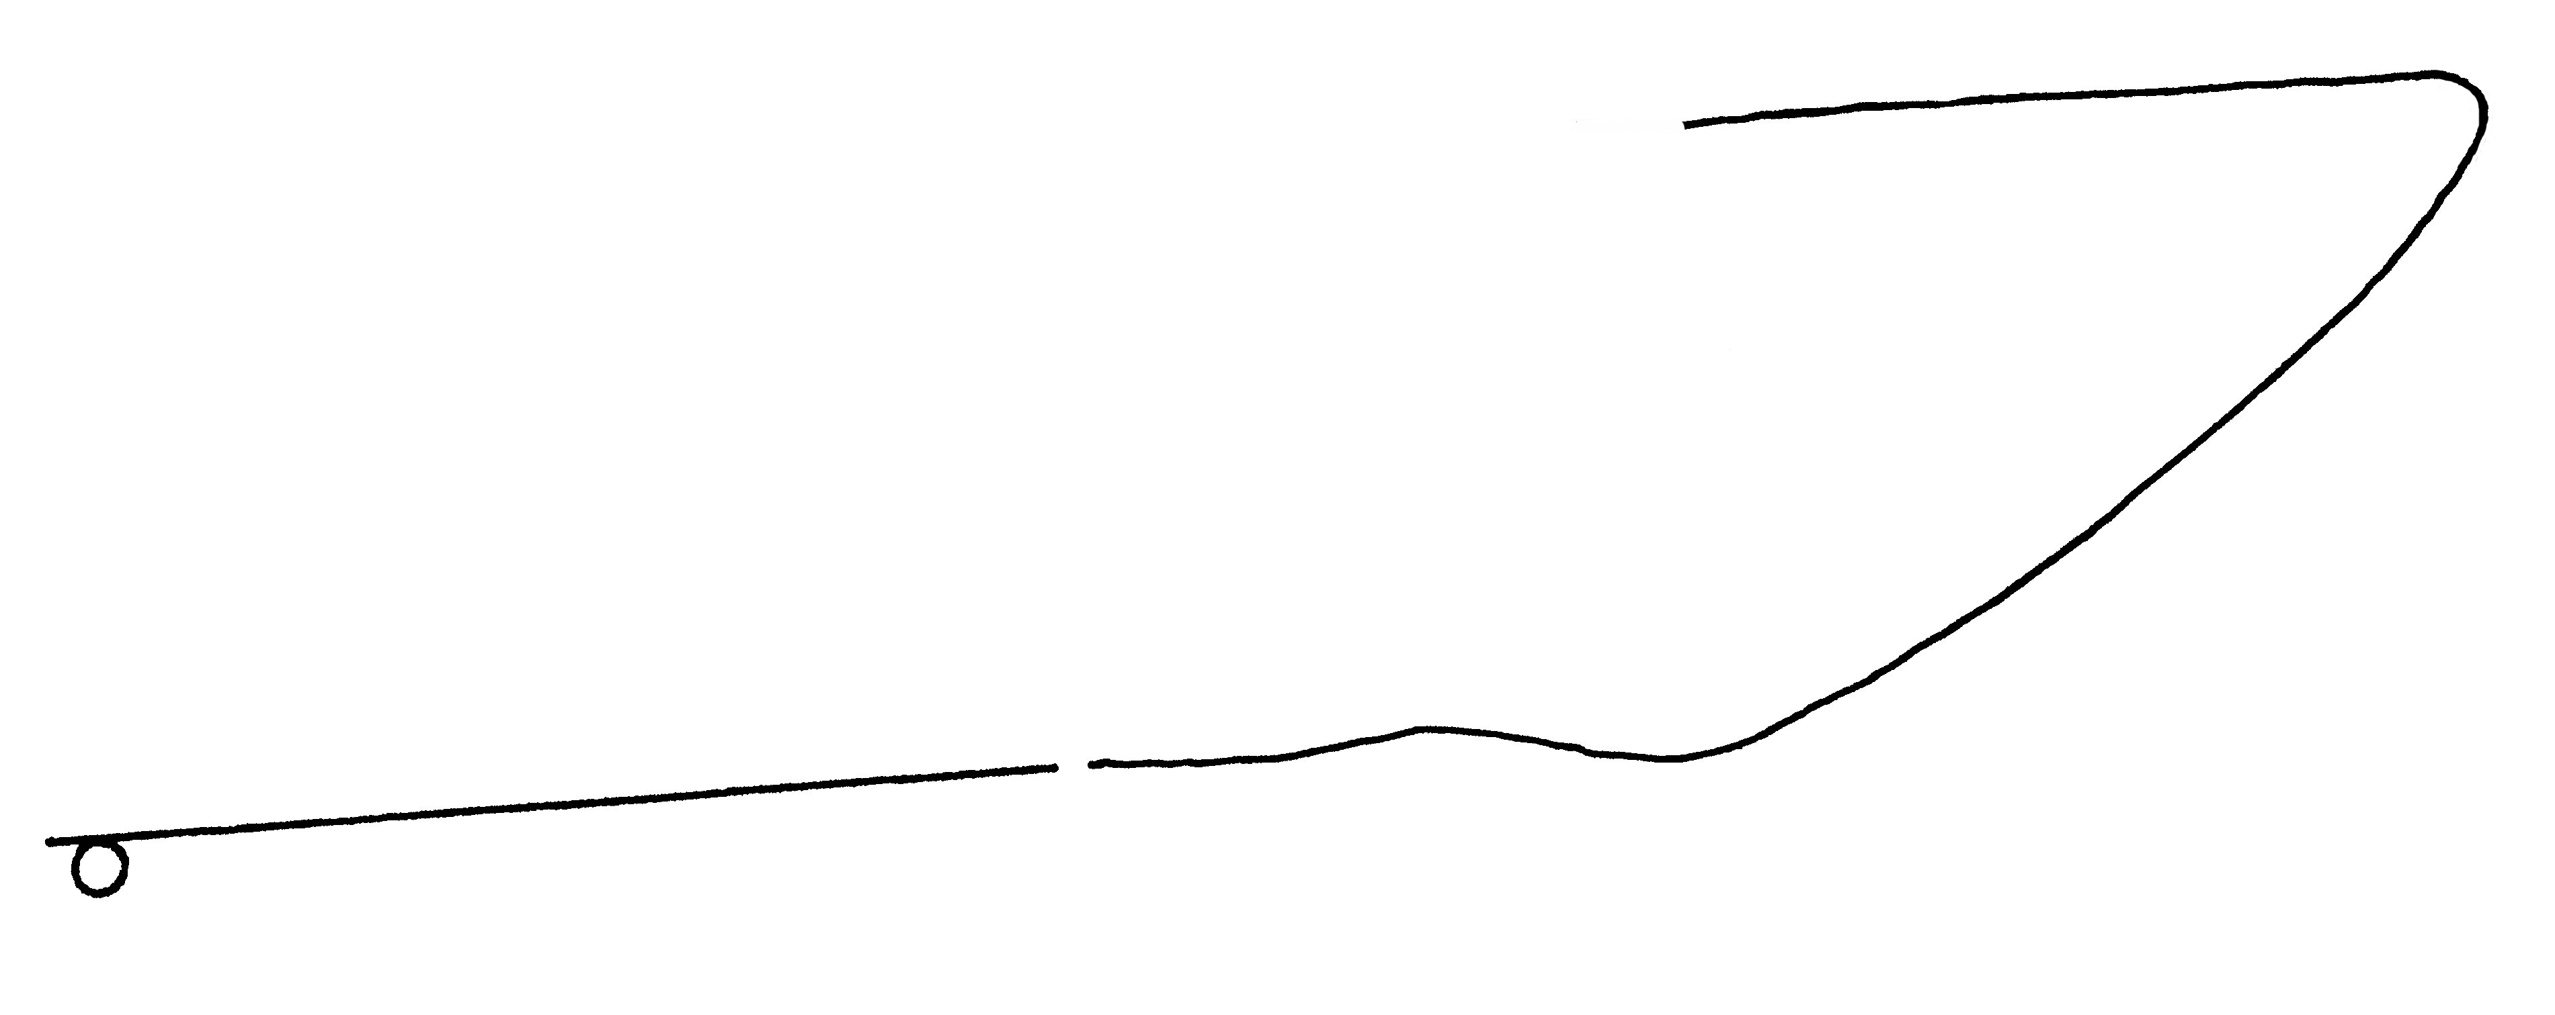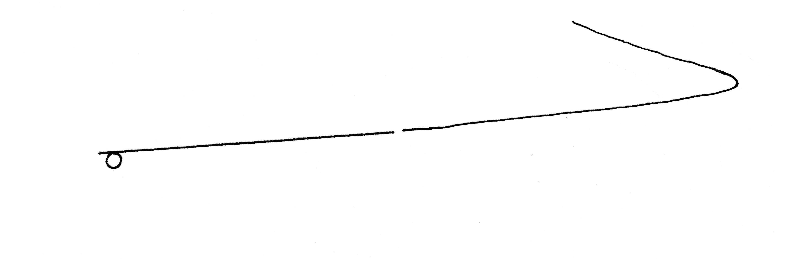
Figure 4. Wide, Power Loop Figure 5. “V” loop produced by a Thrust Cast

The Flick
Fly casting is a profoundly smooth application of power, and during the L phase, the tip is flicked out of the line plane. A flick is defined as a very swift movement that stops sharply (the abrupt stop is the “E” phase). Mac’s Pipe (Figure 6) is the best tool for helping to develop the necessary flick.

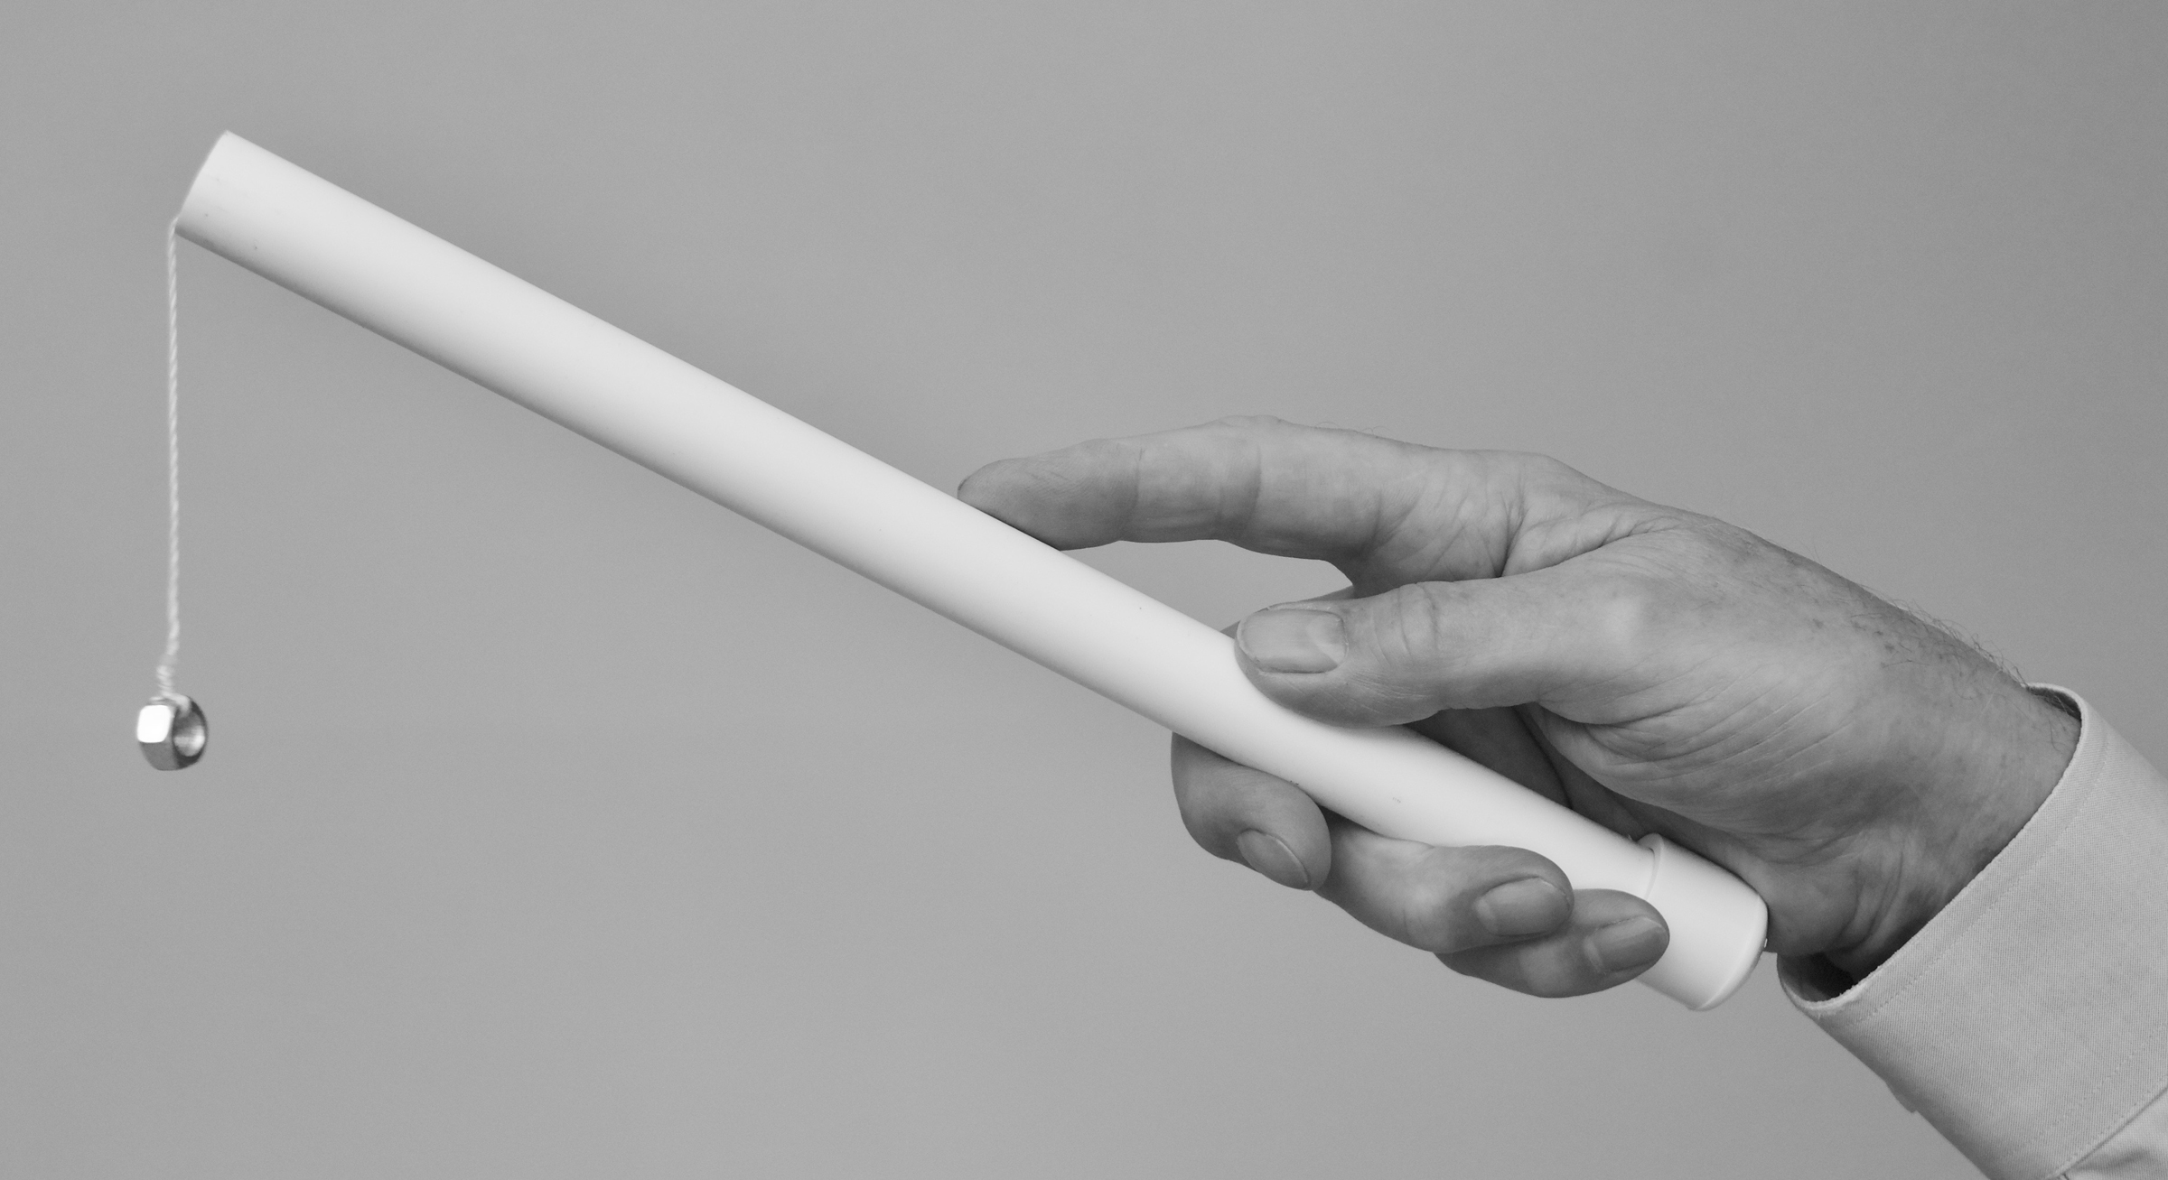
Figure 6. Mac’s Pipe

Whole Arm Casting; The Overhead Cast
The “C” Pickup
The fly line must be fully tensioned before it can be cast. If there is slack on the water, flip the rod tip around in a “C” motion to tension the line instantly before making the back cast.
The Back Cast
The casting arm is relaxed at the side, the forearm is raised and held parallel to the ground (or water). The rod is accelerated back and up in as straight a line as possible until the casting hand is as high as the side of the face and to the outside of the casting arm shoulder. In the last portion of the up and back arm movement, the casting hand is flicked rearward while the arm continues to rise back and up. The rearward movement of the forearm will stop automatically as will the rearward flick of the wrist because of anatomical limitations of the joints. Note: it is always arm lift and wrist flick together, ending simultaneously. It is NEVER arm lift and then wrist flick. The rod should end up pointing 30 degrees behind the vertical. Learn to adjust your stop point, if necessary, so that the rod always stops 30 degrees behind the vertical.

Pause, Creep, Drift
The Pause is the period following the back cast that allows the line to straighten to the rear before the forward cast begins. Some anglers move the rod forward a bit during the pause. This movement is called Creep, and it is a serious casting flaw. To negate creep, Drift the rod back and up a few inches during the Pause period.

The Forward Cast
Again, the cast must start very smoothly. The movement of the arm is as if making a karate chop, stopping the forearm so that the rod is pointed about 45 degrees above the horizontal. Stopping at this position yields a medium size line loop (1-3 feet wide). Stopping the forearm higher yields a tight loop (up to 1 foot wide). Stopping the forearm so the rod is 30 degrees above the horizontal or lower produces a wide loop (over 3 feet wide).
The wrist is very much involved in the forward stroke. During the last part of the stroke, the wrist flicks the rod forward to generate the line loop (the “L” Phase). This is where practice with Mac’s Pipe greatly benefits learning the flick.

The Casting Chart
The Casting Chart is a huge aid in learning to move the rod tip in a straight line during both the back cast and the forward cast. Expand the drawing in Figure 7 on a piece of paper, foam core board, Bristol board, matte board, or other appropriate material, so that the Base Line is the length of your forearm from elbow to knuckles. Hang the Chart on the wall so that the Base Line is horizontal and as high as your elbow, and move your hand along the Stroke Line. Use of the Chart will be fully examined in the class.
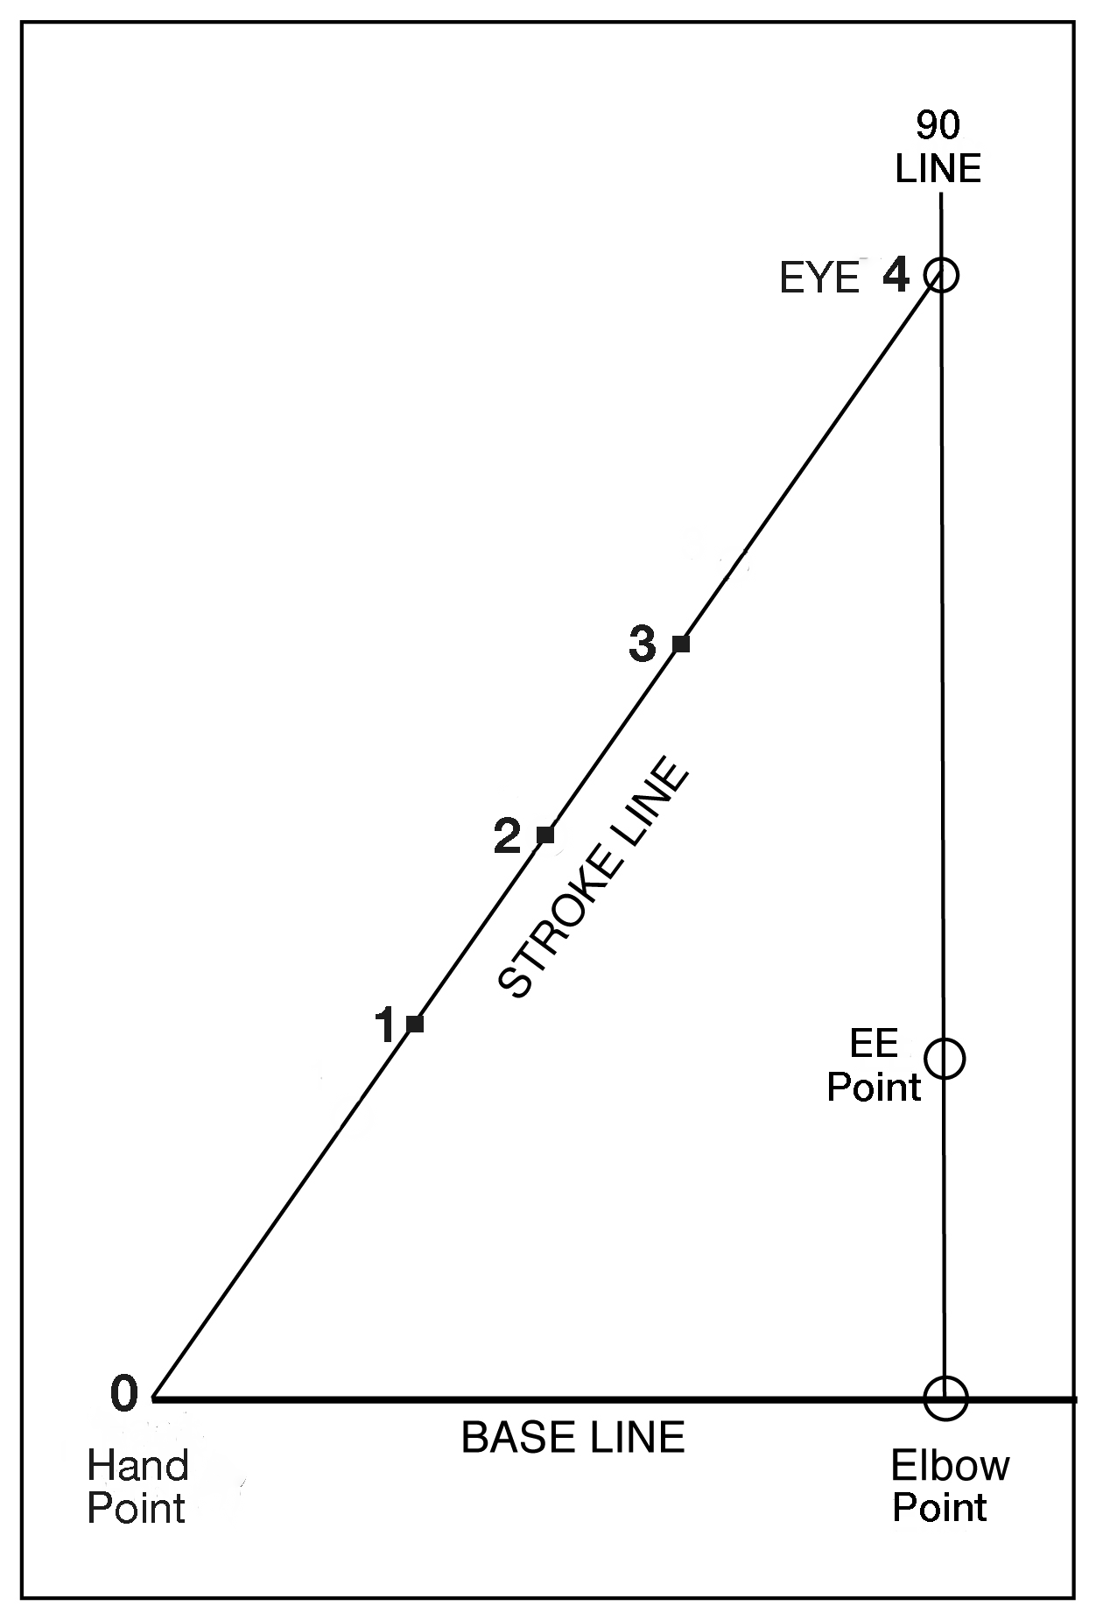
Figure 7. The Casting Chart
Tailing Loop
One of the most common casting errors, usually caused by pushing the rod forward rather than making a “Karate Chop” style forward cast. Such a movement makes the rod tip go in a concave pathway, generating a tailing loop cast (Figure 8). It robs the cast of distance and accuracy and can cause the fly to catch in the rod or line, and is the cause of “wind knots” in the leader.

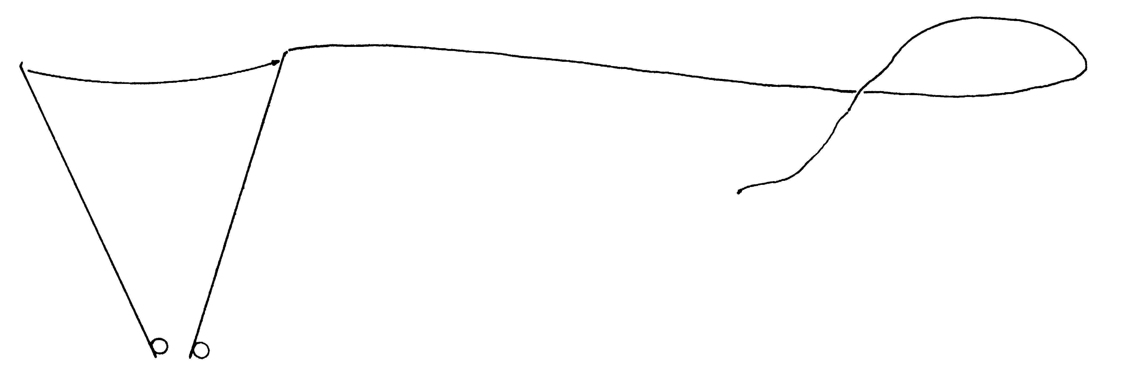
Figure 8. Tailing Loop

Whole Arm Casting; Sidearm Casting
Tipping the fly rod at any angle out to the casting arm side is called “Sidearm Casting.” It is easily done and allows the fly rodder to keep the line lower during the cast and therefore less likely to be seen by the fish. And, since the line is lower to the surface, it has less time to fall, and therefore less time for the wind to have influence. It also allows the angler to cast under bridges, docks, and overhanging vegetation.

Whole Arm Casting; Cross Body and Across the Head
Casting sidearm across the front of the torso is called “Cross Body Casting.” It is effective for short ranges. Angling the rod across the top of the head when making a cast is called “Across the Head Casting.” It is a much stronger stroke and can be used with the Elliptical Stroke (see below) and with Hauling.

Shooting Line
As noted, the reason fly rodders rapidly evolved casting techniques and worked so industriously on developing good casting loops was to enable them to throw as straight a line as possible, and thus increase the distance they could shoot line. Distance casting tournaments were in place in England as early as 1870.

Factors Involved in Shooting Line
There are many factors involved in shooting line. The first five in the list below are by far the most significant to the fly fisher, who for most purposes should consider a long cast as one of 70 or 80 feet.
- Timing of the release
- Line velocity
- Line loop size and shape
- Line mass beyond the rod tip
- Mass Profile of the Line
- Air resistance
- Wind speed
- Wind direction
- Diameter of fly line
- Diameter of running line
- Rod angle relative to rod leg
- How suddenly the rod stops at the end of the casting stroke
- Tightness of the line in the guides
- Straightness of the fly leg and rod leg of the line
- Guide size
- Guide shape
- Friction of the line as it runs through the guides
- Line texture
- Line lubricants
- Line stiffness
- Line slap against the rod
- Air temperature
- Elevation

1. Timing of the Release
Since momentum = mass x velocity, the fly caster needs to shoot the line (by releasing it from the line hand) as soon after the “E” phase as possible. Too soon, and the line will not gain the full advantage of the energy of the cast. Too late, and some of the line’s momentum will have already dissipated.

2. Line Velocity
Obviously the faster the line is going, the further it will fly when shooting. A normal cast has a loop nose speed of about 80 mph. A single haul on the line speeds the nose up to about 150 mph. The Double haul increases loop nose speed to about 260 mph.

3. Loop Size and Shape
These are discussed above, please refer to pages 3 and 4.

4. Line Mass Beyond the Rod Tip
The greater the mass, the greater the momentum at the same line speed. To a point. A Weight Forward line cannot have a great length of overhang or it will not cast well at all, regardless of the mass beyond the rod tip. Same for a Shooting Head. One must be aware of line mass profile.

5. Mass Profile of the Line
This is also called “line taper.” This can greatly affect the ability to shoot line; e.g. a standard WF versus a Long-Head WF. Be aware of the distribution of mass along the length of the line and how it can affect both casting and shooting line.

The “O” Ring
When fishing, use the “O” Ring tactic when shooting (Figure 9). It gives the caster full control of the line. It really is an essential technique, so learn it and use it all the time.
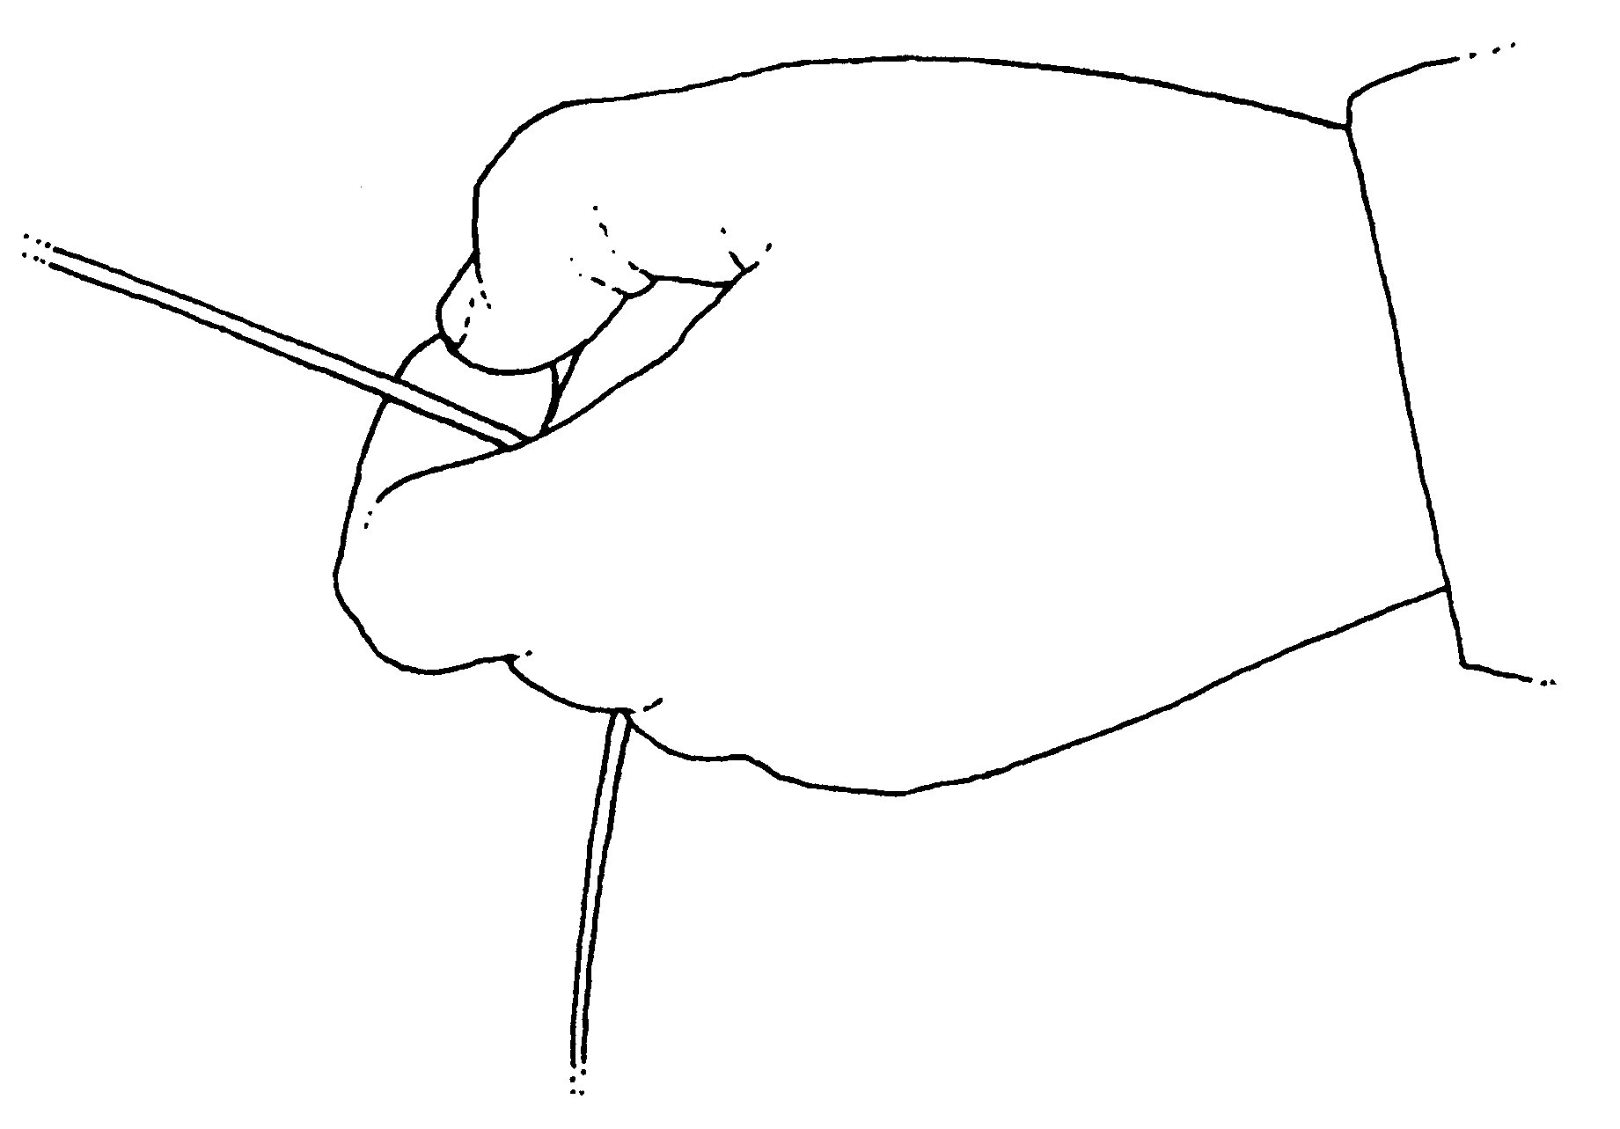

Figure 9. The “O” Ring used when shooting line
Lift and Point
To get more distance, the instant that the caster shoots the line, the rod is lifted a foot or two and pointed down the rod leg of the line. The lift keeps the rod leg higher, and the point greatly decreases frictional drag as the line runs through the guides.

Shooting on the Back cast
It is very difficult to shoot the line on the back cast with an Overhead Cast because the line makes a nearly right angle as it bends through the tip top guide. But, by casting a bit sidearm, and then turning and pointing the rod down the line, the caster can shoot amazingly long distances on the back cast. Use the “O” Ring line handing technique so that the line is always under control.

The Triple Shoot
Really a “Slip” followed by shooting line on the back cast and then again on the forward cast. The line is simply allowed to slide out through the guides during the ”A” Phase. When the rod reaches about 30 degrees ahead of the vertical, the caster seizes the line tightly and hauls hard while the rod continues into the “L” Phase of the cast. This is followed by a shoot on the back cast and another on the forward cast. Hauling on the forward stroke (completing a Double Haul) greatly increases the shoot on the forward cast.

The Elliptical Stroke
Developed in the mid 1930s by Austrian guide Hans Gebetsroither on the Traun River, near Gmunden, Austria, this method has also been called the Belgium Cast, the Belgium Wind Cast, and the Constant Tension Cast. The back cast is made with the rod in some sidearm position, and the forward stroke is made with the rod in a more upright position. During the Pause Phase, the rod is moved up and around from sidearm to a more vertical orientation. The movement describes a more or less elliptical pathway, hence the name (Figure 10).
This is the stroke to use for casting split shot, weighted flies, multiple fly rigs, sink tip lines, huge flies, very air resistant flies, and other situations where a standard dry fly cast is insufficient. Learn this one very well.
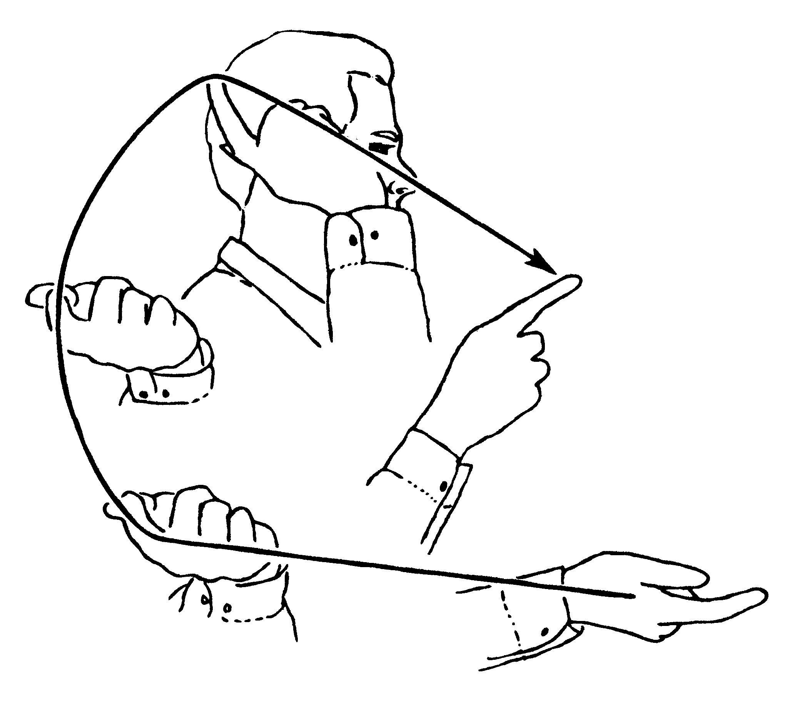
Figure 10. Arm motions of the Elliptical Stroke

Whole Arm Casting; The Roll Cast
The Roll Cast allows the fly rodder to make a forward cast without having to make a back cast. Obviously, it is used in places where a back cast is not possible.
On the back stroke, the rod is lifted back and up in the same way as if making an overhead cast, but this motion is done SLOWLY. So slow that the line never leaves the surface, rather, it merely slides toward the angler. The wrist tips back slowly so the rod ends up pointing 30 degrees behind the vertical. The line slides back toward the angler until it is hanging motionless in an arc (the “D” Loop) from the rod tip (”T”) to the surface of the water (Point “P”). The line lying motionless on the surface of the water beyond “P” is called the “Anchor” (Figure 11).
The forward stroke is made in the same manner as the forward stroke of the Overhead Cast. The flick of the rod at the end of the stroke is critical to getting a good Roll Cast. The energy of the cast is applied to the line in the “D” Loop. The energized line of the “D” loop then lifts the Anchor and casts it. Obviously, if the line in the “D” is relatively short compared to the line in the Anchor, then the flick at the end of the forward stroke must be extra powerful. Eventually the Anchor will simply be too long for the energized line in the “D” Loop to lift and cast. Scottish anglers fishing the river Spey in the 1850s with two-handed rods developed a modified Roll Cast, which has become known as the Forward Spey or Switch Cast. It is the solution to a long anchor and short “D” Loop (see below).
Sidearm Roll Cast
Keeping the rod in a fully sidearm position, make a roll cast. As soon as the rod stops at the end of the forward stroke, point it directly at the target. This cast allows the fly rodder to keep the line very low over the surface in order to throw the fly under branches of other streamside obstructions.

The Switch
The solution to a short “D” and long Anchor is simple: make the “D” longer and the Anchor shorter. This is done by modifying the back cast portion of the Roll Cast. Rather than lifting the rod back and up slowly as in the Roll Cast, the rod is moved back and up rather quickly. Not so fast as to make a fully aerialized back cast, but fast enough so that the line moves very quickly toward the angler and the “D” Loop flows behind the caster for some distance (Figure 12). The incline of the rod tip during this sweep move causes the front section of the line to touch down on the water’s surface to form the Anchor. Immediately, before the rearward flowing “D” can fall to the surface, the forward cast is made.
The Standard way of making the “D” for the Switch is to use an Elliptical Stroke. To Make a “V” Loop, the fly rodder modifies the Elliptical Stroke and keeps the rod tipped outward, making the backstroke with the rod about 45 degrees above the horizontal, and then making the forward stroke with the rod at about 60 degrees above the horizontal.

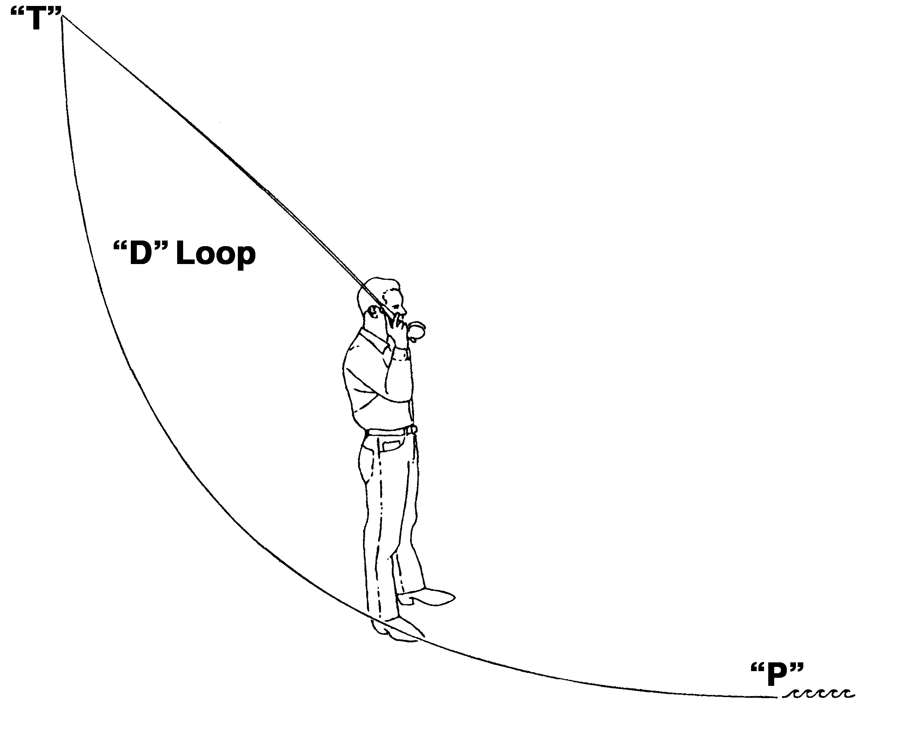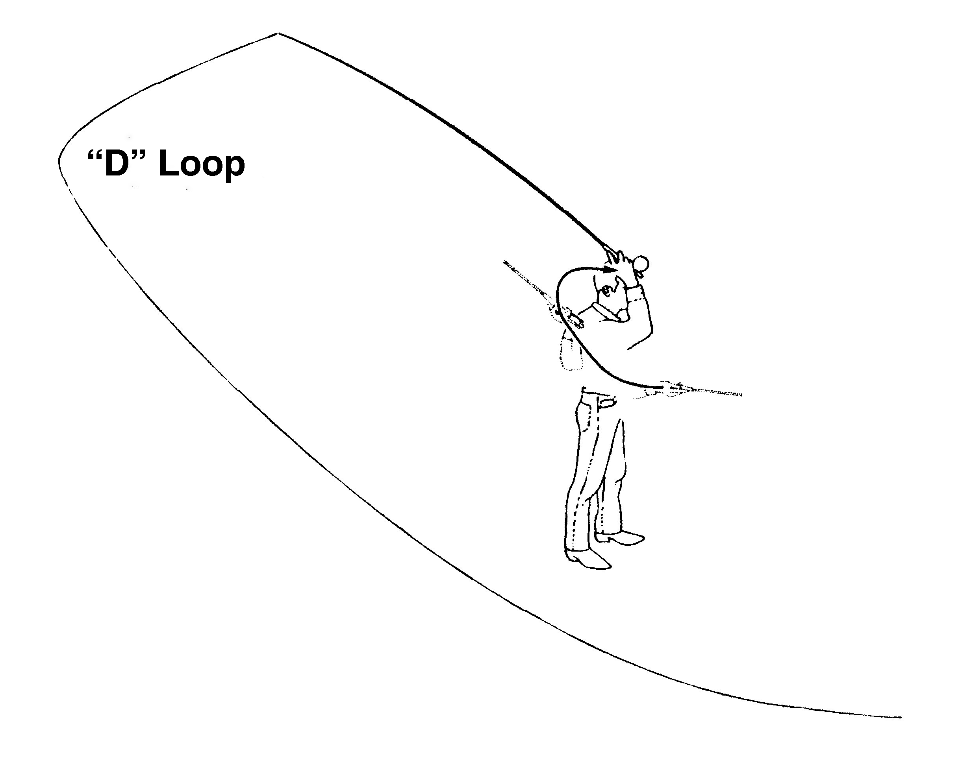
Figure 11. Roll Cast Figure 12. Switch

Sidearm Switch Cast
This is obviously just a Switch made with the rod fully sidearm. It allows longer casts than the Sidearm Roll Cast, and thus is a most useful presentation tactic. Remember that immediately after the rod stops on the forward stroke, point it directly at the target. The Sidearm Switch allows longer casts than the sidearm Roll Cast and is quite effective against the wind. One of the problems that both the Switch and the Sidearm Switch have is the need for some back cast room in which to make the “D” or “V” Loop.

Hauling
Hauling is simply pulling sharply on the line with the line hand. To aid in the cast, the haul must come during the Loop Formation Phase (“L”). Done on either just the back cast or just the forward cast, it is called a “Single Haul.” Done on both the back cast and following forward cast, it is termed the “Double Haul.” The Double Haul dramatically increases line speed—to about 3 times the speed of casting without a haul. It is used for distance casting, tossing heavy or air resistant flies, or shot, or weighted flies. It is also highly useful in the wind. And since the line travels faster, it can be cast lower to the surface.

Single Haul into Double Haul
The Double Haul is easiest to learn by learning the Single Haul on the back cast. A normal back cast is made. As the rod moves back and up, the line hand moves smoothly down toward the hip, and when “L” is made, the line hand pulls sharply (“hauls”) on the line. The line hand immediately, as in immediately is raised back up to within a foot or so of the rod. The haul MUST come during “L.” To get the haul smoothly coordinated with the cast, say, out loud, “Haul Late.”
Once the Single Haul on the backstroke is learned, the caster follows it with a Single Haul on the Forward Stroke (two Singles make a Double). As the rod begins to move down and forward, the line hand moves smoothly down toward the hip. When “L” is executed on the forward cast, the line hand “hauls” on the line (remember, “Haul Late”).

Triple Haul
A third haul can be added after the cast is executed. Made immediately after the rod stops in “E,” a haul will help turn over a reluctant leader and fly. Made a second or two later, the third haul will jerk the line back toward the caster, causing it to fall in “S-Curves” on the surface; or can prevent the line from flying too far and striking vegetation or other obstacles.

Casting in the Wind
Wind is always available to mess up our casting. But there are ways to compensate that can make living with wind at least tolerable. (1) The Double Haul is the center piece for all casting in the wind because there’s less travel time to target, and therefore less time for the wind to have any influence. (2) Casting with the line as low as possible is the second leg of the tripod because when the line is low it has less distance to fall to the surface, and again, less time for the wind to interfere. (3) Using the Elliptical Stroke allows the caster to aim the line more efficiently than other casting styles.
Wind from the Line Hand Side is easiest to deal with. Hauling and “Kentucky Windage” are coupled to keep the line as low as possible under the given conditions.
Wind from the Casting Arm Side is always a threat because it can blow the line across the angler causing an undesirable “hookup.” Casting with the rod fully sidearm helps but casting with the rod in the Across the Head position is the true solution. Again, Hauling and “Kentucky Windage” greatly help to place the fly accurately.
Wind from Behind is a true bother because it blows the line forward and removes tension necessary for making a good forward cast. This is where the Elliptical Stroke really comes into its own. Cast as low as possible on the backstroke, hauling hard. Then bring the rod up and around and aim high on the forward stroke to allow the wind to catch the line and carry it.
Wind from the Front is the most difficult to deal with because air resistance is the greatest factor in reducing distance. Casting low, using a “Squat Cast,” and Hauling certainly help. Learning to cast the line on the surface of the water is a great help in combating a head wind.
The Thrust Cast is another way to address a head wind or a following wind. When the wrist is flicking the rod tip in the “L” Phase of the stroke, the rod is thrust tip first in the direction of the target. The flick of the tip and the thrust must come together. The casting arm straightens directly down the rod leg of the line loop. Pantomime this cast very slowly, and gradually build speed before trying it with the rod. Hauling adds tremendous speed to the Thrust.
The Thrust Cast can be done on the back cast as well. On the back cast, it is best to do the Thrust a bit sidearm.

Mending
Mending is defined as “Changing the position of the line after the cast.” Mending can be done on the water, or while the line is still in the air, i.e., after the cast is complete (after “E”), but before in falls to the water. In-the-Air Mending is most definitely an Advanced Skill and should be the primary form of mending in nearly all cases because it introduces “controlled slack” that the fly fisher can readily manipulate to advantage.
The seminal In-the Air Mend from which all others can be built is the Reach Mend (not a “Reach Cast”). The line is cast straight to target. After the cast, and while the line is flowing to target, the rod is reached to some other position so that the line drops to the water in a position other than directly from the angler to the target. One of the more commonly used Reach Mends is to cast to target and then reach the rod tip out to the side (left or right) (Figure 13). This positions the line on the hypotenuse of a triangle; it’s as if the caster were throwing a straight line from an entirely different position. This is often used for across stream presentations. When pantomiming, say the words, out loud, “Cast/Reach.”
A Curve Mend can be introduced by reaching to the side and then reaching back again (Figure 14). A Puddle Mend is made by aiming the forward cast above the horizontal and then immediately after “E,” dropping the rod tip to the water. A Parachute Mend is executed by casting the line horizontally and immediately after “E,” pulling the rod back to the vertical and allowing the line to fall (parachute) to the water. This is used when fishing downstream, or down and across. Many combinations of mends can be made to eliminate or add drag in any angling situation.
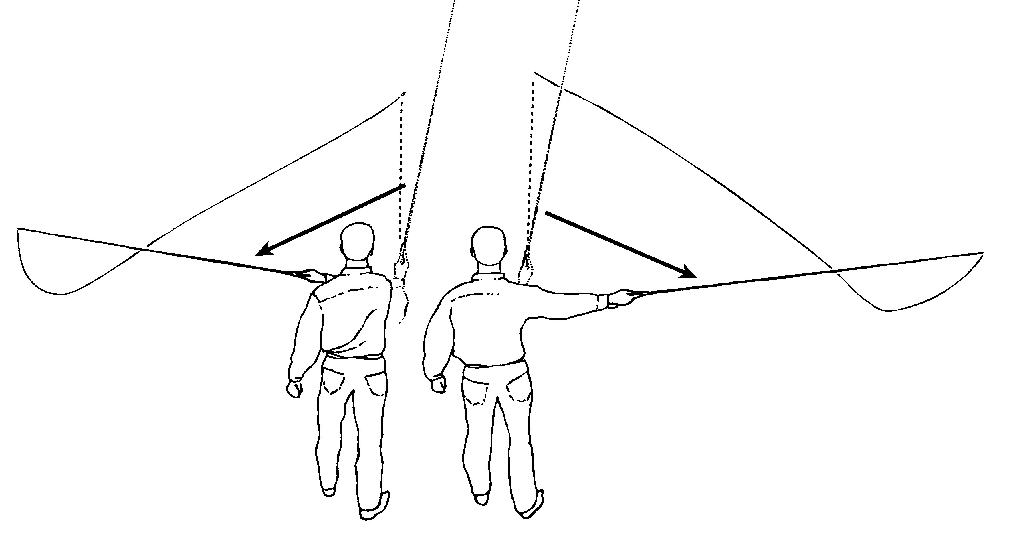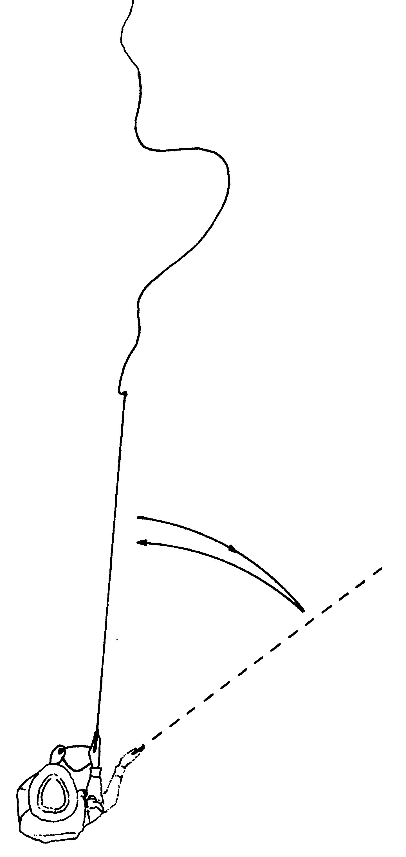
Figure 13. Reach Mend left or right Figure 14.Curve Mend

Mend and Shoot
Since shooting and mending both come after the cast, they can be done together. A simple Reach Mend pulls the line back toward the caster. By shooting line as the rod is reached, the caster can add extra line that allows the fly to flow whatever distance is needed to reach the target.

Casting on the Surface of the Water
This is another way to beat the wind regardless of its incoming direction because the rod leg of the line is anchored on the surface. The fly rodder throws a powerful sidearm cast and anchors it by touching the rod tip on the surface a moment after the rod is stopped in “E.” A straight-line Torque Twist may be used in the cast, or it may be a simple sidearm stroke with a haul. The straight-line Torque Twist is made by rotating the casting hand inward (toward the index finger side of the hand) while simultaneously raising the casting arm elbow out and up.

Curves
Curving the Line is most certainly an Advanced Skill and requires the caster to have absolute control of the rod and line at all times. Positive Curves are made across the front of the body from casting arm side toward the line arm side. Negative Curves are made outward away from the casting arm side. Horizontal Curves are formed parallel to the water’s surface; Vertical Curves are formed hooking upward (a Concave Curve) or looping over downward (a Convex Curve). Slanting Curves are angled between the horizontal and the vertical and can be concave or convex.
There are five ways to introduce curves in the line. Four of these are casting techniques: (1) Aimed Curves, (2) Torque Twist Curves, (3) Overpowered Curves, and (4) Underpowered Curves. All four of these casting techniques will either curve the entire line or place the curve at the end of the line nearest the fly. The fifth way to introduce curves is (as noted above) by (5) Mending; it can place the curve at any point along the length of the line, from directly in front of the rod tip all the way out the leader and fly.
Aimed Curves are made by literally sweeping the rod tip in a curved manner to make the line curve. Shooting line is possible with such curves.
Torque Twist Curves (also called “Hook Curves”) are a special type of Aimed Curve in which the rod is “hooked” out of plane on the cast.
Overpowered Curves are generated by “overcasting,” i.e., by applying extra energy to the cast so the rod tip over flexes after “E,” and when it rebounds, it jerks the tip of the line back and around into a curve. Shooting line with this curve method is readily done.
Underpowered Curves are the result of underpowering the cast, and then dropping the rod tip so the line falls out to the side, forming a curve. These are the hardest curves to control with great accuracy.
Mended Curves are made after the line is cast straight to target. Shooting line with mended curves is easily done.

