**Lab #9**

1. Create a loop that will take all arguments from the user and print out example:  
   Argument: <arg1>

Argument: <arg2>  
Argument: <arg3>

Where <arg3> is the corresponding argument sent from the user

1. Paste or screenshot the bash code here:

1. Screenshot you running your script here:

1. Create a while loop with a counter starting from 4 and ending at 12. Print each number on the screen.
2. Paste or screenshot the bash code here:

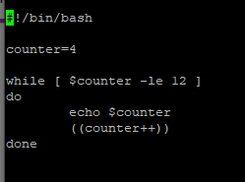

1. Screenshot you running your script here:

