Client Follow-Up Workflow
How the Pipeline, Document Routing, and Call Routing screens work together
Every client moves through the same follow-up process once they're paid: documents get prepared and submitted, a call gets made to the bureau, and the result either closes things out or sends the client back for another round. This guide walks through how that process shows up across the three screens that manage it — the Pipeline tab, Document Routing, and Call Routing — including what's new: checking a document or logging a call now opens a short form instead of just flipping a checkbox, so there's always a record of what actually happened.
What changed
• Checking a document as submitted to Experian, TransUnion, or Equifax now opens Log Document, instead of just checking a box.
• Recording a call outcome now happens through one Log Call button, instead of separate status dropdowns.
• The Pipeline tab now shows who's assigned to each client's next step, and by when, right on the card.

1. The Big Picture
The Pipeline tab is where you go to see where everyone stands. Document Routing and Call Routing are where the actual work happens — preparing paperwork and making calls. Pipeline doesn't hold anything of its own; it simply reflects what's already true on those two screens, so a client always shows up in the same stage everywhere you look.
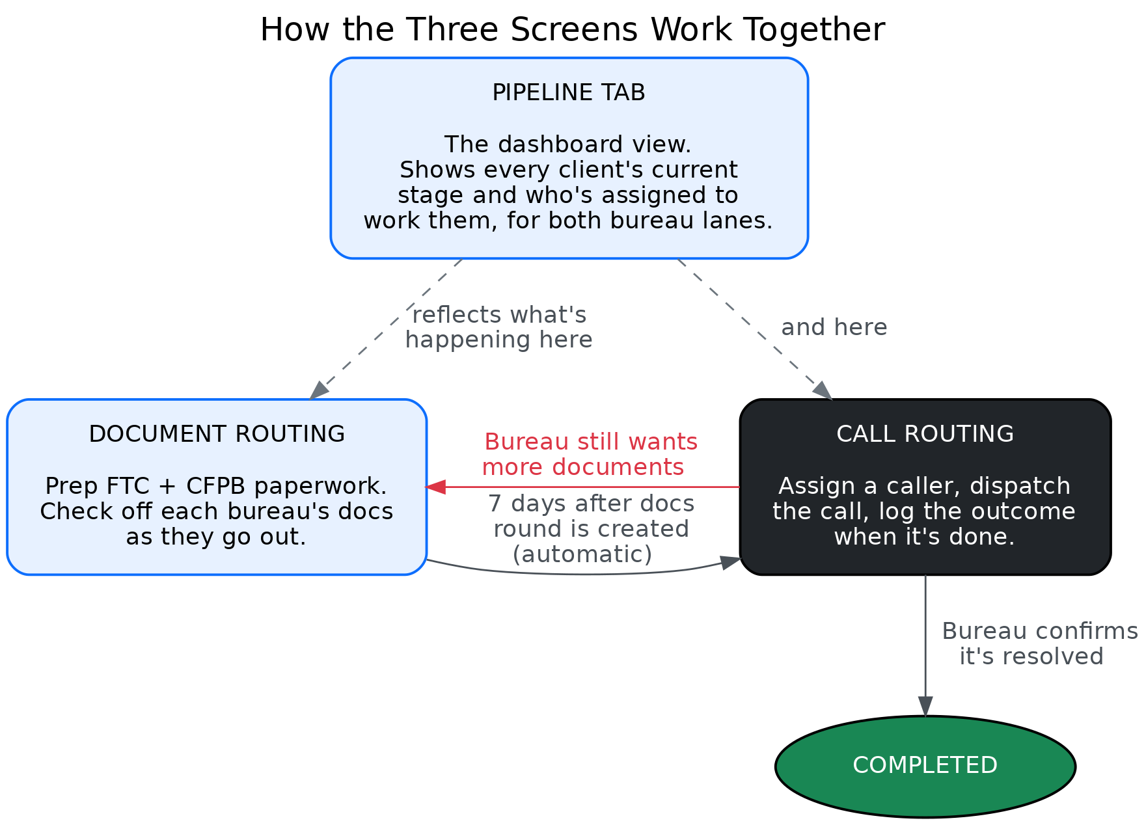
Figure 1 — Document Routing and Call Routing hand a client back and forth until the bureau confirms it's resolved; Pipeline shows that progress at a glance.

2. The Two Bureau Tracks
Experian and TransUnion/Equifax move on two separate clocks, and a single client can be at a different stage on each at the same time.

Experian — no documents needed
Experian can be called the moment a client is paid — there's no documents step at all. If Experian asks for documents on the call, nothing gets prepared; the system simply schedules another Experian call automatically.
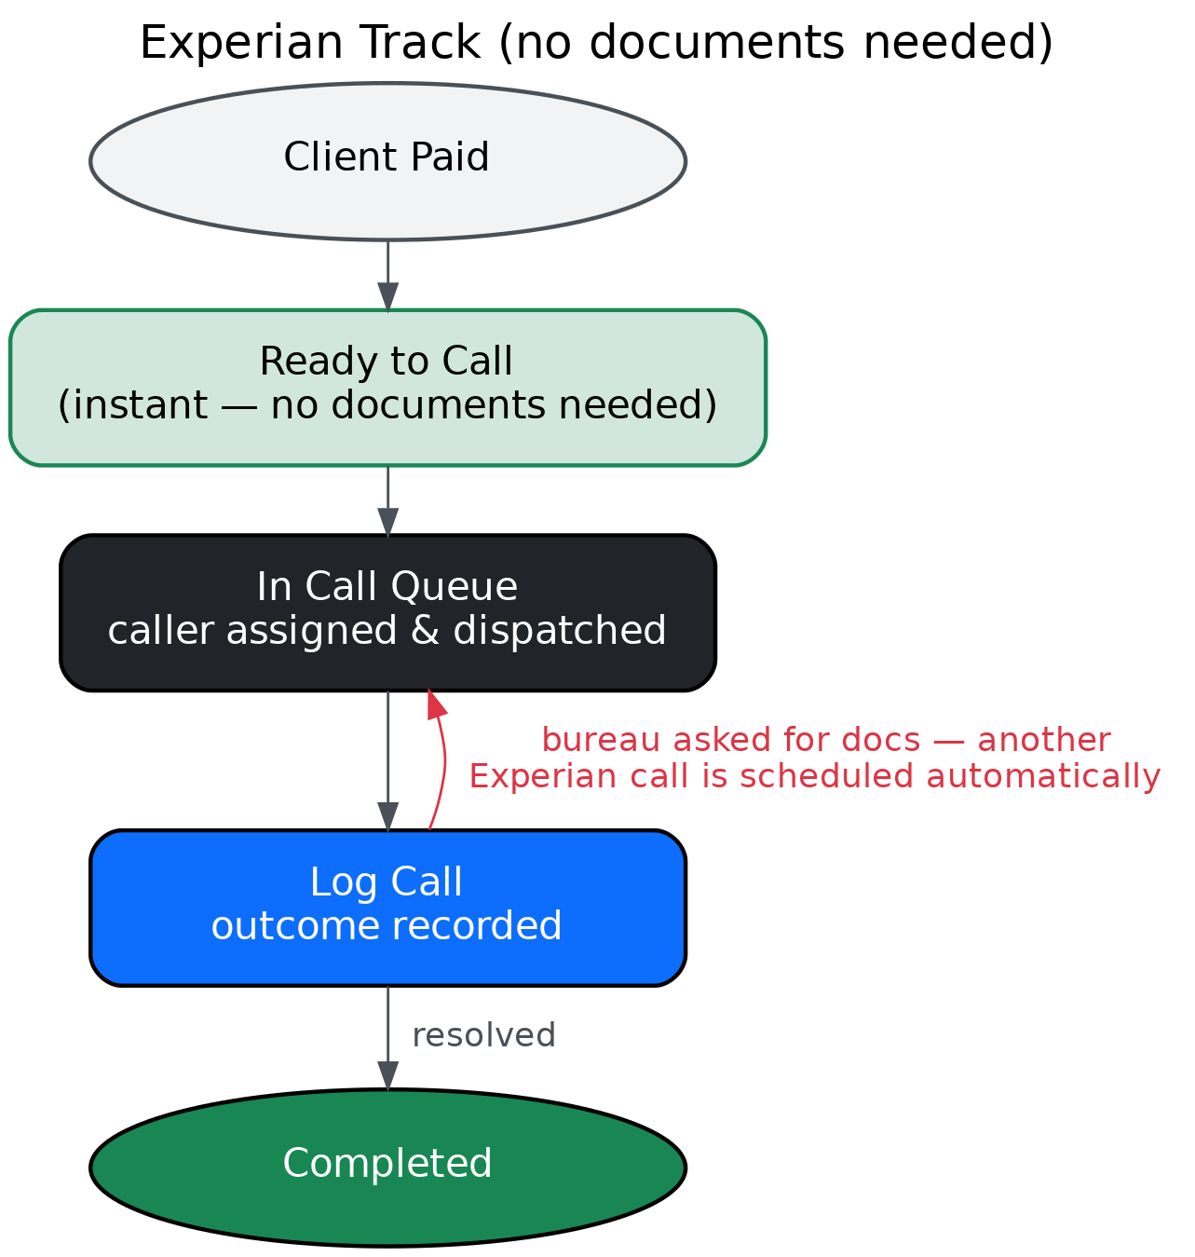
Figure 2 — the Experian track.

TransUnion / Equifax — shared documents cycle
TransUnion and Equifax share one documents round and one 7-day wait. Once the wait is up, the call is ready to go out. If the bureau asks for more documents on that call, a new documents round starts and the 7-day wait begins again.
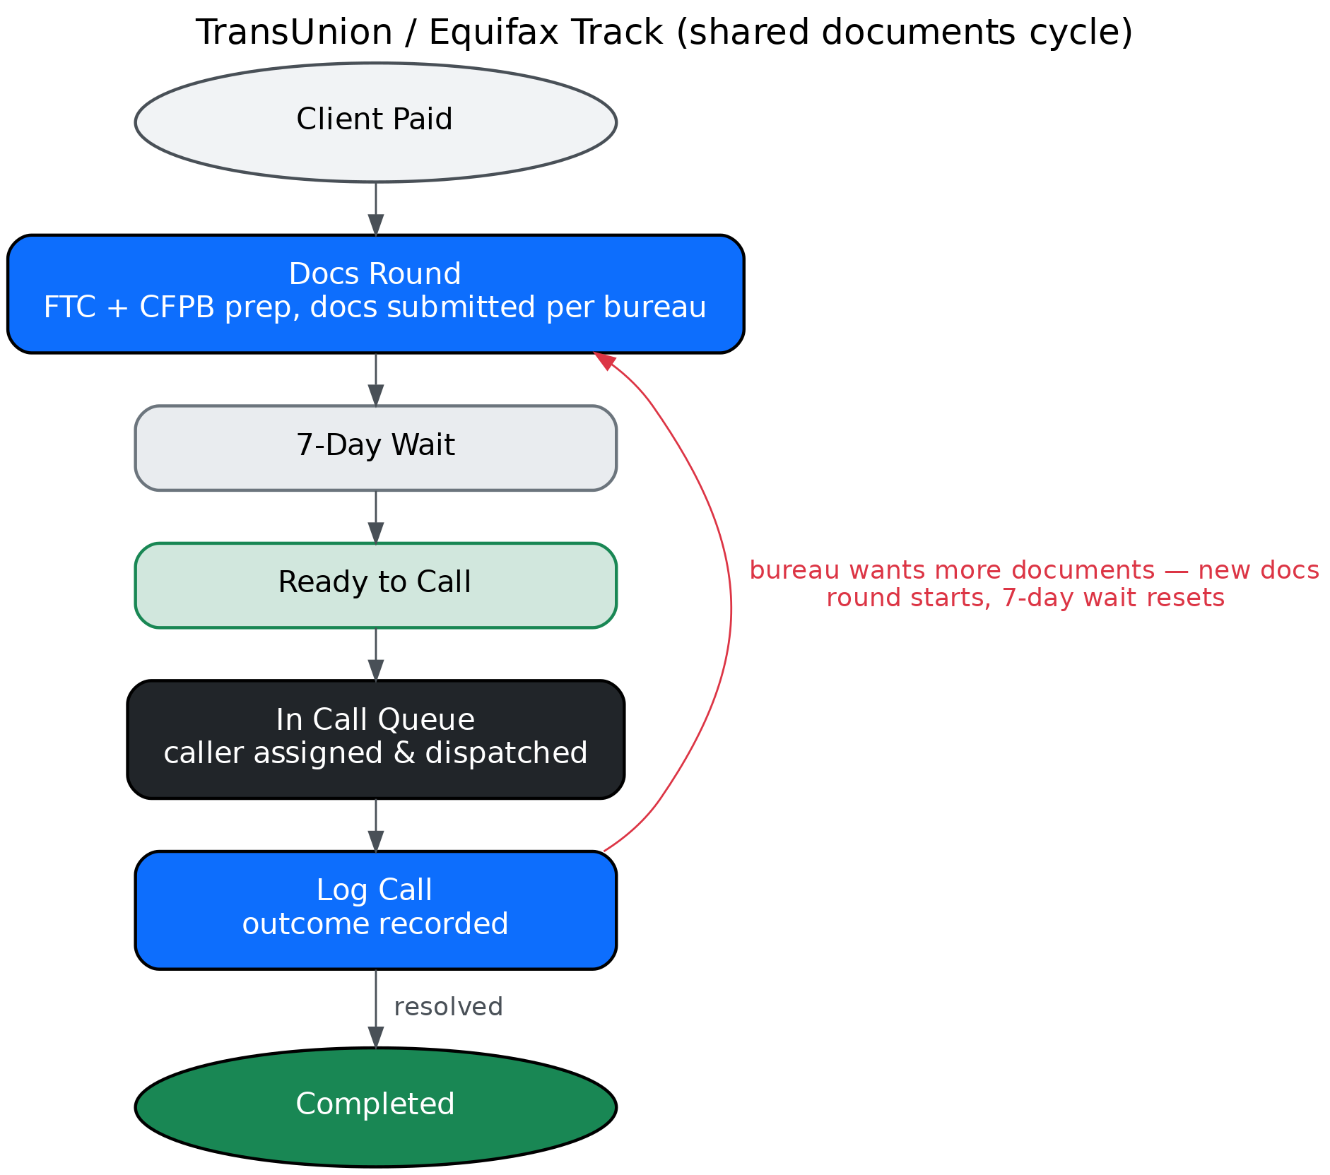
Figure 3 — the TransUnion / Equifax track.

3. The Pipeline Tab
Pipeline shows both tracks side by side as a row of stage tiles — Docs Round, 7-Day Wait, Ready to Call, In Call Queue, Completed — each with a live count of how many clients are sitting there. Company, date, and search filters at the top narrow those counts down to whichever slice you're looking at.
Clicking a tile opens the exact list of clients in that stage, right below it, using the same client cards you already see in Production Queue. For any client sitting in a Docs Round or In Call Queue tile, the card now also shows who's assigned to that step and, for calls, when it's due — so you can see who to call for or who's preparing documents without having to open Document Routing or Call Routing separately. A client with nobody assigned yet is labeled Unassigned, which is itself a useful signal — it means that step hasn't been picked up.

4. Document Routing
Each client's row has five checkboxes: FTC, CFPB, and one for each bureau — EXP, TU, EQ — marking that bureau's documents as submitted.
FTC and CFPB are internal prep steps, so checking them is instant. Checking EXP, TU, or EQ means documents actually went out to that bureau, so it opens Log Document — the bureau is already pre-selected, and there's a spot for a note if anything's worth flagging. Saving it checks the box and clears that client's documents reminder. Unchecking any box, including EXP/TU/EQ, still works instantly — there's nothing to log when you're just undoing a mistake.
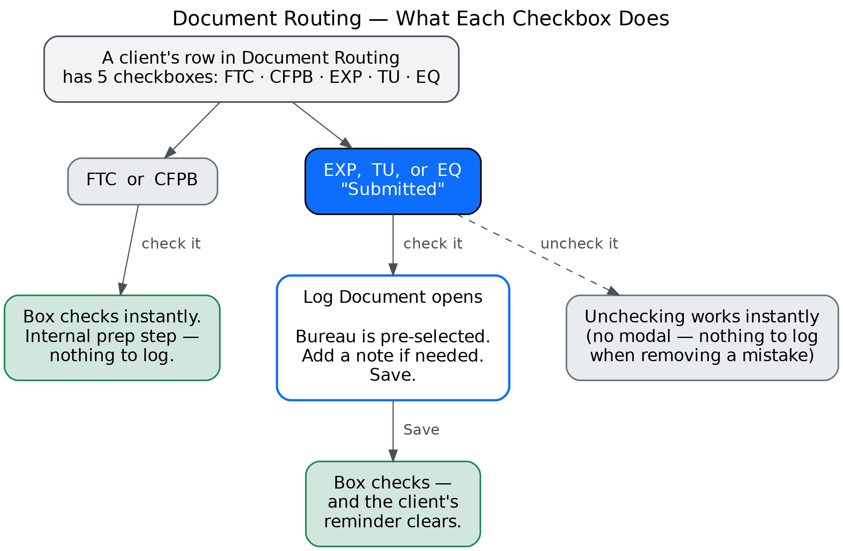
Figure 4 — what each checkbox in Document Routing does.
Once FTC and CFPB are both checked, the row is ready to send — that hands the client to Call Routing on their scheduled date.

5. Call Routing
When a call comes due, it shows up in Call Routing. Assigning a caller from the dropdown and clicking Send to Queue puts it in that caller's queue. The Experian, TransUnion, and Equifax columns show each bureau's current status at a glance, but they're read-only now — the actual result gets recorded through Log Call.
Log Call opens with the bureau already locked to whatever this task is for, so it can't accidentally get logged against the wrong one. Fill in how the call went and save it.
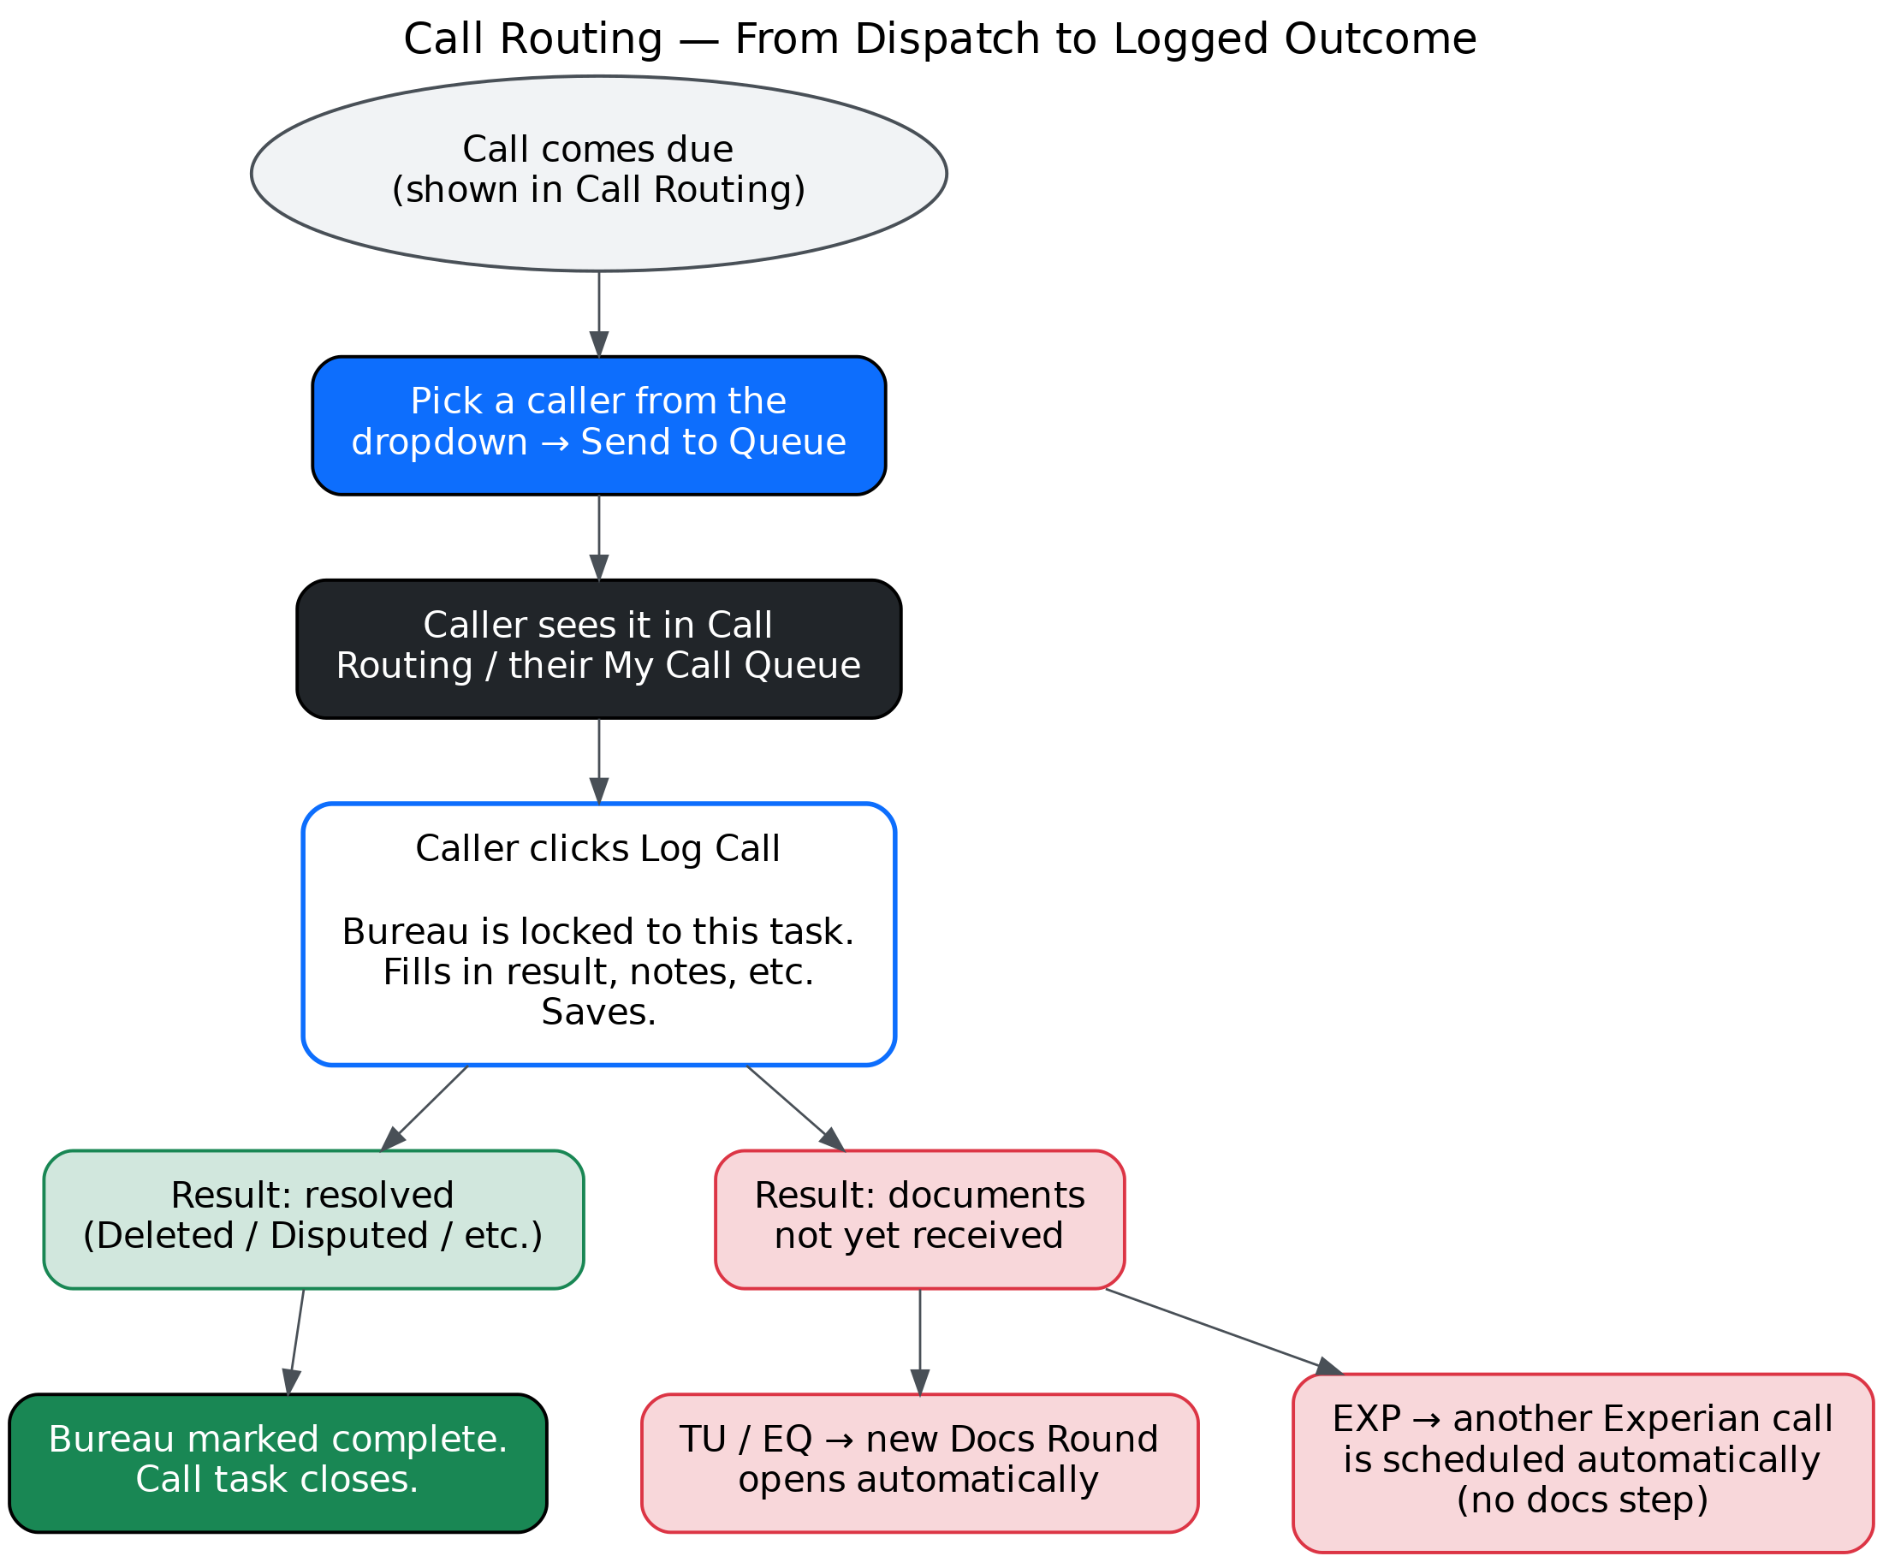
Figure 5 — from dispatch to a logged call outcome.
If the result is a resolution — deleted, disputed, and so on — that bureau is marked complete and the call task closes. If the bureau says it hasn't received documents yet, the system reacts automatically depending on the track: TransUnion or Equifax opens a fresh documents round, while Experian simply schedules another call, since it never needed documents in the first place.

6. Quick Reference
Situation | What to do
Docs went out to a bureau | Check EXP / TU / EQ on that row — fill in Log Document and save
FTC report or CFPB package is done | Check the FTC / CFPB box — no form needed
A call was made to a bureau | Open Log Call on that task, fill it in, and save
You need to know who's calling a client, or prepping their docs | Open Pipeline, click that client's stage tile, check the assignee line on their card
A card says "Unassigned" | That step hasn't been picked up by anyone yet
Bureau asks for documents again | Just save that in Log Call — the next documents round or follow-up call is scheduled automatically

