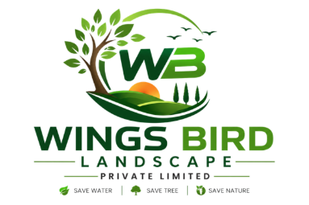
WINGS BIRD LANDSCAPE PRIVATE LIMITED

