Quantitative Analysis and Inference by Chart
Source: Python (pandas) on Cleaned_Primary_Research.csv (27 responses received; 24 valid Uber users used as base, n = 24) and Secondary_Reviews_Verified.csv (33 Apple App Store India reviews, 12 Sep to 14 Oct 2026). Percentages for multi-select questions are shares of respondents and do not sum to 100%. Both samples are small and non-random, so figures describe these samples and are not market estimates.

A. Data information (from the Python run)
Item | Value
Survey responses received | 27
Excluded as suspected test entries (R01-R03, keyboard-string text) | 3 (R01 is also a non-Uber user)
Valid analysis base | 24 Uber users (12 frequent, 12 occasional)
Booked from crowded/complex location (Q3) | 22 of 24 (91.7%): 12 several times, 10 once or twice
Mean options ticked per respondent | Q6 2.58, Q4 2.67, Q7 2.17, Q9 1.75
Secondary reviews | 33 (32 rider, 1 driver); mean rating 1.58; 24 of 33 are 1-star; 27 of 33 are 1-2 star (81.8%)
Secondary window achieved | 12 Sep to 14 Oct 2026 (about 5 weeks). The requested 17 Apr to 17 Oct window was not reachable because Apple's feed returns only the latest 500 reviews
Open limitations | Convenience sample; multi-select overlaps; Google Play and Reddit not accessible

B. Primary survey charts (n = 24)

Chart 1: Overall rating (Q2)
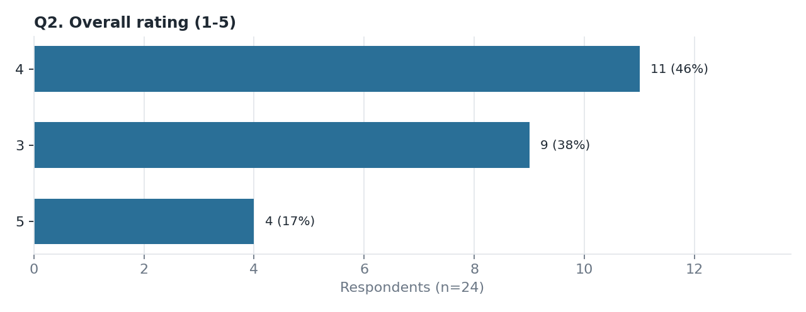
Data computed
- Mean 3.79, median 4.0, SD 0.72; approximate 95% CI 3.49 to 4.10.
- Distribution: 3 stars = 9 (37.5%), 4 stars = 11 (45.8%), 5 stars = 4 (16.7%); no 1 or 2 stars.
- Top-2-box (4-5) = 62.5%.
Inference
- Satisfaction is moderate, not poor: nobody rated below 3, but only 17% gave 5.
- The sample is all current users, so the absence of low ratings is expected (survivorship). Pickup problems coexist with a decent overall rating, so they are a friction point rather than a reason users leave outright.
- Mean rating is 4.67 for riders who met the driver without delay (n = 3), 3.56 after a delay (n = 9) and 3.33 when the rider cancelled (n = 6). Delay and cancellation go with lower ratings, though the groups are very small.

Chart 2: Locations where finding the driver was difficult (Q4)
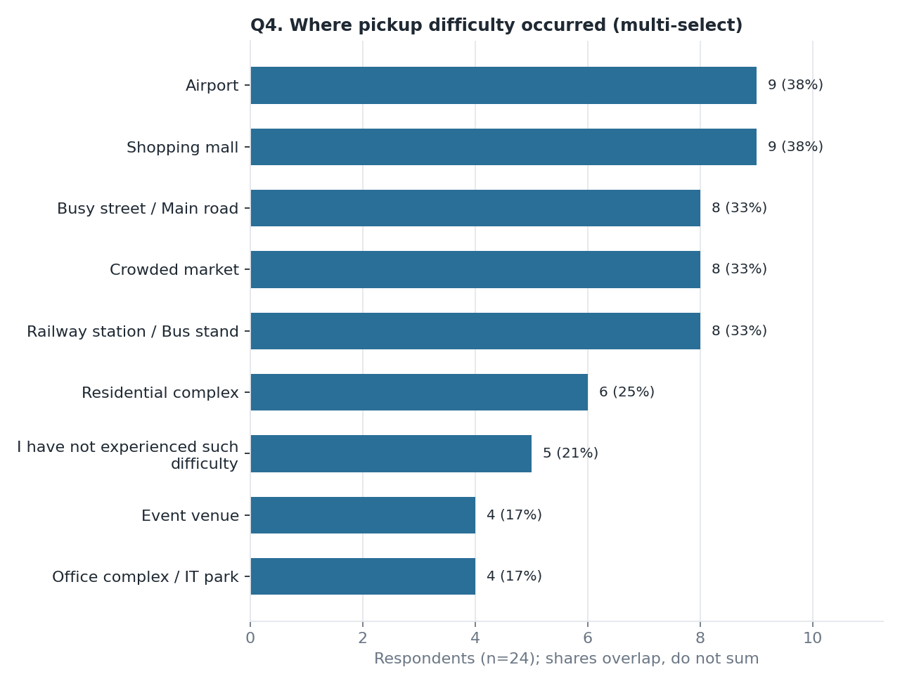
Data computed
- Shopping mall 9 (37.5%); Airport 9 (37.5%); Railway/bus stand 8 (33.3%); Crowded market 8 (33.3%); Busy street 8 (33.3%); Residential complex 6 (25.0%); Office/IT park 4 (16.7%); Event venue 4 (16.7%).
- 'No difficulty' 5 (20.8%), so 79.2% reported difficulty somewhere.
- The average respondent named 2.67 location types.
Inference
- Difficulty is widespread rather than confined to one venue type: the top five locations are within 4 percentage points of each other.
- Malls and airports lead jointly (37.5%), which supports a focus on large, multi-entrance venues. The lead over markets or stations is only one respondent, so the ranking among the top five should not be over-read.
- Residential complexes (25%) show the problem also exists at private gated entry points.

Chart 3: App helpfulness in showing pickup location (Q5)
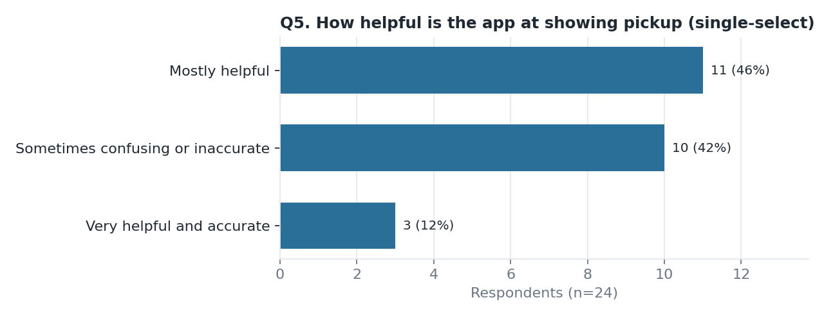
Data computed
- Very helpful 3 (12.5%); Mostly helpful 11 (45.8%); Sometimes confusing/inaccurate 10 (41.7%); Often confusing 0.
- Mean overall rating by Q5: very helpful 4.33, mostly helpful 3.82, sometimes confusing 3.60.
Inference
- A majority (58.3%) find the app helpful, but only 12.5% find it fully accurate and 41.7% find it confusing or inaccurate at least sometimes.
- The location feature works most of the time but is not dependable at complex venues, which is the gap a meeting-point feature would target.
- Riders who find the app confusing rate Uber lower on average (3.60 vs 3.82 to 4.33). With groups of 3 to 11 this is directional only.

Chart 4: Difficulties in crowded places (Q6)
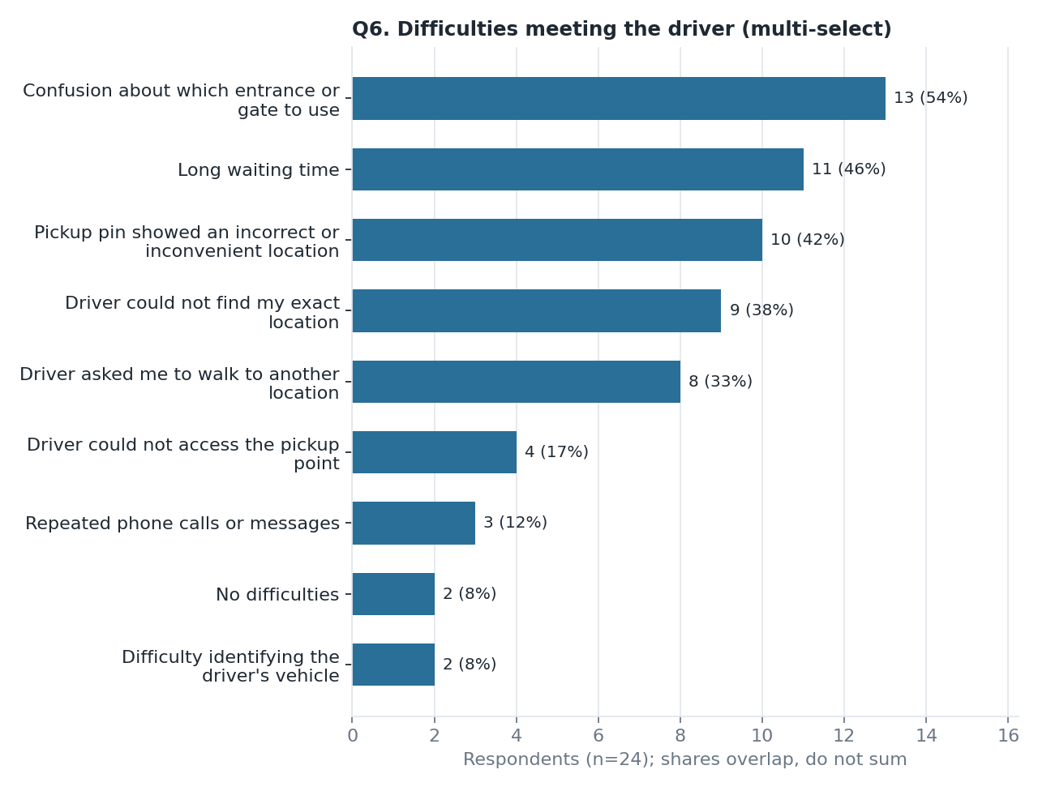
Data computed
- Gate/entrance confusion 13 (54.2%); Long waiting 11 (45.8%); Incorrect pickup pin 10 (41.7%); Driver could not find exact location 9 (37.5%); Driver asked me to walk elsewhere 8 (33.3%); Driver could not access pickup point 4 (16.7%); Repeated calls 3 (12.5%); Hard to identify vehicle 2 (8.3%); No difficulties 2 (8.3%).
- Average 2.58 difficulties per respondent.
Inference
- Gate/entrance confusion is the most common single difficulty (over half of respondents), ahead of waiting and pin errors.
- Location-ambiguity items (gate, pin, driver cannot find location) form the dominant cluster. 54.2% of respondents selected the pin or the driver-cannot-find option.
- Respondents typically face more than one problem at once (2.58 on average), which suggests the problems compound: ambiguity leads to walking, calls and waiting.
- Vehicle identification is rare (8.3%), so the problem is mainly where to meet, not recognising the car.

Chart 5: Driver coordination behaviour (Q7)
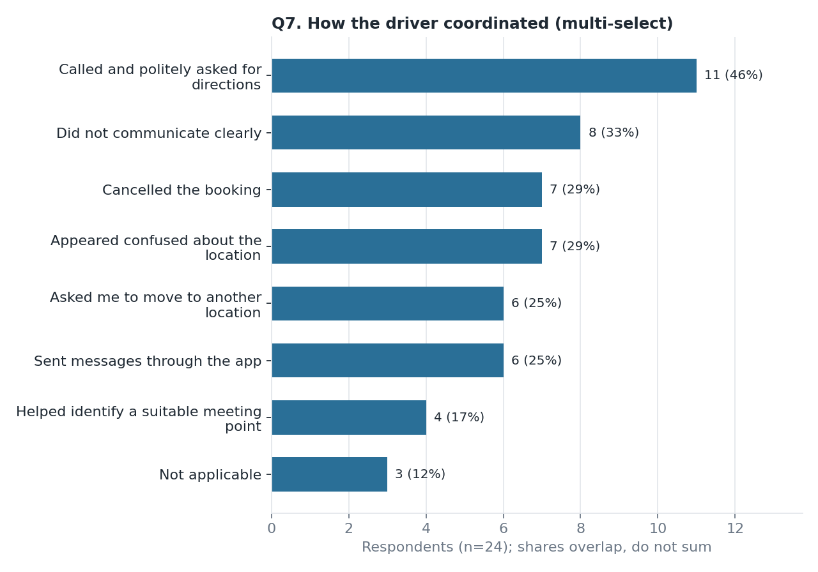
Data computed
- Called and politely asked for directions 11 (45.8%); Did not communicate clearly 8 (33.3%); Appeared confused about location 7 (29.2%); Cancelled the booking 7 (29.2%); Sent in-app messages 6 (25.0%); Asked me to move 6 (25.0%); Helped identify a meeting point 4 (16.7%); Not applicable 3 (12.5%).
Inference
- Phone calls are the main resolution channel (45.8%). In-app messaging (25%) and a driver proposing a meeting point (16.7%) are far less used, so coordination depends on manual effort.
- Negative behaviours (unclear communication, confusion, cancellation) are each ticked by roughly a third, so coordination fails about as often as it succeeds.
- Cancellation is 29.2% in Q7 but 16.7% as the Q10 'driver cancelled' outcome. Q7 is multi-select across several experiences, while Q10 is a single most-recent outcome, so the two are not directly comparable.

Chart 6: Feelings during the difficulty (Q9)
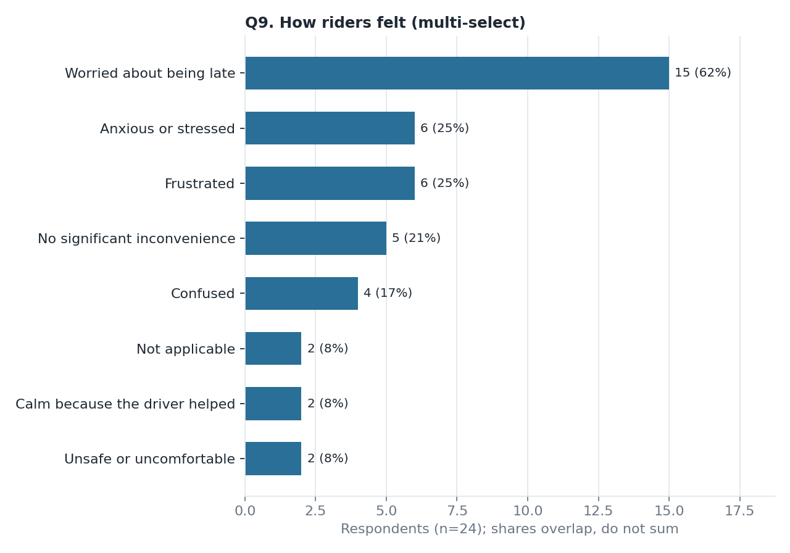
Data computed
- Worried about being late 15 (62.5%); Frustrated 6 (25.0%); Anxious/stressed 6 (25.0%); Confused 4 (16.7%); Unsafe/uncomfortable 2 (8.3%); Calm because driver helped 2 (8.3%); No significant inconvenience 5 (20.8%).
Inference
- Time pressure is the dominant emotional cost (62.5%), more than twice as common as frustration or anxiety.
- Negative emotions are far more frequent than calm (8.3%): a helpful driver is the exception.
- Safety discomfort is low (8.3%) but not zero. The problem is mostly about delay and stress, not danger.

Chart 7: Outcome of the difficult pickup (Q10)
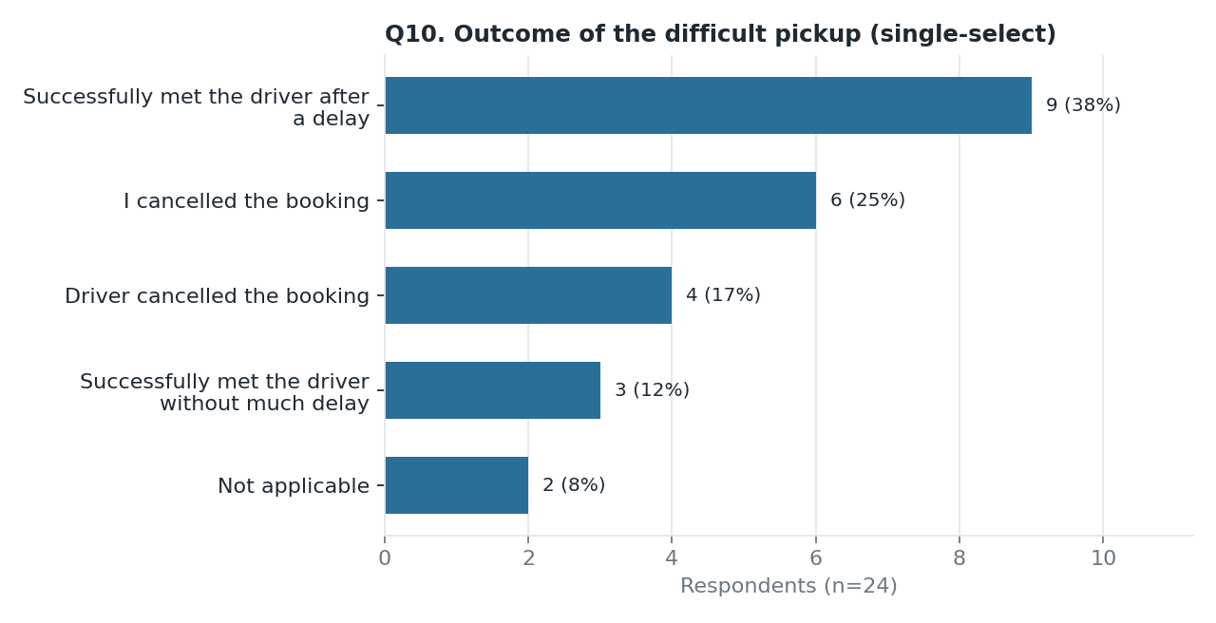
Data computed
- Met driver after a delay 9 (37.5%); Rider cancelled 6 (25.0%); Driver cancelled 4 (16.7%); Met without much delay 3 (12.5%); Not applicable 2 (8.3%).
- Any cancellation = 10 of 24 (41.7%); any delay or cancellation = 21 of 24 (87.5%).
Inference
- Only 1 in 8 difficult pickups ended smoothly; 87.5% involved delay or a cancelled trip.
- Riders cancel more often than drivers (25.0% vs 16.7%), so part of the lost-trip risk comes from rider abandonment after waiting.
- Of the 14 respondents (58.3%) who reported extra-money requests (Q11 = Yes), 7 met the driver after a delay and 4 cancelled. Fare friction and pickup friction co-occur, but the survey cannot show cause.

Chart 8: Heatmap, difficulty by outcome (Q6 x Q10)
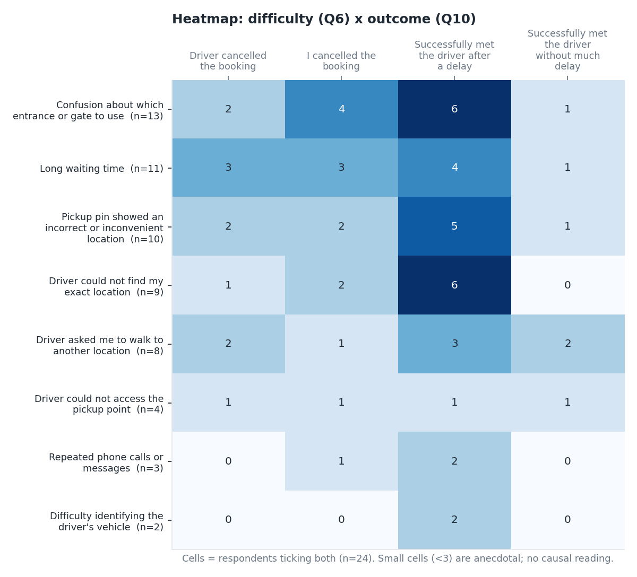
Data computed
- Counts of respondents (met without delay, met after delay, rider cancelled, driver cancelled): Gate confusion 1, 6, 4, 2. Long waiting 1, 4, 3, 3. Incorrect pin 1, 5, 2, 2. Driver could not find location 0, 6, 2, 1. Asked to walk 2, 3, 1, 2.
- No respondent who reported driver-could-not-find-location or repeated calls had a smooth outcome.
Inference
- Gate confusion and long waiting each appear with 6 cancellations, and long waiting has the most driver cancellations (3).
- Driver-cannot-find-location leads mainly to delay (6 of 9), not cancellation.
- Each cell holds 0 to 6 people, so patterns are indicative and need a larger sample before any causal claim.

Chart 9: Heatmap, location by difficulty (Q4 x Q6)
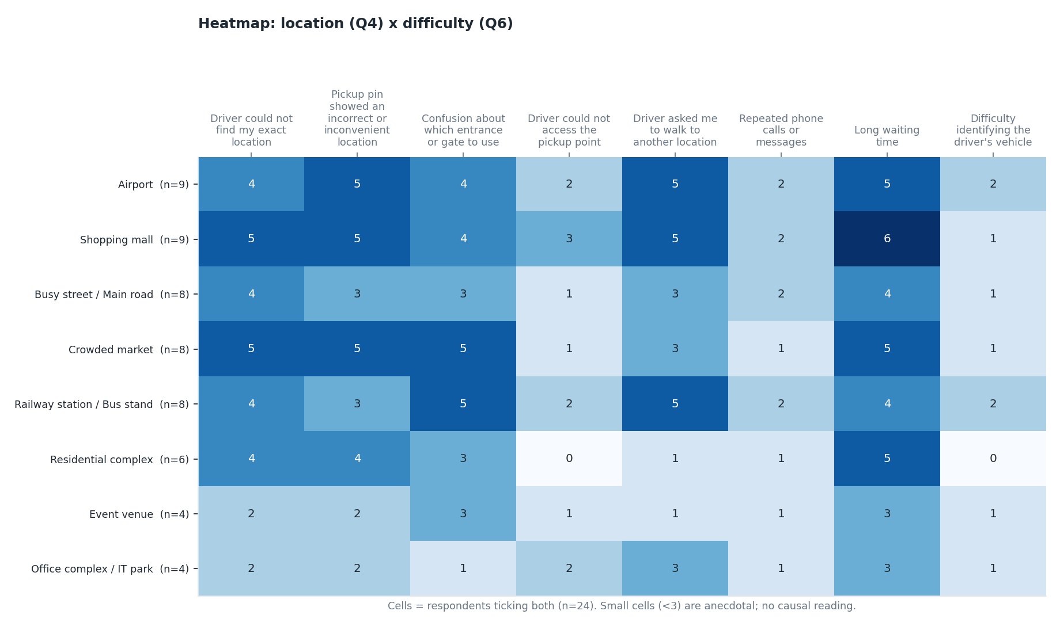
Data computed
- Highest cells: Shopping mall x Long waiting 6; Mall x Pin 5; Mall x Asked to walk 5; Airport x Pin 5; Airport x Walk 5; Airport x Waiting 5; Railway x Gate 5; Railway x Walk 5; Market x Gate 5; Market x Pin 5; Market x Waiting 5; Residential x Waiting 5.
Inference
- Malls and airports show the broadest mix of problems (pin, walking, waiting), consistent with large, multi-entrance sites.
- Gate confusion peaks at railway stations and markets (5 each), and being asked to walk elsewhere peaks at malls, airports and stations (5 each).
- Waiting is spread most evenly across locations, so it is a general pickup problem, while pin and gate issues are more venue-specific.

C. Secondary review charts (n = 33)

Chart 10: Secondary theme frequency
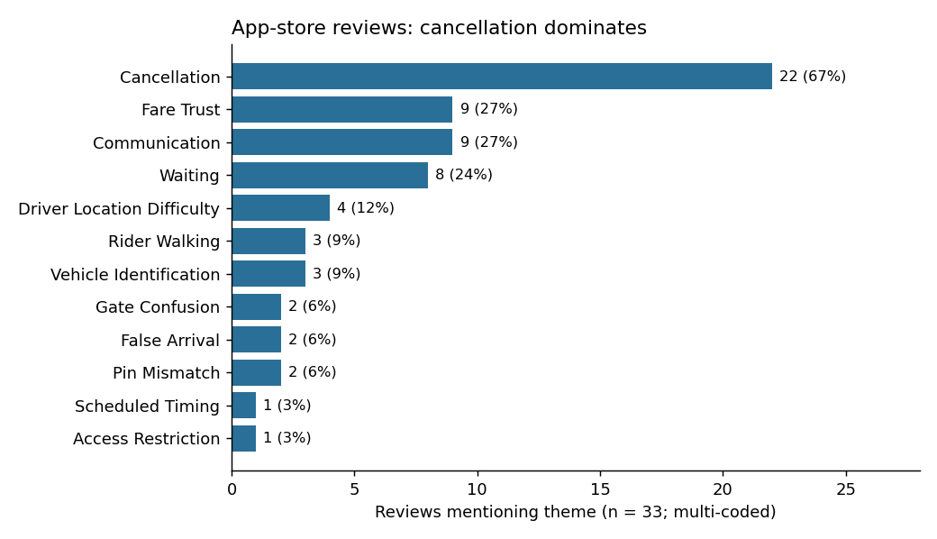
Data computed
- Cancellation 22 (67%); Communication 9 (27%); Fare trust 9 (27%); Waiting 8 (24%); Driver location difficulty 4 (12%); Vehicle identification 3 (9%); Rider walking 3 (9%); Pin mismatch 2 (6%); Gate confusion 2 (6%); False arrival 2 (6%).
- Mean rating by theme: Waiting 1.00; Driver location difficulty 1.25; Fare trust 1.33; Cancellation 1.50; Communication 1.56.
Inference
- Reviews concentrate on cancellation, partly because of the 1-star skew (24 of 33 are 1 star). The share shows what unhappy reviewers write about, not incidence.
- Waiting and driver-location-difficulty reviews carry the lowest ratings, so these are the most severe experiences when they occur.
- Gate and pin themes are rarely named (6% each), though riders may not attribute failures to those causes.

Chart 11: Secondary journey stage
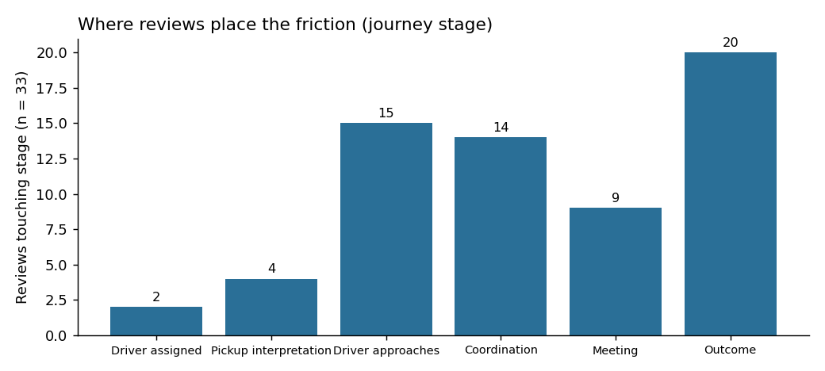
Data computed
- Outcome 20 (61%); Driver approaches 15 (45%); Coordination 14 (42%); Meeting 9 (27%); Pickup interpretation 4 (12%); Driver assigned 2 (6%).
- Relevance screening: 14 high, 19 medium.
Inference
- Problems cluster late in the journey (approach, coordination and outcome); the early interpretation stage is rarely mentioned.
- This supports intervening during approach and coordination, before the cancellation outcome occurs.

Chart 12: Primary vs secondary themes (triangulation)
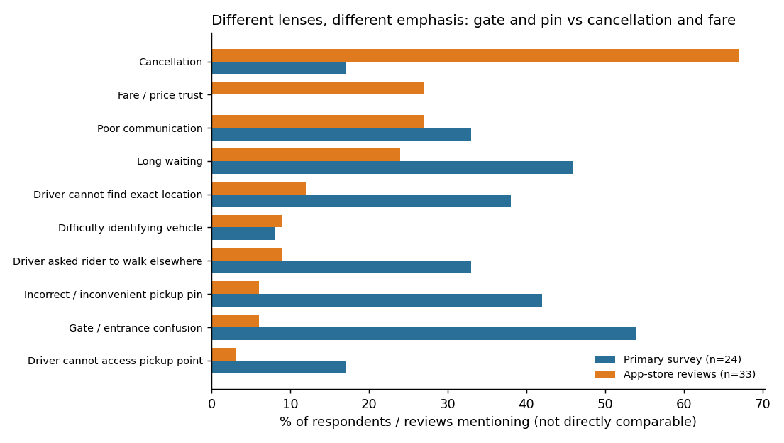
Data computed
- Long waiting: 46% vs 24%. Communication failures: 33% vs 27%. Driver cancellation: 17% vs 67%. Gate confusion: 54% vs 6%. Incorrect pin: 42% vs 6%. Vehicle identification: 8% vs 9%. Fare trust: not measured vs 27%.
Inference
- Communication failures and vehicle identification are similar in both sources, so they are the more robust findings.
- Cancellation is much larger in reviews (67%) than in the survey (17% driver cancelled), which reflects complaint self-selection. Review share should not be read as incidence.
- Gate and pin issues are far more common in the survey (54%, 42%) than in reviews (6%). The survey asked about them directly while reviewers may not name them. This is a research gap to test, not a conflict to settle by picking one source.
- Fare trust appears only in reviews (27%) and was not in the primary survey's main question set, though 58.3% of respondents answered Yes to the later extra-money question (Q11).

D. Market sizing and prioritisation (illustrative)

Chart 13: TAM / SAM / SOM funnel
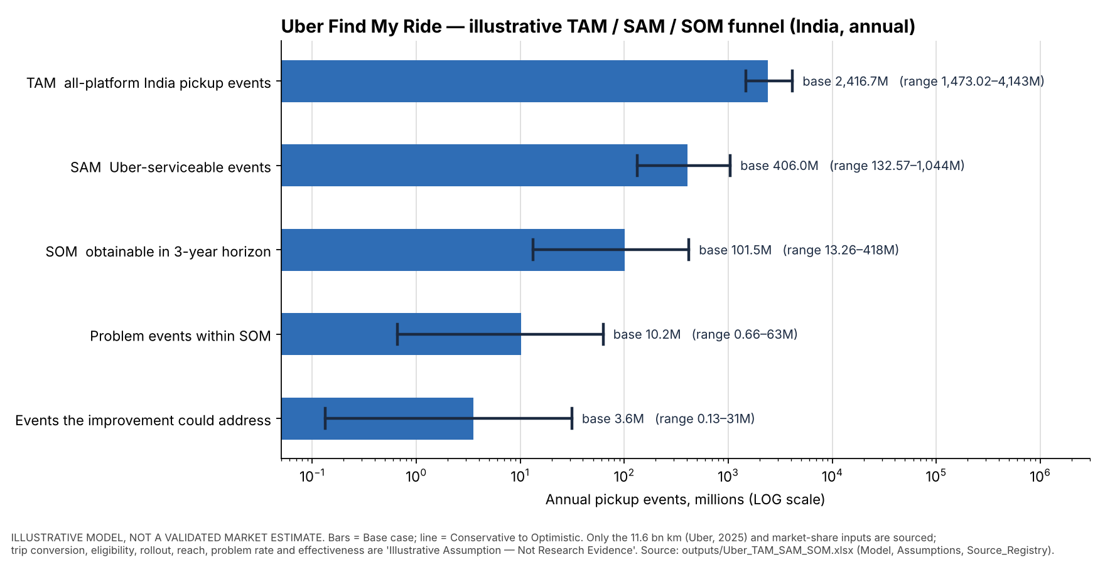
Data computed
- Base case (annual, India, million pickup events): Uber trips 966.7; TAM 2,416.7; SAM 406.0; SOM 101.5; coordination-problem events in SOM 10.15; addressed 3.55; trips retained 1.07.
- Incremental platform revenue: Conservative INR 0.08 crore; Base INR 5.33 crore; Optimistic INR 93.96 crore.
- Sensitivity swing (conservative to optimistic, INR crore): reach 6.39, problem rate 5.33, effectiveness 4.57.
- Cross-check: base-case Uber trips are 1.46x the Rapido-based estimate.
Inference
- The funnel narrows about 6x from TAM to SAM and about 4x from SAM to SOM; SOM is about 4% of TAM.
- Value is highly uncertain: all-conservative to all-optimistic differs by more than 1,000x, so only the funnel structure is informative, not the level. Most inputs are labelled illustrative assumptions, not research evidence.
- The survey was deliberately not used to set the problem rate, because it measures experience rather than trip-level incidence.

Problem prioritisation (weighted score, 1 to 3)
Hypothesis | Score | Rank | Reading
H1 Meeting-point ambiguity | 2.45 | 1 | Recommended initial priority: gate 13/24, pin 10/24, driver cannot find 9/24
H2 Coordination friction | 2.15 | 2 | Related mechanism: waiting 11/24, calls 11/24
H3 Cancellation-related friction | 1.70 | 3 | High impact, but causal link to coordination untested; 0 of 22 cancellation reviews carry a gate or pin code
Scores are analytical judgements on a 1 to 3 scale. The ranking was checked under four weightings.

E. Overall quantitative conclusion
- Among 24 valid users, 79.2% experienced difficulty finding a driver somewhere, 87.5% of difficult pickups involved delay or cancellation, and 62.5% worried about being late.
- Location ambiguity (gate 54.2%, pin 41.7%, driver cannot find 37.5%) is the largest group of causes, and phone calls (45.8%) are the main workaround.
- The app is rated helpful by 58.3% but fully accurate by only 12.5%.
- Reviews add that cancellation, fare trust and waiting drive the harshest ratings (mean 1.0 to 1.5).
- Limits: n = 24, convenience sample, 5 weeks of Apple reviews, no causal tests. Confirm with the proposed validation experiment.

