Name: Nguyễn Tất Thông

Group: iGroup

ID: 1359056

Bài tập Github

1. Github / sourcetree

* 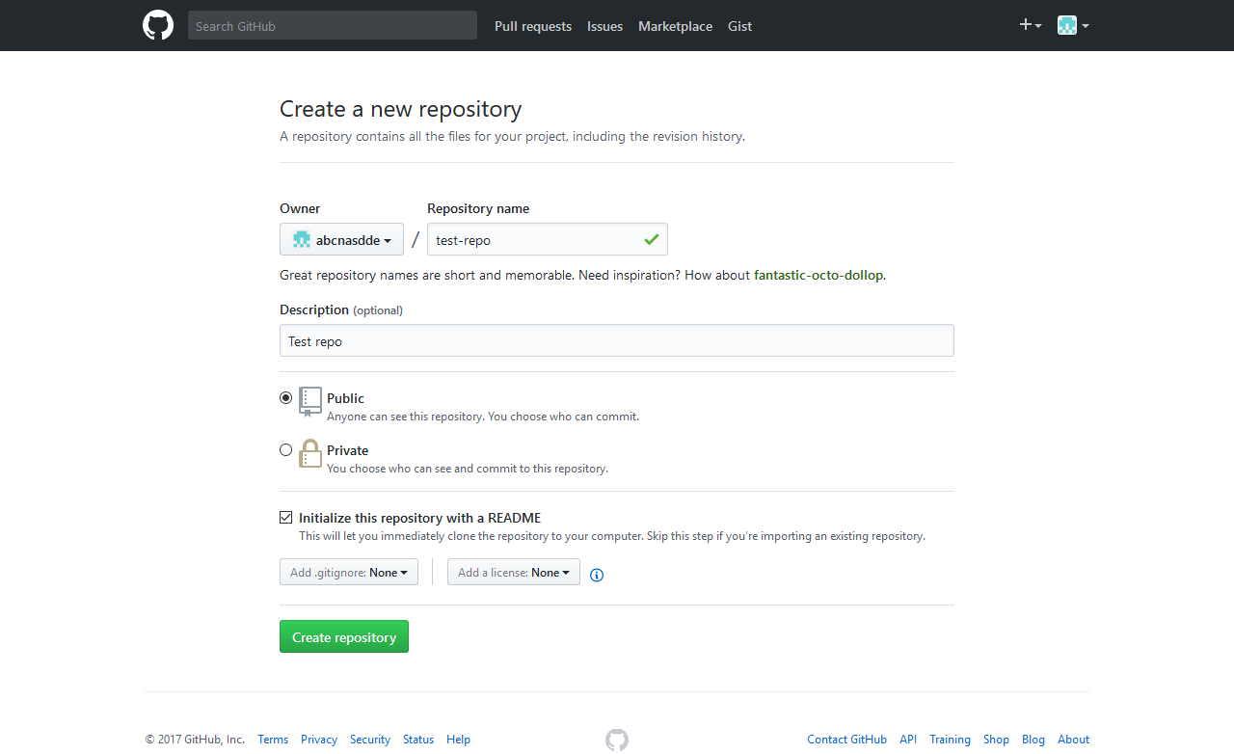Create account:
* 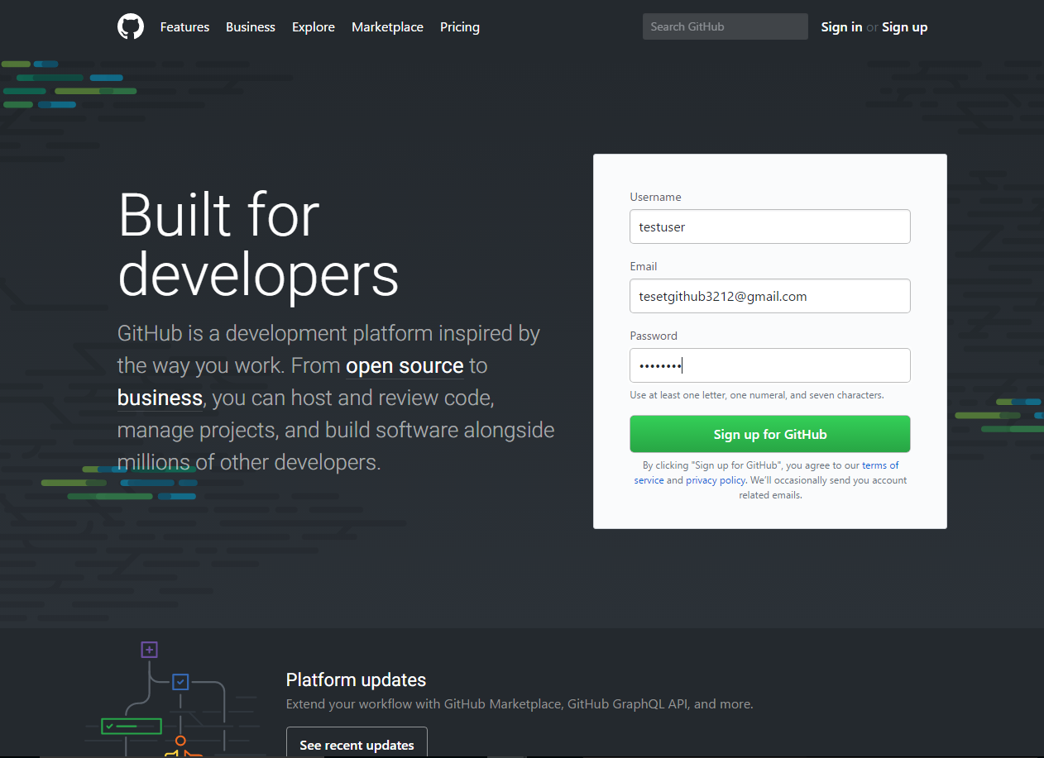Create repo:
* Clone repository:

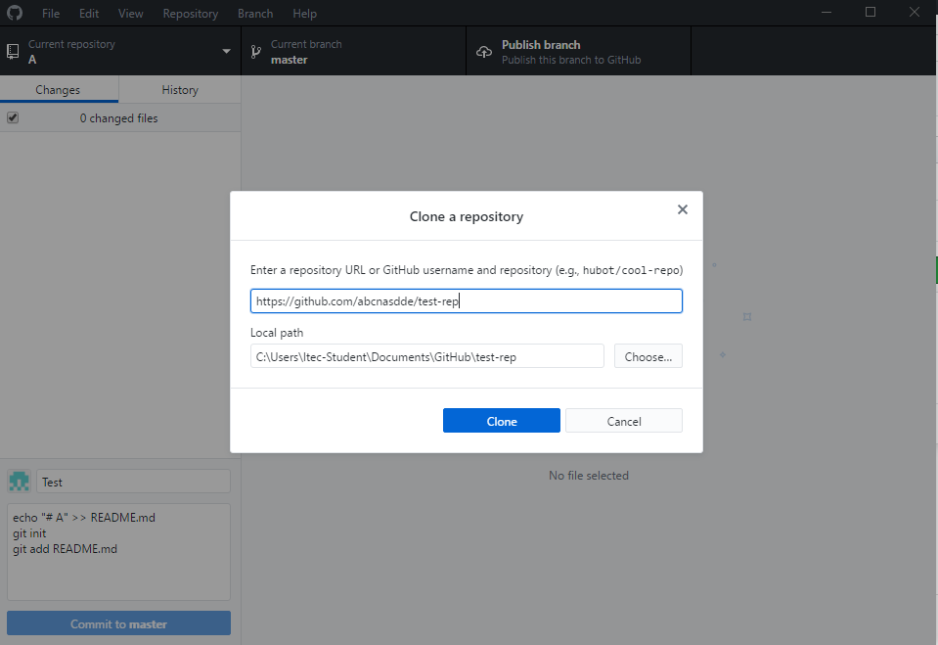Switch to the Github desktop app, then click ‘File’, then ‘Clone a repository’, enter the repository URL, choose the local path, then press clone.

* Commit a change:

In this commit example, I will commit the upload action of a file. On the web interface, click ‘Upload files’ then drag files from your computer to the box ‘Drag files here to add them to repository’

1. Zenhub