User Guide for the DICOM Split Workflow

# Introduction:

The DICOM Split Workflow allows users to split a 3D image containing multiple subjects to multiple 3D images such that each split 3D image contains only one subject. The inputs to the workflow are ZIP files for **whole** experiments downloaded directly from the [SAIP Image Portal](https://frsivg-mip01p.ncifcrf.gov/). The workflow will validate the folder hierarchies in the input ZIP files for correct data parsing and it is not recommended to manually create ZIP files as the workflow input.

# Usage:

1. Navigate to the DICOMSplit interface on the [ABCS SSR web site](https://fr-s-ivg-ssr-p1.ncifcrf.gov/ssr)

1. Login with NIH credential.
2. Click the ‘Apps’ navigation block. (#1 in figure 1)
3. Select ‘DicomSplit’ tab under ‘Tasks’ panel on the left. (#1 in figure 2)

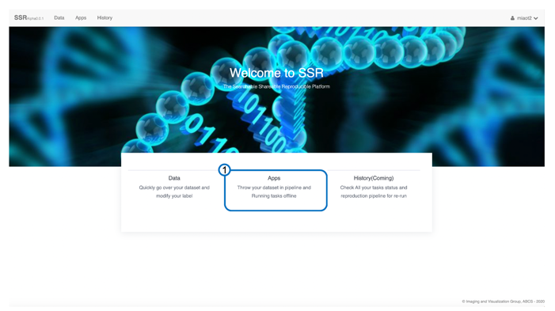

**Figure 1**. Application interface

2. Upload a dataset and create a result folder

1. Navigate to the user folder in the ‘Data management’ panel on the left.
2. Optionally create a folder for the new dataset (#2 in figure 2)
3. Click the green ‘upload’ button to launch the file upload dialog. (#3 in figure 2)
4. Click the green ‘Browse folder’ button, and then multi-selecting **.zip** file(s) downloaded from the SAIP Image Portal to upload. (#1, #3 in figure 3). These ZIP files are experiments downloaded from the SAIP Image Portal. The workflow will validate the folder hierarchies in the input ZIP files for correct data parsing and it is not recommended to manually create ZIP files as the workflow input.
5. Click the blue ‘try upload’ button to start upload. (#2 in figure 3)
6. **Wait** until the automatic unzip processing finished. (#4 in figure 4). The SSR server will automatically unzip and store the uploaded files. Please wait till the process has finished.

**Hint**: ZIP file(s) will be converted to folder(s) when unzipping is done.

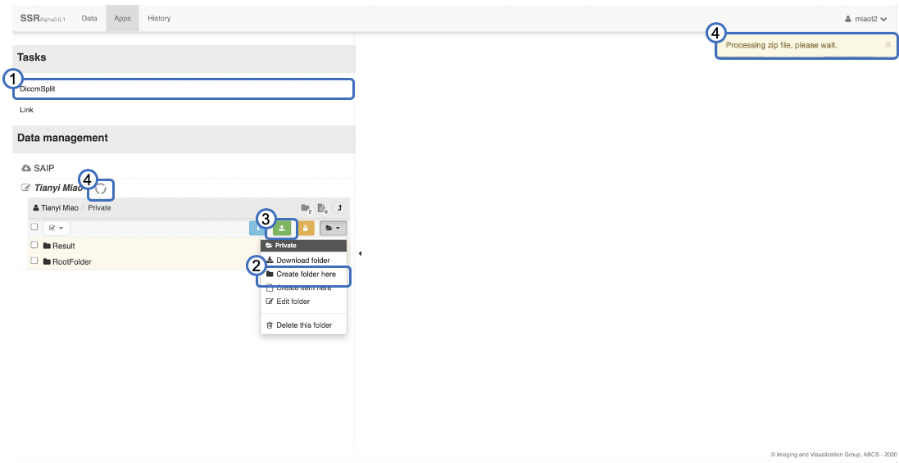

**Figure 2**. Application interface

**Figure 3**. Upload dialog

3. Select the uploaded dataset as input, and a result folder as output

1. You have two input options (#1 in figure 4):
   1. The ‘A group of experiments’ option allows you to drag one root folder (#3 in figure 4) with multiple experiments to the green ‘Drag & Drop’ box (#2 in figure 4). If users have uploaded multiple experiments to a single folder for batch processing, this is the best option.
   2. The ‘Experiments’ option allows you to drag multiple experiments (#4 in figure 4) to the green ‘Drag & Drop’ box (#2 in figure 4). This option allows users to navigate through different data folders and select different experiments as needed.

Hint: Click The ‘RootFolder’ (#3 in figure 4) to inspect experiments as shown in the dash box.

1. Drag and drop the result saving folder (user created) (Example, #5 in figure 4) to the green ‘Drag & Drop’ box area. (#6 in figure 4)

4. Select patterns from the animal arrangement pattern pool

1. Drag and drop pre-defined patterns based on thumbnails (#1 in figure 5) from the pattern pool (#2 in figure 5) to the ‘Drop a pattern from pool’ dash box. (#3 in figure 5)

5. Run the split task

1. Type in a job name. (#4 in figure 5)
2. Click the blue ‘Submit’ button to start the split process. (#5 in figure 5)
3. Submitted jobs will be running at the background without visual feedbacks to end users. It is planned to implement job history in future versions so users could see their status.

6. Download split task result

1. When jobs are finished, users will receive notification emails with download links to access their split results.
2. Alternatively, users could go back to the output folder to manually download the results after receiving the notification email.

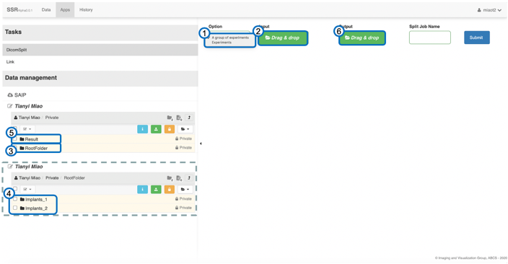

**Figure** **4**. Split task interface

**Figure** **5**. Pattern selection interface

# V2 Update: New 3-mice pattern split workflow (2020/12/04)

1. Select the uploaded dataset as input, and a result folder as output following the instructions in the section 3.a.

2. Select the new 3-mice patterns from the animal arrangement pattern pool. (#3 in figure 6)

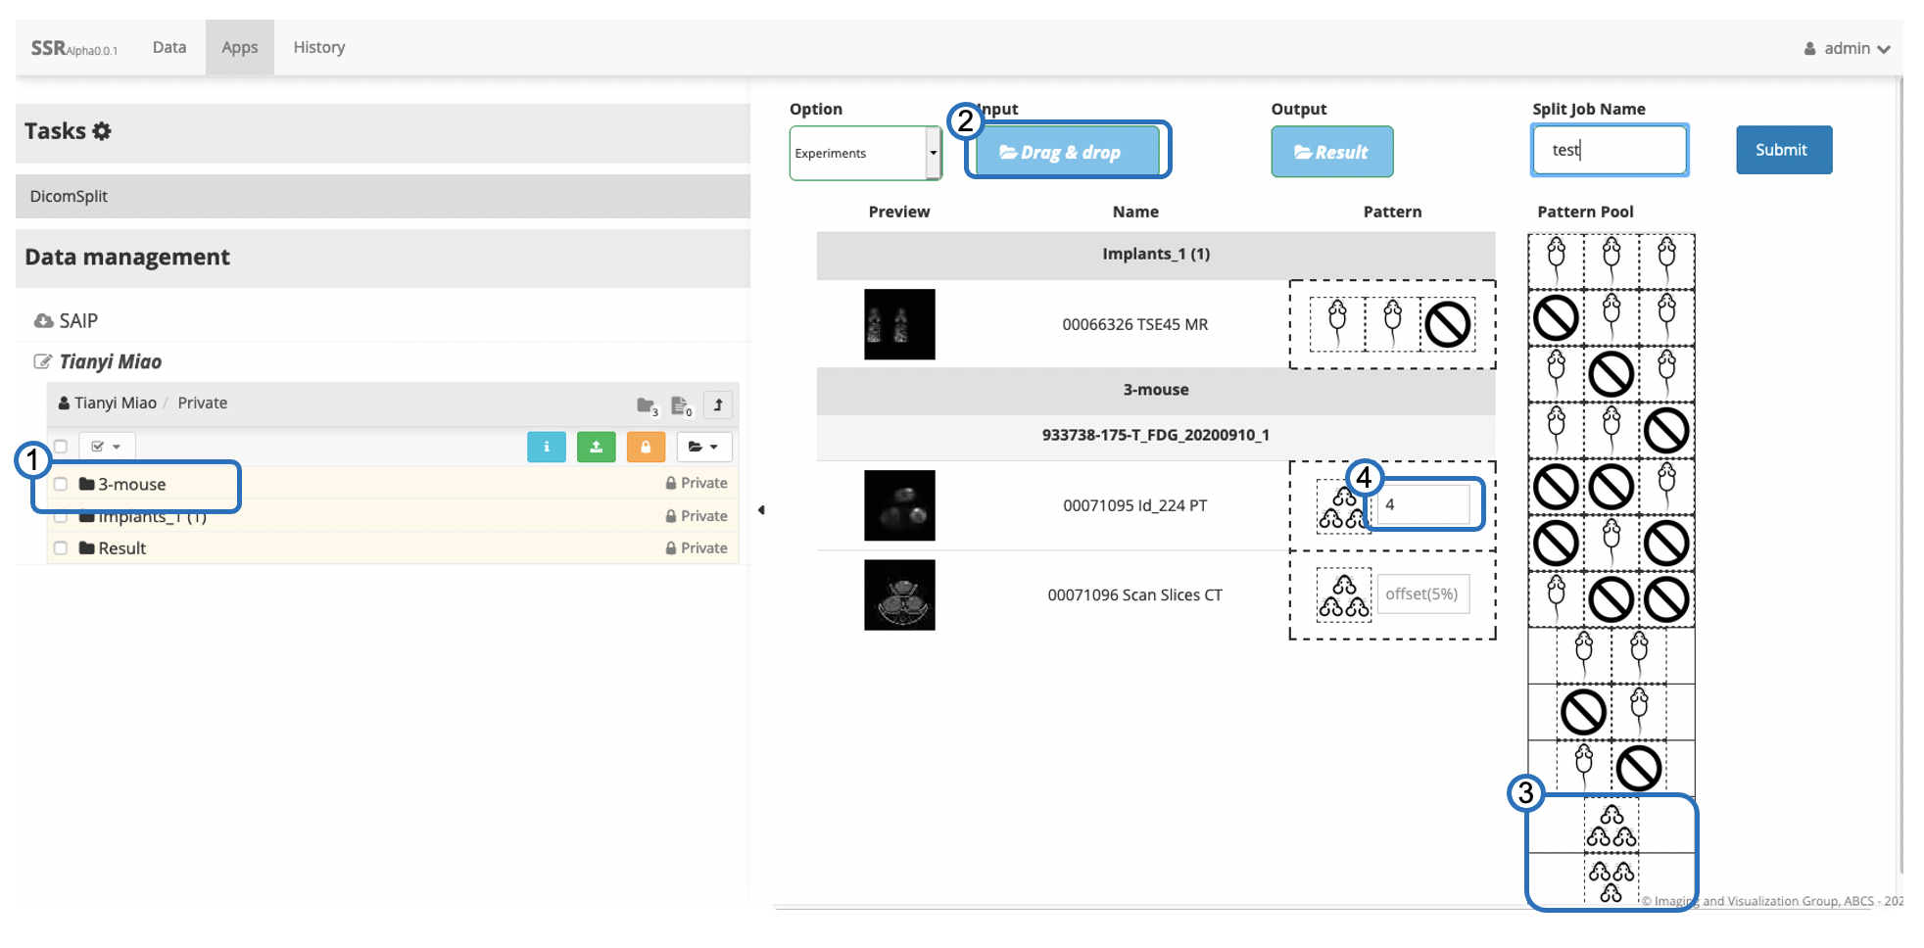

**Figure 6**. New 3-mice Pattern selection interface

3. Type in offset (default is 5% of the image height) to adjust split position as shown in figure 7.

4. Run and download as before.

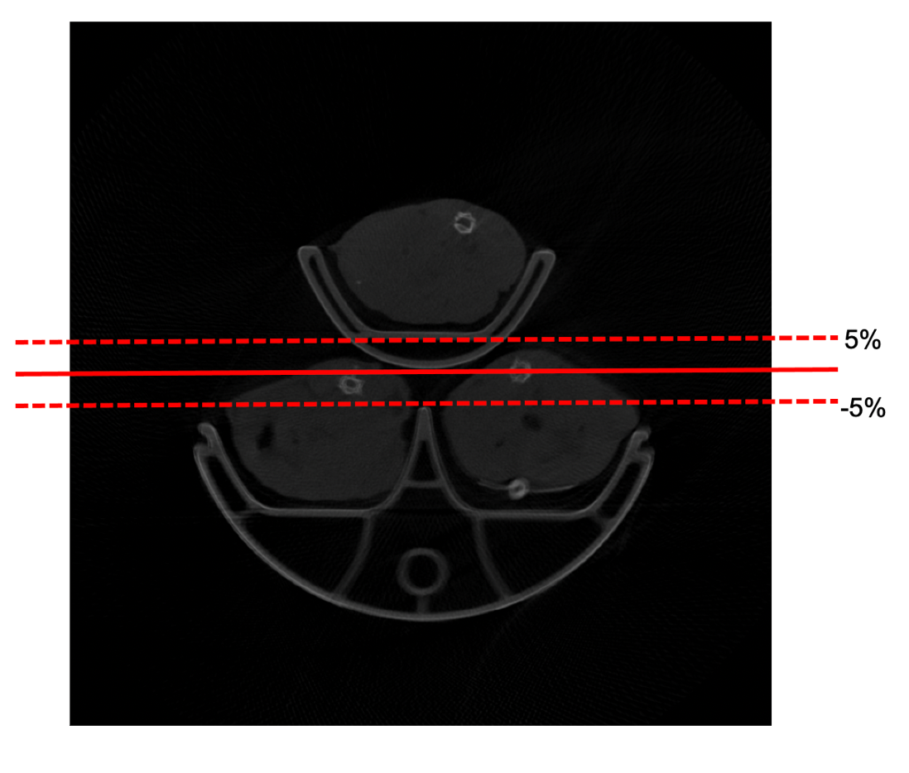

**Figure 7**. Different offset split position