**Introduction:**

The ABCS SSR DICOM split workflow allows users to split a single image containing multiple subjects to multiple images such that each split image contains only one subject. The workflow accepts a user defined root folder and will iterate through all experiments under the root folder. The split results will be stored to a user defined output folder with the same experiment name and folder hierarchy.

**Usage:**

1. Navigate to the DICOMSplit interface on the [ABCS SSR web site](https://fr-s-ivg-ssr-p1.ncifcrf.gov/ssr)

1. Login with NIH credential.
2. Click the ‘Apps’ navigation block. (#1 in figure 1)
3. Select ‘DicomSplit’ tab under ‘Tasks’ panel on the left. (#1 in figure 2)

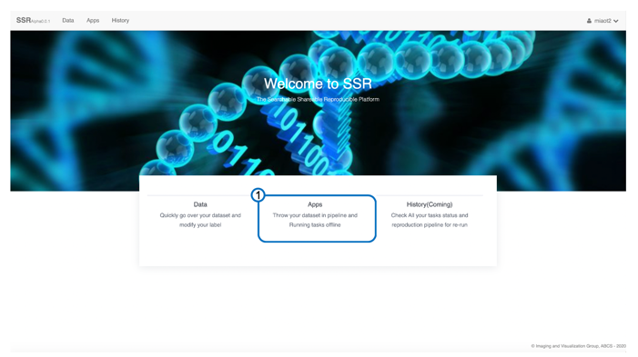

**Figure 1**. Application interface

2. Upload a dataset and create a result folder

1. Navigate to the user folder in the ‘Data management’ panel on the left.
2. Optionally create a folder for the new dataset (#2 in figure 2)
3. Click the green ‘upload’ button to launch the file upload dialog. (#3 in figure 2)
4. Click the green ‘Browse folder’ button, and then multi-selecting **.zip** file(s) downloaded from the SAIP Image Portal to upload. (#1, #3 in figure 3). These ZIP files are experiments downloaded from the SAIP Image Portal.
5. Click the blue ‘try upload’ button to start upload. (#2 in figure 3)
6. **Wait** until the automatic unzip processing finished. (#4 in figure 4). The SSR server will automatically unzip and convert uploaded files. Please wait till the process has finished.

**Hint**: Zip file(s) will be converted to folder(s) when unzipping is done.

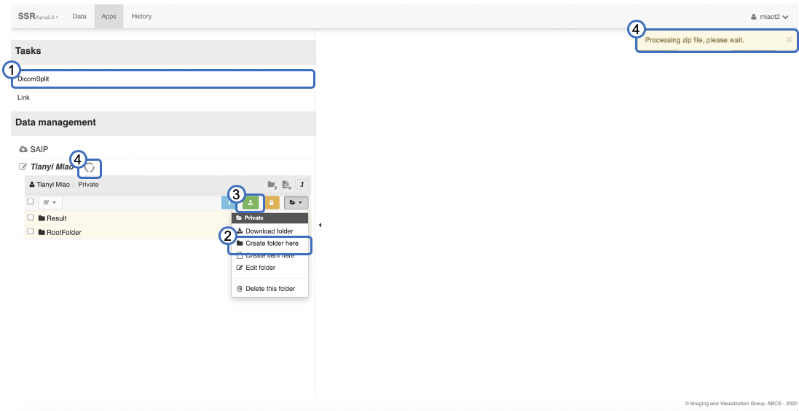

**Figure 2**. Application interface

**Figure 3**. Upload dialog

3. Select the uploaded dataset as input, and a result folder as output

1. You have two input options (#1 in figure 4):
   1. The ‘A group of experiments’ allows you to drag one root folder (#3 in figure 4) with multiple experiments to the green ‘Drag & Drop’ box (#2 in figure 4). If users have uploaded multiple experiments to a single folder for batch processing, this is the best option.
   2. The ‘Experiments’ allows you to drag multiple experiments (#4 in figure 4) to the green ‘Drag & Drop’ box (#2 in figure 4). This option allows users to navigate through different data folders and select different experiments as needed.

Hint: Click The ‘RootFolder’ (#3 in figure 4) to inspect experiments as shown in the dash box.

1. Drag and drop the result folder (user created) (Example, #5 in figure 4) to the green ‘Drag & Drop’ box area. (#6 in figure 4)

4. Select patterns from the animal arrangement pattern pool

1. Drag and drop pre-defined patterns based on thumbnails (#1 in figure 5) from the pattern pool (#2 in figure 5) to the ‘Drop a pattern from pool’ dash box. (#3 in figure 5)

5. Run the split task

1. Type a job name. (#4 in figure 5)
2. Click the blue ‘Submit button to start. (#5 in figure 5)
3. Right now, the submitted jobs will run at the background silently. It is planned to implement job history in future versions so users could see their status.

6. Download split task result

1. When job is finished you will receive a notification email with a download link.
2. Alternatively, users could go back to the output folder to manually download the results after receiving the notification email.

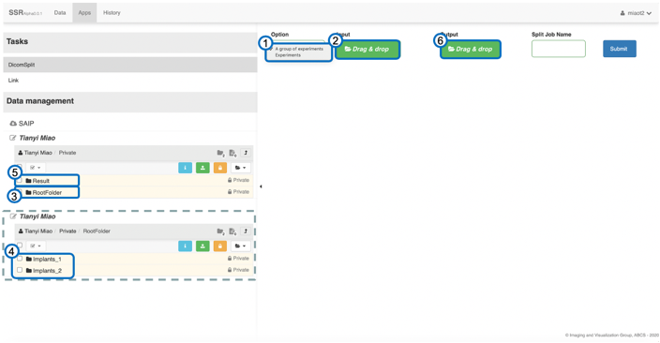

**Figure** **4**. Split task interface

**Figure** **5**. Pattern selection interface

**V2 Update: New 3-mice pattern split workflow (2020/12/04)**

1. Select the uploaded dataset as input, and a result folder as output as in above instruction 3.a.

2. Select New 3-mice patterns from the animal arrangement pattern pool. (#3 in figure 6)

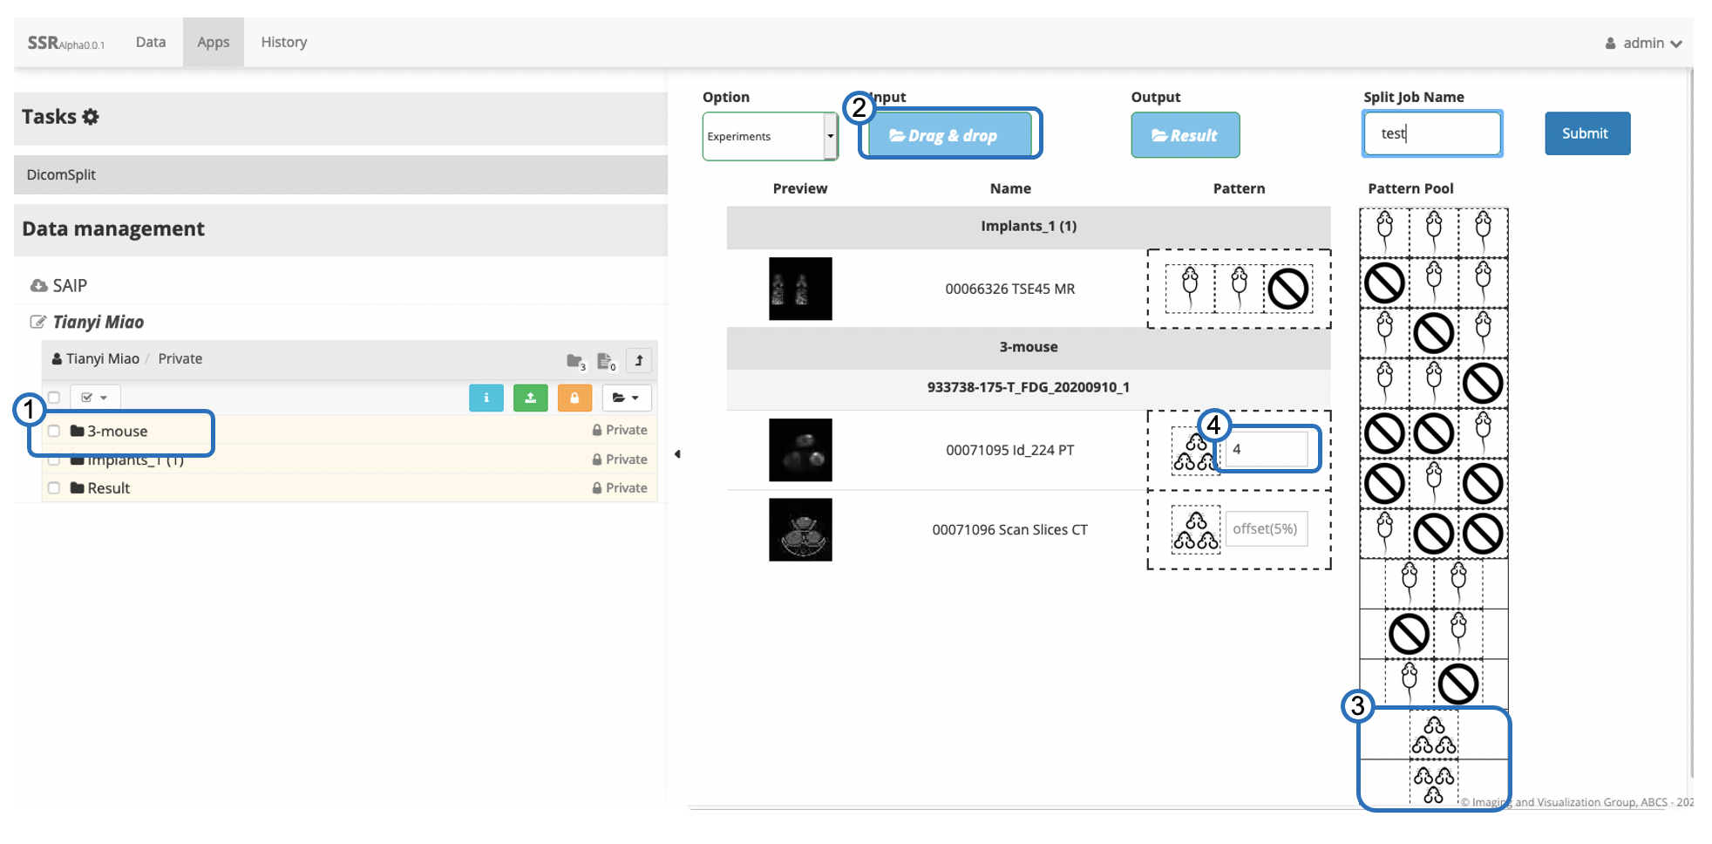

**Figure 6**. New 3-mice Pattern selection interface

3. Type offset (default is 5% of image height) to adjust split position as shown in figure 7.

4. Run and download as before.

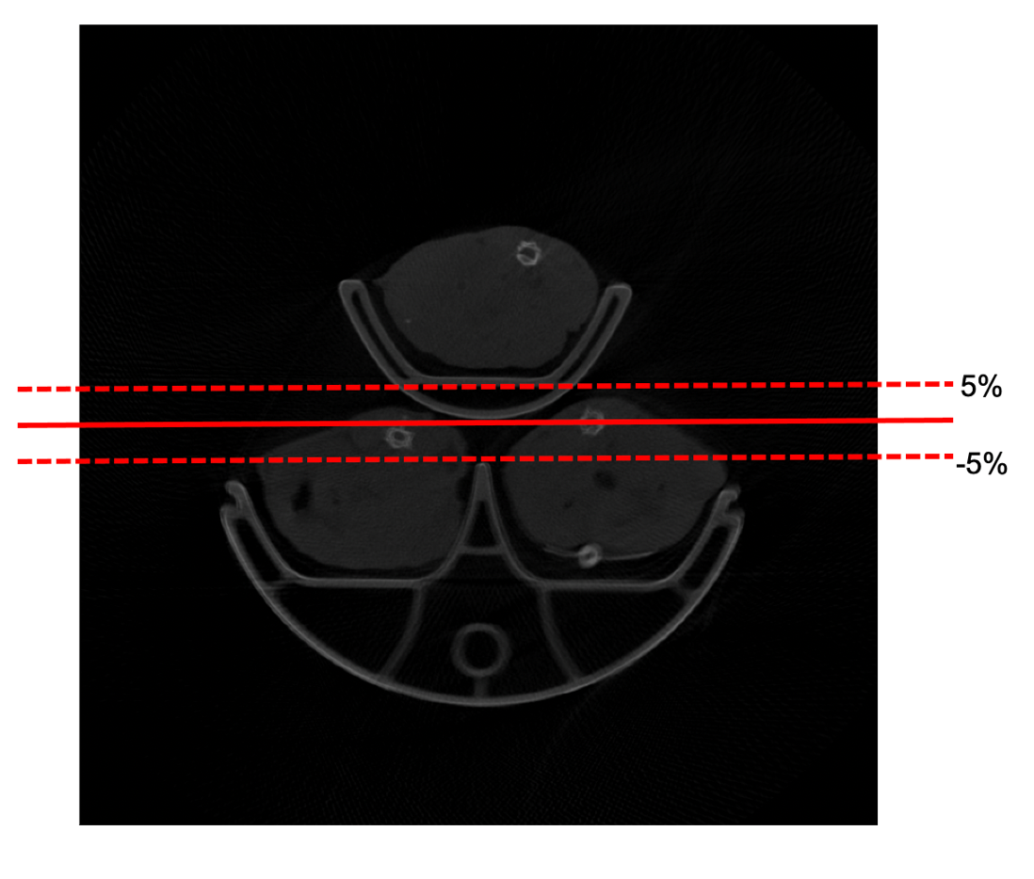

**Figure 7**. Different offset split position